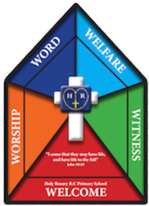

Faith Team Minutes

Date: 10.4.25 Time: 3.15pm-4.15pm Minutes taken by: Mrs Dootson

Meeting attended by: All

Focus of the meeting: Stations of the Cross

Register and opening prayer.

Remind children of the faith team jobs.

Children to plan a short reflection for each class.

Children to order the stations of the cross and discuss as a group what happens at each station.

Children to decide what they would like FS and KS1 to know and what they would like KS2 to know. How are they going to tell them this information? Are they going to get the children involved?

Take the Faith Team outside to show them where the reflections are going to take place (Outside the Y1 classroom where the big stations of the cross boards are).

Children to make notes ready for the reflections – practise.

Resources – Laptop, planning format

Actions for next meeting:

Complete stations of the cross reflections with each class during Holy Week.