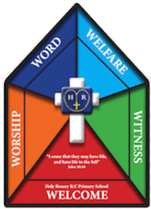

Faith Team Minutes

Date: 12.6.25 Time: 3.15pm-4.15pm Minutes taken by: Mrs Dootson

Meeting attended by: All

Focus of the meeting: Prayer Bags/Pentecost

Collect in Half Term 5 prayer bags.

Faith Team to go through the bags and make sure that everything is in the bags.

Pentecost

Discuss Pentecost with the Faith Team. (The Faith Team recalled the story of Pentecost well!)

Children to decide how they want to share the story of Pentecost around school. The children decided that they wanted to go around classes and share the story.

* Discussed the important parts of the story
* What message do they want the children to take away with them.

Children to group themselves and decide who is going to which class.

Resources – Laptop, planning format

Actions for next meeting:

Children to go around classes and share the story of Pentecost.