
Waverton Community Primary School
Common Lane, Waverton
Chester CH3 7QT
Telephone (01244) 268985
www.waverton.cheshire.sch.uk
Email: admin@waverton.cheshire.sch.uk
Head Teacher: Mrs Carla Cartwright





Learning together; Achieving together.

Friday 16th January 2026
Dear Waverton Families,
The term is well underway and the children seem to have recovered from the excitement of Christmas.

Pyjama Day
This year the children are raising money for their chosen charity - Kids Bank Chester, who support local families in need. As part of their fundraising, the School Parliament have organised a pyjama day on Wednesday 21st January. The children can come to school in their pyjamas and are asked to make a small donation of £2. This can be brought in on the day.
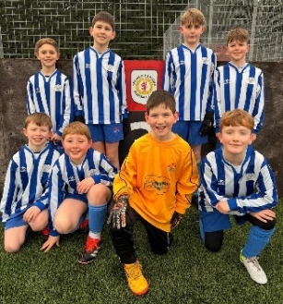
Cheshire Football Finals
Some of our Year 5 and 6 children played in the
Cheshire football finals this week. They showed
amazing teamwork and played very well.
Well done.

Curriculum
Take a look at the curriculum on the class pages on the school website.
This term these are our units:
Reception | Can you catch a star?
Year 1 | How does the weather effect us?
Year 2 | How does the geography of Kampong Ayer compare to where we live?
Year 3 | What impact did the Roman Empire have on Britain and Chester?
Year 4 | How can we live more sustainably?
Year 5 | How has Chester changed over the centuries?
Year 6 | What was life like in Britain during World War Two?

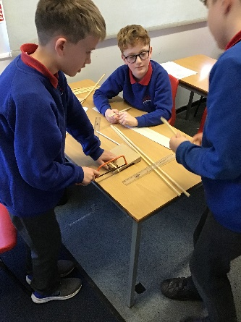
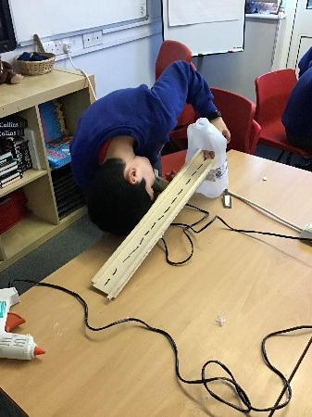
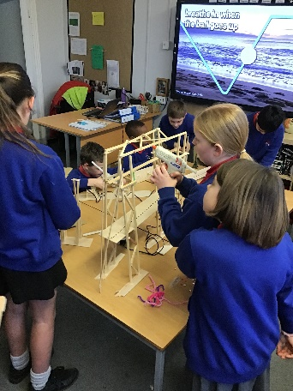
Year 5 DT

Year 5 completed their
unit on rivers by designing
and building bridges in DT.
They worked really hard
designing, measuring,
sawing and gluing.

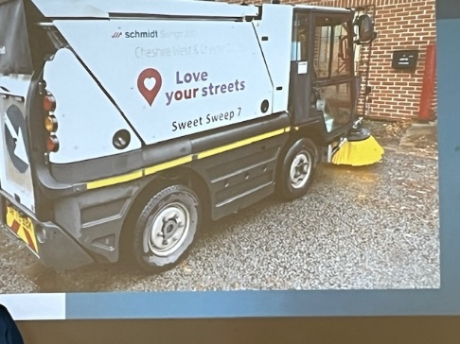
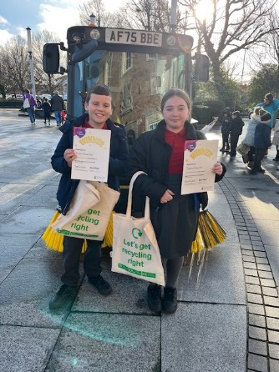
NAME THE ROAD SWEEPER COMPETITION

Two of our Year 6 children attended a
“Sweeper Competition Event” today after
being successful in naming one of the new
Cheshire West & Chester Council Road
Sweepers in a recent competition. The winning
name was “Sweet Sweep”. Keep an eye out to see
if you can spot it when you are out and about.

Have a good weekend.
Mrs C Cartwright

