Music opportunities in Manchester for our children

Be Hear Now – Children and young people with SEND
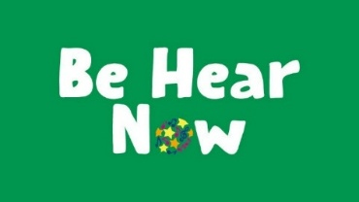
Relaxed musical discovery sessions for children and young people with special education needs and disabilities and their families.
‘Be Hear Now’ also has a ‘Calm’ session each month, a quieter, calmer sensory session for a smaller group, particularly suited for children / young people with profound / multiple learning disabilities.
The Bridgewater Hall, Lower Mosley Street, Manchester. M2 3WS 0161 907 9000

Stoller Story Sounds - children aged 3-5 years

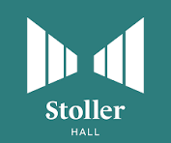

Perfect for children aged 3-5 (and their grown-ups!), the Stoller Story Sounds musical journeys will transport you to a beautiful world of new and exciting sights and sounds.

Saturday 17 January 2026, 1pm www.stollerhall.com

Music Makers – baby and toddler sessions

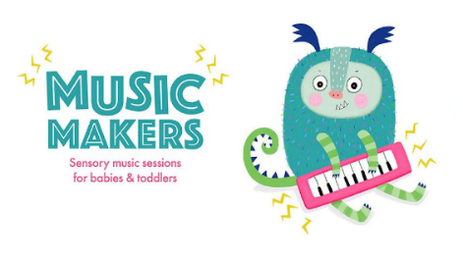

Monthly music and sensory play sessions for babies and toddlers, with songs and musical activities.
The Bridgewater Hall, Lower Mosley Street, Manchester. M2 3WS 0161 907 900

