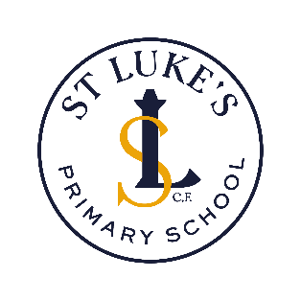
Music development plan summary
St Luke’s CE Primary School
Detail | Information
Academic year that this summary covers | 2025-26
Date this summary was published | September 2025
Date this summary will be reviewed | September 2026
Name of the school music lead | Catherine Nickeas
Name of local music hub | Manchester Music Hub

This is a summary of how our school delivers music education to all our pupils across three areas – curriculum music, co-curricular provision and musical experiences – and what changes we are planning in future years. This information is to help pupils and parents or carers understand what our school music offer is.

Part A: Curriculum music
Children at St Luke’s have regular curriculum music lessons, ensuring the National Curriculum expectations for Music are met in our school. The Charanga music scheme supports our curriculum delivery and enables excellent musical development, as well as being an exciting and engaging learning platform.

KS1 and KS2 children are taught to develop their musical understanding, make musical judgements, develop their aural memory, express themselves physically and emotionally and create their own musical ideas. Children use both voice and instruments (glockenspiels and recorders) to learn, perform, improvise and compose. Children access a range of pieces from across the ages and around the world.

EYFS music as an integral part of the topic work covered during the year. We relate the musical aspects of the children’s learning to the objectives set out in the EYFS curriculum and support our children in EYFS to begin their music curriculum immediately, have an early introduction to the interrelated dimensions of music and progress well through EYFS and into Year 1.

We ensure our music curriculum is inclusive of all learners at St. Luke’s. Mainstream lessons are developed so that all learners can engage, enjoy and develop well.

Part B: Co-curricular music
In addition to our music curriculum, children have access to other musical opportunities including Djembe drumming sessions in lower KS2 and singing coaching in KS1. Alongside this, we have a school choir for our older KS2 children and a recorder ensemble. We signpost our families to local instrumental lesson providers, in particular those offering free instrumental lessons and free instrument loan service (we link with Olympias Music Foundation for this).

Part C: Musical experiences
Other musical events and opportunities at St Luke’s include:
-Annual School musical performances – Christmas play and summer play
-Weekly singing assemblies (EYFS/KS1 and KS2)
-Early Years Musical Celebration at Stoller Hall, where our EYFS children visit Chetham’s Music School auditorium. The children have the opportunity to sing songs, listen to live musicians and play along with percussion instruments, alongside other early years classes from across the city
-One Education KS1 ‘Singaround’ event: an opportunity for our KS1 children to learn new songs in school, then come together with children from other schools in a theatre space
-LADA productions’ annual Christmas pantomime
-Christmas carol concert
-Staff choir performances each half term

In the future
We aim to develop our children’s choir, with a view to holding choir performances in school and in the wider community
We aim to develop a Ukulele ensemble for our KS2 children, where children will learn Ukulele skills and develop performance techniques.

