KS2 progress and attainment in reading, writing and maths

EXS – expected standard 
GDS – greater depth standard
RWM – reading, writing and maths combined

KS2 Reading progress KS2 Reading attainment

School EXS | National EXS | School GDS | National GDS
64% | 73% | 18% | 29%
Below average -1.73
Confidence interval
-3.4 to -0.1

KS2 Writing progress KS2 Writing attainment
School EXS | National EXS | School GDS | National GDS
61% | 71% | 5% | 13%

Well below average -3.00
Confidence interval
-4.6 to -1.4

KS2 Maths progress KS2 Maths attainment

School EXS | National EXS | School GDS | National GDS
54% | 73% | 29% | 24%
Average -1.61
Confidence interval
-3.2 to 0.0

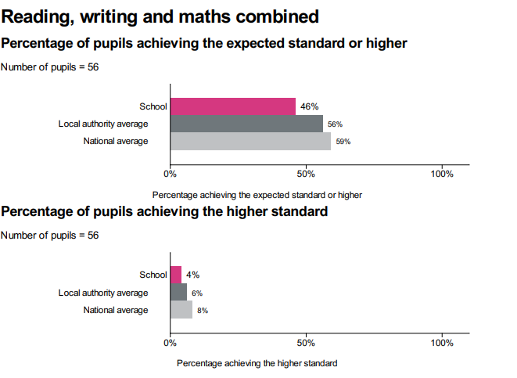

KS1 attainment in reading, writing and maths

KS1 | School EXS | School GDS
Reading | 63% | 23%
Writing | 46% | 0%
Maths | 60% | 9%
R/W/M  combined | 37% | 0%

