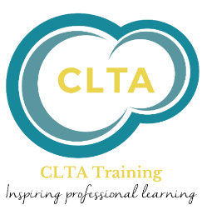


CPD BOOKING FORM

Course name: | PO Number
Course date: | Cost:
School Name: | Telephone No:
School address:

Participant’s name:

Participant’s email address (important for any late minute communications)

Email address for payment:

Note: All reasonable adjustments to provision will be made to ensure that learners with a learning difficulty, disability and/or a medical condition that affects their learning are not substantially disadvantaged. If you have a learning difficulty, disability and/or medical condition, please ensure that we know what you need so that we can make all reasonable adjustments to help you succeed.

Please email completed booking form to admin@cheshirelta.co.uk
Terms and Conditions
Fees
Fees quoted are correct at the time of publication. All fees quoted are exclusive of VAT.
On confirmation of the booking, an invoice will be issued and must be paid within 14 days.

Cancellations
There will be no refund for cancellation but the booking may be transferred to the next available date or an alternative course.

Cheshire LTA reserves the right to cancel a course due to insignificant numbers. Any fees paid will be refunded in full.

Non-Attendance
Non-attendance of a course shall be deemed to be a cancellation and as such you will be charged in full.
In certain circumstances an alternative date/course may be offered at the discretion of CLTA.
Please see our website for a complete set of terms and conditions.

www.cheshirelta.co.uk

