Vine Tree Primary School
English overview Year 2 2025-2026
Term and curriculum link | Title/author | Writing outcome (s)
Autumn 1  Curriculum driver: geography -oceans and continents | Poem: Ocean Travel  Poet: Jennifer Tweedie  Title: The Secret of Black Rock  Author: Joe Todd Stanton  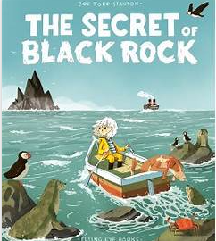  Title: The Big book of blue  Author: Yuval Zommer  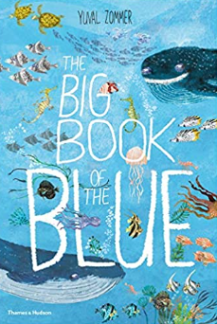 | Incidental – poem about Black Rock  Whole class guided reading – use this book!!  Final outcome:  Non-fiction: Make a non – fiction book about the sea creatures.
Autumn 2 | Poetry: The Hungry Fire  Title: Vlad and The Great Fire of London  Author: Katy Cunningham  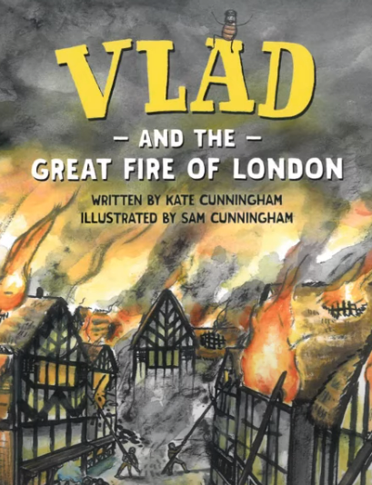 | Incidental :  Fiction: setting description  Final outcome:  Non-fiction – writing recount of Boston the rat
Spring 1  Curriculum driver: PSHE – How do we recognise our feelings? | Title: The day the crayons quit  Author: Drew Daywalt and Oliver Jeffers  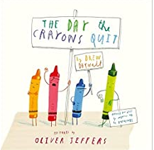 | Incidental :Poem  Emotions of the crayons  Final outcome:  Non- Fiction: writing to recount: letters
Spring 2  Curriculum driver: science – habitats and food chains | Title: The bear and the piano  Author: David Litchfield  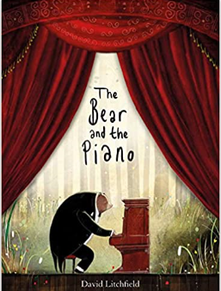 | Incidental : Description of the woods  Final outcome:  Fiction: story opening (setting – up to the Bear goes to the city)
Summer 1 | Title: Inside the villains  Author: Clotilde Perrin  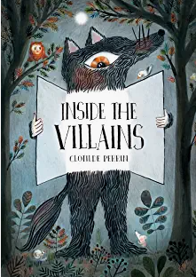  Title: Jack and the baked beanstalk  Author: Colin Stimpson  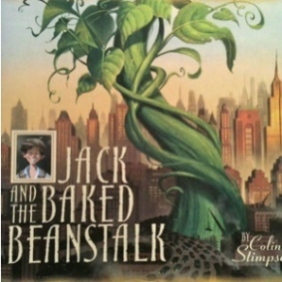 | Incidental : Giant character description  Additional writing: Recount of Gladstone trip  Final outcome:  Fiction: twisted narrative
Summer 2  Curriculum driver: history – local history | Title: If you were a kid aboard the Titanic  Author: Josh Gregory  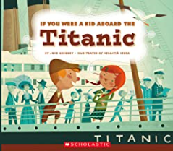 | Incidental write:  Interview with third or first class passenger.  ( answering specific questions for a report)  Final outcome:  Non-fiction: diary entry  (third class versus first class passengers)

