Vine Tree Primary School
English overview EYFS 2025-2026
Term and curriculum link | Title/author | Writing outcome (s)
Autumn 1  Curriculum driver:  All about me | You Choose by Nick Sharratt  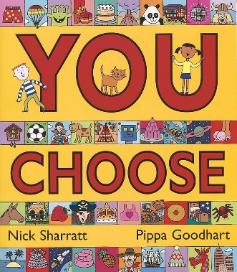  Elmer by David McKee  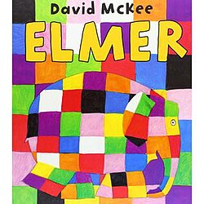  Poems Aloud :  Tiger  Honey bear  I’m a little penguin  Whisky frisky | Narrative: A Losing Story Purpose: Retell the Losing Story and Write Sentences  Non-fiction: Recount: Animal Information sentences  Talk for writing: perform a poem
Autumn 2  Curriculum driver:  Near and Far | Star in the Jar by Sam Hay  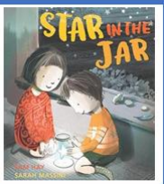  Poetry:  Title: I’m a little alien  Poet: James Carter  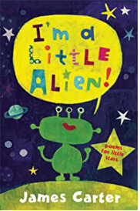 | Narrative: Finding Story Sentences  Non-fiction: Poster Sentences  performance poetry
Spring 1  Curriculum driver:  A superhero like me | Juniper Jupiter by Lizzy Stewart  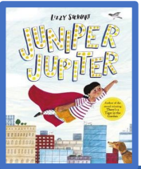  Poetry:  Title: here come the superheroes  Poet: Nell Zetter  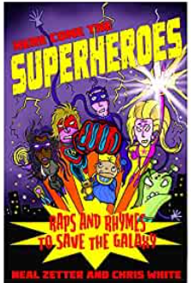 | Narrative: Superhero Sentences  • Letter Sentences
Spring 2  Curriculum driver:  Roots, Shoots and Muddy Boots | The Extraordinary Gardener by Sam Boughton  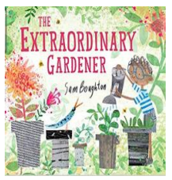 | Non-fiction:  Instruction Sentences  Narrative:  Transformation Story Sentences
Summer 1  Curriculum driver:  Adventure time! Traditional Tales | Little Red by Bethan Woollvin  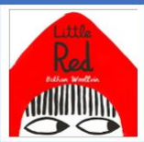  Poetry - Allan Allberg  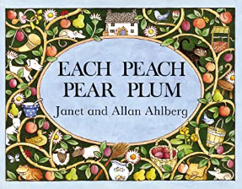 | Narrative:  Traditional Tale Sentences  Non-fiction:  Instruction Sentences  Performance poetry
Summer 2  Curriculum driver: All at Sea | Title: The Snail and the Whale by Julia Donaldson  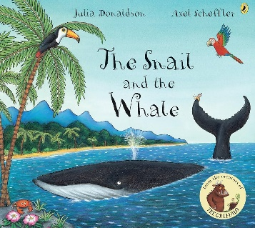  Poetry:  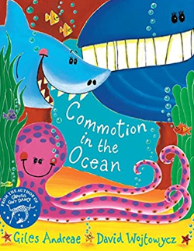 | Narrative: Friendship Story Sentences  • Sea Creature Spine Poem Sentences

