Vine Tree Primary School
Writing Overview Year 6 2025-26
Term | Title/author and curriculum link | Writing outcome
Autumn 1  Curriculum link: Did WW1 and WW2 have the biggest impact on Crewe?  (history) | Title: Rose Blanche  Author: Roberto Innocenti  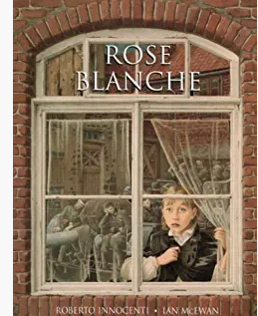 | Incidental write:  Setting description  Final outcome: diary entry  Fiction: Setting description  Non-fiction: diary entry
Autumn 2  Curriculum link: Have we always looked like this?  (science from Autumn 1) | Title: Skellig  Author: David Almond  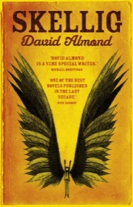 | Incidental write:  Character description  Final outcome: action chapter  Fiction: character description  Fiction: action chapter
Spring 1  Curriculum link: What was the civil rights movement in the USA?  (history) | Title: Dreams of Freedom  Author: Amnesty International  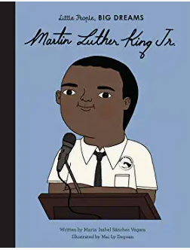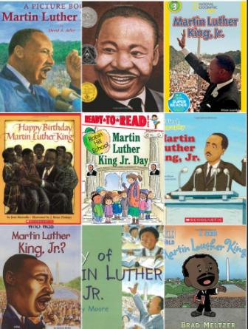  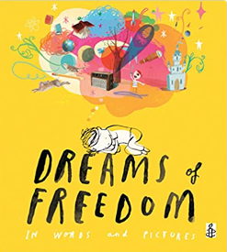 | Incidental write: formal letter/ speech to Mr Locke about students rights  Non-fiction  Final outcome: Biography of Martin Luther King  Non-fiction  Non-fiction: formal letter/ speech  Non-fiction: biography
Spring 2  Curriculum link: How can you light up your life?  (Science: electricity and light) | Title: The Nowhere Emporium  Author: Ross Mackenzie  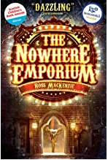 | Incidental write: Suspense paragraph  Final outcome: new entry for the book of wonders  Fiction: suspense paragraph  Fiction: entry to the book of wonders
Summer 1 | Title: The Fantastic Flying Books of Mr Morris Lessmore  Author: W E Joyce  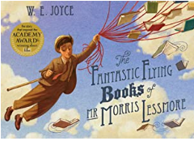  Poems:  - Uses (Rachel Rooney –wonderland Alice in poetry p7)  - The weaver of words (Sue Hardy-Dawson - where zebra’s go p8)  - Just words (Matt Goodfellow – bright bursts of colour p22) | Incidental write: instructions to fix an unwell (broken) book  Final outcome: fantasy short story  Non-fiction: instructions  Fiction: fantasy narrative  Poetry writing: The power of words/books
Summer 2  Curriculum link: Why did the Titanic sink?  (Science) | Title: Survivors  Author: David Long  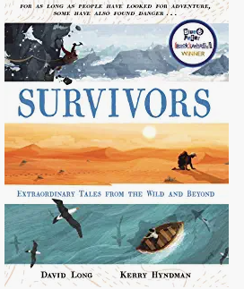  Poem: tomorrow has your name on it  Poet: Roger McGough | Incidental write: setting description  Incidental write: dialogue extract  Fiction: setting description  Fiction: dialogue  Poetry writing: a message to the future/Tomorrow has your name on it!

