Vine Tree Primary School
English overview Year 5
2025-2026
Term | Title/author and curriculum link | Writing outcome
Autumn 1  Geography driver: Can I become a cartographer? | Title: The Girl of Ink & Stars  Author: Kiran Millwood Hargrave  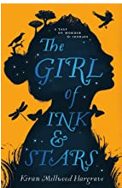  Title: Falling out of the Sky  Poet: Emma Wright  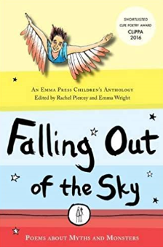 | Incidental write: setting description of the town  Final outcome: labyrinth setting description with mythical creature  mythical monster kenning  poetry performance – The Minotaur (falling out of the sky)
Autumn 2  D&T driver: Can I make a pop-up book? | Title: The Christmas Dinner of Souls  Author: Ross Montgomery  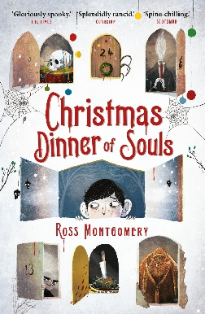 | Incidental write: eccentric character description  Final outcome: tension writing
Spring 1  MFL driver: Warsy France residential  Science – life cycles | Title: Manfish  Author: Jennifer Berne  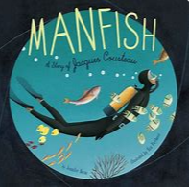 | Incidental write: school report  Final outcome: biography
Spring 2  History driver: Were the Vikings victorious? | Title: How to Train your Dragon  Author: Cressida Cowell  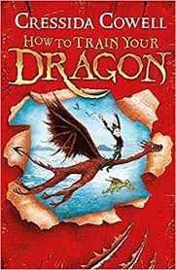 | Incidental write:  Character description (Gobber)  Final outcome:  Non-chronological report on a dragon species
Summer 1  Science driver:  Is there anybody out there? | Title: King Kong  Author: Anthony Browne  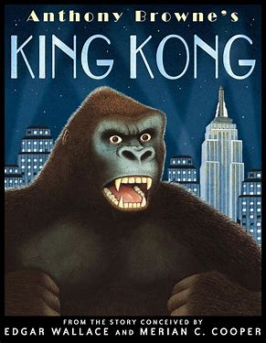 | Incidental write: setting/character description  Final outcome: dilemma narrative  description, action and dialogue
Summer 2  Geography driver: rainforest biomes | Title: The Explorer  Author: Katherine Rundell  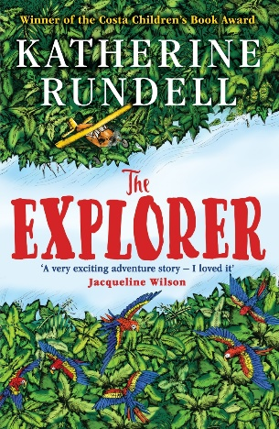 | Incidental write: diary from Fred’s perspective  Final outcome: survival story

