
Community Wellbeing Newsletter
Autumn 2 2024

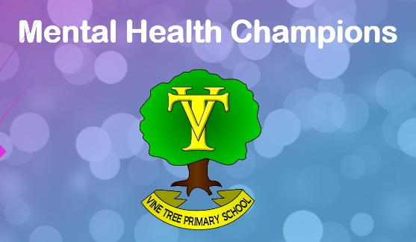
Welcome back to our termly Community Wellbeing Newsletter. This newsletter is designed to give helpful advice and signposting for a range of wellbeing topics. This edition of the newsletter includes the following:
- What have the Mental Health Champions been up to?
- Mindfulness practice
- Supporting Your Child’s Wellbeing
We welcome any feedback or suggestions as to how we can offer further support to our families.
Please email admin@vinetree.cheshire.sch.uk
This term, Mental Health Champions have been working hard to transform The Hub into an inviting and practical space to use for sessions to support mental health. They have also created their first assembly to introduce themselves to the rest of the school and let everyone know what we are doing. They even had a go at leading a mindfulness practice at the end of their assembly! Well done!
Mental Health Champions


- Put your hands on your belly, and imagine that your belly is a balloon.
Mindfulness Practice
- Take a deep breath in and imagine the balloon filling with air.
- Take a long slow breath out and imagine the balloon deflating and getting smaller.
- Repeat 10 times.
Supporting Your Child’s Wellbeing
What to do if your child tells you they’re struggling:
If your child tells you that they’re struggling, it’s important to make sure they feel seen and heard. When responding, it helps to:
1. Validate their feelings. You could say, “It's really understandable that you're feeling...” to let them know that their feelings are okay.
2. Thank them for sharing what's going on and be encouraging about the way they've opened up.
3. Let them know that you love them, you're there for them, they can talk to you whenever they need to, and you can help them get support if they need it.
4. Ask them if there's anything you could do that they would find particularly helpful.
5. Spend time together thinking about what's making them feel this way. It could be something at home or school, a relationship with a friend or family member or something else.

6. Let your child know about helplines, textlines and online chat services that are available - which you can find in the link at the end of this section. Young people can find it difficult to talk and worry about upsetting their parents, so reassure them that it's okay to open up to other people.
7. Remind your child that this is temporary. Reassure them that things can change and they can feel better.
8. Avoid conversations at the height of distress. It's important to be there for them, but it can be more helpful to talk about the causes when things are feeling calmer.
(youngminds.org)
For activities and more advice about how to have these conversations at home, please visit:
https://www.youngminds.org.uk/parent/how-to-talk-to-your-child-about-mental-health/#Whattodoifyourchildtellsyoutheyrestruggling
In-School Support
We have Sarah from the Crewe Mental Health Support Team working with us in school. She works with us on our whole-school approach to wellbeing as well as offering small group sessions and 1:1 sessions to support wellbeing.
Please contact the following members of staff if you need further support:
Mrs Walker (Deputy Headteacher and SENDCO)
Mr Holt (Senior Mental Health Lead)
Mrs Cope (Emotional Literacy Support Assistant)

