Vine Tree Primary School

Social, Emotional and Mental Health Policy

Policy Created March 2024
Ashley Holt (Mental Health Lead)

Contents:
Legal Framework
- Context
- Development Process
- Location and Dissemination
- Relationship to Other Policies
- The Definition of SEMH
- The Principles of High Quality SEMH in our School
- Overall School Aims for SEMH
- To Whom the Policy Applies
- Staff Roles and Responsibilities
- Supporting Children’s Positive Mental Health
- Identifying, Referring and Supporting Children with Mental Health Needs
- Disclosures by Children and Confidentiality
- Assessment, Interventions and Support
- Working with Specialist Services
- Involving Parents and Carers in Promoting Mental Health
- Supporting and Training Staff
- Language
- Answering Questions
Appendices

Legal framework
This policy has due regard to all relevant legislation and statutory guidance including, but not limited to, the following:
- Children and Families Act 2014
- Health and Social Care Act 2012
- Equality Act 2010
- Education Act 2002
- Mental Capacity Act 2005
- Children Act 1989
This policy has been created with regard to the following DfE guidance:
- DfE (2021) ‘Keeping children safe in education 2021’
- DfE (2018) ‘Mental health and behaviour in schools’
- DfE (2016) ‘Counselling in schools: a blueprint for the future’
- DfE (2015) ‘Special educational needs and disabilities code of practice: 0 to 25’
This policy also has due regard to the school’s policies including, but not limited to, the following:
- Child Protection and Safeguarding Policy
- SEND Policy
- Behaviour Policy
- Supporting Pupils with Medical Conditions Policy
- Staff Code of Conduct
- Administering Medication Policy
- Exclusion Policy

Context – Why Teaching SEMH is Important
At Vine Tree Primary School, we aim to promote positive mental health and wellbeing for our whole school community (children, staff, parents and carers), and we recognise how important mental health and emotional wellbeing is to our lives in just the same way as physical health.
We recognise that children’s mental health is a crucial factor in their overall wellbeing and can affect their learning and achievement. All children go through ups and downs during their school career and some face significant life events. In the last three years, the likelihood of young people having a mental health problem has increased by 50% (Children’s Society 2021), which means that now 5 out of a class of 30 children are likely to have a mental health problem, and these can have an enormous impact on quality of life, relationships and academic achievement. In many cases it is life-limiting.
The Department for Education (DfE) recognises that: “in order to help their children succeed; schools have a role to play in supporting them to be resilient and mentally healthy”. Schools can be a place for children and young people to experience a nurturing and supportive environment that has the potential to develop self-esteem and give positive experiences for overcoming adversity and building resilience.
For some, school will be a place of respite from difficult home lives and it will offer positive role models and relationships, which are critical in promoting children’s wellbeing and can help engender a sense of belonging and community. Our role in school is to ensure that children are able to manage times of change and stress, and that they are supported to reach their potential or access help when they need it.
We also have a role to ensure that children learn about what they can do to maintain positive mental health, what affects their mental health, how they can help reduce the stigma surrounding mental health issues, and where they can go if they need help and support. Our aim is to help develop the protective factors which build resilience to mental health problems and to be a school where:
- All children are valued
- Children have a sense of belonging and feel safe
- Children feel able to talk openly with trusted adults about their problems without feeling any stigma
- Positive mental health is promoted and valued
- Bullying is not tolerated
In addition to children’s wellbeing, we recognise the importance of promoting staff mental health and wellbeing (see appendix 1).
Prevalence of Mental Health Problems

In any classroom of 30 children who are 15 years old (from PHE 2015):

- 3 could have a mental disorder
- 10 are likely to have witnessed their parents separate
- 1 could have experienced the death of a parent
- 7 are likely to have been bullied
- 6 may be self-harming

According to the Guardian (December 2016) pressure on mental health services for children is increasing, with figures from NHS Digital showing that the number of under-18s attending A&E in England due to a mental health crisis has risen by more than half in the past five years. Those turning up as a result of psychiatric conditions such as psychosis more than doubled from 6,950 in 2010-11 to 14,917 in 2014-15, while those seeking treatment after harming themselves rose from 13,504 to 17,019 over the same period. Schools need to play a key role in addressing this.
Disability and Mental Health
Children with learning disabilities are 6 times more likely to have mental health problems. Children with long-lasting physical disabilities are twice as likely to suffer emotional or behavioural issues. Issues may include: Diagnostic overshadowing, multiple diagnoses/co-morbidity.
Learning Difficulties and Disabilities: children with learning disabilities are six times more likely to have mental health problems than other children and more than 40% of families with learning disabled children feel they do not receive sufficient help from medical professionals, social workers or mental health services.
Autistic Spectrum: The National Autistic Society cites data showing that one in 100 children has autism, and that more than seven in ten children with autism have a co-morbid mental health problem. They argue that many of these problems are preventable with the right support and that changes to the way that CAMHS are delivered can stop them from occurring.
Chronic Physical Health Problems: children with a long-lasting physical illness are twice as likely to suffer from emotional problems or disturbed behaviour. This is especially true of physical illnesses that involve the brain, such as epilepsy and cerebral palsy. 12% of young people live with a long-term condition (LTC) (Sawyer et al 2007).
Corbett (1979) showed in a study of children with severe learning disabilities aged 0–15 years in south-east London that 47% of the sample had some form of psychiatric disorder. Gillberg et al (1986), in a study of 13- to 17-year-olds in Sweden, demonstrated increased rates of autism, language and social impairment and psychosis in those with an IQ of less than 50.

Development Process

This policy was drafted by the Mental Health Lead. Parents/carers were consulted through forum meetings, teaching and non-teaching staff were consulted through whole school staff meetings and pupils were consulted through pupil voice sessions. Governors were consulted through the Teaching and Learning committee. This policy has been approved and adopted by the head teacher and governing body. The member of staff responsible for overseeing and reviewing this policy is: Ashley Holt. It will be reviewed briefly annually and in full every 2 years, or in line with new legislation.
We are committed to the ongoing development of SEMH in our school. We will use the following indicators to monitor and evaluate progress:
- a coordinated and consistent approach to curriculum delivery has been adopted, based on the PSHE Association Curriculum and the No-Outsiders book-link resources (see appendix 2)
- the content of the SEMH curriculum is flexible and responsive to pupils’ differing needs which are gathered at least annually through the use of pupil perception data
- children are receiving an entitlement curriculum for SEMH in line with national and local guidance
- there are clearly identified learning objectives for all SEMH activities and pupils’ learning is assessed using formative approaches
- opportunities for cross-curricular approaches are being used where appropriate
- the impact of training for staff and governors on practice is evaluated
- policy and practice are revised regularly and involve staff, governors, parents/carers and, where appropriate, pupils
- opportunities are provided for parents/carers and members of our community to consider the purpose and nature of our SEMH, for example, through parent/carer information sessions
- a variety of methods are employed to communicate the key points of the policy and curriculum to the community

In developing this policy, we have taken account of:
- Children and Young People’s Mental Health: State of the Nation 2016
- Promoting children and young people’s emotional health and wellbeing, Public Health England 2015
- Preparing to teach about mental health, PSHE Association 2015
- Mental Health and Behaviour in Schools, DfE 2014
- Supporting children with medical conditions, DfE 2014.

Location and Dissemination

This policy document is freely available on request to the whole school community. A copy of the policy can be found on the school website. A physical copy of the policy is available from the school office.

Relationship to Other Policies

This policy links to:
- Anti-bullying
- Assessment, Recording and Reporting
- Attendance
- Behaviour
- Child Protection/Safeguarding Children (including FGM)
- Confidentiality
- Continued Professional Development
- Equal Opportunities
- Online safety/Computing
- First Aid
- Health & Safety
- Monitoring and Evaluation
- PSHE
- Race Related Incidents
- Restorative Practice
- Science
- SEN/Inclusion
- SRE
- Teaching and Learning
- Visitors in School

The Definition of SEMH
We use the World Health Organisation’s definition of mental health and wellbeing “a state of well-being in which every individual realises his or her own potential, can cope with the normal stresses of life, can work productively and fruitfully, and is able to make a contribution to her or his community”.
Mental health and wellbeing is not just the absence of mental health problems. We want all children/young people to:
- feel confident in themselves
- be able to express a range of emotions appropriately
- be able to make and maintain positive relationships with other
- cope with the stresses of everyday life
- manage times of stress and be able to deal with change
- learn and achieve
‘Social and Emotional Well-being’ refers to a state of positive mental health and wellness. It involves a sense of optimism, confidence, happiness, clarity, vitality, self-worth, achievement, having a meaning and purpose, engagement, having supportive and satisfying relationships with others and understanding oneself, and responding effectively to one’s own emotions
‘Mental Health Problems’ refers to the wide range of mental health, emotional and social challenges, difficulties, conditions and illnesses that can beset both pupils and staff, including stress and burnout, anxiety, depression, attachment difficulties and behavioural problems.

The Principles of High Quality SEMH in our School

- is a partnership between home and school
- ensures pupils’ views are actively sought to influence lesson planning and teaching
- starts early and is relevant to pupils at each stage in their development and maturity
- includes the acquisition of knowledge, the development of life skills and respectful attitudes and values
- has sufficient time to cover a wide range of topics, based on the PSHE Association Curriculum
- is inclusive of difference: gender identity, sexual orientation, disability, ethnicity, culture, age, faith or belief, or other life experience
- uses active learning methods, and is rigorously planned and evaluated
- promotes equality in relationships, recognises and challenges gender inequality and reflects girls’ and boys’ different experiences and needs
We take a whole school approach to promoting positive mental health that aims to help children become more resilient, happy and successful and to prevent problems before they arise. This is based on the PSHE Association Curriculum and encompasses the following key aspects:
- Creating an ethos, policies and behaviours that support mental health and resilience, and which everyone understands
- Helping children to develop social relationships, support each other and seek help when they need it
- Helping children to be resilient learners
- Teaching children social and emotional skills and an awareness of mental health
- Early identification of children who have mental health needs and planning support to meet their needs, including working with specialist services
- Effectively working with parents and carers
- Supporting and training staff to develop their skills and their own resilience
We also recognise the role that stigma can play in preventing understanding and awareness of mental health issues. We therefore aim to create an open and positive culture that encourages discussion and understanding of these issues.

- Overall School Aims for SEMH

Our approach to SEMH consists of a comprehensive and developmental programme of teaching and learning, which is delivered in the context of the PSHE Association Curriculum, where the social, emotional and mental health and wellbeing of pupils and the whole school community are actively promoted. Our SEMH curriculum has a positive influence on the ethos, learning and relationships throughout the school. It is central to our values and to achieving our school’s stated aims and objectives. Our SEMH programme helps pupils to develop the knowledge, understanding, skills and attitudes they need to live confident, healthy, independent lives now and in the future.

- To Whom the Policy Applies

The policy applies to:
- The head teacher
- All school staff
- The governing body
- Pupils
- Parents/carers
- School nurse and other health professionals
- Partner agencies working in or with the school
- Religious leaders/faith groups

- Staff Roles and Responsibilities, including those with Specific Responsibility

We believe that all staff have a responsibility to promote positive mental health, and to understand about protective and risk factors for mental health. Some children will require additional help and all staff should have the skills to look out for any early warning signs of mental health problems and ensure that children with mental health needs get early intervention and the support they need.

All staff will teach a spiral SEMH curriculum, following the PSHE Association lesson plans to meet the identified learning objectives. These lessons will be taught in the afternoon of the first Monday back after any school holidays and are referred to as ‘Mental Health Mondays’.

All staff understand about possible risk factors that might make some children more likely to experience problems, such as: physical long-term illness, having a parent who has a mental health problem, death and loss, including loss of friendships, family breakdown and bullying. They should also understand the factors that protect children from adversity, such as self-esteem, communication and problem-solving skills, a sense of worth and belonging and emotional literacy (see appendix 3 on risk and protective factors).
Our Mental Health Lead:

- Leads and works with other staff to coordinate whole school activities to promote positive mental health and wellbeing
- Leads on PSHE professional development for staff about mental health
- Provides advice and support to staff and organises training and updates
- Works with the safeguarding team to be the first point of contact with mental health services, and makes individual referrals to them.
We recognise that many behaviours and emotional problems can be supported within the School environment, or with advice from external professionals. Some children will need more intensive support at times, and there are a range of mental health professionals and organisations that provide support to children with mental health needs and their families.
Sources of relevant support include:
- Our own Senior Leadership Team
- Our own PSHE and SEMH Lead
- Our Safeguarding/Child Protection Leads
- School support staff employed to manage mental health needs of particular children (ELSA)
- Our SENDCO who helps staff understand their responsibilities to children with special educational needs and disabilities (SEND), including children whose mental health problems mean they need special educational provision.
- Cheshire East Mental Health Support Team

- Supporting Children’s Positive Mental Health
We believe the School has a key role in promoting children positive mental health and helping to prevent mental health problems. Our School has developed a range of strategies and approaches:
Pupil-led activities
• Whole school assemblies to raise the awareness of mental health
• Peer mediation and Peer mentoring through the use of ‘Restorative Stars’ – children working together to solve problems and planned sessions where identified adults mentor and train children in restorative approaches
Transition programmes
•Transition Programme to secondary schools which includes all Year 6 children having taster days to support a smooth transition to secondary school
Class activities
• Stars of the Week- a mechanism where children can be praised for certain duties, tasks or things they have done and have them celebrated in whole-school assembly
• Ask-it-Basket or Worry Boxes - a mechanism where children can anonymously share worries or concerns in class, all of which will be answered by the class teacher
• Mental health teaching programmes, including the use of ‘My Happy Mind’ and ‘Mindfulness in Schools Project’ teaching
• Circle times

Whole school
- World Mental Health Day celebrated as a whole school- assembly, followed by class activities
- Displays and information around the School about positive mental health and where to go for help and support
- Anti-Bullying week- whole school participates in the national campaign through activities in class and attending a whole school assembly
- Nurture groups run by in-school ELSA
- Resilience Training for all staff and children- Growth Mindset
- Children’s Mental Health Week celebrated as a whole school- assembly, followed by class activities
- Participation in Autism Awareness Week (led by SENDCO)

- Identifying, Referring and Supporting Children with Mental Health Needs
Our approach:
- Provide a safe environment to enable children to express themselves and be listened to
- Ensure the welfare and safety of children are paramount
- Identify appropriate support for children based on their needs
- Involve parents and carers when their child needs support
- Involve children in the care and support they have
- Monitor, review and evaluate the support with children and keep parents and carers updated.

Early Identification
Our identification system involves a range of processes. We aim to identify children with mental health needs as early as possible to prevent things getting worse. We do this in different ways including:
- SDQ (Social Difficulty Questionnaires)
- Analysing behaviour, exclusions, visits for First Aid, attendance and sanctions.
- Using Leuven scales to identify children in EYFS who need support
- Staff report concerns about individual children to the relevant lead persons.
- Ask-it-Baskets in each class for children to raise concerns which are checked by the Class Teachers and Mental Health Lead (these are anonymous but give an indication of needs in particular classes regularly)
- Pupil Progress Review meetings termly
- Regular meetings for staff to raise concerns.
- ‘Early Help’ visits to home
- Gathering information from a previous school at transfer.
- Parental meetings in EYFS and nursery visits.
- Enabling children to raise concerns to any member of staff.
- Enabling parents and carers to raise concerns to any member of staff.
All staff at Vine Tree Primary School have had training on the protective and risk factors (see Appendix 3), types of mental health needs (see Appendix 4) and signs that might mean a pupil is experiencing mental health problems. Any member of staff concerned about a pupil will take this seriously and talk to the Mental Health Lead or the SENDCO.
These signs might include:
- Isolation from friends and family and becoming socially withdrawn
- Changes in activity or mood or eating/sleeping habits
- Falling academic achievement
- Talking or joking about self-harm or suicide
- Expressing feelings of failure, uselessness or loss of hope
- Secretive behaviour
- An increase in lateness or absenteeism
- Not wanting to do PE or get changed for PE
- Wearing long sleeves in hot weather
- Drugs or alcohol misuse
- Physical signs of harm that are repeated or appear non-accidental
- Repeated physical pain or nausea with no evident cause.
Staff are aware that mental health needs, such as anxiety, might appear as non-compliant, disruptive or aggressive behaviour, which could include problems with attention or hyperactivity. This may be related to home problems, difficulties with learning, peer relationships or development. If there is a concern that a pupil is in danger of immediate harm then the School’s child protection procedures are followed. If there is a medical emergency then the School’s procedures for medical emergencies are followed.

- Disclosures by Children and Confidentiality
We recognise how important it is that staff are calm, supportive and non-judgemental with children who disclose a concern about themselves or a friend. The emotional and physical safety of our children is paramount and staff listen rather than give advice.
Staff make it clear to children that the concern will be shared with the Mental Health Lead and the Safeguarding Lead and will be recorded, in order to provide appropriate support to the pupil. All disclosures are recorded on CPOMS and held on the pupil’s confidential file, including date, name of pupil and member of staff to whom they disclosed, summary of the disclosure and next steps.

- Assessment, Interventions and Support
All concerns are reported to the Mental Health Lead, to the SENDCO and/or to the Head Teacher and are recorded. We then implement our assessment system, which is based on levels of need to ensure that children get the support they need, either from within the School or from an external specialist service. Our aim is to put in place interventions as early as possible to prevent problems escalating.

Need  The level of need is based on discussions at the regular inclusion meetings with key members of staff and involves parents and children. | Evidence-based Intervention and Support  The kinds of intervention and support provided will be decided in consultation with key members of staff, parents and children. | Monitoring
Highest need | CAMHS-assessment, 1:1 or family support or treatment, consultation with school staff and other agencies Other External agency support Other interventions e.g. art therapy. If the school, professionals and/or parents conclude that a statutory Education, Health and Care Assessment is required, we refer to the SEND policy and SEN School Information Report. | All children needing targeted individualised support will have an Individual Care Plan drawn up setting out  • The needs of the children  • How the pupil will be supported  • Actions to provide that support  • Any special requirements  Children and parents/carers will be involved in the plan. The plan and interventions are monitored, reviewed and evaluated to assess the impact e.g. through a pre and post SDQ and if needed a different kind of support can be provided. The Care Plan is overseen by the SEMH Lead.
Some need | Access to in school nurture group, family support worker, school nurse, art therapy, play therapy, educational psychologist, 1:1 intervention, small group intervention, skills for life/wellbeing programmes, circle of friends.
Low need | General support E.g. School Nurse drop in, class teacher/TA.

Children are informed that the Mental Health Lead is available when a pupil is dissatisfied with the level of care and support.
Support for friends
We recognise that when a pupil is experiencing mental health problems it can be challenging for their friends, who often want to help them but are not sure the best thing to do and can also be emotionally affected. In the case of eating disorders and self-harm, it is possible that friends may learn unhealthy coping strategies from each other, and we will consider on a case by case basis what support might be appropriate, including one to one and group support.
We will involve the pupil who is suffering and their parents/carers and consider what is helpful for friends to know and what they should not be told, how they can best support, things they should avoid doing/saying which may inadvertently cause upset and warning signs that their friend needs help.
We will also make information available about where and how to access information and support for themselves and healthy ways of coping with the difficult emotions they may be feeling.

- Working with Specialist Services
In some case a pupil’s mental health needs require support from a specialist service. These might include anxiety, depression, self-harm and eating disorders. We have access to a range of specialist services and during the support will have regular contact with the service to review the support and consider next steps, as part of monitoring the children’ Individual Care Plan.
School referrals to a specialist service will be made by the Mental Health Lead or the SENDCO following the assessment process and in consultation with the pupil and his/her parents and carers. Referrals will only go ahead with the consent of the pupil and parent/carer and when it is the most appropriate support for the pupil’s specific needs.
Main Specialist Service | Referral process
Child and Adolescent Mental Health Service (CAMHS) | Accessed through school, GP or self-referral
Educational Psychologist Consultation | Accessed through the Mental Health Lead or SENDCO

SEND and persistent mental health problems may lead to children having significantly greater difficulty in learning than the majority of those of the same age. In some cases, the child may benefit from being identified as having a special educational need or disability (SEND).

- Involving Parents and Carers in Promoting Mental Health

We recognise the important role parents and carers have in promoting and supporting the mental health and wellbeing of their children, and in particular supporting children who do have mental health needs. We ask parents to inform us of any mental health needs their child has and any issues that they think might have an impact on their child’s mental health and wellbeing, based on a list of risk factors pertaining to the child or family (see appendix 3). It is very helpful if parents and carers can share information with the School, so that we can better support their child from the outset. All information will be treated in confidence.
To support parents and carers:
- We organise a range of activities and workshops, which focus on ways to actively build children’s self-esteem and confidence
- We provide information and websites on mental health issues and local wellbeing and parenting programmes and have produced leaflets for parents on mental health and resilience, which can be accessed on the School website. The information includes who parents can talk to if they have concerns about their own child or a friend of their child and where parents can access support for themselves. We include the mental health topics that are taught in both the PSHE and SEMH curriculum sections, on the School website.
We are aware that parents and carers react in different ways to knowing their child has a mental health problem and we will be sensitive and supportive. We also aim to reassure by explaining that mental health problems are common, that the school has experience of working with similar issues and that help and advice are available.
When a concern has been raised, the school will:
- Contact parents and carers and meet with them (In almost all cases, parents and carers will be involved in their children’s interventions, although there may be circumstances when this may not happen, such as where child protection issues are identified.)
- Offer information to take away and places to seek further information
- Be available for follow up calls
- Make a record of the meeting
- Agree a Mental Health Individual Care Plan including clear next steps, where needed
- Discuss how the parents and carers can support their child.
- Keep parents and carers up to date and fully informed of decisions about the support and interventions provided.
Parents and carers will always be informed if their child is at risk of danger. We make every effort to support parents and carers to access services where appropriate.
Our primary concern is the children, and in the rare event that parents and carers are not accessing services we will seek advice from the Local Authority. We also provide information for parents and carers to access support for their own mental health needs.

- Supporting and training staff
We want all staff to be confident in their knowledge of mental health and wellbeing and to be able to promote positive mental health and wellbeing, identify mental health needs early in children and know what to do and where to get help.
Supporting and promoting the mental health and wellbeing of staff is an essential component of a healthy school and we promote opportunities to maintain a healthy work life balance and wellbeing, such as awarding a dedicating ‘wellbeing day’ as an in-service day and celebrating key events together, such as the end of term or Christmas.

- Language

Slang or everyday terms used in certain social circles will be discussed; this will surround discussion about what is and isn’t acceptable language to use. Acceptable and agreed language will be shared with parents/carers before it is delivered in class as an appendix to this policy (see appendix 5).

- Answering questions

We acknowledge that sensitive and potentially difficult issues will arise in SEMH as pupils will naturally share information and ask questions. When spontaneous discussion arises, it is guided in a way that reflects the stated school aims and curriculum content for SEMH. As a first principle, we answer questions relating to taught, planned curriculum for that age group to the whole class. We answer questions relating to areas beyond the taught, planned curriculum for that age group, in a sensitive and age appropriate way, only to the pupil or pupils who have asked the question. If a member of staff is uncertain about the answer to a question, or indeed whether they should answer it, they will seek guidance from the PSHE leader/ Safeguarding Lead. Questions may be referred to parents/carers if it is not appropriate to answer them in school. We use ‘Ask-it-Baskets’ where questions may be asked anonymously.

When answering questions, we ensure that sharing personal information by adults, pupils or their families is discouraged. Where a question or comment from a pupil in the classroom indicates the possibilities of abuse or risk of harm, teachers will pass this information to the designated person for safeguarding and child protection, in line with school policy and procedures.

Staff training will include sessions on how to deal with difficult questions. Agreed phrases, where appropriate, will be used in response to difficult questions and these have been created by all staff.

Appendices
Appendix 1
Vine Tree Primary Staff Wellbeing Charter
The Senior Leadership Team and Governing Body are committed to the wellbeing of all staff and pupils at Vine Tree Primary School.
We believe that our staff are our most precious resource and provide valuable, high impact learning experiences for all learners.

The following charter has been developed to promote and foster wellbeing across the school.

Our overarching principal is that we trust our staff to deliver high quality lessons and to provide high quality care, support and guidance for all of our learners.

Teaching and Learning

  - We trust our teachers to decide the best approach for their pupils.
  - There is no need for teachers to produce lesson plans for any aspects of their role.
  - Teaching and learning policies are consulted upon and designed to work best in different subjects.
  - Although we provide schemes of work, they are not prescriptive – teachers and pupils can take the direction of the learning in any way they like.
  - No differentiation for the sake of differentiation. Everyone teaches for the top with additional support, structure or resources for those who need it/if they need it/when they need it.
  - No formal lesson observations will take place.
  - No individual judgements of teaching and learning will be awarded.

Behaviour

  - Everyone has the highest expectations of behaviour, with all staff members reinforcing this.
  - The positive behaviour policy is applied consistently and reinforced by all staff.
  - A clear system of sanctions are applied consistently so staff feel supported to deal with pupils.
  - Senior Leadership Team is visible and supports colleagues.
  - Senior Leadership Team complete lunch duties to help manage behaviours at unstructured times and to allow staff to have their allocated lunch break.

Assessment and Reporting to Parents

  - The school has a feedback policy largely based around oral feedback.
  - There is no expectation for teachers to write detailed comments “for the sake of it” in pupils’ books. Comments should only be written to extend learning and then should be short and to the point.
  - Marking is for one audience – the pupils. Teachers are not expected to mark for Senior Leaders or external agencies.
  - There are two formal parents’ evenings per the academic year.
  - A short focused written report will be provided once per year.
  - Time will be provided for teachers to complete the report writing process.
  - Teachers should only enter data that will be used and is valuable for the teaching and learning of pupils.
  - Teachers will not be asked to enter any data sets more than once.
  - The office, and Senior Leaders will support teachers with parental phone-calls and emails (if needed)

Professional Learning

  - Professional Learning (PL) is specifically tailored to meet the needs of staff.
  - Time is provided for staff to put new ideas into action.
  - Staff meetings will not run beyond 5pm.
  - Staff twilights will be agreed and not run beyond 6pm three times a year. The time will be repaid in days in lieu.
  - Briefings will be kept to a minimum.
  - Comprehensive support for Early Career Teachers (ECTs) and new staff.
  - Performance Management is tailored to the individual needs. Data targets are not used punitively but are aspirational. We begin from the assumption that everyone will get their pay rise unless they haven’t done all they reasonably can to improve pupil outcomes.
  - We develop leadership positions at all levels. We believe that if a colleague is ready then they should have exposure to leadership opportunities. This will be completed with a senior leader mentor.
  - Subject Leadership comes with opportunities to develop and designated time out of class to perform subject leadership duties.

Work Hard | Play Hard

  - There are no prizes for looking busy or staying late – work in a way that suits you and make sure you make time for yourself and family.
  - No expectation of answering emails outside of working hours.
  - We are constantly streamlining our systems and processes so they take less time.
  - No tick box culture – do not do anything unless it has impact and makes a difference.
  - We regularly survey staff to get their honest opinions on how to improve.
  - A culture of peer-to-peer praise is established to support each other.
  - Annual INSET on staff wellbeing.
  - Open door to Senior Leaders – no concern is ever too small.
  - Regular staff social events – out of school.
  - In school events to promote wellbeing
  - Seasonal events for everyone to show their less serious side (e.g. World book day, Christmas jumpers).
  - Countless opportunities to get involved in the wider life of the school (e.g. residential trips).
  - If something new is introduced then something old is taken away.
  - Well-being is a key focus of the work of the school. Everyone looks after each other.

WELLBEING CHARTER OVERVIEW:

- Trust – we trust each other in what we do

- Support – we will support each other when/if we need it

- Care – we care about each other

- Guidance – we will offer guidance when/if someone needs it

- Interest - we take an interest in each other beyond the school

- Happiness – we want each other to be happy in work

- Balance – we want each other to get the balance of work and personal life right. We make time for ourselves and family.

Appendix 2
 | Autumn 1 | Autumn 2 | Spring 1 | Spring 2 | Summer 1 | Summer 2
EYFS | New Beginnings | Getting on and Falling Out | Relationships | Good to be Me | Going for Goals | Changes
No Outsiders in Our School Book Link |  | You choose by Nick Sharratt and Pippa Goodheart   | Blue Chameleon by Emily Gravett   |   Red Rockets and Rainbow Jelly by Sue Heap and Nick Sharratt | The Family Book by Todd Parr   | Mommy Mama and Me by Leslea Newman and Carol Thompson  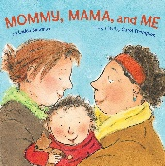
No Outsiders in our school Learning Intention |  | To say what I think | To make friends with someone different | To understand that it’s OK to like different things | To understand that all families are different | To celebrate my family
Year 1 | What is the same and different about us? | Who is special to us? | What helps us stay healthy? | What can we do with money? | Who helps us to keep safe? | How can we look after each other and the world?
No Outsiders in Our School Book Link | Elmer by David McKee   | My Grandpa is Amazing by Nick Butterworth  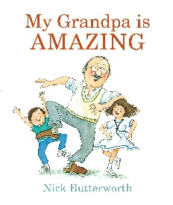 | Max the Champion by Sean Stockdale, Alexandra Strick and Ros Asquith  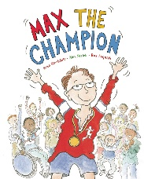 |  | Ten Little Pirates by Mike Brownlow and Simon Rickerty  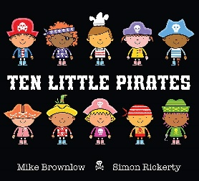 | My World, Your World by Melanie Walsh  
No Outsiders in our school Learning Intention | To like the way I am | To recognise that people are different ages | To understand that our bodies work in different ways |  | To play with boys and girl | To understand that we share the world with lots of pe
Year 2 | What makes a good friend? | What is bullying? | What jobs do people do? | What helps us to stay safe? | What helps us grow and stay healthy? | How do we recognise our feelings?
No Outsiders in Our School Book Link |   The Great big book of families by Mary Hoffman and Ros Asquith |  | The first Slodge by Jeanne Willis  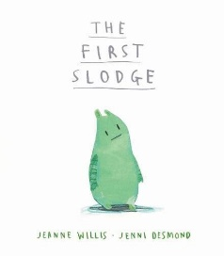 | The Odd Egg by Emily Gravett  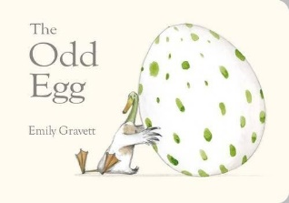 | Just Because by Rebecca Elliot  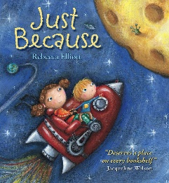 | Blown Away by Rob Biddulph  
No Outsiders in our school Learning Intention | To understand what diversity is |  | To understand how we share the world | To understand what makes someone feel proud | To feel proud of being different | To be able to work with everyone in my class
Year 3 | How can we be a good friend? | What keeps us safe? | What are families like? | What makes a community? | Why should we eat well and look after our teeth? | Why should we keep active and sleep well?
No Outsiders in Our School Book Link | Beegu by Alexis Deacon  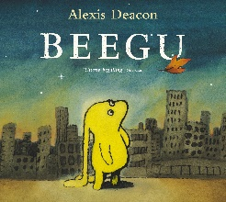 | Oliver by Birgitta Sif  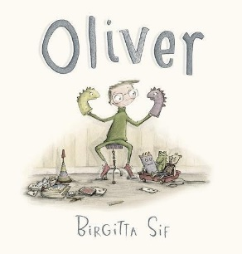 | Two Monsters by David McKee   | This is Our House by Michael Rosen  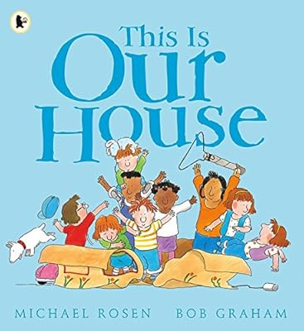 |  | The Hueys in the New Jumper by Oliver Jeffers  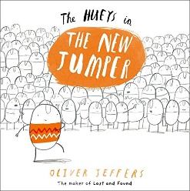
No Outsiders in our school Learning Intention | To be welcoming | To understand how difference can affect someone | To find a solution to a problem | To understand what ‘discrimination means’ |  | Use strategies to help someone who feels different
Year 4 | What strengths, skills and interests do we have? | How do we treat each other with respect? | How can we manage our feelings? | How will we grow and change? | How can our choices make a difference to others and the environment? | How can we manage risk in different places?
No Outsiders in Our School Book Link | Dogs don’t do ballet by Anna Kemp and Sara Ogilvie   | The Way back home by Oliver Jeffers  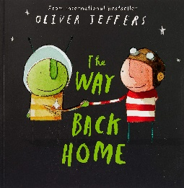 | King and King by Linda de Hann and Stern Nijland  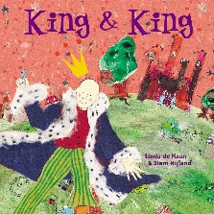 | The Flower by John Light  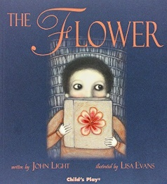 | Red: A Crayon’s Story by Michael Hall  
No Outsiders in our school Learning Intention | To know when to be assertive | To overcome language as a barrier | To understand why people choose to get married | To ask questions | To be who you want to be
Year 5 | What makes up a person’s identity? | What decisions can people make with money? | How can we help in an accident or emergency? | How can friends communicate safely? | How can drugs common to everyday life affect health? | What jobs would we like?
No Outsiders in Our School Book Link | And Tango Makes Three by Justin Richardson and Peter Parnell  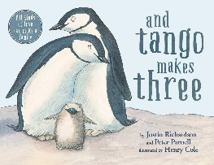 | Where the Poppies Now Grow by Hilary Robinson and Martin Impey  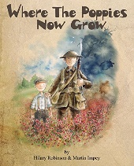 | How to Heal a Broken Wing by Bob Graham  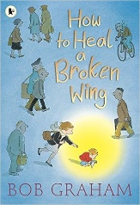 | Rose Blanche by Ian McEwan and Roberto Innocenti   |  | The Artist who Painted a Blue Horse by Eric Carle  
No Outsiders in our school Learning Intention | To accept people who are different from me | To learn from our past | To recognise when someone needs help | To justify my actions |  | To appreciate artistic freedom
Year 6 | How can we keep healthy as we grow? |  | How can the media influence people? |  | What will change as we become more independent?  How do friendships change as we grow?
No Outsiders in Our School Book Link | Love you forever by Robert Munsch   |  | My Princess Boy by Cheryl Kilodavis and Suzanne DeSimone  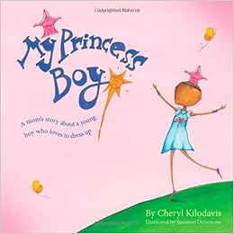 | The Whisperer by Nick Butterworth  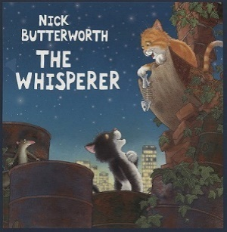 | The Island by Armin Greder   | Dreams of Freedom by Amnesty International  
No Outsiders in our school Learning Intention | To consider how my life may change as I grow up |  | To promote diversity | To stand up to discrimination | To challenge the causes of racism | To recognise my freedom

Appendix 3
Protective and Risk factors (adapted from Mental Health and Behaviour DfE March 2016)
 | Risk Factors | Protective Factors
In the child | - Genetic influences  - Specific development delay  - Communication difficulties  - Physical illness  - Academic failure  - Low self-esteem  - • SEND | - Being female (in younger children)  - Secure attachment experience  - Outgoing temperament as an infant  - Good communication skills, sociability  - Being a planner and having a belief in control  - Humour  - Problem solving skills and a positive attitude  - Experiences of success and achievement  - Faith or spirituality  - Capacity to reflect
In the Family | - Overt parental conflict including domestic violence  - Family breakdown (including where children are taken into care or adopted)  - Inconsistent or unclear discipline  - Hostile and rejecting relationships  - Failure to adapt to a child’s changing needs  - Physical, sexual, emotional abuse or neglect  - Parental psychiatric illness  - Parental criminality, alcoholism or personality disorder  - • Death and loss – including loss of friendship | - At least one good parent-child relationship (or one supportive adult)  - Affection  - Clear, consistent discipline  - Support for education  - Supportive long term relationship or the absence of severe discord

In the School | - Bullying  - Discrimination  - Breakdown in or lack of positive friendships  - Negative peer influences  - Peer pressure  - Poor pupil and teacher relationships | - Clear policies on behaviour and bullying  - ‘Open door’ policy for children to raise problems  - A whole-school approach to promoting good mental health  - Positive classroom management  - A sense of belonging  - • Positive peer influence
In the Community | - Socio-economic disadvantage  - Homelessness  - Disaster, accidents, war or other overwhelming events  - Discrimination  - • Other significant life events | - Wider supportive network  - Good housing  - High standard of living  - High morale school with positive policies for behaviour, attitudes and anti-bullying  - Opportunities for valued social roles  - • Range of sport/leisure activities

Appendix 4
Specific mental health needs most commonly seen in school-aged children
For information see Annex C Main Types of Mental Health Needs Mental Health and Behaviour in School DfE March 2016 https://www.gov.uk/government/publications/mental-health-and-behaviour-in-schools--2
Annex C includes definitions, signs and symptoms and suggested interventions for
• Anxiety (including panic attacks, phobias and Obsessive Compulsive Disorder OCD)
• Depression
• Eating Disorders
• Substance Misuse
• Self-Harm

Appendix 5
GLOSSARY OF TERMS:
Mental Health
An umbrella term embracing concepts of mental well-being, mental health problems, mental disorder and mental illness.

Mental Well-being
The positive capacities and qualities that enable young people to deal with the ups and downs of life.

Mental Health Problems
Broad range of emotional and behavioural difficulties that may cause concern to parents and carers and/or distress to the young person. Can be short or long term and will disrupt the child or young person’s life even though they may not be diagnosable as a mental disorder.

Mental Illness
Problems that meet ICD-10, an internationally recognised classification system for mental and behavioural disorders. Associated with considerable distress and substantial interference in young person’s daily life

Mental Disorder
Refers to the most severe types of mental disorder
(Taken from NCB’s ‘A whole school framework for emotional well-being and mental health- A self-assessment and improvement tool for school leaders 2016’)

