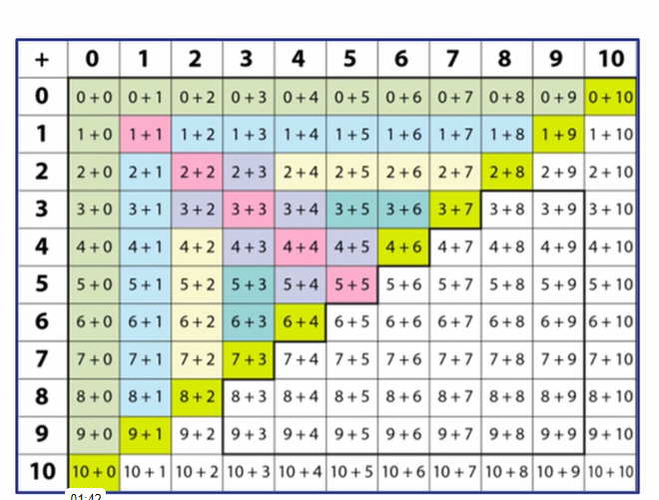
Please help your child to develop a quick recall of all the coloured squares below.

