Stage 2
PROMPT sheet

2/1 Know the 2, 3, 5, 10 times tables
0 | x | 2 | = | 0
1 | x | 2 | = | 2
2 | x | 2 | = | 4
3 | x | 2 | = | 6
4 | x | 2 | = | 8
5 | x | 2 | = | 10
6 | x | 2 | = | 12
7 | x | 2 | = | 14
8 | x | 2 | = | 16
9 | x | 2 | = | 18
10 | x | 2 | = | 20
11 | x | 2 | = | 22
12 | x | 2 | = | 24
0 | x | 5 | = | 0
1 | x | 5 | = | 5
2 | x | 5 | = | 10
3 | x | 5 | = | 15
4 | x | 5 | = | 20
5 | x | 5 | = | 25
6 | x | 5 | = | 30
7 | x | 5 | = | 35
8 | x | 5 | = | 40
9 | x | 5 | = | 45
10 | x | 5 | = | 50
11 | x | 5 | = | 55
12 | x | 5 | = | 60
0 | x | 10 | = | 0
1 | x | 10 | = | 10
2 | x | 10 | = | 20
3 | x | 10 | = | 30
4 | x | 10 | = | 40
5 | x | 10 | = | 50
6 | x | 10 | = | 60
7 | x | 10 | = | 70
8 | x | 10 | = | 80
9 | x | 10 | = | 90
10 | x | 10 | = | 100
11 | x | 10 | = | 110
12 | x | 10 | = | 120
0 | x | 3 | = | 0
1 | x | 3 | = | 3
2 | x | 3 | = | 6
3 | x | 3 | = | 9
4 | x | 3 | = | 12
5 | x | 3 | = | 15
6 | x | 3 | = | 18
7 | x | 3 | = | 21
8 | x | 3 | = | 24
9 | x | 3 | = | 27
10 | x | 3 | = | 30
11 | x | 3 | = | 33
12 | x | 3 | = | 36
Count in 10s

tens | units
3 | 7

Counting up in tens this digit changes:
37 47 57 67 77 87
tens | units
2 | 8
2/2 Place value

28 means 2 tens and 8 units (ones)
20 and 8
2/3 Estimate numbers
- Eyeball estimate

Here are 3 sweets

Use this to estimate larger amounts
- Estimate on a number line

Fill in the half way number first
Then split up the half with the arrow
7
0 10

5 ₆ ₇ ₈ ₉

12
10 20

₁₁ ₁₂ ₁₃ ₁₄ 15

2/4 Order numbers

Ten | Unit
3 | 7
3 | 2
7 | 6
6 | 2

- Begin at the tens and compare
76 is the biggest
62 is next biggest

Ten | Unit
3 | 7
3 | 2
7 | 6
6 | 2
- Move to the units and compare

Order is: 76 62 37 32

2/4 (continued) Inequality symbols

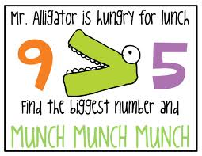

We say: 9 is bigger than 5
We write: 9 > 5

We say 5 is smaller than 9
We write: 5 < 9

2/5 Numbers in figures and words
1 one
2 two
3 three
4 four
5 five
6 six
7 seven
8 eight
9 nine
10 ten

11 eleven
12 twelve
13 thirteen
14 fourteen
15 fifteen
16 sixteen
17 seventeen
18 eighteen
19 nineteen

20 twenty
21 twenty one
22 twenty two
23 twenty three
24 twenty four
25 twenty five
26 twenty six
27 twenty seven
28 twenty eight
29 twenty nine

30 thirty
40 forty
50 fifty
60 sixty
70 seventy
80 eighty
90 ninety
100 one hundred

2/6 Addition & subtraction problems
Words for ADD
plus
total
sum of
altogether

Words for SUBTRACT
difference
take away
how many left?
how many less?
how many more?
2/7 Addition facts to 10
 |  |  |  |  |  |  |  |  | 10
1 |  |  |  |  |  |  |  |  | 9
 | 2 |  |  |  |  |  |  |  | 8
 |  | 3 |  |  |  |  |  |  | 7
 |  |  | 4 |  |  |  |  |  | 6
 |  |  |  | 5 |  |  |  |  | 5
 |  |  |  |  | 6 |  |  |  | 4
 |  |  |  |  |  | 7 |  |  | 3
 |  |  |  |  |  |  | 8 |  | 2
 |  |  |  |  |  |  |  | 9 | 1

0 + 10 | 1 + 9 | 2 + 8 | 3 + 7 | 4 + 6
10 + 0 | 9 + 1 | 8 + 2 | 7 + 3 | 6 + 4
 |  | 5 + 5

Addition facts to 20
10 + 10 | 11 + 9 | 12 + 8 | 13 + 7 | 14 + 6
15 + 5 | 16 + 4 | 17 + 3 | 18 + 2 | 19 + 1
 |  | 20 + 0

Subtraction is the inverse of addition



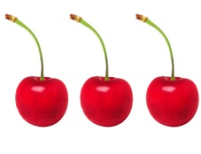
=
+

3 + 2 = 5

-

5 - 2 = 3
-

5 - 3 = 2

2/8 Add & subtract
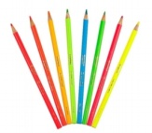



= 28

20 + 8 = 28
20
8 +
28

28 - 3 = 25

28
3 -
25

28 - 10 = 18

28
10 -
18

28 - 13 = 15

28
13 -
15

2/9 Add & subtact

7 + 3 = 10 is the same as 3 + 7


10 – 7 = 3 is NOT the same as 7-10

2/10 Add & subtact
Fact family for add and subtract
- + 7 = 20

20 - 13 = 7 20 - 7 = 13

2/11 2, 5, 10 times tables

- See 2/1
Odds & even numbers
- Even numbers – can be paired up



Tip – the last digit always 0 2 4 6 8
- Odd numbers – cannot be paired up

Tip – the last digit always 1 3 5 7 9

2/12 Multiply & divide

Words for MULTIPLY
triple
double
product
times

Words for DIVIDE
split
share

Words for EQUALS
gives
is

Fact family for multiply and divide
7 x 5 = 35

35 ÷ 5 = 7 35 ÷ 7 = 5

2/13 Multiply & divide

7 x 5 = 35 is the same as 5 x 7
35 ÷ 7 = 5 is NOT the same as 7÷35

2/14 Multiply & divide

Example1: Here are 20 sweets to share
Each child gets 5 sweets
How many children are there?

Divide them up into groups of 5 sweets-like this

There must be 4 children

Example2: Here are 12 marbles to share
There are 4 children.
How many marbles does each get?

Divide them up into 4 groups - like this

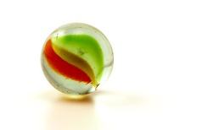
Each child gets 3 marbles
Repeated addition (Multiplication)

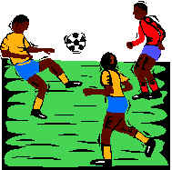
Here are 3 footballers.
How many legs do they have altogether?

Addition sentence Multiplication sentence
2 + 2 + 2 = 6 3 x 2 = 6

Repeated addition is the same as multiplication

Addition sentence | Multiplication sentence
5 + 5 + 5 + 5 = 20 | 4 x 5 = 20
10 + 10 + 10 = 30 | 3 x 10 = 30

Repeated subtraction (Division)
Repeated subtraction is the same as division

15
This is the same as 15 ÷ 5 = 3

Because 5 has been subtracted 3 times to get to 0
-5 (1)
10
-5 (2)
5
-5 (3)
0

2/15 & 16 Fractions

To work out a half
Split into two equal parts
YES NO!!!!


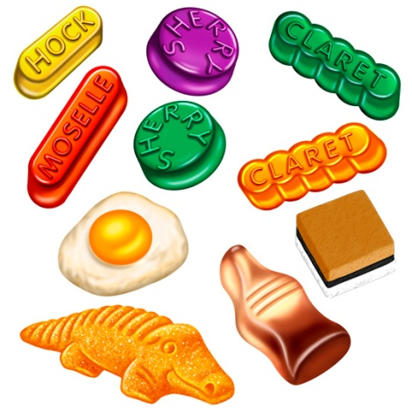

10sweets ÷ 2 = 5sweets
OR of 10 = 10 ÷ 2 = 5

To work out a quarter
Split into four equal parts


=

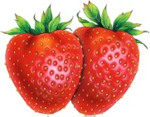

8 strawberries ÷ 4 = 2 strawberries
OR of 8 = 8 ÷ 4 = 2

2/17 Units of measure
METRIC units of length are:
Millimetre (mm)

Centimetre (cm)

Metre (m)

Kilometre (km)

2cm = 20mm 4.5cm = 45mm
1cm = 10mm
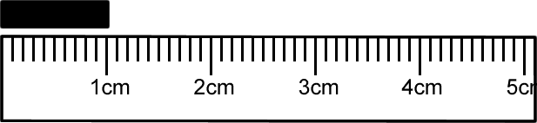

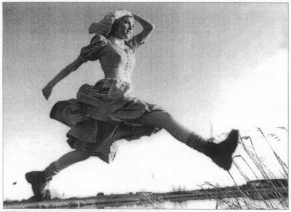

- A big stride is about a metre

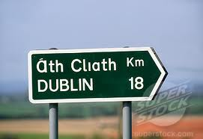
- Distance to Dublin is measured in kilometres

METRIC units of mass are:
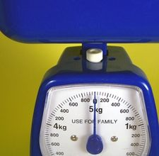
Gram (g)

Kilogram (kg)

1 kilogram(kg) = 1000grams(g)
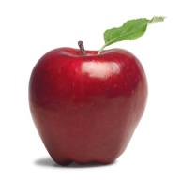
- An apple weighs 150grams

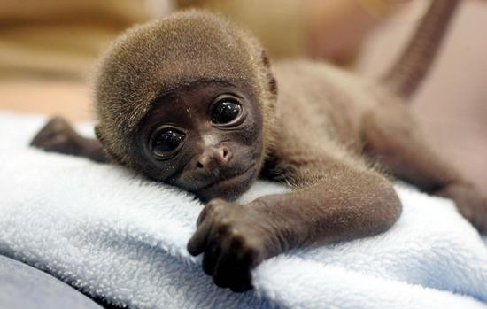
- Baby chimp weighs 3kg

2/17 Units of measure (continued)
METRIC units of capacity (liquids) are:
Millilitre (ml)

Centilitre (cl)

Litre (l)
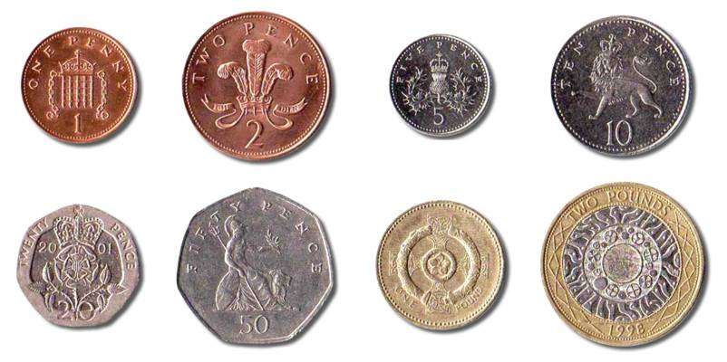
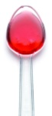
- A medicine spoon holds 5ml


- A 5-litre bucket

- Fuel for the car is measured in litres


2/18 Compare units of measure

Think of the units of mass then order:
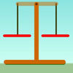
a bar of chocolate
your teacher
a blown-up balloon
a loaf of bread

A blown-up balloon < a bar of chocolate < a loaf of bread < your teacher

Think of the units of length used then order:
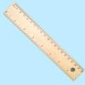
How high you could jump in the air
How far you can kick a football
How far you can run in ½ minute
Length of a bug

Length of a bug < you could jump in the air < you can kick a football < you can run in half a minute

2/19 Money
To write amounts of money
£3 or £3.00
50p or £0.50
£3.50 or 350p BUT never £3.50p or £3.5

Value of coins
1p or £0.01 2p or £0.02 5p or £0.05 10p or £0.10

20p or £0.20 50p or £0.50 £1 or £1.00 £2 or £2.00

2/20 Bills and change

To add amounts of money

24p + 32p
=20p + 4p + 30p + 2p
=20p + 30p + 4p + 2p
=50p + 6p
=56p

To find change from £1
Add-on method
56p + 4p = 60p
60p + 40p = £1
= 4p + 40p
= 44p

Subtraction method
£1 – 56p
= £1 – 50p – 6p
= 50p – 6p
= 44p

2/21 Sequence of time
60
60
24
7
4
12
Smallest Second(s)
Minute(min)
Hour(h)
Day
Week
Month
Largest Year
2/22 Write time
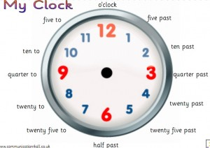

The time shown is:
5 past 6 OR 6:05

2/23 2D shapes
- 3 sides – Triangles
A vertical line of symmetry

equilateral isosceles
- 4 sides - Quadrilaterals

rectangle square parallelogram

trapezium kite rhombus
2/24 3D shapes

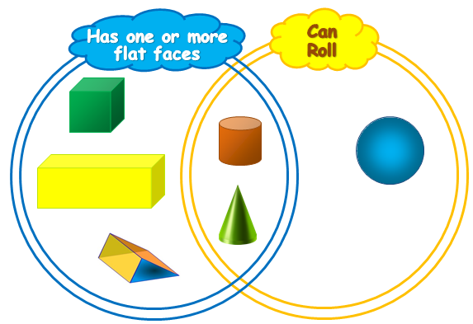

cube cylinder cuboid
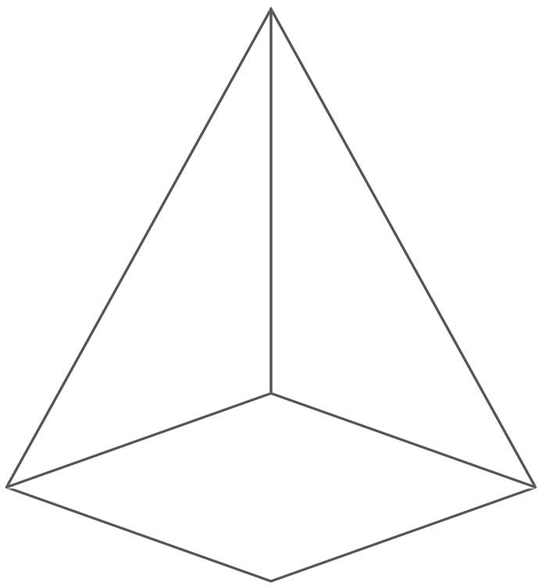
pyramid sphere

corner edge face

2/25 2D shapes on 3D shapes

6 6 faces – all rectangles

5 faces – 2 triangles
- 3 rectangles

3 faces – 2 circles
- 1 curved surface

2 faces – 1 circle
- 1 curved surface

5 faces – 1 rectangle
- 4 triangles

2/26 To sort 2D shapes and 3D shapes
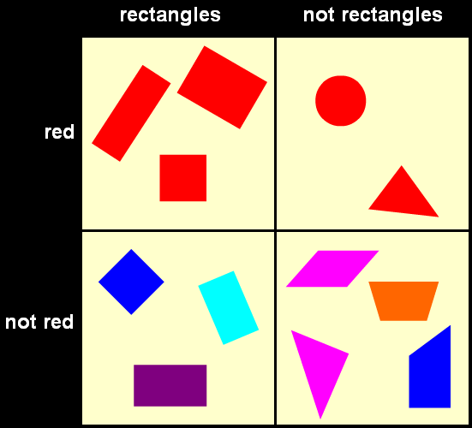
Carroll
diagram

Venn
diagram

2/27 Sequence of shapes
Make these shapes into a pattern

2/28 Describe position, direction &
movement

LEFT RIGHT

ANTICLOCKWISE CLOCKWISE

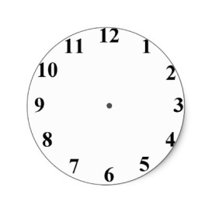

Clockwise (1 right angle)
or ¼ turn

Anticlockwise(1 right angle) or ¼ turn

Half turn (2 right angles)

2/29 Tables and graphs
Pictogram of
Year 2 favourite fruits
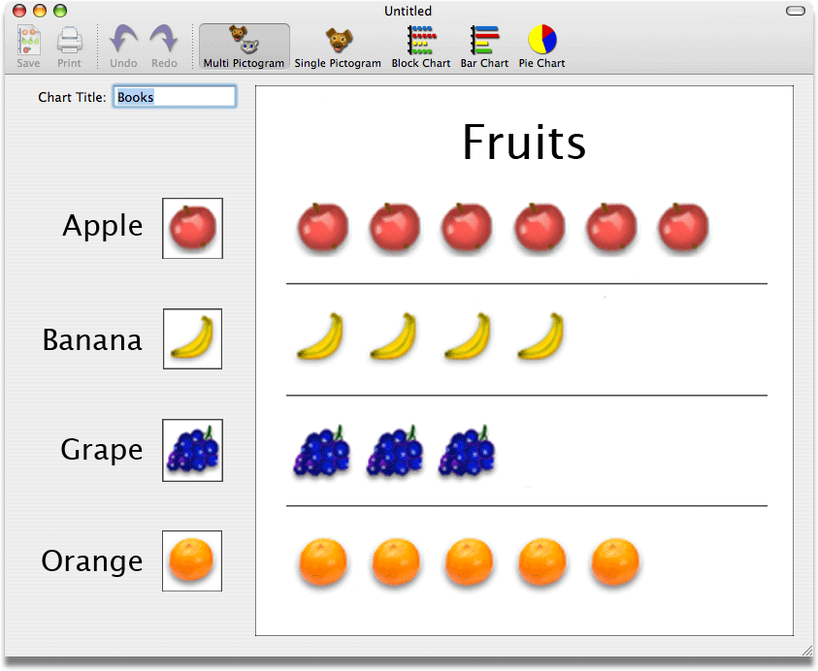

Tally chart showing animals in the zoo
Animal | Tally | Number of animals
Penguin | llll | 4
Lion | lll | 3
Snake | llll l | 6
Giraffe | ll | 2
Monkey | llll ll | 7

Block graph to show animals in the zoo
7
6
5
4
3
2
1
 |  | 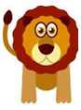 | 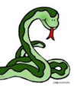 | 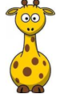 | 

2/30 Questions about tables and graphs

Example:
Questions about ‘Animals in the zoo’

- How many animals are there altogether?
4+3+6+2+7=22
- How many more monkeys are there than lions?
7-3=4
- What animal is there least of?
giraffe

