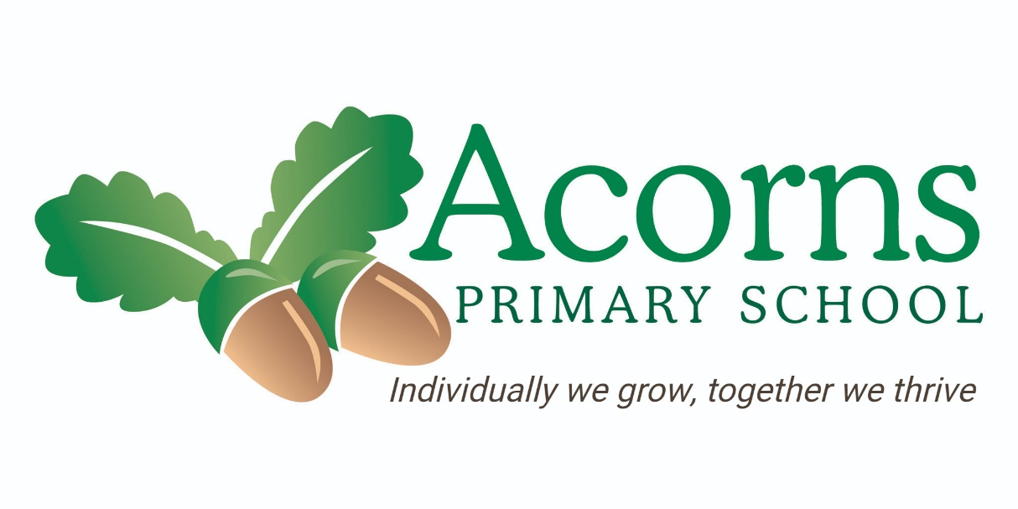

MOVE
Policy

Philosophy and purpose of the MOVE programme

“The MOVE Programme is an activity-based practice that helps disabled children and young adults gain independent movement. It uses the combined approach of education, therapy and family knowledge to teach the skills of sitting, standing, walking and transitioning between. The programme’s central philosophy is that movement is the foundation for learning. A toddler just learning to walk, learns special concepts about the environment around them by being able to move and explore. A disabled child, who uses a wheelchair and is reliant on others for movement, is not able to do this as easily. Their opportunities for learning are significantly diminished. The aim of the MOVE Programme is to offer these movement opportunities to disabled people, opening up and transforming the world around them and creating an accessible, interesting and educational world full of opportunity and choice”

MOVE Europe 2025
The six steps of MOVE
- Assessment: where are you now?
- Goal setting: Where do you want to get to?
- Task Analysis: what skills do you need to get there?
- Measuring prompts: What support do you need now?
- Adjusting prompts: What assistance do you need to achieve your goals?
- Teaching the skills: How do you ensure you reach the goal?

Leading and teaching of MOVE at Acorns Primary School

Acorns School has achieved the Silver award in September 2025

The MOVE lead will oversee all individuals on the MOVE programme. The lead will ensure that classes have access to appropriate resources and individual MOVE profiles. All school staff will have a shared responsibility to ensure pupils are provided with the best possible opportunities to develop their independent movement skills. Teachers will be responsible for ensuring their planning allows opportunity for practicing skills.

Structure and teaching of MOVE

MOVE is not a stand alone lesson and opportunities should be planned throughout the school day to practice skills identified for individual pupils. A ‘MOVE clinic’ will be planned fortnightly and led by the MOVE lead. The clinic provides the opportunity for the MOVE lead to assess pupils, adapt activities and refine targets. Informal training and coaching opportunities will also be utilised at the MOVE clinic. MOVE files are kept in the classroom of the MOVE lead. Parents will be involved in target setting, through the annual review process.

Assessment

The MOVE lead will work alongside class teams to formally assess pupils initially and at least once per academic year to track progress. This will be done using the MOVE assessment proforma. Targets will be adapted and changed based on the progress made, using the MOVE documentation.
Progress can also be recorded on Evidence for Learning (EfL) and tagged against the MOVE framework.
Informal assessment will be made during MOVE clinic sessions by the MOVE lead.
MOVE targets can be added onto pupil annual review targets or IEPs. There will be time allowed for the MOVE lead to discuss this with parents during the annual review meetings.

Health and Safety

The health and safety of both pupils and staff is paramount during any MOVE and physical work. The MOVE lead will work alongside the Moving and Handling lead to ensure any moving and handling is in line with guidance. All children will have a Moving and Handling plan, and all staff will have full training in Moving and Handling.
All equipment is regularly checked by occupational therapists or physiotherapists. Any faults with equipment must be reported to therapists.
Where possible, therapists are involved in goal setting and routine plans.

Training

There is currently one MOVE trainer at Acorns Primary School. Awareness training is delivered to all new staff. There are 8 senior practitioners within school. Practitioner training is delivered to relevant staff.

September 2025

Written by: Sophie Martindale (MOVE Co Ordinator)

