PSED/PSHE
Policy

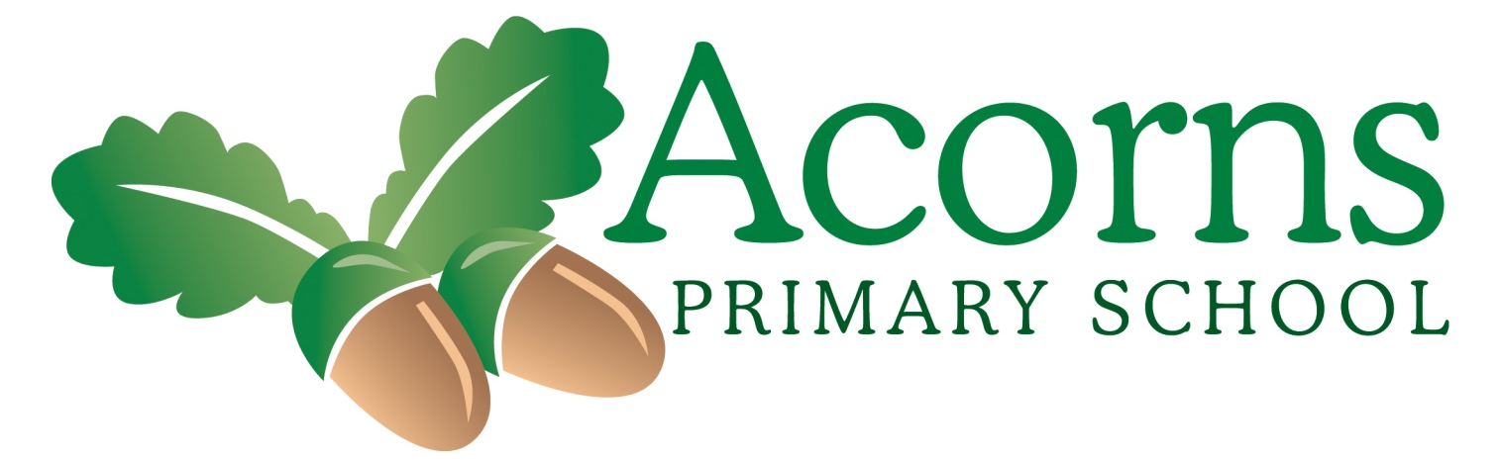

Introduction
Acorns is a primary school that provides a specialist learning environment for pupils with a wide range of learning difficulties including moderate and severe learning difficulties, complex needs and pupils on the Autistic spectrum. We meet the needs of pupils from 2-11 years.
Acorns School Values
We care for each other
We welcome everyone
We create opportunities
We are always positive
We celebrate each other and our achievements.
Introduction Acorns Primary School is a primary school that provides a specialist learning environment for pupils with a wide range of learning difficulties including moderate and severe learning difficulties, complex needs and pupils on the Autistic spectrum. We meet the needs of pupils aged between 2–11 years. Acorns School Values We care for each other We welcome everyone We create opportunities We are always positive We celebrate each other and our achievements. Our school values are embedded into school life and our school day. Our school is Welcoming, Nurturing and Positive.
We promote a specific value each half term. The value is incorporated into our daily collective worship; identifying ways in which we demonstrated the value that day. We provide a learning environment that offers mutual-respect, supports emotional well-being and provides equal opportunities for all our pupils to achieve and thrive together
Definition of PSHCE:
• Personal
• Social
• Health
• Citizenship
• Education
Statement of Intent
Our Aims for PSHCE at Acorns are:
• To promote healthy and safer lifestyles
• To support the development of the whole child
• To encourage independence, self – efficacy and individual responsibility
• To deliver high quality, appropriate PSHCE that can support pupils in managing opportunities, experiences and responsibilities in later life.
• To provide knowledge and information for our pupils to make informed decisions.
These aims and our comprehensive PSHCE framework underpins all we do. They encompass Acorns’ ethos and philosophy. Developing the ‘whole child’ is an integral part of our aims. We encourage resilience and ambition. The programme has been created for our pupils to equip our pupils to make informed decisions about their wellbeing, health and relationships. To support the transition from leaving our school family to becoming responsible, respectful citizens in our modern and diverse world.
The Thrive Approach-
This is led by Donna Carey our Thrive Licensed Practitioner. The approach has been developed over many years helping children to flourish. It supports their emotional and social development and helps them feel happy and secure, able to enjoy friendships, relate well to others and be ready and able to learn.
Thrive is a special way of working with all children that helps to develop their social and emotional wellbeing, enabling them to engage with life and learning. It supports them in becoming more self-assured, capable and adaptable. It can also address any troubling behaviours providing a firm foundation for academic attainment.
Positive relationships are at the heart of Thrive. We use these relationships, together with play and creative activities, to give children key experiences at each different stage of their development. Repetition of these activities supports their development, helping them to:
· feel good about themselves and know that they matter
· increase their sense of security and trust
· increase their emotional well-being
· improve their capacity to be creative and curious
· increase their self-esteem and confidence to learn
· learn to recognise and regulate their feelings
· learn to think before behaving in a certain way
…and more.
We use a screening tool and activity planning resource called Thrive-Online. This allows us to check that children are working appropriately for their age and to develop the whole group with activities that ensure that they are as emotionally and socially supported as they can be, using Thrive online assessment tools we create action plans and targets for all of our children, these are used in class, during 1:1 times and are also sent home for families.
ELSA- Donna Carey is our ELSA practitioner in school. We want and aim to make children and young people feel happy in school. and to reach their potential socially, emotionally and academically. The ELSA understands the barriers to learning that some children and young people might have and can help them with this.
An ELSA can support the children and young person’s emotional development and help them cope with life’s challenges. They will also help children and young people find solutions to problems they might have.
The ELSA is not there to fix problems but to help them find their own solutions and offer that important support to a child or young person.
Relationships are key in helping children and young people to feel safe and nurtured. ELSA is about creating a reflective space for the child or young person.
Our Elsa practitioner can help children with the following:
Loss and bereavement
Emotional Literacy
Self-esteem
Social Skills
Friendship issues
Relationships
Managing strong feelings
Anxiety and worries
Bullying
Conflict
Emotional Regulation
Growth Mindset
Social and therapeutic stories
Problem solving.
Equal Opportunities:
All pupils at Acorns are entitled to receive education that is fully inclusive, irrespective of Age, Disability, Gender, Sexual orientation, Religion, Ethnicity or Social circumstance.
Teaching and Learning:
Knowledgeable staff who have a good understanding of our pupils, deliver inclusive PSHCE in a sensitive and well-judged manner. Staff have the flexibility to deliver content in a way that is age and developmentally appropriate and sensitive to the needs and religious background of our pupils.
Our skilled teachers use their knowledge of individual pupils to provide personalised learning that is attainable with appropriate challenge. Staff present pupils with activities and language aimed in accordance with both their cognitive abilities and emotional maturity in mind. They deliver active learning; making practical and engaging resources and opportunities that are motivating, enjoyable and accessible. Circle times, Role Play, visitors, community links, charity events and educational visits. Physical resources are kept in a central point in the shared shed. The resources have been created and collated to support and enhance the teaching of PSHCE at Acorns school. They have been carefully considered to ensure that they are appropriate and purposeful in making the PSHCE topics accessible to our pupils and enable us to meet our pupil’s wide spectrum of learning needs and abilities.
Staff use a variety of teaching and learning styles and total communication in order to meet pupils needs. Stimulating and engaging resources are used by class teams to involve pupils and to maintain levels of engagement. The use of videos, songs, stories, visual aids and visitors such a NSPCC along with online resources like ESPRESSO.
Pupils get the opportunity to work in small groups or as part of a whole class. Groupings are flexible to suit pupil need. These may be single or mixed sex depending on what is deemed appropriate. There may also be occasions where issues need to be addressed as they arise and an immediate response is needed.
PSHCE is cross-curricular. It is interwoven into daily life at Acorns school. We follow our PSHCE framework for discrete, weekly, half hour lessons.
We utilise staff knowledge to tailor activities and build on prior learning that best meets pupils’ individual needs. This personalisation makes the learning experiences meaningful for our pupils.
In addition to discrete lessons, Acorns offer a child centred approach to the delivery of PSHCE. Discussions are held with PSHE subject lead, our Emotional Literacy Support lead and senior management; to identify pupils whom would benefit from specific interventions and enhanced support as and when it is required.
Organisation:
Children in the Early Years are taught Personal, Social and Emotional Development following the objectives set out in the Early Years Foundation Stage Profile. All our other pupils follow our broad and balanced spiral PSHCE framework. The framework supports the statutory guidance outlined in the National curriculum for Personal, Social, Health and Citizenship Education and is in keeping with the PSHE associations guidance to ensure breadth and subject coverage.
The mapping is structured and progressive. It has been arranged into half termly topics and are separated into levelled tiers. It allows for our pupils to make connections and learn through repeated, generalised, revisited and interwoven skills. This allows staff the flexibility to deliver content at the most appropriate level for pupils. They can build on prior knowledge and build progression.
Staff utilise opportunities to enhance understanding of the current affairs in the news, calendar events, fund raising and charity events and strong links with the community.
We provide opportunities for the school to share experiences together through festivals and celebrations and events planned by pupils on our school council. Calendar events and enrichment days throughout the academic year include Road Safety, Anti-bullying, Safer Internet Day, Diversity Week, Pupil Voice week, NSPCC, World Awareness, Mental Health Awareness and many more.
Throughout the curriculum an emphasis is placed on the underlying Spiritual, Moral, Social and Cultural development of our pupils. We explore moral and spiritual values common to the great religions of the world, together with the promotion of positive and caring attitudes. We celebrate many cultural events such as World Awareness Week, Chinese New Year, Diwali, St. Patricks Day, Eid, St.George’s Day, Harvest Festival, Easter, Christmas and Holi. These events celebrate differences, increase empathy and develop understanding and tolerance. Pupils are encouraged to participate in shared prayer at lunchtime and classes participate in collective worship each day.
Monitoring and Evaluation:
It is the responsibility of the subject lead to oversee PSHCE within school and ensure to shares good practice. Subject lead liaises regularly with management and class staff regarding PSHCE in classes. Subject lead or a member of senior management attend network meetings to remain up to date with subject developments. Information is fed back and shared amongst staff during staff meetings and through staff email; informing colleagues of relevant updates to practice.
Personal Development:
Personal Development is monitored through the delivery of PSHCE sessions to meet need as outlined in every child's EHCP. In addition personal development is further tracked and reported to the head of the virtual school in the case of Children Looked After. Personal development is commented upon daily in some instances on the talking tile. Personal development is a key element of our annual review process and our ongoing professional conversations between ourselves, our families and other professionals. A multi – disciplinary approach with good dialogue gives our pupils the best, tailored and personalised support.
Pupils achievements and developments are celebrated in weekly key stage assemblies. PSHCE is a big focus – highlighting a pupils progress, celebrating them in front of their peers and providing them with a sense of achievement.
PSHE Opportunities:
Acorns have spent Sports Premium money from the Physical Education budget to support Active Lifestyles. The professional input support our pupils’ physical abilities, confidence and self-esteem. Acorns hire Rugby Tots professionals into school to work with classes throughout school.
Acorns School follow a Three-week programme by Lancashire County Council called the ‘Lancashire School Lunches’ menu to promote Healthy Food choices and Lifestyles. Kitchen catering staff cook from fresh on a daily basis and use some organic foods such as rice, pasta, milk and flour.
Pupils participate in daily feeding programmes that develop communication and independence. Children are encouraged to make their own food choices using their preferred means of communication, carry their own plates and clear their own plates.
Pupils take part in hygiene routines, washing hands as independently as possible, they are encouraged to help give out place mats and cups, to pour their own water, use cutlery where possible, wait their turn in a line and are supported to clear away their own plates after eating. Staff work hard to support pupils in developing self–feeding techniques and strive to ensure pupils try to access as healthy and varied a diet as possible. Along with this; table manners and appropriate behaviours are taught to support British Values and Citizenship. This supports families to share positive mealtimes with their children at home and in the community.
Acorns Continuous Provision and Role-Play activities-
Children have regular opportunities to access continuous provision activities where staff model and encourage children to play and learn how to share, take turns and develop friendships with others in class. Role-play boxes are stored in the KS1 resource area. These include a dentist, hospital, hairdresser, shop. Classes use these regularly sometimes linking to their termly topic. These opportunities are given to build resilience and confidence in visiting different places in the local community.
Eco Schools and Sustainability-
The children at Acorn’s are part of the Eco School’s programme. It encourages the children take part in Eco projects that make our school more sustainable and increases environmental learning which benefits the local community. With support of staff the Eco Council lead the programme. The children undertake an environmental review which helps the children to understand how environmentally friendly our school is. Inspired by their findings the children find and deliver their action plan of Eco projects. This are completed across the school and making our school a greener and cleaner space for everyone. With help from staff the children monitor the reductions we can achieve in regards to waste, water or energy.
Physical Development:
Pupils participate in daily exercise or movement songs. Pupils have access to bikes, vestibular swings inside and outdoors equipment, an Forest School Environment, Outdoor trampolines and climbing equipment. Bucket swings, slides and break out equipment within each classroom including; Trampolines, Spinning Dishes and Yoga balls. Pupils access regular body awareness and regulation activities through Sensory TAC PAC and sensory integration sessions as well as massage. Active playtimes provide opportunities for children to access outdoor equipment in different areas of the outdoor play areas.
Pupils’ mental health and well – being is supported by our School Council. – Pupils are given a voice through opportunities to discuss their opinions, share ideas, to make choices and feedback information to their peers and class staff. School council is very effective in developing pupils’ confidence and self-esteem. It gives our pupils responsibility and ownership over the running of their school. It makes them feel valued and provides them with a sense of belonging.
Pupils feedback information from their classes via our ‘Pupil Voice’ speech bubble posters. We address pupils‘ requests/concerns. Pupils are asked to discuss topics and often make decisions via voting, symbol pointing, use of photographs or questionnaires with staff supporting and advocating. School council meetings are held by the Emotional Literacy lead each half term.
Opportunities for pupil voice run throughout the year in classes with staff who know the children best. We use total communication; using a range of Alternative, Augmentative communication strategies to ensure all Pupil Voices are heard. The information fed back will be collated by the subject lead and acted upon with the help of councillors. Feedback will be shared with classes.
Children help to organise and run whole school well-being and cultural events throughout the school year. These include things such as St. Patricks Day, Halloween, Internet Safety Day and more. Acorns follow the National Online Safety programme which offers our staff, pupils, parents and the wider community support to meet the online safeguarding of our pupils.
Mini – Enterprise –
Our eldest pupils conduct mini enterprise through planning, buying and making toasted teacakes and soups at different times of the year. School host Strawberry Tea events where pupils choose, buy and sell sweet treats. Pupils navigate their way around school, collecting tea cake orders and money. Pupils use their profits towards class outings.
School Café-
Classes in school take it in turns to run the school café. Pupils make food items to sell in the café. The café links to different cultures around the world by selling food items typical to specific cultures. This provides opportunities for children to develop a sense of belonging and to learn to value and respect other cultures. Pupils use PEC’S and ALI boards to communicate what they would like to buy. This is non-profit, each class has coins that the children use to buy items proving opportunities for children to learn to name and use coins.
Representing the school –
Acorns are very proud of our pupils and have celebrated our school by establishing a link with a local mainstream primary school to promote and share our pupils, collaborating with our signing and signing assemblies. This promotes our pupil’s self-image and provides a sense of belonging. Our school football team participates in events with other Generic Learning Difficulty schools.
Effective links –
Rugby Tots, NSPCC, More music, Salvation Army, Intact centre.
Managing Emotions –
The learning environment at Acorns displays elements of emotional development. Classrooms have self – registration, pupil photographs, emotion visuals and communication boards enabling children to express their feelings, Communication books with ‘Feelings’ pages for pupils to express their emotions. We have accessible behaviour management choosing boards, workstations, soft room and ‘break out’ areas as well as regulatory equipment in each classroom to promote self – regulation; Heavy lifting sessions, mindfulness activities and regulatory sessions built in to daily routines including breaks, physical and sensory interventions. Our focus it to support our pupils in their readiness to learn.
Assessment and Recording
Teachers must continually assess pupils’ current understanding and knowledge in order to ensure that appropriate learning targets are set through formative and summative assessment. Formative assessments and evidence of learning are recorded on the Evidence for Learning platform and B - Squared is used as a summative assessment.
Staff members take regular photographic evidence of pupils or comments stating specific examples of PSHCE and record these onto Evidence for learning and link to Individual Education Plans. Evidence is always visible to the subject lead and senior management staff. PSHCE is a focus area on the end of the school year reports and reported back to parents. Each class has a Pupil Voice sheet where pupil photographs/comments can be seen. Subject lead liaises with classes and carries out learning walks to see evidence of PSHCE on displays and in the school environment.
Parents/Carers and the Wider Community –
Acorns work hard to provide effective home school links with parents establishing effective working relationships between home and school to support pupils. This is done through our introductory Parents meet evening, our school website, newsletters, daily talking tiles, class blogs, teacher emails, regular phone calls home as well as a calendar of events including with our parent’s group throughout the school year that encourage parent participation.
Community Links – We pride ourselves on the many opportunities pupils are given to access the local community. Pupils attend community visits on a regular basis which provide our pupils with contextual and purposeful learning experiences. We have a successful link with a neighbouring school, St. Gregory’s and our local supermarket. Many pupils visit the supermarket on a weekly basis developing life skills, communication and independence skills. Rugby Tots and Music therapy provide weekly external intervention services for our pupils. We have annual visits from Leyland choir.
Definition of Relationship Sex Education:
RSE teaches children about the different physical, social and emotional aspects of growing up, relationships and sexuality. It helps to prepare children for changes like puberty and the transition into adult life. It provides our pupils with a safe space where pupils can feel comfortable to participate in discussions and questioning that they may not otherwise get the opportunity to do.
Relationship Education became a statutory requirement for all maintained schools in September 2020. Sex Education is compulsory at primary level. At Acorns, we have chosen to offer elements of Sex Education to those pupils with the cognitive ability and emotional maturity. Relationships and sex education is learning about the emotional, social and physical aspects of growing up, relationships and conception. Some aspects are taught in science, and others are taught as part of personal, social, health and economic education.
We want our pupils to receive high quality, appropriate PSHCE and RSE that can support them in managing opportunities, experiences and responsibilities in later life. We reviewed our PSHCE and Relationship Sex Education mapping to ensure that our lessons met the requirements that the government set out for the content of Relationships and Health Education. We used the PSHE association material to support our mapping and to ensure breadth of content.
Our PSHCE and ‘Growing Up’ programmes provides accurate information about the body, relationships and reproduction. This knowledge and information also gives children and young people essential skills for building positive, respectful and nonexploitative relationships and helps understanding of how to stay safe on and offline.
Teachers follow the framework and focus on a theme per half term. In addition to themes, KS2 also deliver a ‘Growing Up’ section as a dedicated block that focuses on physical and emotional changes during Puberty; Personal Hygiene, Private/Public, Consent and Personal Safety online.
This is delivered by experienced class staff to pupils with the appropriate cognitive ability and emotional maturity.
We aim to:
• Teach scientifically correct names for male and female body parts
• How bodies grow and change and what happens to bodies during puberty.
• We aim to equip our pupils with the knowledge to make safe, positive decisions in their lives
• Develop awareness of self-efficacy, self – worth and self – respect.
• Teach how families are all different and all are to be valued
• Knowledge of Healthy relationships including online safety and where to seek help As part of our science curriculum; pupils build an understanding about growth and reproduction:
Key Stage 1- To identify, name, draw and label the basic parts of the human body and say which part of the body is associated with each sense.
Upper Key Stage 1 – To notice that animals, including humans, have offspring which grow into adults.
Key stage 2 – To describe the life process of reproduction in some plants and animals. They should learn about the changes experienced in puberty.
Importance of RSE:
• Avoid misconceptions
• Vulnerability of pupils
• Safeguarding
• Puberty
• Abuse
• Online pornography Confidentiality Relationship, Sex Education is taught in a highly respectful, sensitive manner. Staff ensure the pupils learn in a positive and supportive learning environment. Staff know and follow procedures to inform our safeguarding lead of any disclosures made.

Parents:
Parents have the right to withdraw their child from Sex Education. If you wish to do this, you must make a request to the headteacher stating which aspects you’d like them to be removed from. The science curriculum however is statutory. Pupils are required to learn about human development including reproduction.
LINKS WITH OTHER POLICIES
Personal, Social, Health, Citizenship Education Relationship Education
Safeguarding Behaviour Policy Drugs and Alcohol education Confidentiality Anti-bullying Child Protection Protocol for visitors to school
School Policy Review Date: October 2025
Policy written by Katie Mcilwraith (Subject Lead)
Reviewed: October 2025 Document to be reviewed at the beginning of each academic year by the subject lead.
Next Review Date: September 2026

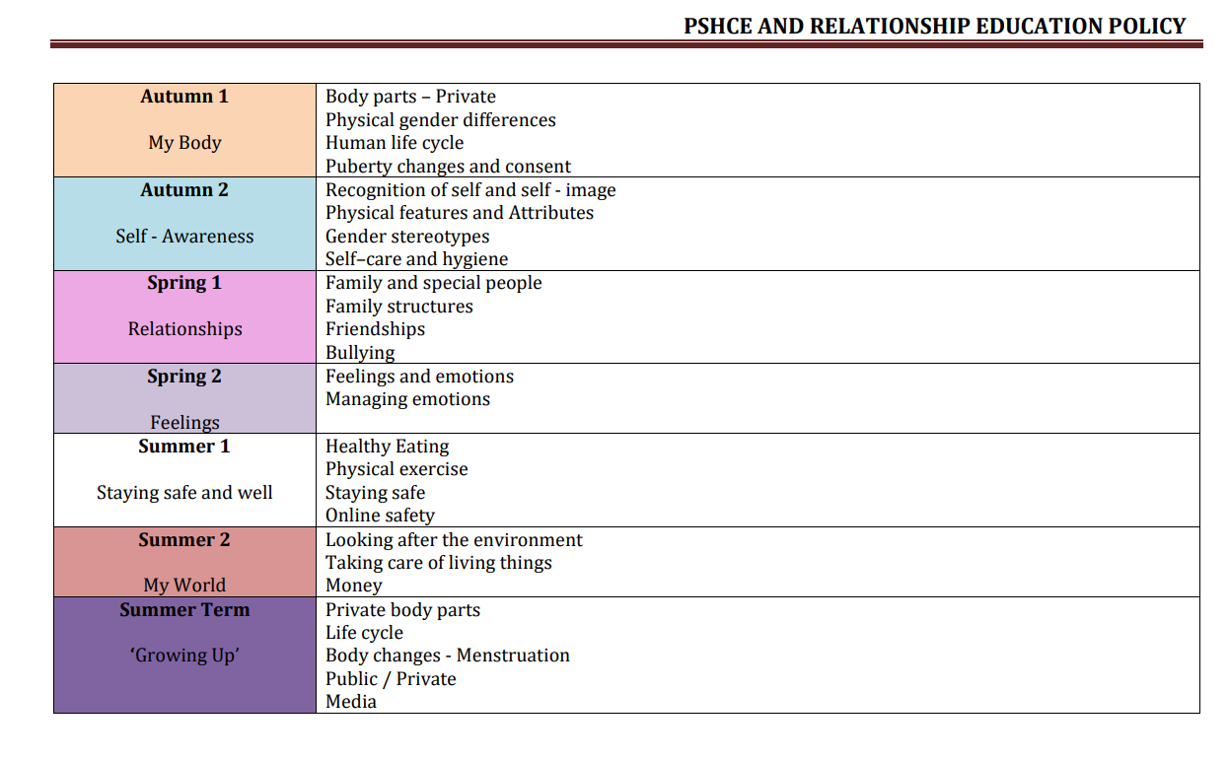
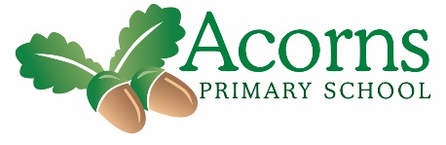
PSHE whole School Curriculum Overview
