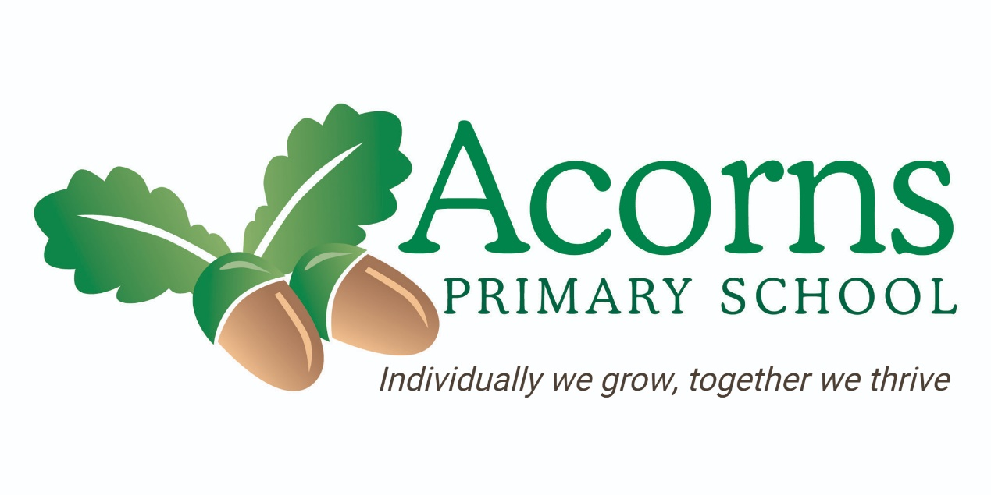

Writing Policy

Philosophy and Purpose

This policy reflects the school values and philosophy in relation to the teaching and learning of English and specifically writing and recording at Acorns School. It sets out a framework within which teaching and non-teaching staff can operate and gives guidance on planning, teaching and assessment.

At Acorns, we recognise the importance of providing an enriching learning environment and giving pupils the opportunity to develop enthusiasm towards writing.
Children need a means of communicating and recording thoughts, ideas and information in a clear, economical and fluent way. Handwriting or equivalent ICT methods will provide such a means, both in school and leisure time and in adult life for some students whilst alternative means i.e. symbols, photos, pictures will be more appropriate for others.

Intent:

- To provide children with the opportunity to record mark-making and writing in a legible method.
- To use sensory strategies and pre-writing techniques to develop hand movements and fine motor skills and control.
- To provide opportunities for pupils to use different textures and medias to explore mark making.
- To provide opportunities for pupils to hold and use different writing implements to make their own marks.
- To provide clarity for staff to understand accepted styles of handwriting (within the constraints of individual differences and abilities).
- To ensure progression of the development of writing skills and capability for all pupils, helping each pupil to achieve the highest standard of achievement.

Implementation:

At Acorns Primary School, staff have worked together to create a curriculum that suits the needs of our pupils and their abilities. The curriculum is divided into 4 layers: Pre – formal, Semi- Formal (Experiential), Semi-Formal (Bridge) and Formal. The curriculum is thematic and ensures a broad and balanced coverage which teaches both the skills and knowledge pupils need to become functional independent young people.

The methods of teaching writing employed by teachers is varied and dependent on a pupil’s starting point. We value the importance of both writing and fine motor skills and ensure the two intertwine.

To teach writing we:

- Providing the children with frequent opportunities to engage in high quality fine motor activities linked to their own IEPs.

- Involve and engage children in the teaching process in order to stimulate their interest.

- Set ambitious, yet realistic targets.

- The teacher will use a range of teaching styles in order to meet the wide range of needs of the children in class. These include fine motor interventions, mark making and colourful semantics.

Early Years follow the guidance for the Foundation Stage and the early learning goals for language and communication.

At all times individual needs, abilities and differences must be taken into account. It is accepted that some children will not be able to acquire handwriting skills or style and their specific needs will be addressed with alternative methods.

The importance of these should never be underestimated and their development should never be rushed.
Children will experience lots of activities to develop gross and fine motor skills. Opportunities will be provided to access a wide variety of textures and mediums: sand, paint, water, chalk, pencils etc.
It is essential that this stage is not missed at the early stages of writing. Children must have the opportunity to be exposed to a range of resources inside and outside the classroom to build on these skills.

- Letter Formation:
Letter formation should be taught in tandem with phonics activities.
The Red Rose scheme incorporates handwriting activities ranging from marking making to letter formation.
We teach children how to develop pencil grasps and making marks associated with letters using different writing tools. We use a variety of methods to develop an understanding of how letters are formed based on the children’s individual needs, including tracing, over writing and copying letters.

- Implements:
Children will have access to a wide variety of tools and mediums from very early stages: sand, water, paints, chalks, crayons, felt tipped pens and various pencils and pens. This list is by no means exhaustive and any suitable medium can be used. Computer based recording e.g. use of switches, joysticks, clicker grids etc will be available where appropriate and children will be assessed individually.
For the majority of writing/recording pencils should be used for ‘work’ although opportunity to write with pens should be available and at the discretion of staff. Individual pencil grips may be used if appropriate.

- Seating / Positioning:
Children’s individual needs in terms of seating / tables, lighting and space and other aids (slopes, dycem etc.) should be assessed in consultation with therapists.

- Left Handed Children:
Children who use their left hand may benefit from some of the following considerations:
- Using softer pencils or felt tip pens.
- Using a sloping surface.
- Positioned near a window – light is important.
- Holding pencil further away from point.
Also, take care when seating left handed and right handed children at the same table – allowing elbow room for both is important.

- SPAG and sentence structure:
We teach our children the understanding of spelling, punctuation and grammar through phonics, developing spelling skills and using simple grammar and punctuation in writing.
We teach sentence structure based on the children’s individual needs, developing an understanding of sentences beginning with capital letters and ending with full stops and developing finger spaces between words. Children are taught how to orally compose sentences as well as write them down with strategies such as colourful semantics.

Impact:

The procedures for assessment, recording and reporting of pupil’ progress is outlined in the policy document of the same name. In relation to writing/recording however, the following considerations apply:

Recording Achievement:
Achievement is recorded against IEPS and B- Squared and evidenced using EFL. Special Achievements can be rewarded with a certificate, Star of the Week award, which is sent home to parents. Parents also can see the special Achievements through EFL on a regular basis.

Assessing Achievement:
Assessment against learning outcomes is made on an individual basis. Assessment informs future planning. Pupils are assessed at the end of a Key Stage according to statutory requirements.

Reporting Achievement:
Achievement will be reported on the basis of completed evaluations. The teacher responsible for subject delivery will report to parents via annual reports, through the Annual Review meetings and EFL.

Monitoring and Evaluating
Monitoring and evaluating curricular strengths and challenges to ensure and maintain high standards in the quality of teaching and learning is a vital part of the curriculum development process. It is a process, which is the responsibility of all staff and is monitored by Senior Leadership Team and the Subject lead. Opportunities are made available to subject leads to allow them to work alongside colleagues within the school in order to monitor the balance and coverage of English (writing/recording) and to evaluate standards of teaching and learning within the school.

Equal Opportunities Statement

The school will ensure that equal access is available to all pupils. Due consideration will be given to gender in terms of activities and their components, race regarding culture / social expectations and attitudes, disability with regard to ensuring optimum access through communication aides, signing, appropriate IT, physical aides for practical activities and the appropriate deployment of classroom staff and assistants.

Curriculum

At Acorns Primary School, the curriculum is divided into 4 layers: Pre – formal, Semi- Formal (Experiential), Semi-Formal (Bridge) and Formal.

We recognise that the children are individuals and may follow different pathways for each area of learning. For example, a child may be a formal learner in reading but experimental in writing. Therefore, we tailor activities based on the pathway which the children follow, as we recognise that each pupil’s learn differently, thus the need for a multi – modal and multi-sensory approach to delivering the curriculum.
Please see below the document ‘Writing at Acorns School’ to see what writing looks like at pupils in each pathway.

For our formal learners, we follow The National Curriculum. The National Curriculum contains the Programmes of Study and Attainment Targets for pupils from Year One to Year Six.
Also, although the sequence and chronology of the learning activities will be that of the National Curriculum, the time frame over which it is delivered will vary depending on the needs of individual pupils.
The aim of the National Curriculum is to promote high standards of Language and Literacy by equipping pupils with a strong command of spoken language (or alternative and/or augmented means of communication), written word and to develop a love of literature through Reading for Pleasure activities.

Policy Review

This policy will be reviewed each year
October 2025

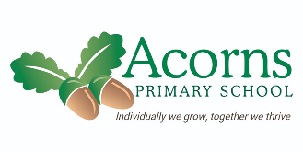
Pre-Formal

- Pre-writing sessions
- Fine motor
- Senseology – Exploring touch
- Gross motor activities, including physio plans.
- Making purposefully marks
- Messy sensory play
- Sand and water play
- Painting
- Exploring and manipulating malleable materials
- Hand awareness

Formal

- Finger spaces
- Capital letters
- Writing on lines
- Sentence structure
- Continued development of letter/number formation
- Phonics sessions
- Colourful semantic session
- Vocabulary sessions
- Spelling practice
- Writing for purpose

Semi-Formal (Experiential)

- Phonics sessions/ activities
Using writing tools.
- Fine motor activities.
- Making purposeful marks
- Magnetic letters
- Dough disco
- Making controlled marks e.g. lines, circle, shapes
- Developing preference for dominant hand.
- Using symbols to support sentence building.

Semi-Formal (Bridge)

- Phonics sessions/ activities
- Fine motor activities. E.g. threading, pincer grip, jigsaws
- Cutting skills
- Dough disco
- Colourful Semantics
- Tracing activities
- Copying activities
- Letter formation/ number formation
- CVC activities
- Using writing tools
- Mark making
- Colourful semantics
- Developing preference for dominant hand.

Writing at Acorns in each pathway

