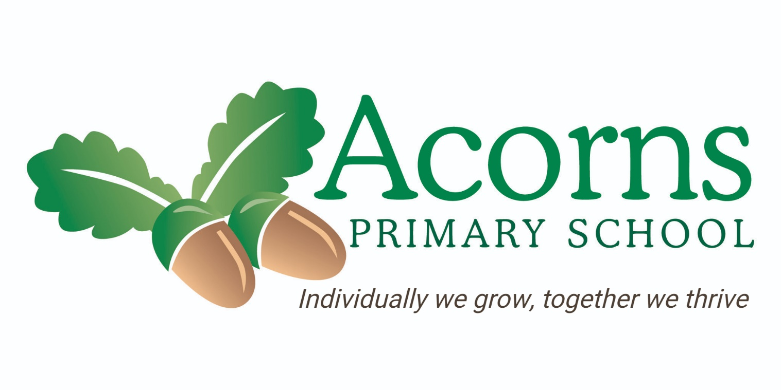

Religious Education Policy

Philosophy and purpose

This policy reflects the school values and philosophy in relation to the teaching and learning of Religious Education It sets out a framework within which teaching and non-teaching staff can operate and gives guidance on planning, teaching and assessment.

The policy should be read in conjunction with the Schemes of Work for Religious Education and the School Safety Manual which set out in detail what pupils in different class groupings will be taught.

The philosophy and purpose of the teaching of Religious Education at Acorns School is in line with our belief that every child matters so we provide all children with the support they need to;
- Be healthy
- Stay safe
- Enjoy and achieve
- Make a positive contribution
- Achieve economic well being

Every state-funded school must offer a curriculum which is balanced and broadly based, and
which:
· Promotes the spiritual, moral, cultural, mental and physical development of pupils, and prepares pupils at the school for the opportunities, responsibilities and experiences of later
life.
(Education Act 2002)

Aims:

'To support pupils' personal search for meaning by engaging enquiry into the question 'what is
it to be human?' - exploring answers offered by religion and belief.'

The aims of Religious Education, as laid down by the Lancashire Agreed Syllabus are to provide opportunities for children to focus on:

1. Know about and understand a range of religions and worldviews, so that they can:
· Describe, explain and analyse beliefs and practices, recognising the diversity which exists
within and between communities and amongst individuals;
· Identify, investigate and respond to questions posed, and responses offered by some of
the sources of wisdom found in religions and worldviews; and
· Appreciate and appraise the nature, significance and impact of different ways of life and
ways of expressing meaning.

2. Express ideas and insights about the nature, significance and impact of religions and
worldviews, so that they can:
· Explain reasonably their ideas about how beliefs, practices and forms of expression
influence individuals and communities;
· Express with increasing discernment their personal reflections and critical responses to
questions and teachings about identity, diversity, meaning and value, including ethical
issues; and
· Appreciate and appraise varied dimensions of religion or a worldview.

3. Gain and deploy the skills needed to engage seriously with religions and worldviews, so
that they can:
· Find out about and investigate key concepts and questions of belonging, meaning, purpose
and truth, responding creatively;
· Enquire into what enables different individuals and communities to live together respectfully
for the wellbeing of all; and
· Articulate beliefs, values and commitments clearly in order to explain why they may be
important in their own and other people’s lives.
('Review of Religious Education in England', RE Council of England and Wales, Oct 2013 p.14).

These aims are consistent with our school philosophy and take account of National Curriculum Statutory guidance.

The Lancashire agreed syllabus states that RE should enable pupils to:
- be aware that human life is not merely material life, and be open to the possibility of transcendent or spiritual life, exploring such experiences in their own lives and the lives of others;
- approach sensitively and respectfully the beliefs, actions and feelings of all people, so that they can take full part in building a more cohesive community where people of different religions and no religion can live well together;
- understand the relationships between the individual and the community in religious life;
- develop appropriate ways of communicating their own thoughts, feelings and responses;
- and apply these insights to the development of their own beliefs, values and attitudes.

Why is RE important?

Religion and belief inform our values and are reflected in what we say and how we behave.
RE is an important subject in itself, developing an individual’s knowledge and understanding of the religion and belief which form part of contemporary society.
Religious Education provokes challenging questions about the ultimate meaning and purpose of life, beliefs about God, the self and the nature of reality, issues of right and wrong, and what it means to be human. It can develop pupils’ knowledge and understanding of Christianity, of other principal religions, other religious traditions and worldviews that offer answers to questions such as these.
RE also contributes to pupils’ personal development and well-being and to community cohesion by promoting mutual respect and tolerance in a diverse society. RE can also make important contributions to other parts of the school curriculum such as citizenship, personal, social, health and economic education (PSHE education), the humanities, education for sustainable development, thinking skills and others. It offers opportunities for deep personal reflection and spiritual development, deepening the understanding of the significance of religion in the lives of others – individually, communally and cross-culturally.
(Adapted from 'RE in English Schools Non-statutory Guidance 2010, p.7)

Programmes of study

Lancashire agreed Syllabus 2021
The syllabus has been updated in 1994, 2000, 2006, 2011, 2016 and 2021 to take account of changes in education/ national curriculum.

Lancashire SACRE have stated that
“Lancashire's Agreed Syllabus for Religious Education was reviewed and relaunched in September 2021. This should be used 'as far as is applicable' in special school settings.” March 2022
The latest RE syllabus is enquiry based, each year group is given a focus question for the year and each topic is based around a question.
At the centre is the question ‘what does it mean to be human?’
Exploration – 4 key areas
· shared human experience - the nature of human being.
· living religious tradition - principal religious traditions encountered in the world.
· beliefs and values - which lie at the heart of these traditions.
· the search for personal meaning – a lifelong quest for understanding.

Each programme of study is differentiated to allow all our pupils to access the content in a meaningful and realistic way.

Requirements
Christianity is compulsory for at least 50% of RE curriculum time and no more than 75%.
Islam and Hindu Dharma are studied at KS1 and again at KS2 as a progressed study.
KS1 – 36 hours, 50 mins per week. KS2 – 45 hours, 60 minutes per week. This can be combined into themed days or weeks.

In accordance with the Lancashire agreed syllabus, other ‘non progressed’ religions should be studied, and these are no less significant. Access to these religions, not chosen for progression, may be delivered through celebration throughout the year. These religions include Judaism, Buddhism and Sikh Dhoram.

RE is delivered as an integral part of the early years curriculum.
The QCA scheme of work for Religious Education at KS1 and KS2 may be used in the medium and long terms planning whilst meeting the requirements of the Lancashire Agreed Syllabus RE.

Method of delivery

RE is planned on a 3-year rolling programme to ensure children are provided with the opportunities to learn about the six major world faiths. The RE subject leader has produced an ‘RE curriculum’ document to explain the structures and procedures for planning teaching and learning of RE. This document is attached in Appendix 1.
In relation to Religious Education however, additional considerations apply as outlined below. Teachers are expected to use these as a basis for their planning and differentiate to the level of understanding of the children in their class. This could look different each year. The different topics offer the opportunity for a broad range of learning experiences in which pupils develop skills at an appropriate level. Teaching subjects at the same time as a partner class allows further opportunities for sharing and differentiation. Teachers should also plan visits outside of school to enrich learning, as well as invite visitors into school.

Early Years
Provide experiences and support to enable children to develop a positive sense of themselves and their relationships with others. Early years classes will also be expected to take part in festivals and celebrations as listed in the curriculum planning document.

Pre-Formal
These children are considered to be working at a pre subject specific level. The pre-formal curriculum consists of the following areas
- Speech, language and communication
- Cognition and learning
- Sensory and physical
- Independence and self-help
- Social, emotional and mental health
For our pre-formal learners, RE consists of shared experiences, celebrations and sensory activities. This will be based around the festivals and celebrations in our calendar, including, but not limited to Diwali, Christmas, Lent, Easter, Eid and birthday celebrations. Events will also be shared with other classes in school.
Semi-formal (Experimental)
Pupils accessing the semi-formal (E)l layer of the curriculum will be taught through the school RE curriculum which will be adapted by the class teacher to give pupils the best opportunities to build on progress. This could include, but not limited to, sensory sessions, attention autism sessions, creative work, role play and visits.

Semi-formal (Bridge)
Pupils accessing the bridge pathway will learn through a mixture of sensory experiences as notes above and formal learning as noted below.

Formal
Pupils accessing a formal curriculum will continue to be taught the RE curriculum, building on skills and knowledge of each religion.

KS1
Have opportunities to build on their own experiences and knowledge of activities from the foundation stage. Each class will teach a different element/ focus of the same religion per half term. They will also have opportunities to celebrate festivals and events. Partner classes are expected to plan sharing events each half term.

KS2
Pupils are encouraged to learn more about the characteristics of, and people associated with religion. Each class will teach a different element/ focus of the same religion in a term. They will also have opportunities to celebrate festivals and events.

Planning & Class Organisation
At the foundation stage and at KS1 and 2, Religious Education is delivered by the class teacher or HLTA.
The subject, if appropriate, is also reinforced via cross curricular means. The Subject leader will consult and offer guidance to all staff through discussion, resources and planning.

Resources:
Resources are stored in the outside storage and resource building and are organised into sections specific to religions and aspects of world faith.

Information and Communication Technology
Each class has a PC with a range of software designed to help develop skills in each of the programmes of study in Religious Education. Each class also has their own iPad, with access to a class set of iPads as timetabled.

Equal Opportunities
Multi cultural and gender aspects of Religious Education are addressed wherever it is relevant. There is regular monitoring of the language used within the classroom as well as the equipment used to teach Religious Education.

Role of Religious Education Subject leader

- To have a good knowledge and understanding of their subject and to keep up to date with any initiatives and developments
- Support colleagues in their development of planning, assessment and recording of activities
- To lead in policy development and the production of schemes of work designed to ensure progression and continuity throughout school
- To offer advice and support to class teachers in the purchase of resources
- Monitor progression of subject throughout school, including moderation

Assessment, recording and reporting
The procedures for assessment, recording and reporting of pupils’ progress are outlined in the policy document of the same name in relation to Religious Education, however, the following considerations apply.

Recording Achievement
Observations in RE should be recorded on Evidence for Learning. These should comprise of photos, videos and records of observations. Achievement can be recorded against ‘I can’ statements listed on Evidence for learning. A list of these is attached in Appendix 2. Evidence for learning is to be used by all teaching staff and support staff to record achievements using photos and videos with narrative. RE can be ‘tagged’ into the recordings. Special achievements are rewarded with a certificate; star of the week with evidence displayed on the Achievement Board.

Assessing Achievement
Assessment against ‘I can statements’ can be made on an individual basis to demonstrate progress. Comments are noted on examples of work against specific learning outcomes identified in short term planning. Assessment informs termly evaluation and future planning. Pupils are assessed at the end of key stage according to statutory requirements. The ‘I can’ statements have been produced by a team of RE subject leaders from Lancashire schools.

Reporting Achievement
Achievement can be reported on through evaluations in individual pupil’s annual report. Achievements can be shared throughout the year on the EfL app.

Monitoring and Evaluating Religious Education
Monitoring and evaluating curricular strengths and weaknesses to ensure and maintain high standards in the quality of teaching and learning is a vital part of the curriculum development process. It is a process which is the responsibility of all staff but is seen as a major facet of sound management of school and thus it is directed from a senior management level. Opportunities are made available to subject co-ordinators to allow them to work alongside colleagues in other classes within the school in order to monitor the balance and coverage of the Religious Education strategy and to evaluate the standards of teaching and learning within the school. Opportunities are also available to access and attend RE special schools network meetings. This in turn affects future planning and delivery of the subject. Evidence for Learning is used to monitor RE, both what is being taught and learning/ progress.

Signed by:

Headteacher : L Hall Date: October 2025

Chair of Governors: S Jukes Date: October 2025

Next Review Date: October 2026

