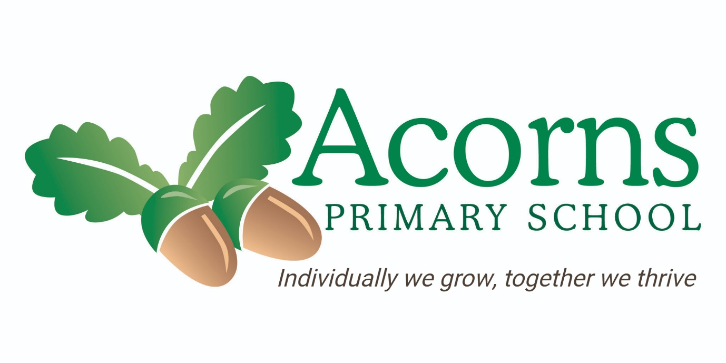

Literacy
Policy

Philosophy and Purpose:

At Acorns, we believe that learning to communicate and read is an important skill for all our learners, therefore we feel it is important to provide the opportunity for children to learn to read in a way that is tailored to the individual at their own rate of development. We provide a successful approach to the teaching of communication, phonics and reading that allow children to become effective communicators and fluent readers. The appreciation of books and words is taught through ‘my communication’ sessions and a broad, balanced and age-appropriate content is provided throughout our curriculum. As well as this, we want children to read for pleasure on a regular basis and develop a lifelong love for reading.

Intent:

- To develop functional communication skills to communicate.
- To provide opportunities for children to develop a love of reading by accessing a literacy-rich environment with a wide range of high-quality books and resources.
- To use a range of teaching and learning strategies that are relevant to individual children so that they can acquire functional reading skills.
- To offer a systematic, synthetic phonics scheme for all appropriate children.
- To develop children’s knowledge of language across the curriculum through the use of curriculum rich vocabulary.
- To experience literacy in a multi-sensory and engaging way.
- To offer all individuals the opportunity to develop and make progress in reading skills at their level i.e. pre-readers, early readers and readers through Acorns Inclusive Reading Scheme (AIRS).

Implementation:

In all classes, communication, phonics and reading are taught in structured teaching sessions and also in less formal settings such as breaktime and outside. The generalisation of skills is encouraged at all times. Acorns School recognises its responsibility to pupils and their families to provide a well-considered and consistent approach when teaching. We realise the key role that the process of development in literacy plays in every child’s life. We provide a range of teaching strategies and methods that promote phonemic awareness, phonics, fluency, vocabulary, and comprehension.

Acorns Inclusive Reading Scheme (AIRS)

AIRS is an inclusive reading scheme that every child in school can access.
It offers individuals the opportunity to develop and make progress in reading skills at their level. AIRS has three levels and each child in school participates in activities and lessons that meet their individual needs. The levels include pre-readers, early readers and readers. We provide a range of example of activities which can be seen in the table below of what reading looks like at each level.
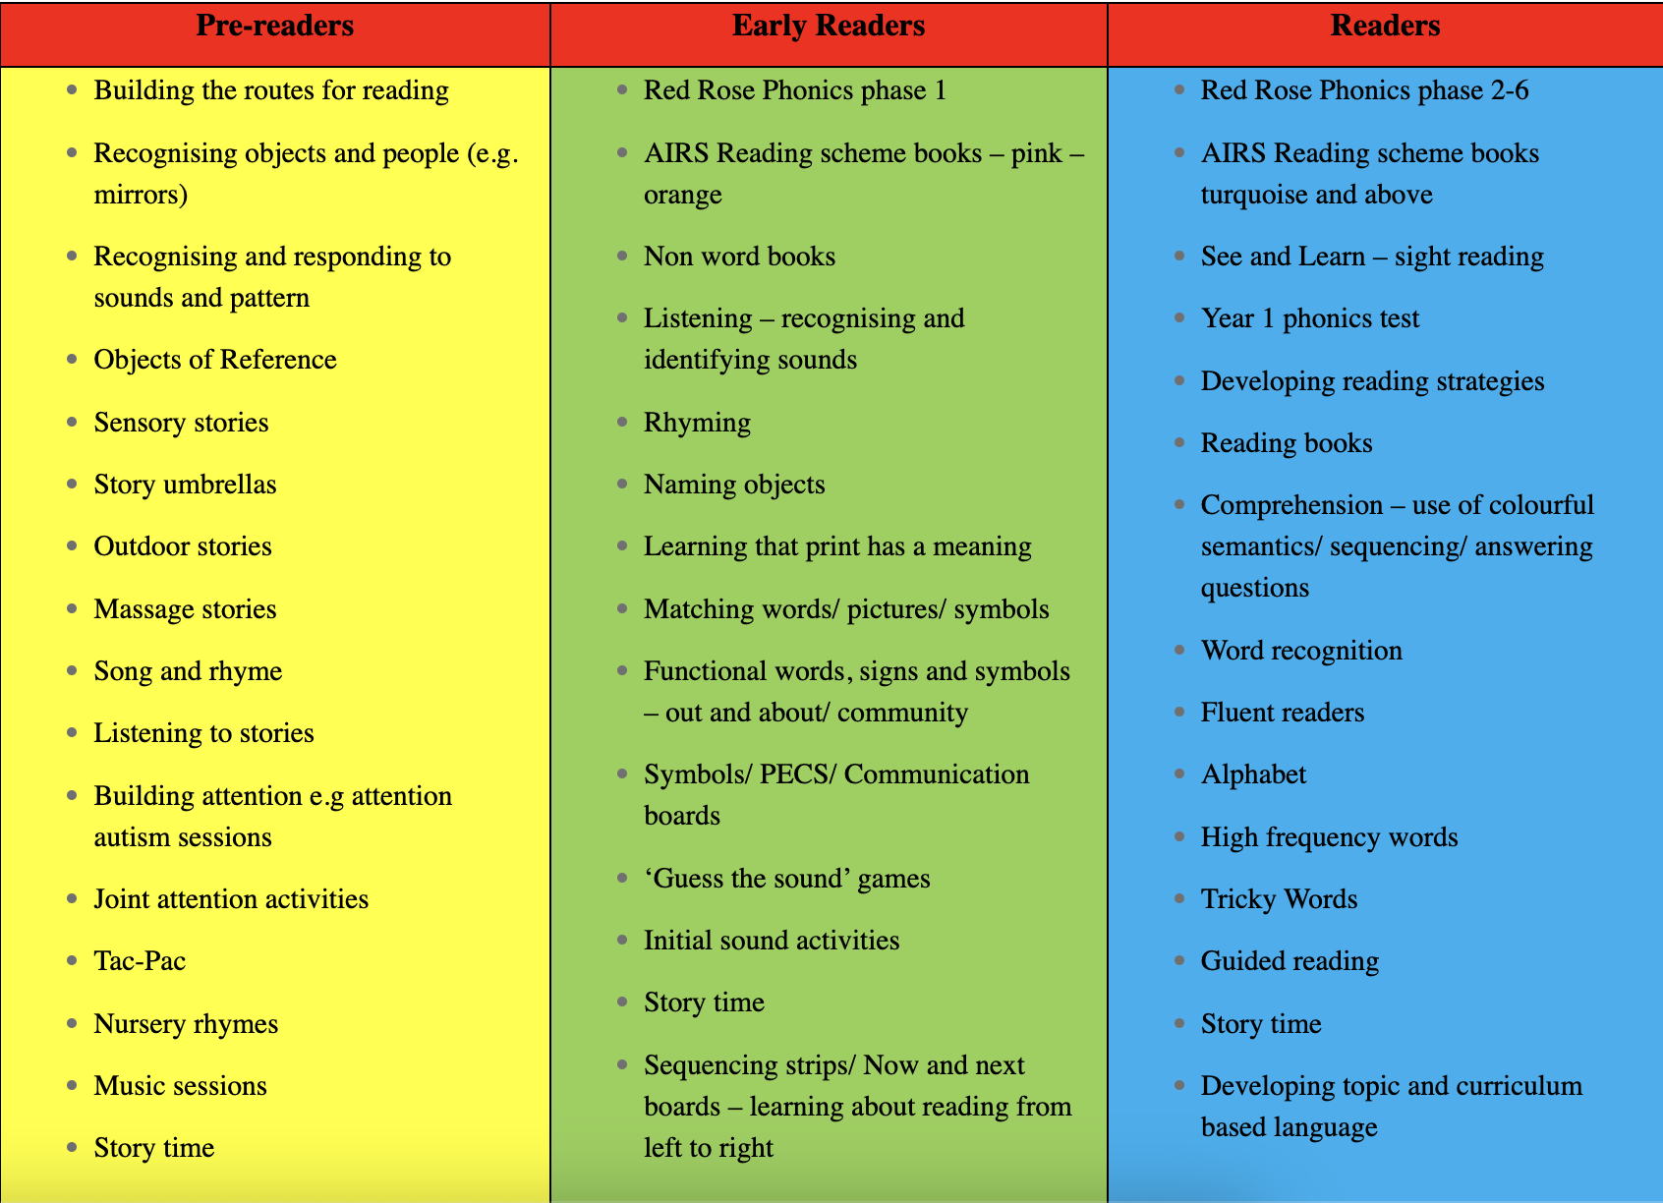

Phonics

At Acorns, we have developed and established a successful approach towards the teaching and learning of phonics. We are committed to the planning and delivery of high-quality phonics lessons, ensuring pupils have the best start possible in developing their reading skills.

At Acorns, we teach phonics following the Red Rose Phonics Scheme from phase 1- 5, following and systematic and synthetic approach to recognise letters (graphemes) and their corresponding sounds (phonemes). The sessions include practical and engaging activities and games, which supports children to become enthusiastic and successful readers and writers. From the Red Rose scheme, we also use ‘phonics fingers’ when segmenting sounds and a ‘smooth blend’ for blending sounds together.

The children in Key Stage 2 are grouped in phonics, so that the pupils are accessing lessons targeting at the appropriate phase they are working at. As well as the children being in differentiated groups, we further differentiate lessons to meet the individual needs of pupils in the school. This allows for lessons to be tailored and children to be challenged further, allowing for greater progression.

Children at Acorns school often have ‘spikey’ profiles and although may be able to learn how to blend and segment, often need support to engage in sessions or need support learning the games included in the Red Rose Phonics scheme. We recognise the importance of supporting children to engage and teach them the skills of phonics, so we teach children the games in simplified ways before adding the phonetic elements.

AIRS Book Banding

At Acorns, we have ‘AIRS Book Banding’ which is a range of books which are colour co-ordinated to the level of the book. The book bands help children to develop reading skills and confidence by providing books that match their abilities. Appropriate children are provided with a reading record book and are encouraged to read books to their teachers and independently. Teachers can match children with books that are appropriate for their reading level and comprehension. We use blank level questions at Acorns to help children develop key oral language comprehension skills. Parents are offered a home reading pack, in which reading books are sent home with some pupils so that parents can hear them read. Progress in reading is recorded in individual reading records. We also signpost parents to online reading resources for free.

Developing a Love for Reading

At Acorns School, we believe that children deserve a rich curriculum which encourages reading and sharing a range of books and texts. We believe that active encouragement of reading for pleasure is a core entitlement of every child, whatever their background, ability or attainment. Research tells us that exposure to a wide range of texts makes a huge contribution to pupils’ educational attainment and understanding of the world.

We aim to promote the concepts of reading for ‘fun’, ‘enjoyment’ and ‘pleasure’ and provide opportunity for reading and sharing a range of fiction and non-fiction text. We want our pupils to develop a love for reading. Reading looks different for every child, and at Acorns we want to provide the opportunity for every child to develop a love for reading. The way we approach teaching and learning in reading will be different for every child, but the love of reading is at the heart of what we offer.

Enthusiasm and engagement around reading is developed by offering a range of activities, stories, books and resources. We have created library trollies, which can be used in class and on an individual basis. The books have been carefully selected to promote reading for pleasure for our pupils (e.g. character books), as well as breadth and depth (e.g. early reader books, noisy books and story books). The trollies are stocked with books that meet the individual needs of all students in school. In addition, all classrooms have a book corner to provide all pupils the opportunity to choose books to read or share. Children are offered structured curriculum time to work on reading skills, but they also have access to reading opportunities throughout the day.

Throughout the year, we aim to provide specific ‘reading for pleasure’ events and activities such as celebrating national event such as; World Book Day, World Nursery Rhyme Week, as well as ‘in house’ reading events. We encourage older pupils to read/share stories with younger pupils, also to create and maintain links with local schools to allow their students to share stories with groups/classes. Throughout the year there are wall displays around school celebrating reading for pleasure activities, the teaching of communication and phonics and school reading events.

Exploring Text and Guided Reading

At Acorns, every class has a story that they are sharing. Teachers choose a story based on their class topic in the semi formal curriculum. The literacy subject lead provides a document of book suggestions, but it is agreed that teachers choose a story that best serves the pupils. The subject lead will monitor the books being taught in class and add texts to the Curriculum Map. Every class in school has their current story displayed on their classroom door to promote discussion adults and children in that class. This story might last a week or a full term. Classes share these in a range of ways appropriate for the class, this could be an Interactive Whiteboard story, a sensory story, or a big book. The text can be explored in a way that meet the individual needs of all the students. For some pupils, we offer sensory stories, where simple text is used with a sensory experience (e.g. senses) to support the telling of the story. Sensory stories are repeated to aid children to understand the sequence and offers opportunities to communicate preferences and develop anticipation skills. Some pupils may access guided reading sessions, which allows children to develop reading comprehension skills, build fluency and improve attention to detail.

We recognise the importance of children’s communication; therefore, we support children to engage and comment on text using their preferred method of communication to develop their understanding of the story. We tailor activities for children to use their preferred method of communication, which may include verbal communication, PECS symbols, communication books, ALI Boards, Makaton signing, PODD and AAC devices.

Colourful Semantics

Colourful Semantics is an approach that uses colour coded words, supporting pupils to understand and put together the different elements within a sentence. This technique encourages pupils to develop their skills in spoken language, supports them in answering who, what, where questions and promotes the use of nouns, verbs, prepositions and adjectives in both reading and writing skills.

We use colourful semantics to teach:
- Storytelling
- Describing Pictures
- Creating Sentences from Words
- Peer Interaction
- Role Play
- Writing Tasks
- Reading Comprehension
- Vocabulary Building

Extended Writing

At Acorns, we challenge our children to achieve their full potential. We plan lessons to meet the pupil’s individual needs. If children are able to, we promote children to try to extend their writing. Due to the nature of our pupils all staff are aware that most do not follow a linear learning pattern and may show ‘spikey’ progress across all areas;
- Gross/Fine Motor skills
- Pre-writing skills
- Letter Like/Letter Formation
- Using beginning and end letters of words
- Using phonetic spelling
- Fluent writing

Where appropriate, pupils will use alternative means of documenting their work such as recording devices, communication boards, tracing, over writing and recording stories.

Role Play

At Acorns, we recognise the importance of role play to promote communication, language and understanding of the world. The sessions will offer opportunities to experience and use explorative speech to develop imagination and vocabulary, using a variety of objects and materials, from small world toys to dressing up costumes. Staff are advised to use appropriate levels of speech depending on the pupil’s role play needs, for some pupils too much speech can be overwhelming, but for other pupils, adult will need to provide more modelling in vocabulary and speech structure but also the time and freedom to express themselves without interruption.

Use of Technology

At Acorns, children use ICT to enhance the teaching of reading, through interactive games and material. We access Busy Things, Help Kidz Learn and phonics games to support children to develop their communication, reading skills and comprehension skills. We support children in their reading development through the use of iPad applications and online games and activities on the laptops.

Cross Curricular links and Learning Outside the Classroom

At Acorns, children are encouraged to notice print in their environment and in their local community. Print may include sign, pictures, symbols, phrases, sentences or individual words. We provide opportunities for children to develop their reading and comprehension skills across the curriculum and in everyday life. Pupils are encouraged to read in a variety of lessons including registration session, circle times, kitchen and creative sessions. Stories are often taken outside and reading sessions occur in forest school e.g. reading recipes for potions.

We also recognise the importance of developing children’s skills in the wider community, and we provide practical lessons such as reading a shopping list in Sainsburys, getting on the correct public bus and reading the bus stop timetable, reading menus in a restaurant etc. We also visit the local libraries in the community.

At Christmas, we produce a Christmas play which all children in the school participate in. Children have the opportunity to participate in drama, music and a play. Some children read and memorise scripts to perform in the play.

Cultural Capital

At Acorns School, we provide our pupils with rich and meaningful opportunities to develop their cultural capital, ensuring we equip them with the essential knowledge and experiences needed for their future. From the very start of their school journeys, our pupils are taught the fundamental skills of communication and early reading, allowing them access to all other areas of the curriculum. We promote cultural capital in reading, by providing and exposing our pupils to a range of texts, from different authors, cultures and genres. Through educational visits, local community links, drama/role play and storytelling, we embed all important life experiences and expand pupils understanding of the world around them. Other ways in which we promote cultural capital through communication and reading:
•Using a total communication approach.
• Daily reading/story telling.
• Story/song time at local libraries
• Café visits – ordering own food and drink from a menu.
• Walking in the local community and recognising signs/logos.
• Visiting local shops – following a simple shopping list.
• Music, art, poetry and rhyme activities.

Impact:

Key roles and responsibilities:

Headteacher

- To be responsible for the day-to-day implementation and management of the Literacy Policy of the school.
- To be responsible for handling complaints regarding this policy as outlined in the school’s Complaints Policy.

Governing Body
- To be responsible for overseeing and reviewing whole-school literacy curriculum delivery and should regularly receive updates on the progress of literacy provision within the school, ensuring high standards are upheld.
- Members of the governing body have links to classes and subject areas. They will regularly receive updates regarding the development of literacy throughout school.

Subject Lead
- To co-ordinate phonics and reading throughout the school. This includes monitoring the teaching of phonics and reading and strategies used via learning walks and EFL.
- To monitor the progress in reading and phonics in EFL and on B Squared.
- Monitoring the quality of teaching and learning in phonics and reading across school.
- To ensure that resources match the needs of pupils and are up to date and in line with Curriculum content and government change.
- To liaise and support colleagues, providing necessary training in the planning, delivery and assessment of reading.

Teacher
- All teachers will be responsible for ensuring high-quality engaging teaching, allowing development and progression of pupil’s literacy skills.
- To plan, implement and assess effective and engaging reading sessions.
- To record and assess evidence of pupil’s progress via EFL and B Squared.
- To set IEP targets in phonics for pupils accessing phase 2 to 5 sessions.
- To support teaching support assistants to provide high quality teaching of phonics and reading to the students.

Assessment:

Assessment for reading will be recorded via Evidence for Learning (EFL), all staff are responsible for taking photographs and videos of pupils’ experiences.
Evidence is ‘captured’ using the EFL iPad app or online program and will consist of a combination of images and videos. Each ‘capture’ of evidence will also contain a quality comment to accompany the learning, the evidence is to be linked to pupils’ IEP. ‘Tags’ highlight the skills or progress demonstrated in a number of curricular areas. The literacy subject lead is responsible for tracking progress and having discussion with SLT to ensure progress of all pupils. Pupils who are in accessing phase 2 or higher in phonics must have an IEP target.

Phonics is assessed twice a year. This is done using a highlighted Phonics tracker sheet. Each pupil has an assessment sheet appropriate to their Phonics Phase. The English subject leader keeps a copy of all Phonics assessments.

Literacy is also assessed on B squared twice a year by teachers. The literacy subject lead is responsible for tracking progress and having discussion with SLT to ensure progress of all pupils.

We have reading records for pupils at our school to track the books that they have read and the progress that they are making. These are both for school and at home.

Monitoring and review

The literacy policy shall be reviewed annually to ensure all aspects of the policy meet the latest statutory regulations and reflect the needs of our pupils. Assessment shall be ongoing using B Squared, EFL and the phonics tracker, to link all work to individual IEPs and will be tracked by the subject lead.

Equal Opportunities

We incorporate phonics and reading into a wide range of cross curricular subjects and seek to take advantage of multicultural aspects of reading. All children have equal access to the curriculum regardless of their gender or ethnicity. This is monitored by analysing pupil performance throughout the school to ensure that there is no disparity between groups.

Policy written by: April Baxendell (Literacy Subject Lead)

Signed By:

L Hall Headteacher Date: December 2025
S Jukes Chair of Governors Date: December 2025

Next Review Date: December 2026

