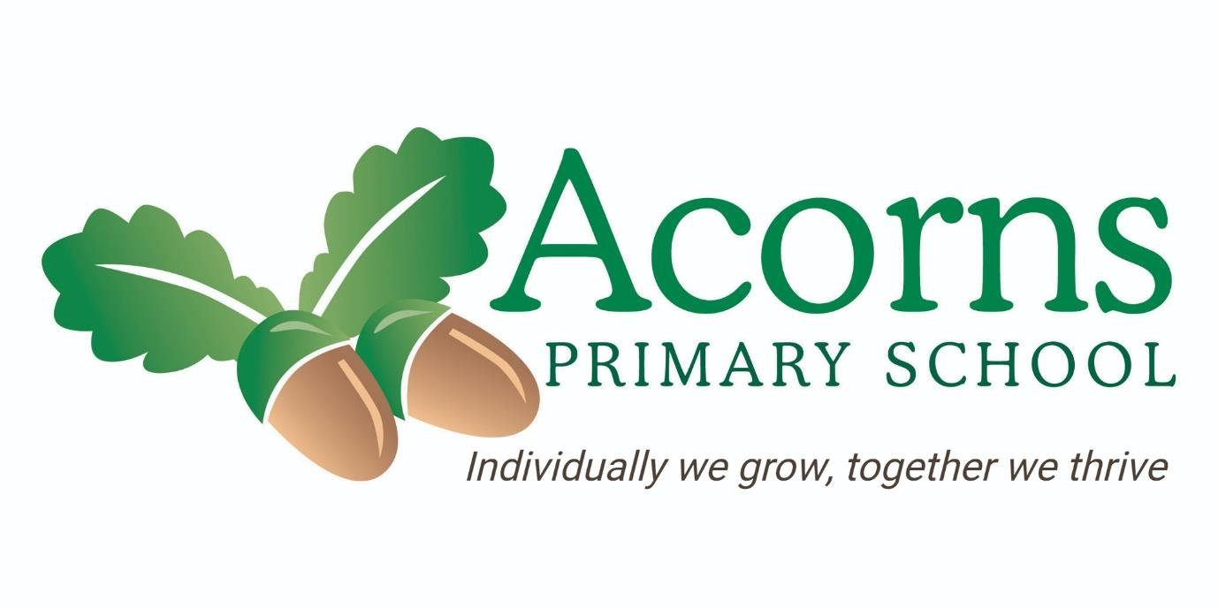
TOTAL COMMUNICATION
Total
Communication
Policy

Acorns Primary School Preston

TOTAL COMMUNICATION

STATEMENT OF INTENT

“Acorns School aims to develop communication as an all-day long approach.
We will provide staff with the training, resources and support needed to
develop and implement aids to support a communication approach suitable to
individual’s needs.
Vocabulary will be modelled with the aim to expand individuals
understanding and use of language at a level appropriate to them.
Appropriate, engaging, and purposeful activities will be provided to support
the development of children’s functional communication skills. Skills will be
practiced in the school environment, wider community and within the home
environment to provide children with the opportunities to continually make
their want and needs known in a way that can be understood by all.
A consistent whole-school approach will be developed supporting consistency
and continual progression for all”.
AIMS AND PURPOSE

The aim of this policy is to:

•
Set out clear and consistent strategies to meet the diverse
communication needs of our pupils to equip them for life and enable
them to operate successfully within their own environment and the
wider community.

•
Identify the ways in which Acorns Primary School will provide and
maintain a successful communication environment, which allows all
children the opportunity to develop his/her language and
communication across the curriculum.

•
Promote regular liaison between parents/carers and professionals to
ensure continuous and consistent communication experiences at
home and school.

TOTAL COMMUNICATION AT ACORNS PRIMARY

At Acorns Primary School we adopt a total communication approach using a
range of communication methods and strategies to support and encourage
communication skills and the development of speech and language. The

Acorns Primary School Preston

TOTAL COMMUNICATION

methods are not used in isolation and a pupil may use a combination of the
following methods.
Intensive Interaction –
This is a pre-verbal approach that facilitates children’s engagement with a
supporting adult or peer to develop their communication skills. By copying
the actions or vocalisations of a child, we can help support them to develop
the ideas that communication can influence interaction with our
environment.
Object Cues and Objects of Reference –
The use of objects as a means by which pupils are helped to make sense of
their world and to develop an understanding of events.
An object of reference is presented to a pupil with accompanying language
in preparation for an event which is to follow e.g., in preparation for ‘lunch’
the pupils are shown the object of reference representing lunch time – a
spoon.
At Acorns Primary School we have an agreed consistent set of objects of
reference which are to be used by agreed classes and identified pupils.
Some pupils may also use objects of reference to aid choice making.
Photographs and Symbols –
The use of photographs and symbols provides valuable support for pupils
and is encouraged for most pupils especially those pupils who are
considered visual learners and those with ASD.
Examples of symbol use includes but is not limited to timetables (individual
and class timetables), communication books, ALI boards.
It is the responsibility of class staff to provide symbols / photographs as
appropriate to support and aid communication. Acorns has an agreed set of
commonly used symbols which aims to ensure consistency across school.
All symbols should be generated using Boardmaker.
PECS (Picture Exchange Communication System) –
The Picture Exchange Communication System is a form of augmentative
and alternative communication.
It is a structured approach to developing communication with a student by
‘exchanging’ a photograph or symbol for a desired item. It aims to develop a
pupil’s functional communication.

Acorns Primary School Preston

TOTAL COMMUNICATION

PECS is a very structured approach and has a defined hierarchy that must
be followed for it to become a successful communication system. At Acorns
we also use many PECS strategies to support pupils e.g. Now / Next and
individual timetables.
There are 6 phases of PECS that pupils move through These are:

1.
Exchanging a symbol

2.
Travelling

3.
Discrimination 4

4.
Sentence structure

5.
Spontaneous requesting

6.
Social communication.

Makaton –
Makaton is a hand-based system where children learn to develop motor
patterns or signs with their hands to communicate different activities/
objects/ requests and curriculum core language. Makaton is used as a visual
and kinesthetic support to aid the development of the spoken word and as a
means of communicating everyday needs and wants.
Makaton should be used throughout lessons where appropriate as a visual
to aid understanding of language. Some pupils may also choose to use
Makaton signs to convey meaning or understanding.
Colourful Semantics –
Colourful semantics is aimed at helping children to develop their grammar,
but it is routed in the meaning of words (semantics). Some students at
Acorns Primary School use colourful semantics to support their
understanding of language.
Spoken word –
Spoken communication is made up of speech sounds, word meanings,
putting words into sentences and grammar.
The use of speech is always encouraged, and we provide models of clear
speech and language for the students.
Some of those who do use spoken communication may have difficulties
with the organization, clarity and fluency of speech sounds and words.

Acorns Primary School Preston

TOTAL COMMUNICATION

Assessment
Assessment of communication skills is in line with the assessment,
recording and reporting policy for the school.
In relation to communication the following considerations apply:

•
All pupils should be assessed using the Communication Matrix twice
yearly. This assesses a child’s functional communication skills and
any developments made towards their communication skills.

•
Pupils who are in the Early Years Foundation Stage are assessed
using the Early Years Foundation Stage Development Matters.

•
Most pupils have communication targets on their IEP’s. Assessment
against learning outcomes is made on an individual basis to
demonstrate progress and inform future targets relating to EHCP and
Annual Review outcomes.

•
For pupils who are involved with Speech and Language Therapy, a
formal report is submitted with the pupil’s annual review.

Monitoring and Evaluating
The Senior Leadership Team, supported by Hannah Serventi and Kelly
Vacchiano, will take responsibility for the monitoring and evaluation of
communication through:

•
Planned observations

•
Peer to peer observations (feedback)

•
Informal feedback and discussions with staff including Speech and
Language

•
Monitoring of progress towards targets on EFL (evidence for
learning); including written comments and pictural or video evidence.

•
Tracking pupil data using Communication Matrix devised by Acorns
School.

•
Speech and Language will monitor progress through specialized
Speech and Language assessments.

Acorns Primary School Preston

TOTAL COMMUNICATION

Inset and Training
At Acorns Primary School we recognise the importance of up skilling all
teaching team to enable all pupils to reach their potential.
All new staff undergo staff induction which includes Communication at
Acorns.
The teaching team and support staff have an ongoing programme of CPD
support based on individual needs.
Parental / Carers
The school recognises that home-school partnership is pivotal to the
success of pupils’ achievements in communication.
Close liaison is encouraged through:

•
Parent / carer meeting with class teachers and / or Speech and
Language Therapists

•
Parent / carer communication workshops

•
IEPs shared with parents and outcomes reported to parents termly.

•
EFL (Evidence for Learning) parent view to share progress with
parents / carers.

•
Annual reports

•
Annual reviews

Speech and Language Therapy (SALT)
To ensure the successful communication development of all students at the
school it is essential that the Speech and Language Therapist, SALT
department and school staff work collaboratively.
Speech and Language Therapists adopt a Consultative Approach, they work
in conjunction with school staff, and parents to assess the communication
needs of the child. Assessment may involve observation in the classroom,
teacher discussion and individual assessments.
Following assessment, the SALTs advice and plans are carried out
throughout the day by school staff and parents/carers for the majority of
our pupils. This is the Universal Approach.
The Speech and Language Team can be contacted on 01772 777318

Acorns Primary School Preston

TOTAL COMMUNICATION

Signed by:

Headteacher:
L Hall

Date: October 2025

Chair of Governors:
S Jukes

Date: October 2025

Next Review Date: October 2026

Acorns Primary School Preston

