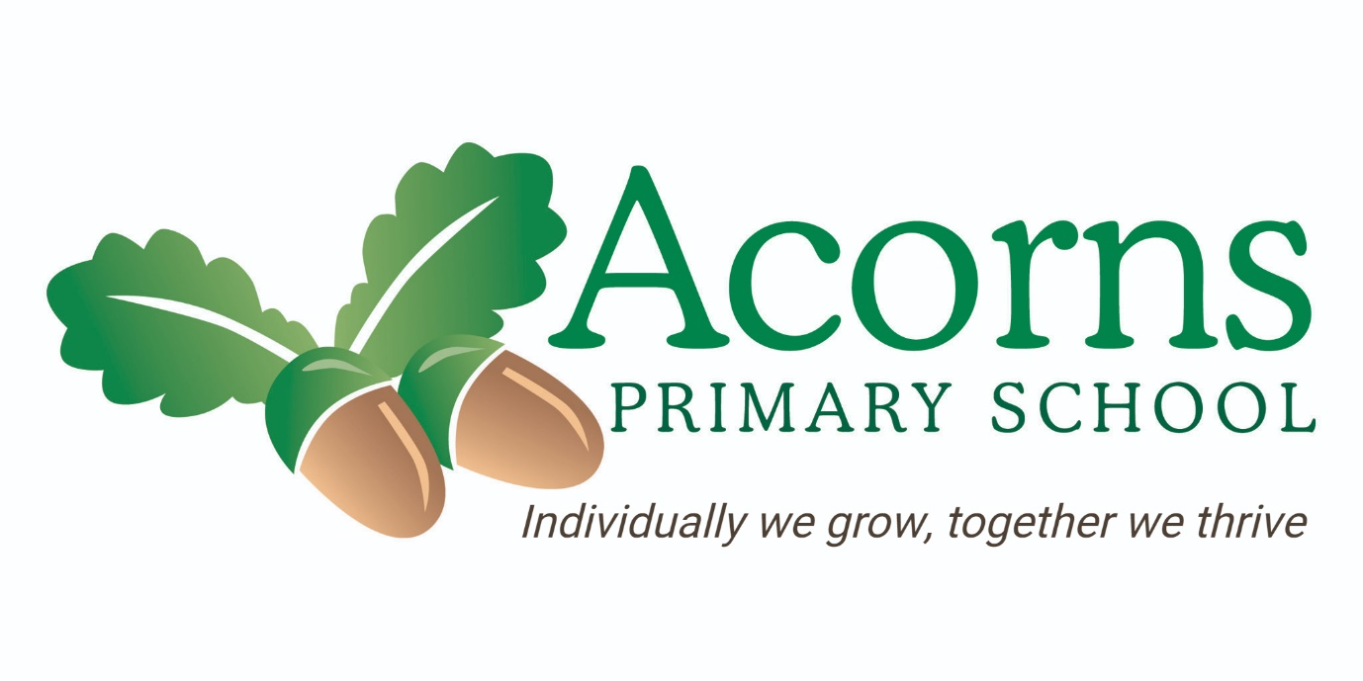

Science Policy

MISSION STATEMENT

- To provide a happy safe caring environment for pupils and staff.
- To encourage each child to fulfil their potential.
- To create an environment in which every child's efforts and achievements can be celebrated.
- To develop an inclusive curriculum with enjoyment and excellence at its heart.
- To encourage all children to be independent learners.

RATIONALE

At Acorns we aim to provide quality, fun and engaging learning experiences and ensure that all children can experience and develop learning and skills at an appropriate level, in a safe, but stimulating environment. The indoor and outdoor learning environments provide access to appropriate continuous provision, focused and guided activities which are tailored to meet the varying needs of our children. A sensory diet curriculum has been developed throughout EYFS, KS1 and KS2, to encompass learning needs, styles and we adapt our provision accordingly. It is an integral component of our curriculum at Acorns Primary school.

‘Communication’ is central to all areas of our curriculum at Acorns School, and this should be a primary consideration in teachers’ planning of their science topics. Science lessons should adopt a total communication approach and pupils should have access to personalised communication strategies including Aided Language Displays, use of Signalong (including topic vocabulary) and individual high-tech and paper-based communication aids. Research highlights that pupil participating in enquiry based science activities benefit from developing much wider skills than simply their science skills and /or knowledge. This includes the ability to attend and engage in learning, anticipate, make choices, work as a member of a team and develop their confidence to communicate with both peers and staff. This highlights the important role that science can have in developing pupils’ communication skills and wider personal development.

AIMS AND PURPOSE

The National Curriculum for Science aim is to:

- Develop enquiring minds and the ability to question,
- Build on their natural curiosity, and develop language to communicate their findings
- Learn to use equipment safely and sensibly
- Develop links with other subject areas throughout the curriculum
- Develop scientific knowledge and conceptual understanding through the specific disciplines of biology, chemistry and physics
- Develop and understanding of the nature, processes and methods of Science through a range of quality learning experiences which help them question and learn about the world around them.
- To equip them with the scientific knowledge required to help them understand the use and implications of Science, today and in the future.

SCIENCE AT ACORNS PRIMARY

Children are naturally fascinated by everything in the world around them and this natural curiosity is what we hope to encourage in our learners through our Science curriculum. We are developing an enticing and engaging learning environment where working in an investigative way can be encouraged and promoted safely.

At Acorns our pupils learn best when this curiosity is given time and opportunity to be explored. When they can be given multiple opportunities to interact with their environment and can be shown different ways to explore, engage and question what they find. The skills they begin to develop are key skills such as making observations, anticipating outcomes, predictions and evaluating first hand observations. Working scientifically like this and having the communication skills to facilitate it are of equal importance to developing knowledge and understanding. Therefore, Science is present throughout our curriculum. It contributes significantly to pupils’ enjoyment and understanding of the world and aids their understanding of their place within it.

Our aim is to make Science accessible to all pupils through either discrete subject teaching, continuous provision or more intrinsically within our Semi formal and PMLD curriculums. We are always striving to offer new opportunities to build on these experiences and develop knowledge and understanding. Therefore at Acorns we develop fun and engaging ways to promote Science inside and outside of the classroom, with a focus on practical work, first-hand experiences in a range of contexts and special events designed to inspire and engage learners.

Acorns has based our teaching on the National Curriculum Programmes of Study and this is particularly helpful with ensuring that there is sufficient breadth and coverage as well as the required fluidity and progression. The programmes of study describe a sequence of knowledge and concepts. While it is important that pupils make progress, it is also vitally important that they develop secure understanding of each key block of knowledge and concepts in order to progress to the next stage.

The National Curriculum document for Science sets out a clear, full and statutory requirement for all children. It determines the content of what will be taught and sets attainment targets for learning. The programmes of study set out what should be taught at Key Stage 1 and 2 and The Foundation Stage programmes of study for Understanding of the World are set out in the EYFS.

The Science Curriculum at Acorns has been tailored to meet the wide ranging and diverse needs of our pupils. The National Curriculum Programmes of Study for Science along with EYFS/Early Learning Goals have been used as a foundation and framework for a developmental curriculum which is differentiated to meet the needs and ages of all our pupils. This ensures that pupils are accessing the curriculum at the relevant stage for their development whilst also accessing and experiencing the full range of the National Curriculum as appropriate. An ongoing thread throughout the year (including whole school activities) as well as provision of a range of opportunities for individual development ensures all pupils are working towards appropriate goals.

Nursery/Foundation Stage
Children enter Reception classes in the September after their fourth birthday. The EYFS in Reception sets out the learning objectives for the seven areas of learning:

- Physical Development  - Expressive Arts and Design  - Personal, Social and Emotional Development  - Literacy | - Understanding of the World  - Communication and Language.  - Mathematics
Key Stage 1 & 2

Pre formal curriculum:
The Pre formal Curriculum provides an integrated approach that uses sensory experiences and activities to help children learn about the world around them. A holistic approach to learning takes place so personalised objectives may be taught in a variety of sessions, including Sensory Stories, TACPAC, Messy Food Play/Sensory Cooking and Creative Arts. Learning will also take place in a variety of settings, such as the classroom, Multi Sensory Room, Art Room and in the sensory garden or forest school areas.
Children who access the pre formal curriculum are working at a pre subject specific level. The pre-formal curriculum consists of the following areas:
- Speech, language and communication
- Cognition and learning
- Sensory and physical
- Independence and self-help
- Social, emotional and mental health

Pupils are given the opportunity to access the world through themes in class and special celebrations/ Pupils use their senses to develop awareness of the world and have opportunities to explore the school environment as well as the local area.

Semi formal: (Experiential)
Pupils accessing the semi-formal layer of the curriculum are working on gaining knowledge of science and learning to work scientifically. The curriculum and outcomes are written as pre cursers to the National Curriculum ensuring breadth. Science is either taught separately or under the umbrella of “My World”. The semi-formal curriculum provides a more integrated approach that uses a thematic approach to teaching, with a focus on generalized skills. The teaching in these groups will be holistic where possible, often focusing around a termly overall ‘topic’. Opportunities will be made for pupils to learn through exploring, Attention Autism sessions, play and practical activities in a variety of environments across school.

Semi formal bridge and Formal pathway:
Formal Science is taught through themes to ensure pupils can make links in their learning and remember more. Pupils follow a broad and balanced curriculum and work towards National Curriculum outcomes whilst developing their natural curiosity and scientific enquiry.

Classroom Organisation
Children will be grouped as appropriate for the task to encourage flexibility and fluidity:

- Ability groups  - Mixed ability groups  - Mixed ability partners | - Ability partners  - Individuals  - Whole class groups

Resources
Science resources are stored in the outside shed (key 14) and are stored in labelled boxes. All resources should be returned to the correct box when finished with. Advice on available resources and ICT programs available will be available from the subject coordinator.

Assessment
In the Foundation Stage (reception) children are assessed against the Early Learning Goals. Individual learning journeys are completed, which include a mix of photographic evidence, observations and examples of work. Evidence For Learning allows us to capture evidence to support this assessment and allows all staff to contribute to the assessment process. It also offers an opportunity to tag Science skills being developed in other curriculum areas. More informal assessment takes place throughout each day through adult observation, assessment tasks and the annotation of pupils work where appropriate. Progress is tracked against National Curriculum Outcomes and Acorns’ ‘I can’ statements.

Recording
Children’s recording will take many forms according to the nature of the activity and the ability of the class:

- Verbal  - Pictorial  - Diagrammatic  - Graphical | - Written  - Symbolic  - Photographic
Reporting
Parents are invited to attend an Annual Review to discuss their child’s progress and set Annual Review Targets. Parent’s evenings are held in the summer term to share achievements and progress. Parents also receive Interim progress reports in the spring term and an Annual Report at the end of each Summer Term. These provide information about attainment in each area and provides photographic evidence to support this. Evidence is also shared via the EFL app.

Health and Safety

In addition to the general health and safety practices of the school all teachers of Science should promote safe practice at all times and where necessary teachers should complete or refer to specific school risk assessments (e.g. handling guinea pigs, use of the pond etc.). With reference to specialist science equipment and chemicals, student ‘hazards’ should be referred to by staff and pupils and the staff member working directly with pupils is responsible for ensuring that both they and the pupil is able to use the equipment safely. Any concerns should be raised immediately with the class teacher.

Equal Opportunities
The Governors and staff are committed to provide the full range of opportunities for all pupils regardless of gender, disability, ethnicity, social, cultural or religious background.

The Role of the Science lead and “My World” team
- To review changes to the National Curriculum requirements with SLT and advise on their implementation throughout EYFS/KS1 & KS2.
- To implement the My World plan.
- Attend relevant CPD courses for Science as appropriate in line with the School Development plan.
- Arrange staff meetings to discuss the continuing development of Science and provide support and INSET where necessary.
- Manage the school’s Science resources and organise these resources to ensure that our children can learn effectively in and through Science.
- Monitor the learning and teaching in Science and provide support for staff when necessary.
- Take a lead role in organising Science Events in school in line with LA and national initiatives.
- Liaise with other GLD schools for moderation and developing the science curriculum.
- Endeavour to involve parents/ carers in their children’s learning in and through science.
- Analyse end of unit assessment and progression data in order to set new priorities for development of Science in subsequent years.

Linked Policies:
Acorns School Science policy should be read in conjunction with additional policies for:
- Community Visits
- Health and Safety
- Total Communication Policy
- Assessment, recording and reporting

L Hall Headteacher Date: October 2025
S Jukes Chair of Governors Date: October 2025

Next Review Date: October 2026

