Relationship and Sex Education Policy

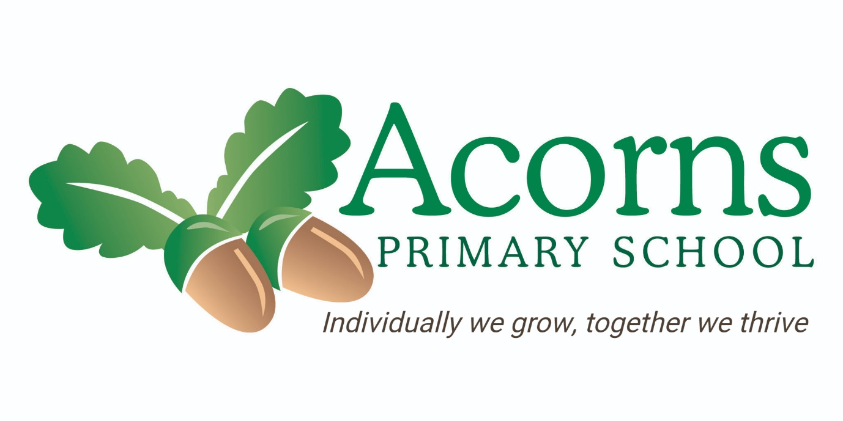

Introduction
Current regulations and guidance set out from the Department for Education state that from September 2020 all primary schools should deliver Relationship Education. This policy sets out our school’s approach to delivering statutory Relationships Education and non-statutory Sex Education.
Their guidance states that the teaching of Sex Education in primary schools remains non-statutory, with the exception of the elements of sex education contained in the science national curriculum including the main external body parts, the human life cycle (including puberty) and reproduction in some plants and animals.
At Acorns Primary School we have made the decision to offer aspects of Sex Education for our pupils. We value the importance of our role as educators in safeguarding our vulnerable children.

Intent
We consider RSE to provide pupils with lifelong skills that supports them to establish positive relationships; both physical and online. It helps our learners to develop knowledge around the Emotional, Physical, Moral and Social aspects of growing up.
Relationship and Sex Education at Acorns focuses on nurturing and developing the whole child, as reflected in our school motto. ACORNS: Achieve, Celebrate, Opportunities, Respect, Nurture and Success. It is embedded throughout school life and underpins our school’s philosophy. At Acorns we provide opportunities to respect and celebrate all; to build self-esteem, confidence and resilience. This includes delivering a broad spectrum of content in context through awareness days and celebrations.
Relationship and Sex Education is delivered through discrete PSHE and Science lessons and within our specified ‘Growing Up’ sessions within Key Stage Two. Relationship Education is very much embedded within school life at Acorns. We believe Relationship and Sex Education is important for our pupils to ensure they are equipped with the necessary knowledge and tools to make informed decisions, navigate the wider world and overall, prepare them for experiences, opportunities and responsibilities of adult life.

Impact
Our subject content aims to support our pupils in understanding the outcomes below;
- To teach factual knowledge
- To encourage self-awareness, respect and responsibility
- To support our children in ways to protect themselves and ask for help and support (including when online)
- Give our pupils understanding, vocabulary and strategies to navigate and build healthy relationships including friendships
- Understand acceptable behaviours regarding the body
- Develop an understanding of boundaries, personal space and privacy
- To help prepare pupils for puberty
- Develop their self-awareness
- Know and understand physical and emotional changes
- Understand that they have a right to consent and say ‘no’
- Awareness of different kinds of relationships (including those formed online)
- Develop factual knowledge around conception, pregnancy and birth

Implement
Relationship and Sex Education is a cross-curricular subject where elements are taught within Physical Education, discrete PSHE and Science lessons as well as within our specified ‘Growing Up’ sessions during the summer terms of Key Stage Two. Naturally there are overlaps between these subjects; however, we have set out clear subject content within our PSHE and RSE curriculum overviews to ensure that RSE compliments Science and PSHE but does not duplicate it. The science curriculum covers the main external body parts, the human body as it grows from birth to old age (including puberty) and reproduction in some plants and animals.
Aspects of Sex and Relationship Education will also be delivered through circle times, assemblies and ultimately is embedded within school life.
Early Years pupils will gain skills from the Personal, Social and Emotional development strand. These develop the foundations for future Sex Education when the children are ready.
Our pre-subject specific pupils access their Relationship and Sex Education through their own education programmes. The delivery and focus for these pupils is through activities that develop body awareness, a sense of self and that focuses on relationships.

Equal Opportunities
Staff at Acorns Primary School are committed to providing all our pupils with effective Relationship education. We want all our pupils to be represented and feel respected. We take account of faiths, cultures and family backgrounds.
We are a school for pupils with generic learning difficulties. This can mean our pupils are particularly vulnerable and reinforces our endeavour to ensure our pupils can all access appropriate, effective and meaningful Relationship education. To effectively engage our pupils, we deliver content using a range of preferred learning styles and communication methods.

Roles and Responsibilities
- School governors – role is to liaise with the headteacher and subject co-ordinator. The governor will ensure this policy is up to date. Our governors believe that learning about sexual development, together with an awareness of relationships with others, can greatly enhance the pupils’ ability to lead their lives competently and with fulfilment.

- Headteacher – Our headteacher is our safeguarding lead. She will work with our RSE lead and link governor. They will ensure the policy is adhered to by staff members and organise staff training.

- Subject co-ordinator – needs to monitor and evaluate the effectiveness of teaching and learning of Relationship Sex Education. Support staff, keep up-to date with developments and attend network meetings.

- Online Safety DSL – Our Online Safety DSL will work with our RSE lead and link governor to ensure the online aspects of the policy and curriculum reflect current best practice and that they are adhered to provide support and advice where needed.

- Parents – We acknowledge the important role parents play in the teaching and learning of Relationship and Sex Education. Our aim is to compliment and support the work that they do. Parents are informed of our curriculum content and are offered open dialogue with school staff about questions or issues of concern.

- School Nurse - The RSE programme is supported by our school nurse. It is the school nurse along with KS2 staff who deliver Relationship and Sex Education through our ‘Growing Up’ sessions. The school nurse is a familiar member of staff to our pupils.

- Class staff are ultimately responsible for delivering Relationship and Sex Education to our pupils at an age appropriate level that also considers pupils emotional maturity and their cognitive abilities. Staff use their knowledge of pupils and assess individual needs. They tailor the content and delivery accordingly. As such, we encourage our staff to be flexible in providing children with the necessary support regarding Relationship and Sex Education.

Delivery
Staff make choices of the most appropriate ways of working for their class. Staff are supported with timetables, staff or pupil group changes in response to pupils needs. We want teaching staff to be confident in their organisation. For example, they may need to respond to pupil questioning which would lead the teaching. RSE needs to be delivered sensitively, and this may mean mixed sex groups, single sex groups, whole class formats, issues discussed on a 1:1 basis and things needing to be covered immediately.
Teaching Staff are encouraged to provide learning opportunities that enable children to apply their knowledge and understanding in real-life contexts.
Staff at Acorns are very good at communicating with one another to establish best practice, appropriate delivery and the needs of individual learners. At Acorns teaching staff use a range of teaching methods and interactive activities to encourage pupil participation.
Staff deliver evidence based information in a professional, sensitive, non-bias manner. They are supported to use appropriate language and terminology. An example being that staff are encouraged to use the correct terminology for parts of the children’s body and genitalia during personal care. We also have a resource available to staff that provides scripts on appropriate language to use when answering difficult questions.
Delivery of our curriculum will reflect our wider school community, religious backgrounds of our families and the particular needs of our pupils.

Safeguarding and Confidentiality
It is important to us that we provide a trusting environment with a level of confidentiality. However staff cannot promise to ‘keep a secret’. Due to the nature of RSE, discussions could lead to accusations of child protection issues. It is important for parents to be aware that this confidentiality cannot always be maintained with regards to safeguarding procedures. It is the responsibility of the staff member to consult with our designated Safeguarding Lead or Online Safety DSL if a child is at risk. The safeguarding lead(s) will then then deal with other social, health and education professionals, in accordance with statutory safeguarding procedures.

Parents and RSE
As a school we value the importance of parental involvement in Relationship and Sex Education. At Acorns we maintain good levels of communication with our parents, but it is especially important when RSE content is being delivered. It needs to be a partnership for it to be most effective. Parents need to understand the value of what is being delivered in the sessions.
For those who are not comfortable, parents do have the right to request that their child be withdrawn from some or all sex education delivered.
Parents are sent an informative letter outlining what their children will be covering and an explanation of the right to withdraw their child.
As a school we signpost parents to appropriate resources and share information regarding the impact of faith on Relationship, Sex Education.
Parents are made aware that this policy is published on our school website and can be accessed at any time. If anyone would like to contact school regarding our policy, they can do so by emailing: bursar@acorns.lancs.sch.uk

Monitoring and Evaluating
Regular ongoing monitoring of RSE teaching at Acorns is the responsibility of the RSE co-ordinator. It is carried out through effective working relationships where open communication is used and opportunities for staff consultations and feedback are encouraged.
The use of staff questionnaires, staff meetings, learning walks, staff and pupil observations and the use of pupil voice all contribute to the RSE coordinator having a good understanding of RSE education at Acorns.
Relationship Education is predominately practical, verbal and informal. However formal evidence of work along with teacher comments recorded on Evidence for learning, all provide our subject leader with formative assessment to ensure the efficacy of our RSE at Acorns.

Use of visitors
We utilise the skills of our school nurse in delivering two sessions within Key Stage Two to pupils who are at an appropriate ability level. The school nurse supports the children to:
- Understand the physical and emotional changes during puberty.
- Have a better understanding of their body and how it works.
- Ways to stay healthy and maintain good levels of personal hygiene.

Resources
‘Let’s Do It’ programme by Widgit Communication Boards and Social stories.
Powerpoints and useful documents available for all staff on the shared drive.
Inclusive and Representative books.

Policy Links:
Documents that inform our RSE Policy include:
- Equality Act (2010)
- Keeping children safe in education statutory guidance (2016)
- Children and social work act (2017)
- Department for Education guidance ‘Relationships Education, Relationships and Sex Education (SRE) and Health Education, DfE (2019)
- Relationships Education, Relationships and Sex Education (RSE) and Health Education (for introduction 1st September 2026)
- Science programmes of study: Key Stages 1 and 2
- The PSHE Association
This policy complements the following policies:
PSHE, Child protection and Safeguarding, Science and Anti-bullying

Written and Reviewed by:
Jenny Adam (RSE LEAD)
Reviewed: November 2025
The policy will be reviewed on an annual basis. The next review date is October 2026

