EAL Policy

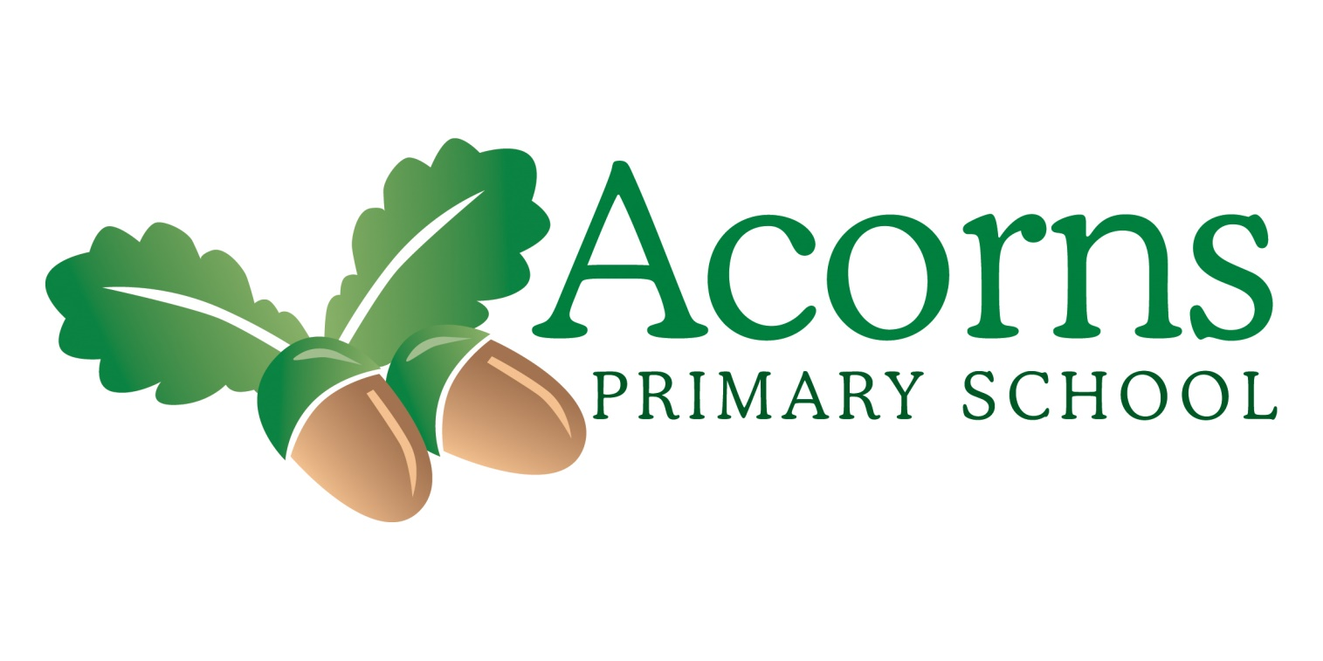

Acorns Primary School, Preston
English as an Additional Language Policy – reviewed September 2024

Introduction
At Acorns Primary School, we value all members of our community. For pupils who are learning English as an Additional Language, this includes recognising their home language and culture. As a school, we are aware that bilingualism is a strength and that EAL pupils have a valuable contribution to make. We take a whole school approach, including ethos, curriculum, education against racism, and promoting language awareness.

This policy aims to raise awareness of the school’s obligations to support pupils who have EAL and the staff that support them, in turn leading to raised impact and achievement.

Aims/Intent
At Acorns our aims for EAL learners are as follows:
- to ensure that all our learners feel safe and know that they are valued;
- to provide appropriate provision of teaching and resources;
- to raise achievement of minority ethnic pupils who are at risk from underachievement;
- to identify an individual’s needs, recognise the skills they bring to the school, and ensure quality of access to the curriculum;
- to involve all parties involved in each child’s education, ensuring that parents and carers feel welcomed and valued by the school.

Context
We are a Generic Learning Difficulties Primary School. Our pupils have needs ranging from autism to physical disabilities - often our pupils have multiple needs.

We currently have 33 pupils who are registered as having English as an additional language – this represents 35% of our school population. There are 14 home/heritage languages: Urdu, Gujarati, Arabic, Igbo, Punjabi, Malayalam, French, Chinese, Hungarian, Dari, Farsi, Shona, Tamil and Welsh

The children come from a variety of backgrounds – some were born in the UK, but are exposed to a language other than English at home; others were born outside of the UK. As many of our pupils have challenges with communication, it will often be the case that they are not literate, or only partly literate, in their home language.

Key Principles
- At Acorns Primary School, the children with EAL are entitled to opportunities for educational success that are equal to those of our English-speaking children;
- All staff in school play a crucial role in modelling the English language;
- Children with EAL have varying needs and a range of teaching and learning activities are provided to meet curriculum demands, needs, and learning styles. This works alongside the pre-formal, semi-formal, semi-formal bridge and formal curriculum offers. There is not a ‘one size fits all’ approach;
- We implement well-planned lessons using approaches, resources and settings that provide the best environment for the acquisition of English by children with EAL;
- Language develops best when used in purposeful contexts across the curriculum;
- Although English should be the medium of teaching, there should be appropriate opportunities for children with EAL to use their home language;
- We believe strongly that the bi/multilingualism of our children and staff enriches our school and our community;
- Parents and the local community are in important and valuable resource in helping our children to achieve and to have high esteem;
- Parents and carers should be reminded that their home languages are to be valued, and that attempts to change to using English at home may actually hamper children’s progress;
- All languages, dialects, accents, and cultures are equally valued, and time to celebrate similarities and differences is encouraged;
- EAL provision is intrinsically interlinked with equality and diversity – the school is currently working towards the Lancashire Equality Mark and has gained one badge towards this. In addition, during the recent pandemic, work and support for pupils and families from ethnic minorities was carried out and offered via our website and other channels.

Roles and Responsibilities
The school has an appointed leader who oversees the provision of EAL. The EAL leader has a number of core responsibilities which include maintaining an EAL register, advising on teaching strategies and sharing examples of good practice, designing an assessment framework, collating assessment information, and reporting on impact and progress. All teachers and teaching assistants in school are language teachers; there is a collective responsibility to identify and remove barriers that stand in the way of the learning and success of EAL learners and to support their language development.

Teaching and Learning
As most of the children at Acorns Primary School have challenges with communication, we offer a wide range of teaching and learning strategies to suit their different needs. These strategies can be grouped broadly under four different skill areas – Listening and Attention, Speaking, Reading, and Understanding and Writing - although there are many approaches that work across the skill areas. As some of our pupils have severe learning difficulties, it may be that learning and progress in a certain skill area is limited or stops at a certain level due to the nature of their conditions. Please refer to the appendix for a more detailed list of the way we implement teaching and learning strategies at Acorns Primary School.

Planning, Moderation, and Evaluation
When planning (whether tong-term, medium-term, or short-term), teaching staff and HLTAs will take into account the additional needs of EAL learners, setting appropriate targets and tasks with targeted resources. Information on home languages*, teaching strategies, and assessment is passed on to staff at the start of the new school year. As our pupils have Special Educational Needs, many of the EAL targets will be the same, overlap, or be related to their communication targets. Monitoring impact and progress takes place with continuous assessment of each child’s progress in communication, with summative assessments using IEPs, the ‘Engagement Model’, ‘B Squared’, ‘Routes for Learning’ and the Acorns own electronic assessment matrix which is housed on the ‘Evidence for Learning’ platform. This matrix uses in-house criteria and criteria from QCA’s ‘A Language in Common’ and Early Education’s ‘Development Matters’. This assessment tool was designed by a working party of staff from Acorns Primary School to work effectively for our children, staff, and setting. It includes four key assessment foci – ‘Listening and Attention’, ‘Speaking’, ‘Reading and Understanding’ and ‘Writing’. Each focus is assessed by a series of criteria which become progressively more challenging, and work up in steps from ‘Entry Step’ through to ‘Step 4’. Teaching staff and TAs will use this assessment tool to record progress made throughout the academic year, with a final summative assessment of progress made in the school’s last assessment window. Moderation and discussion take place with the EAL Coordinator and class staff to validate the assessment process. This information is then used by the EAL Coordinator for recording and analysis, and the electronic assessment sheets are available to pupils’ new class teachers. We also gather evidence using the regular ‘Evidence for Learning’ tool on iPads, so that staff, pupils, and parents can see the work done and the impact it has.

Assessment, Feedback, and Monitoring
Assessing pupils with EAL at Acorns school is an integral part of the whole-school assessment procedures to get a clear picture of the impact of learning, next steps, and any measures that need to be taken. Assessment of pupils’ progress is measured using IEPs, ‘Evidence for Learning’, the ‘Communication Matrix’ the ‘Engagement Model’, ‘B Squared’ and ‘Routes for Learning’; in addition, our EAL learners are assessed with an in-house criteria – this is a combination of the ‘A Language in Common’ and ‘Development Matters’. Staff teams discuss and highlight the pupils’ attainment using criteria on the ‘Evidence for Learning’ platform – this profile follows the pupils through school to demonstrate progress; pupils are constantly assessed in accordance with their IEP targets, and are given next steps or intervention strategies, where applicable; feedback is given at parents’ evenings, in interim and yearly reports, during annual reviews, directly to the EAL leader, and at governors’ meetings; praise and encouragement is given, for example in class star charts and ‘Star of the Week’ in assemblies.

Admitting New Pupils
When new pupils and parents/carers arrive at Acorns Primary School, they are given a full tour of the school and important information to help them to settle in. Where possible, key information is given in the home language to ease the process and to make the new arrivals feel welcome. This is done by issuing translated documents and face-to-face/telephone conversations using our skilled team, where we have staff who have the same home languages as the new pupils and parents. The school requests any data and information that has come from the children’s previous settings, if this is not supplied. Any relevant details are then passed onto the class teachers and EAL leader. It must be noted that in some circumstances data received may be sketchy, incomplete, or irrelevant, depending on the child’s provenance. There may also be cases where there is no information at all, and staff in school have to make professional judgements alongside advice and support from parents/carers and from outside agencies. On occasion, it may be that new pupils are refugees and have suffered trauma. Where this is the case, school would aim to fully support the pupil and family in line with advice and assistance from the Lancashire English as an Additional Language Team (Ethnic Minority, Gypsy, Roma and Traveller Achievement Service).

Parents/Carers and the Wider Community
At Acorns, we endeavour to make effective links with the parents and carers of all our children, including those with EAL. Some examples of this: parents and community members are welcomed to the school on many occasions during the year; we have greetings in parents’ and pupils’ different home languages at the entrance to school; we host regular coffee mornings to invite and include all parents; there is a special parents’ EAL coffee morning to celebrate heritages and to offer support; newsletters, blogs, the school website and social media are used to celebrate achievement and disseminate information; communication with parents and carers is very effective – we use ‘talking tiles’, email, and make regular phone calls. Where possible we make good use of staff who have other home languages to make contact (either by telephone, or face-to-face) with our parents; teachers also build ‘cultural’ times into their lessons, so that others’ cultures may be valued and celebrated – our ‘World Awareness Day’ is one of these such activities. Most recently, as a whole school, we have celebrated a variety of cultures through theme days/weeks such as: ‘Acorns Caribbean Carnival’, ‘African Adventure’, ‘Explore Esat Asia’ and a religious buildings project. We also recognise different religious festivals, such as Eid and Diwali celebrations in school. Some of our pupils have only recently moved to the UK, so may be baffled by the culture that accompanies the language. Developing pupils’ cultural capital in the local community is essential. Trips out to local supermarkets, the park, town, and other places, help pupils familiarise themselves with the new culture and surroundings; clear explanations of what is happening in school, or what is going to happen, are important, for example, visual timetables or ‘now’ and ‘next’ cards; pupils are given time and support to adapt to new eating times and foods; class staff strive to find out as much as possible about the child’s home culture to see where there may be differences and to be mindful of these.

Staff Development
The EAL leader will attend link meetings and any relevant training that is possible throughout the academic year. Relevant courses may be offered to other staff (for example, TAs who have a home language that is matched to that of a child or group of children in school), if there is funding, time, and the necessity to do so. Appropriate information will be disseminated to the rest of the staff in whole-school staff meetings, teachers’ meetings and on INSET days/twilight sessions. The EAL leader will pass on relevant information and previous assessments to new teachers. Although the EAL leader has an overview of EAL provision throughout the school, it is important to remember that the progress and well-being of EAL learners lies with all the staff in the school, both teaching and non-teaching.

Review of Policy
This policy will be reviewed by the EAL leader, at the beginning of each academic year, when the new intake of pupils is finalised.

Reviewed Autumn Term 2025 by DC Worsley (EAL Lead)

Signed By:
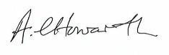………………………………….. Headteacher Date: October 2025
………………………………….. Chair of Governors Date: October 2025
Next Review Date: September 2026
Appendix
INTENT and IMPLEMENTATION
Teaching and Learning Strategies for EAL Leaners at Acorns Primary School

Across the board, Acorns uses a ‘total communication approach’ which helps pupils to communicate and have a voice using a wide range of approaches and techniques, from symbols to ‘Colourful Semantics’ tools, communication technology to more formal approaches, all dependent on needs and abilities.

LISTENING and ATTENTION:
- Use clear, short instructions;
- Ensure there is good eye contact;
- Gestures and Makaton signing to support understanding;
- Pictures, photographs and modelling support comprehension;
- Symbols, including PECS symbols (Picture Exchange Communication System), help with understanding;
- Pupils who are visually impaired are given objects to explore to help with understanding;
- Attention Autism is an approach used to help our pupils engage, learn and communicate;
- Routines and consistency of approach are essential;
- Pupils are given time to process what they have heard;
- Visiting speakers attend regularly to give interesting workshop
and talks; pupil shave the chance to hear others speaking;
- Music is used on many occasions to deliver stories and to teach certain aspects of the curriculum;
- Sensory drama and sensory stories, using tactile props and other stimuli, are used with our sensory learners, to help them understand narratives and to give them auditory, visual and other sensory experiences they may not normally encounter.

SPEAKING:
- Communication books are widely used in school (and other aids) to give pupils a voice and to help them practice and develop language skills;
- Some pupils use Makaton signing to support and give confidence to their speech;
- We give pupils many real opportunities to communicate with others, for example, finding out the day’s menu and telling others, giving news, or explaining why they are ‘Star of the Week’ in assembly;
- PSHE and circle time activities provide a safe forum for our pupils to speak and express themselves;
- School Council gives pupils an opportunity to express opinions and develop debating skills;
- EyeGaze technology is used to support PMLD, pupils with PD and other pupils to access communication programmes and games on the iPad;
- Non-verbal pupils are given a ‘voice’ with the use of ‘sound buttons’ e.g. ‘talking tiles’;
- Singing is a large part of the school day, from maths songs to singing club; this is supported by Makaton signing;
- Pupils use ‘Audacity’ software, record themselves on ‘sound buttons’, or are filmed regularly to give them motivation to speak and present their work;
- Vocalisations and speech are praised, where appropriate;
- Some pupils use PECS symbols to communicate, or point at images to make choices or express their needs;
- ALI boards help all pupils with their productive and receptive communication;
- Other pupils may use physical gestures to indicate a need, for example, leading an adult by the hand to a desired object;
- We work closely with other professionals such as speech therapists and a VI teacher to give additional support where deemed necessary.

READING and UNDERSTANDING:
- Phonics and reading following the ‘AIRS’ programme, which is bespoke to school;
- We host reading events on a regular basis, with guest readers or visits from the library;
- ‘Reading for pleasure’ is a major part of our literacy programme, with pupils given time to browse and choose at will;
- The school’s library trolleys have a wide variety of books, including tactile books for pupils who need a sensory approach to reading;
- Staged reading schemes are used for daily reading;
- Sensory stories, using pictures, props, sounds and smells are told on a regular basis;
- Braille has been used by some children, with support from the teacher of the visually impaired;
- Exploratory techniques to are used to support pupils with reading their immediate environment and objects linked to the curriculum;
- EyeGaze technology is used to support PMLD, pupils with PD and other pupils to access communication programmes and games on the iPad;
- A yellow background on worksheets and the interactive whiteboard often helps pupils to see the letters and words more clearly.

WRITING:
- Pupils with Profound and Multiple Learning Difficulties can sometimes make marks using different implements and surfaces;
- ‘Colourful Semantics’ is used with many pupils to help develop writing skills, particularly building sentences;
- Hand-over-hand assistance is a way to help pupils who have poor fine motor skills to produce simple writing;
- Messy play (writing and drawing in foam, etc.) is a good way to encourage reluctant writers and to learn how to form letter shapes;
- Overwriting can give children confidence;
- Handwriting templates are used – often produced using ‘StartWrite’ software to produce personalised handwriting practice sheets;
- Writing frames are used for the more competent writers;
- Modelling different types of writing is an important step in the writing process;
- Typing on the computer (we have some Braille and ‘Big Keys’ keyboards) is usually motivating;
- Writing for a purpose is encouraged;
- Poetry is a fun way of getting the children involved in writing;
- We look for regular writing competitions – ‘Out of this World’ is a poetry competition in which we recently entered some of our KS2 pupils, and many won prizes!

