
Governors’ Handbook

This handbook is designed to help you to be as effective as possible in your role as a member of the Governing Body at Acorns Primary School. Hopefully you will be able to find answers to any questions you may have either in this document or in the linked sources of information.
If, however, you cannot find the answer please do not hesitate to ask! The world of education and governance can be a mysterious place full of acronyms, people, services and relationships that can be confusing!

Contents

Page Number Welcome 4
Membership of the Governing Body and Committees 6
Sub Committees of the Governing Body 7
Code of Conduct 8
The Seven Principles of Public Life 11
The Framework for Ethical Leadership in Education 12
School Information 14
Other Sources of Information for the Members of the Governing Body 17
Visiting Classes and Responsibility Links 19
Appendix A 21
Appendix B 23 Appendix C 24

Welcome

Becoming the Governor of any school is a responsible and privileged position; being a governor at Acorns Primary School will also bring you a lot of pleasure as it is a fabulous school to be involved with and to represent!
The Governing Body of every maintained school has 3 core functions: -

Establishing the strategic direction, by:
- Setting and ensuring clarity of vision, values, and objectives for the school(s)/trust
- Agreeing the school improvement strategy with priorities and targets
- Meeting statutory duties

Ensuring accountability, by:
- Appointing the lead executive/headteacher (where delegated)
- Monitoring the educational performance of the school/s and progress towards agreed targets
- Performance managing the lead executive/headteacher (where delegated) - Engaging with stakeholders
- Contributing to school self-evaluation

Overseeing financial performance, by:
- Setting the budget
- Monitoring spending against the budget
- Ensuring money is well spent and value for money is obtained
- Ensuring risks to the organisation are managed
A fourth key function of governance is to:
Ensure that other key players with a stake in the organisation get their voices heard by: - Gathering the views of pupils, parents and staff and reporting on the results.
- Reaching out to the school’s wider community and inviting them to play their part.
- Using the views of stakeholders to shape the school’s culture and the underpinning strategy, policies and procedures.

The Governing Body Currently consists of 12 full members plus the Headteacher. There are representatives from the school, the Local Authority, the parents and carers of pupils in the school, and co-opted members from the community. As a body we meet a minimum of once a term as a full governing body in addition various sub committees meet and their decisions and recommendations feed into these termly meetings. As well as this individual governors have their own areas of responsibility or links with classes in school. The aim is for governors to organise at least one “link” meeting per term.

Whilst there is no rule book for how much time should or could be spent on the role of governor it is a good idea to try to set aside some time each week to ensure that you keep up to date with things like emails and information from the LEA. In addition, you should think perhaps in terms of three days per term for visits / meetings in school.

There is a wealth of training available for governors both through the LEA and various local and national bodies. Again, to be as effective as you can be you should be prepared to take advantage of this.

Membership of the Governing Body and Committees

A brief biography of each governor is placed on the school website

Mandy Howarth – LEA Governor – Chair
Laura Hall – Headteacher
Barry Probin – Co-opted Governor
Shaun Jukes – Co-opted Governor
Sylvia Crowder – Co-opted Governor
Bev Hennefer – Co-opted Governor
Michelle Orrell – Co-opted Governor
James Maguire – Parent / Carer Governor
Tasneem Zubair – Parent / Carer Governor
Sophie Martindale – Staff Governor

Sub Committees of the Governing Body

Resources Committee
Laura Hall

Mandy Howarth
Shaun Jukes

James Maguire

Michelle Orrell

Dan Williams (Observer)

Curriculum & Standards Committee

Sylvia Crowder
Laura Hall
Bev Hennefer
Mandy Howarth
Barry Probin
Tasneem Zubair
Emma Barker (Observer)

Pay Committee
Barry Probin
James Maguire
Bev Hennefer

Performance Management and Appraisal Committee

Mandy Howarth
Shaun Jukes
Michelle Orrell
Appeals Committee
Three untainted governors

Grievance /Complaints Appeals Committee

Three untainted governors

Staff Discipline / Attendance and Dismissal Committee

Three untainted governors

Class / Area Links

All governors have links with school in addition to their involvement through meetings. These are reviewed each year. Currently Sophie Martindale has responsibility for liaising between governors and Acorns staff members.
See appendix A

Code of Conduct

This code is based upon a model drawn up by the National Governance Association and is based on guidance issue by the Department for Education.
Each academic year governors are asked to recommit themselves to this code.

As individuals on the Governing Body:

Role & Responsibilities
- We understand the purpose of the GB and its strategic role.
- We understand how the role of the GB differs from and works with others including the headteacher and where appropriate other leaders.
- We accept that we have no legal authority to act individually, except when the GB has given us delegated authority to do so, and therefore we will only speak on behalf of the governing body when we have been specifically authorised to do so.
- We accept collective responsibility for all decisions made by the GB. This means that we will not speak against majority decisions outside the governing body meeting.

- We have a duty to act fairly and without prejudice, and in so far as we have responsibility for staff, we will fulfil all that is expected of a good employer.
- We will encourage open governance and will act appropriately.
- We will consider carefully how our decisions may affect the community and other schools.
- We will always be mindful of our responsibility to maintain and develop the ethos and reputation of Acorns Primary School. Our actions within the school and the local community will reflect this.
- In making or responding to criticism or complaints we will follow the procedures established by the governing body.
- We will actively support and challenge the Headteacher and other leaders.
- We will accept and respect the difference in roles between the GB and staff, ensuring that we work collectively for the benefit of the organisation.
- We will respect the role of the Headteacher and their responsibility for the day to day management of the organisation and avoid any actions that might undermine such arrangements.
- We agree to adhere to the school’s rules and polices and the procedures of the governing body as set out by the relevant governing documents and law.

- When formally speaking or writing in our governing role we will ensure our comments reflect current organisational policy even if they might be different to our personal views

- When communicating in our private capacity (including on social media) we will be mindful of and strive to uphold the reputation of the organisation.
- We will avoid, as far as possible, becoming involved in any communication which may lead to a conflict of interest with the role of the governing body.

Commitment
- We acknowledge that accepting office as a governor involves the commitment of significant amounts of time and energy.
- We will each involve ourselves actively in the work of the governing body, and accept our fair share of responsibilities, including service on committees or working groups.
- We will make full efforts to attend all meetings and where we cannot attend explain in advance why we are unable to.
- We will get to know the school well and respond to opportunities to involve ourselves in school activities.
- We will visit the school, with all visits arranged in advance with the headteacher and/or appropriate staff member and undertaken within the framework established by the governing body.
- When visiting the school in a personal capacity (i.e. as a parent or carer), we will maintain our underlying responsibility as a governor.
- We will consider seriously our individual and collective needs for induction, training and development, and will undertake relevant training.
- We accept that in the interests of open governance, our full names, date of appointment, terms of office, roles on the governing board, attendance records, relevant business and pecuniary interests,

category of governor and the body responsible for appointing us will be published on the school’s website.
- In the interests of transparency, we accept that information relating to governors will be collected and logged on the DfE’s national database of governors (Get information about schools).

Relationships
- We will strive to work as a team in which constructive working relationships are actively promoted.
- We will express views openly, courteously and respectfully in all our communications with other governors, the clerk to the governing board and school staff both in and outside of meetings.
- We will support the chair in their role of ensuring appropriate conduct both at meetings and at all times.
- We will confront malpractice by speaking up against and bringing to the attention of the relevant authorities’ any decisions and actions that conflict with the Seven Principles of Public Life or which may place pupils at risk.
- We are prepared to answer queries from other GB members in relation to delegated functions and take into account any concerns expressed, and we will acknowledge the time, effort and skills that have been committed to the delegated function by those involved.
- We will seek to develop effective working relationships with the headteacher, staff and parents, the trust, the local authority and other relevant agencies and the community.

Confidentiality
- We will observe complete confidentiality when matters are deemed confidential or where they concern specific members of staff or pupils, both inside or outside school.
- We will exercise the greatest prudence at all times when discussions regarding school matters arise outside a governing body meeting.
- We will not reveal the details of any governing body vote. • We will ensure all confidential papers are held and disposed of appropriately.

Conflicts of interest
- We will record any pecuniary or other business interest (including those related to people we are connected with) that we have in connection with the governing body’s business in the Register of Business Interests, and if any such conflicted matter arises in a meeting we will offer to leave the meeting for the appropriate length of time.
- We accept that the Register of Business Interests will be published on the school website.
- We will also declare any conflict of loyalty at the start of any meeting should the situation arise.
- We will act in the best interests of the school as a whole and not as a representative of any group, even if elected to the governing body.

Ceasing to be a governing body member
• We understand that the requirements relating to confidentiality will continue to apply after a governor leaves office

Breach of this code of conduct
- If we believe this code has been breached, we will raise this issue with the chair and the chair will investigate; the governing body will only use suspension/removal as a last resort after seeking to resolve any difficulties or disputes in more constructive ways.
- Should it be the chair that we believe has breached this code, another governing body member, such as the vice chair will investigate.

The Seven Principles of Public Life

All governors are asked to ensure that they follow these principles.

Originally published by the Nolan Committee: The Committee on Standards in Public Life was established by the then Prime Minister in October 1994, under the Chairmanship of Lord Nolan, to consider standards of conduct in various areas of public life, and to make recommendations
Selflessness - Holders of public office should act solely in terms of the public interest.

Integrity - Holders of public office must avoid placing themselves under any obligation to people or organisations that might try inappropriately to influence them in their work. They should not act or take decisions in order to gain financial or other material benefits for themselves, their family, or their friends. They must declare and resolve any interests and relationships.
Objectivity - Holders of public office must act and take decisions impartially, fairly and on merit, using the best evidence and without discrimination or bias.
Accountability - Holders of public office are accountable to the public for their decisions and actions and must submit themselves to the scrutiny necessary to ensure this.
Openness - Holders of public office should act and take decisions in an open and transparent manner.
Information should not be withheld from the public unless there are clear and lawful reasons for so doing.
Honesty – Holders of public office should be truthful
Leadership – Holders of public office should exhibit these principles in their own behaviour. They should actively promote and robustly support the principles and be willing to challenge poor behaviour wherever it occurs.

In addition to these principles Governors as leaders in education should show that leadership as follows:

Schools and colleges serve children and young people and help them grow into fulfilled and valued citizens. As role models for the young, how we behave as leaders is as important as what we do. Leaders should show leadership through the following personal characteristics or virtues:
- Trust: leaders are trustworthy and reliable
We hold trust on behalf of children and should be beyond reproach. We are honest about our motivations.
- Wisdom: leaders use experience, knowledge and insight
We demonstrate moderation and self-awareness. We act calmly and rationally. We serve our schools and colleges with propriety and good sense.
- Kindness: leaders demonstrate respect, generosity of spirit, understanding and good temper
We give difficult messages humanely where conflict is unavoidable. d.
Justice: leaders are fair and work for the good of all children
We seek to enable all young people to lead useful, happy and fulfilling lives.
- Service: leaders are conscientious and dutiful
We demonstrate humility and self-control, supporting the structures, conventions and rules which safeguard quality. Our actions protect high-quality education.
- Courage: leaders work courageously in the best interests of children and young people We protect their safety and their right to a broad, effective and creative education. We hold one another to account courageously.
- Optimism: leaders are positive and encouraging
Despite difficulties and pressures, we are developing excellent education to change the world for the better.

School Information

School Website

https://www.acorns.lancs.sch.uk/

This is a valuable source of information for all; parents, staff and governors. It should be noted that the contents will be amended as required, so it is important to keep checking the website for new information.
This is also the place to read our regular Newsletters, class blogs and daily diaries of events.

Our School Prospectus is also located on our website, along with photographs of our children enjoying class and school trips.
Governors have a dedicated section on the web page and after each governing body meeting key matters and decisions made are shared with stakeholders

Facebook Page

https://www.facebook.com/Acorns-Primary-School-108633970547067/

Whilst not every governor may wish to join this social platform, for those that do it is a useful source of information about the school.

Staff members and class links

The full list of staff members can be found on our website.

Useful phone numbers / contacts

All governors will be given an Acorns email address. ALL communication via email should be conducted using this address. This is a requirement of GDPR.
All governors have access to Microsoft Teams through their Outlook link. It is possible to “chat” via this secure platform.

September 2025

Mandy Howarth mhowarth@acorns.lancs.sch.co.uk
Headteacher head@acorns.lancs.sch.uk 01772
Acorns School Office 792681
IT help (Martin) ittech@acorns.lancs.sch.uk
Lancashire Governor Services 01257 516150

Holidays and Closures

The full list can be found on our website

Map of School

A map of the school can be found on the next page

- | P a g e September 2025

- | P a g e

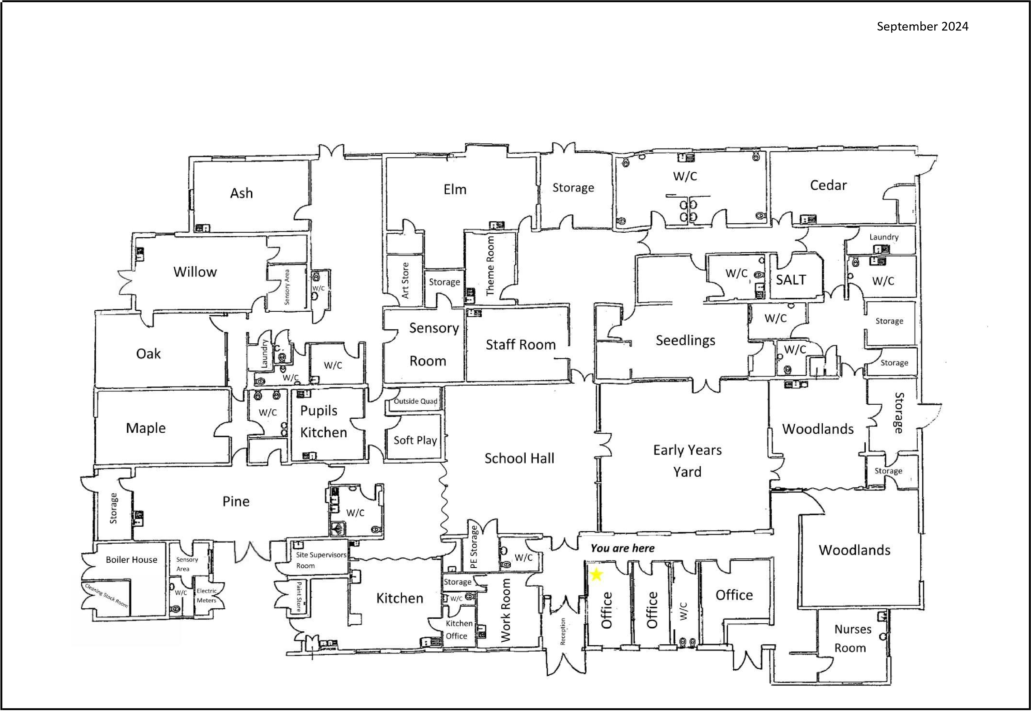

Other Sources of Information for members of the Governing Body

When you first become a member of the Governing Body you will receive a welcome pack from the LEA.
This should include information to help you in your role.
Other support will be gained from the following:

Governorhub

All governors will be given access to Governorhub. This platform contains a wealth of information both about local and national issues. Governors can also use the facility to send and receive messages either to/from each other or the whole Governing Body. All documentation for Governing Body meetings are posted on Governorhub. In addition it is possible to access and book all training and courses on this platform.

Training

Governors should expect to keep themselves up to date by undertaking training. As a school we “buy in” to the LEA training programme. These offer a mixture of both “face-to-face” and online courses. All can be accessed via Governorhub.
As a school and as a purchaser of LEA training we have access to the NGA Learning Link online courses. These can be completed at your convenience and range from very brief “updates” to full certificated courses. Again these can be accessed via Governorhub.

Governors are asked to compete a very simple feedback form when they have completed any training. (Appendix D)

LGA

Acorns is a member of LASGB (The Lancashire Association of Governing Bodies). This local organisation provides training courses and conferences for any governors from member schools. This includes sessions of particular interest to the special school sector. There is a website and Facebook page for LASGB.
The access link for LASGB is…

https://www.lancashirega.org.uk/

NGA

As a school we subscribe to the NGA (National Governance Association)

This organisation represents governors at a national level and is a powerful lobbying group. As well as this they provide a wealth of materials and support for governing bodies.
Each week you will receive a newsletter from NGA via your Acorns email with up to date information on current educational matters and thinking. The organisation holds conferences each year for the different sectors in education and as members we are entitled to send representatives.
The access link for NGA is: https://www.nga.org.uk/

The Department for Education (DFE)

The Department regularly publishes and updates materials for Governors.
Relevant DFE updates are posted on Governorhub.
The link to the governor’s handbook published by the DFE is;

https://assets.publishing.service.gov.uk/government/uploads/system/uploads/attachment_data/file/788
234/governance_handbook_2019.pdf https://assets.publishing.service.gov.uk/government/uploads/system/uploads/attachment_data/file/583 733/Competency_framework_for_governance_.pdf

Governors should familiarise themselves with this publication – it is lengthy but not all is relevant to LEA maintained school

OFSTED (Office for Standards in Education)

A link to the latest OFSTED report for Acorns is …
https://reports.ofsted.gov.uk/provider/25/135347

The OFSTED website https://www.gov.uk/government/organisations/ofsted includes guidance regarding the expectations on a Governing Body in respect of a school inspection. As well as this there are useful short videos on YouTube which illustrate examples of governor questions and expectations.
https://www.youtube.com/user/Ofstednews

Visiting Classes and Responsibility Links

The best way to increase our knowledge and understanding of Acorns is to visit and see staff and pupils at work!

Governors should ensure that they follow the protocol for visits to school and complete a visit proforma after each visit. Copies are available from the school office. See Appendix B
The following guidelines were drawn up by governors following training undertaken.

When we visit a class we are not going in to judge or inspect; we are going in to learn! It is very useful though to give thought to what makes a classroom experience effective and enjoyable for a pupil and what we might expect to see in and from the adults in the room which will contribute to this effectiveness.
It is worth giving thought to those things which we experienced at school …

WHICH TEACHERS DO WE REMEMBER - WHY?
WHICH LESSONS DID WE ENJOY – WHY?
WHICH LESSONS DID WE NOT ENJOY – WHY?

The answers we give to those questions will be more or less the same answers as any other individual!
Good teachers will use many personal skills - including their good subject knowledge - in their lessons:
They will be organised and will need to plan well
They will need to have an overview of the whole class
They will be positive an encouraging
They will be caring and give guidance
They will nurture a love of learning
They will make learning active and fun
They will guide and hold the learners’ hands – but know when to let go!

These may be recognised as the sort of qualities you appreciated in the teachers whose lessons you enjoyed!
When considering a lesson visit, we need to think about the TEACHING and the LEARNING.
Key areas we may think about in TEACHING:

Does the teacher have a plan or overview which is shared with the pupils and other staff?
Do the staff model / teach learning to the pupils?
Do the staff use key vocabulary?

Are individual needs catered for? How?

Do staff provide care, guidance and support to pupils?
Does the teacher use support staff well?
Does the teacher know what the pupils have learnt and what the barriers to learning are?

Key areas we may think about in LEARNING:

Are the pupils engaged throughout the lesson?
Are pupils taking an active role in their learning?
Are pupils confident to “have a go”?
Is behaviour good in class?

Are pupils encouraged to reengage / extend their learning?

Are there strategies to manage behaviour/ sensory/medical needs?
Are pupils happy and having fun?
Is the environment suitable for learning?

WHAT WOULD WE EXPECT TO SEE IN CLASS TO DEMONSTRATE THESE THINGS?

Use lesson visit prompt sheet to assist you. See Appendix C.

Appendix A

Governing Body Roles / Areas of Interest

Link with an area to involve – at best – two meetings over the course of the school year of no more than one hour.

Ideally governors to arrange an occasion to interact with their class link once a term – may be a class visit or joining the class for a particular event.

Class Link | Staff Link | Governor Link
Seedlings /EYFS | Corrine Spear  cspear@acorns.lancs.sch.uk | Bev Hennefer
Woodlands | Hannah Serventi  hparkinson@acorns.lancs.sch.uk | Michelle Orrell
Pine
Ash | Dan Murphy  dmurphy@acorns.lancs.sch.uk | James Maguire
Willow | Claire Bradford  cbradford@acorns.lancs.sch.uk | Barry Probin
Oak | April Baxendell  abaxendell@acorns.lancs.sch.uk | Shaun Jukes
Elm | Sophie Martindale  smartindale@acorns.lancs.sch.uk | Sylvia Crowder
Maple | Katie Mcilwraith  kmcilwraith@acorns.lancs.sch.uk | Mandy Howarth
Cedar
Safeguarding | Laura Hall  head@acorns.lancs.sch.uk | Mandy Howarth
Finance | Dan Williams  sbm@acorns.lancs.sch.uk | James Maguire
EVC | Christian Worsley  cworsley@acorns.lancs.sch.uk | Bev Hennefer
Training Link |  | Sophie Martindale
Equality and Diversity | Christian Worsley  cworsley@acorns.lancs.sch.uk | Sylvia Crowder / Tasneem Zubair
LGA | n/a | Mandy Howarth
Health and Safety | Dan Williams  sbm@acorns.lancs.sch.uk | James Maguire
Cyber Security | Martin White  ittech@acorns.lancs.sch.uk | Shaun Jukes
Attendance | Laura Hall  head@acorns.lancs.sch.uk | Sylvia Crowder
School Improvement Areas
Leadership and Management | Laura Hall  head@acorns.lancs.sch.uk | Shaun Jukes
Quality of Education | Laura Hall  head@acorns.lancs.sch.uk | Shaun Jukes

Behaviour and Attitudes | Emma Barker etaylor@acorns.sch.co.uk | Mandy Howarth
Personal Development | Laura Hall head@acorns.lancs.sch.uk | Mandy Howarth
Mental Health and Well-Being | Laura Hall head@acorns.lancs.sch.uk | Bev Hennefer
EYFS | Laura Hall head@acorns.lancs.sch.uk | Bev Hennefer
Premises | Dan Williams  SBM@acorns.sch.co.uk | James /Shaun / Mandy

September 2025

Appendix B


Protocol for Visits by Members of the Governing Body

Visits into school by members of the Governing Body should be accepted as part of individual governor’s responsibility to aid them with their statutory responsibilities and accountability.

Governing Body visits will:
- Improve Governing Body knowledge of the school, its pupils and the people who work
in it
- Assist the Governing Body in making informed decisions and in future planning
- Assist the Governing Body in fulfilling its statutory responsibilities e. in relation to Health and Safety, safeguarding and monitoring and evaluation. • Be planned and part of an overall strategy

Governors will:
- Arrange and plan visits in conjunction with the head teacher, class teacher and governor responsible for liaison
- Arrive on time and stay for the agreed time
- Ensure confidentiality in relation to pupils and staff
- Be sensitive to the classroom ‘mood’ and accept if a visit is not feasible
- Feedback to the class teacher / teacher with specific responsibility as appropriate
- Feedback to the Governing Body
- Thank pupils and staff after the visit

Governors will not:
- Make visits to their child’s own class
- Make judgements in relation to pupil work, behaviour or classroom practice
- Make judgements in relation to teaching
- Arrive unannounced in a classroom or expect to see a member of staff without notice • Interrupt teaching and learning





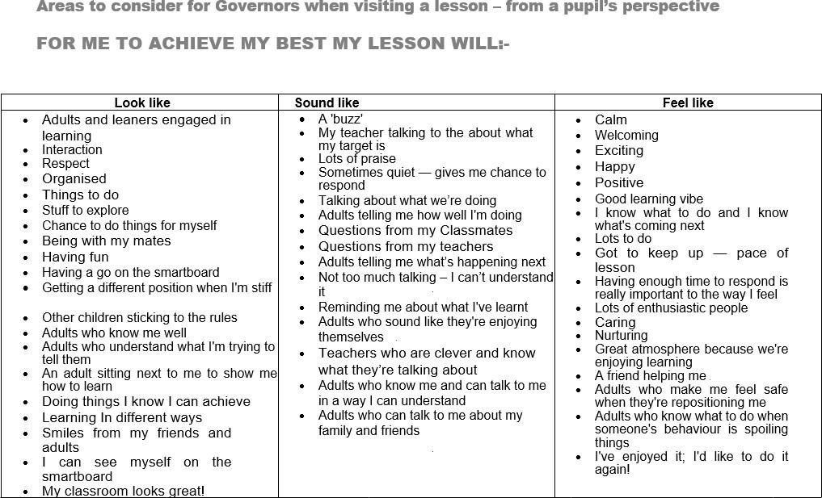

2

4

|

P

a

g

e

S

eptember

2025

Appendix

C

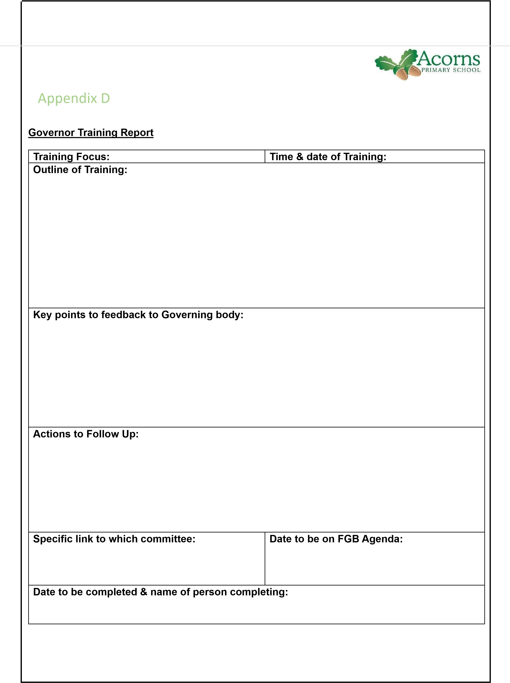
SD

