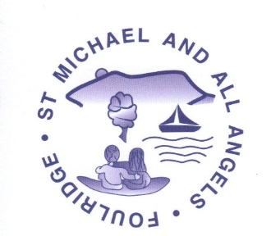
St Michael & All Angels C of E Primary School
Progression of skills
Curriculum Area: PE
EYFS | Physical Development | Moving & Handling | Health & Self-Care | Expressive Arts & Design | Exploring & Using Media & Materials | Being Imaginative
30-50 Months |  | - To move freely with pleasure & confidence in a variety of ways e.g. shuffling, slithering, rolling, crawling, walking, running, jumping, skipping, sliding & hopping.  - To mount stairs, steps or climbing equipment using alternate feet.  - To walk downstairs, two feet to each step, while carrying a small object.  - To run skilfully & negotiate space successfully, adjusting speed & direction to avoid obstacles.  - To stand momentarily on one foot when shown.  - To catch a large ball.  - To draw lines & circles using gross motor movements. | - To observe the effects of activity on their bodies.  - To understand equipment & tools must be used safely. |  | - To enjoy joining in with dancing & ring games.  - To begin to move rhythmically.  - To imitate movement in response to music.  - To tap out simple repeated rhythms. | - To develop preferences for forms of expression.  - To use movement to express feelings.  - To create movement in response to music.  - To capture experiences & responses with a range of media e.g. music, dance, paint, other materials or words.
40-60 Months |  | - To experiment with different ways of moving.  - To jump off an object & land appropriately.  - To negotiate space successfully when playing racing & chasing games with other children, adjusting speed & direction to avoid obstacles.  - To travel with confidence & skill around, under, over & through balancing & climbing equipment.  - To show increasing control over an object in pushing, patting, throwing, catching or kicking it. | - To show understanding for safety when attempting new challenges & to consider & manage some risk.  - To show understanding of how to transport & store equipment safely.  - To practice some appropriate safety measures without direct supervision. |  |  | To initiate new combinations of movement & gesture in order to express & respond to feelings, ideas & experiences.
ELG |  | - To show good control & co-ordination in large & small movements. Move confidently in a variety of ways, safely negotiating space. Handle equipment & tools effectively e.g. pencils for writing. | - To know the importance for good health of physical exercise, a healthy diet & talk about ways to stay healthy & safe. |  |  | - To represent their own ideas, thoughts & feelings through design & technology, art, music, dance, role play & stories.

