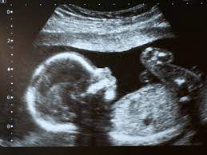
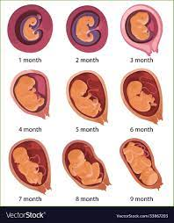
Scientific Vocabulary:
Reproduction: process by which new living things are made. There are two types; asexual and sexual.
Asexual reproduction: needs only one parent, which creates offspring that are exact copies of the parent
Sexual reproduction: requires two parents to make one offspring
Gestation period: the time between fertilisation and birth
Embryo: fertilisation creates an embryo – a new life in early development
Foetus: an unborn animal in the later stages of development
Puberty: the period of time where sexual organs mature and additional physical and emotional changes occur
Sex Cell: egg (female), sperm (male)
Womb: an organ in which the foetus grows and develops

Fertilisation - when the egg and the sperm meet to begin the development of a foetus

