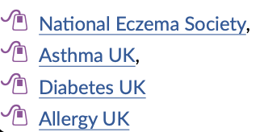
Health and Wellbeing Knowledge Organiser
Health-related Support

Allergy – When the body reacts to certain things such as pollen, animals, foods or insect bites.
Bacteria – A small organism, some of which can cause infections and/or cause people to feel ill (though not all!)
Consequence – Something that happens as a result of a particular action or condition.
Decision – The act or result of making up one’s mind.
Dose – The amount of medicine to be taken at one time. This can follow a health professional’s instructions or the instructions that come with over-the-counter medicines.
Exposure – Having no protection from something harmful.
Immune – Protected from an illness, either because a person has had the illness before or because they have received a vaccine.
Infection – An illness caused by germs.
Informed – Having or showing knowledge of a subject or situation.
Legal drug – Substances such as caffeine or over-the-counter medication, these may have age-restrictions.
Lifestyle – The way in which a person lives.
Medicine – A drug or remedy that may be prescribed by a health professional or purchased over-the-counter.
Mental – Relating to the mind.
Physical – Relating to the body.
Sleep deprived – Not getting enough or not getting any sleep.
SPF – Sun Protection Factor.
UV – Ultraviolet Light – a type of radiation that the Sun gives out that damages our skin.
Vaccine – A medical preparation that protects a person from an illness by making them immune.
Virus – A small particle that can cause infection and/or cause people to feel ill.

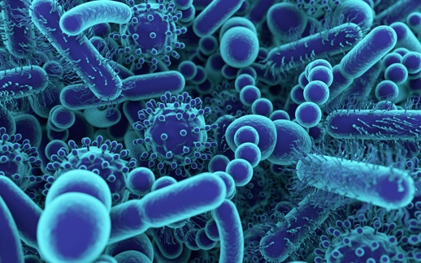
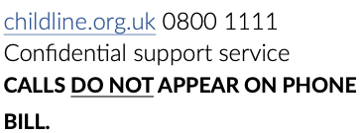
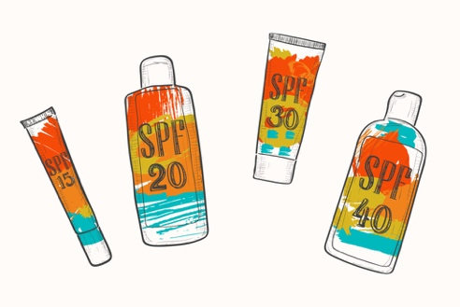
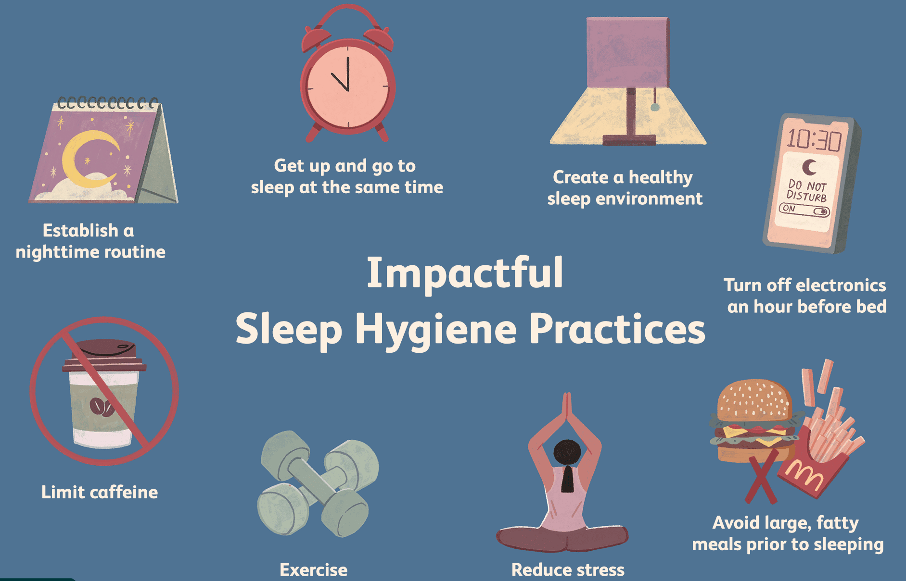
Childline

