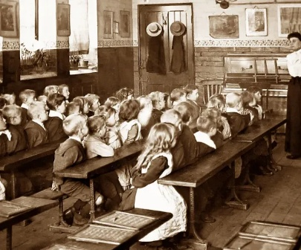
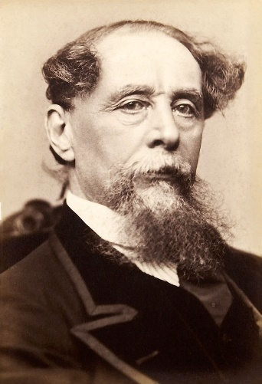
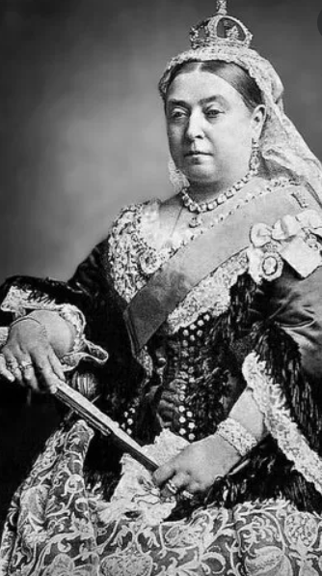
Dunce hat- a pointed hat used as a form of discipline and embarrassment in schools.
Monarch- a sovereign head of state, especially a king, queen, or emperor (Queen Victoria).
The British Empire- the group of countries under the control of the monarch which included Australia, New Zealand, Canada, South Africa, India, Jamaica, Barbados and many more.
Industrial Revolution- a period of major changes in the way products were made which brought a shift in culture.
Workhouses- where poor people who had no job or home lived and earned their keep by doing jobs.
Migrate- moving to a different area in search of work of better living conditions.
The three Rs- reading, writing and arithmetic.
Mutiny – an act of rebellion against authorities by soldiers
Treaty – an agreement between two places (countries, states)
Colony (colonial)– area under the military control of another country.

