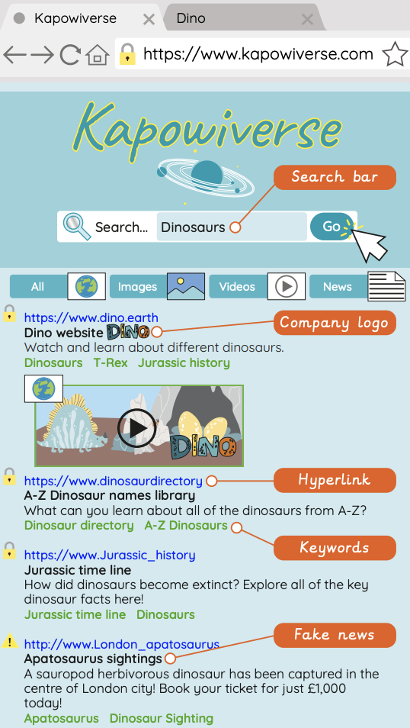
Search Engines Knowledge Organiser
Algorithm – A sequence of instructions which, when followed, solve a problem.
Company logo – A symbol or motif, used to represent an organisation, so that it can be identified quickly and easily in a busy environment online or in the real world.
Data leak – When information is released without approval from the owner of creator.
Data privacy – The right to keep information private and away from those you do not wish to have access.
Fake news – False and inaccurate information that is shared in a convincing way, usually on social media in websites.
Inaccurate information – When information is false and untrue.
Index – A compute saves key information about previously searched results, to make this quicker next time they are accessed.
Keywords (internet) – A set of words used to define and produce an accurate search engine result.
Network – When more than one electronic device is connected in a network through the internet or a local connection in order to share files and information.
Online – When a person is accessing the internet through an electronic device.
Page rank – A large natural object that orbits around a star.
Search engine – A way for a user to search the internet’s database of information.
T A S K – Title, Author, Summary, Kids
Web crawler – A program that uses keywords to search the WWW in a logical and systematic way to find the most suitable results for the user.
Website – A series of web pages and other content, which can be discovered and read through an internet browser, that all belong to a single domain name. For example, Google. The main place where particular web pages can be viewed or accessed.
WWW – The acronym used to express the ‘World Wide Web’. It is found at the beginning of website addresses.

