Geography Knowledge Organiser Rivers
Bank: the land beside or sloping down to a river.
Course: the path a river takes. There are usually three courses (upper, middle and lower) of a river.
Confluence: the point where two rivers, usually of a similar size, meet and merge.
Current: water moving in a particular direction, often picking up debris or other objects with it.
Estuary: the wide part of a river before it joins the sea; fresh water from the flowing river mixes with salt water from the sea due to a current.
Flood: water which has overflowed onto land which usually sits above the water level.
Lake: a large area of water surrounded by land.
Meander: following a winding path or course that is specifically not straight or direct.
Mouth: the mouth of a river is where it opens out into the sea.
Oxbow lake: a lake formed when a bend in a river has been cut off and the river now flows straight, leaving behind a curved lake.
River: a large natural stream of fresh water ﬂ owing along a deﬁnite course, usually into the sea.
Source: the beginning or starting point of a river or stream.
Tidal river: a river whose flow depends on tides, e.g. when a high tide pushes back on and reverses the flow of the downstream part of a river.
Tributary: a smaller river or stream flowing in to join or feed a larger river.

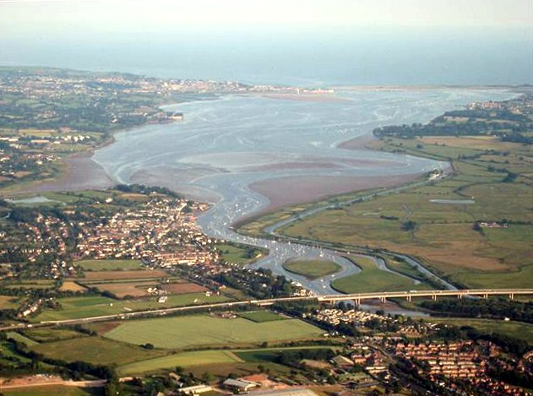

Estuary

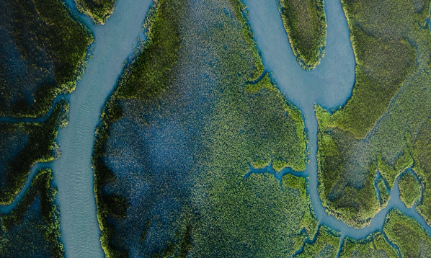

Tributary

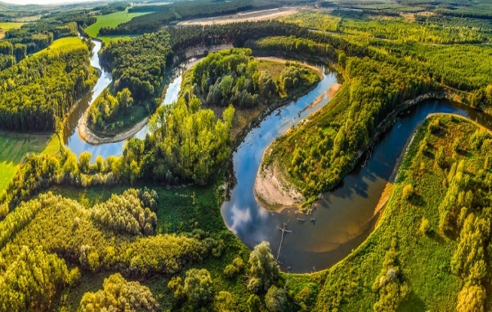

Meander

