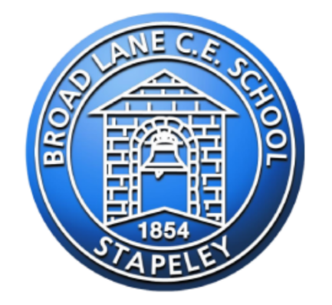
Citizenship Award

Name: ________________________
Year group: 5
We want to help you to become fabulous citizens of our school and wider community!
You can earn your citizenship award at the end of the year by doing the activities suggested each term, or equivalent challenges (if your teacher agrees).You may complete activities from different terms even if it is not that term.
Many of the challenges connect to other learning values as well.
Your teacher needs to sign your sheet to say you have been successful, and if the challenge has been done at home, you need a signed note, picture or video from your grown-up as evidence.
Good luck!

Skill | Year 5  Autumn Term | Signed | Year 5  Spring Term | Signed | Year 5  Summer Term | Signed
School Community Help others regularly in school | Teach younger children a game to play during lunch |  | Offer to do a job for a teacher – other than Mr Blenkiron |  | Tidy away any litter you see in school or on the playground.
Wider Community Give your time outside school to  help others | Take a regular donation box to your local charity shop, or  raise money for a local  cause |  | Go on a walk in your local community and appreciate the environment |  | Take part in a club, activity or group which supports your local community
Independence  Develop your self-discipline | Be responsible for regular jobs at home |  | Learn how to make your own bed – including changing the sheets! |  | Have a go at (with supervision) making your own lunch – can you do this independently?
Communication  Learn to speak and write clearly | Write a letter or email to a friend or family member. |  | Write a letter to a business, shop or company! Tell them what they are doing well |  | Write a letter to Mrs Holden. The letter can say whatever you wish, as long as it is polite and formal.
Problem-solving  Spot and deal with issues pro-actively and fairly | When you notice a problem and tell Mr Blenkiron, suggest a solution yourself |  | Solve a problem for a member of your family |  | Recognise a problem you have noticed in school and suggest to a member of staff a solution (not Mr Blenkiron)
Co-operation  Listen to others and respect opinions | I can listen well during lessons and always work my hardest on my independent work. |  | Contribute regularly to class discussions, sharing your views |  | In class discussions, contest other people’s ideas and points courteously
Get involved  Taking part in school (and out of school) events | Take part in a whole school (or outside of school) club |  | Take part in a school sports competition |  | Compete in sports day to the best of my ability!
Eco Warrior  Make small changes to benefit the environment | Help your family to make some plastic free swaps |  | Go litter picking with a family member or friend |  | Suggest a way the school could be more eco-friendly to the eco-council

