Autumn Term
Inspiring Texts used in English | 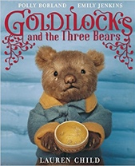  Goldilocks using three different versions by Lauren Child, Anthony Browne & Leigh Hodgkinson | 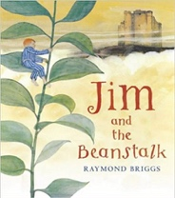  Jim and the Beanstalk  Raymond Briggs | 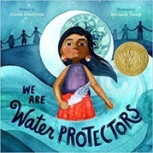  We Are Water Protectors  Carole Lindstrom |  | 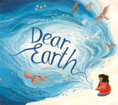  Dear Earth  Isabel Otter & Clara Anganuzzi
Whole Class Reading | 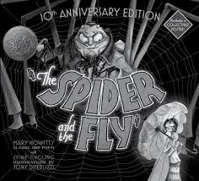  The Spider and the Fly  Mary Howitt and Tony DiTerlizzi | Cinderella An Art Deco Fairy Tale  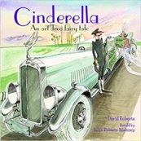  Lynn Roberts and David Roberts | 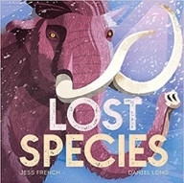  Lost Species  Jess French |  | 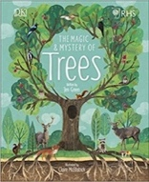  The Magic and Mystery of Trees  Jen Green
Class Author Focus | Ronda Armitage
Spring Term
Inspiring Texts used in English | 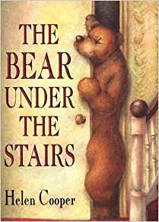  The Bear Under the Stairs  Helen Cooper | 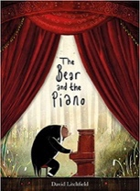  The Bear and the Piano  David Litchfield | 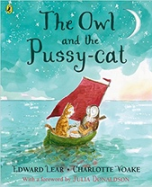  The Owl and the Pussy-cat  Edward Lear |  | 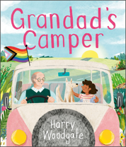  Grandad’s Camper  Harry Woodgate
Whole Class Reading | 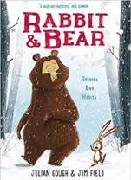  Rabbit and Bear by Julian Gough & Jim Field | 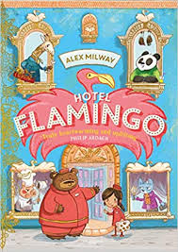  Hotel Flamingo  Alex Milway | 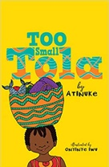  Too Small Tola  Atinuke |  | 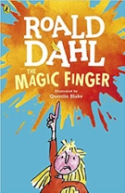  The Magic Finger  Roald Dahl
Class Author Focus | Roger Hargreaves
Summer Term

Inspiring Texts used in English | 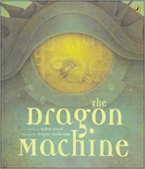  The Dragon Machine  Helen Ward | 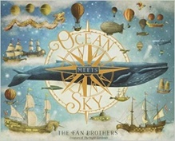  Ocean Meets Sky  Eric Fan and Terry Fan | 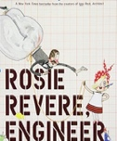  Rosie Revere, Engineer Andrea Beaty | 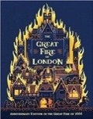  The Great Fire of London Emma Adams | 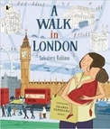  A Walk in London  Salvatore Rubbino
Whole Class Reading | 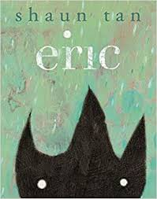  Eric  Shaun Tan | 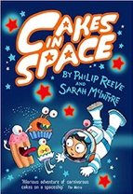  Cakes in Space  Philip Reeve | 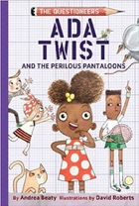  Ada Twist and the Perilous Pantaloons  Andrea Beaty |  | 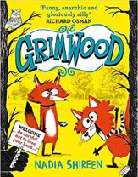  Grimwood  Nadia Shireen
Class Author Focus | Ben Miller

