Year 4 Home Learning Tasks – Spring 1 Due Date: Monday 9th February 2026
Weekly Activities: Reading daily, phonics homework and year group spellings, number bonds or times table practise. Blue boxes are compulsory, white boxes optional. Record your homework grid pieces in this book. Feel free to be creative! Use colours, IT or photographs to present your work.

Cosford Visit  What can you find out about the RAF Museum in Cosford?  Present your findings as you wish (e.g. a poster, information text, fact file etc.) | Make heart-shaped biscuits for Valentine’s Day. | Art  In class we will be looking at the work of French artist Paul Cezanne.  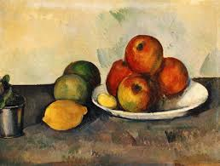  Collect a group of objects together to draw using pencils, pastels or paints.
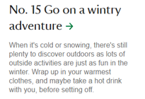 | Science  We have begun to look at the famous scientist Alexander Graham Bell. Find out some more facts about him and his work. Perhaps you could draw and label his inventions. Perhaps you could design and draw your own clever invention. | Explore your street using Google Maps Street View. What year were the photos taken in? Can you notice many changes between then and how your street is now? Or between two dates when photos were taken - You can view this by clicking the clock in the top left corner on street view.
  50 things to do before you’re 11 ¾ National Trust
Geography – Make a treasure map  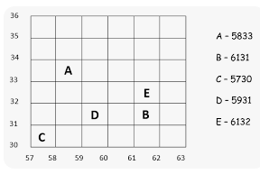  Draw a simple grid like the one shown here. Then draw a treasure map with objects marked in some of the squares e.g. a pirate’s hat, a boot, the treasure etc.  Record the four –figure grid references for each object. | Write a menu for one meal that you have had this week. Try and make it sound as exciting as possible.   | French  Create a poster of your family members and label them in French  - Père: Father Mère: Mother  - Frère: Brother Sœur: Sister  Grand-père: Grandpa  Grand-mère: Grandma  - Tante: Aunt Oncle: Uncle

