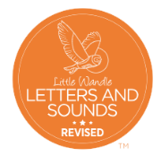
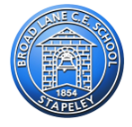
Year 1 and 2 Tricky Words
Year 1 |  |  | Year 2
their  people  oh  your  Mr  Mrs  Ms  could  would  should  our  house  mouse  water | want  any  many  again  who  whole  where  two  school  call  different  thought  through  friend | work  once  laugh  because  eye  busy  beautiful  pretty  hour  move  improve  parents  shoe | door  floor  poor  find  kind  mind  behind  child  children  wild  climb  most | only  both  old  cold  gold  hold  told  every  everybody  even  great  break  steak  after | father  prove  sugar  clothes  half  money  Christmas  Monday  Tuesday  Wednesday  Thursday  Friday  Saturday  Sunday

