Weekly Activities: Y3/4 Spellings, independent reading (10-15 minutes each night recorded in planner), multiplication and division facts: x2, x5, x10, x3, x4, x8 for Year 3 and all facts up to 12x12. Blue boxes are compulsory, white boxes optional.
Record your homework grid pieces in this book. Feel free to be creative! Use colours, IT or photographs to present your work. If you create something that needs printing feel free to email it to me sailsby@stapeleybl.cheshire.sch.uk
Book review: Create a book review about a book of your choice. Try to include some of the following:  Name of the book/ author  Fiction or non-fiction  What is the book about?  Who would you recommend the book?  An illustration  Favourite character and why.  A short description of where the story is set. | Physical Activity: Go on a bike or scooter ride… You could take your bike somewhere and cycle along a cycle path or cycle somewhere safe near home. Make sure you wear a helmet and something bright so you can be seen. BE SAFE! | Reading: Make your own simple non-fiction/information book about your own hobby. Include: glossary, chapters, index You could include pictures and photos too.  
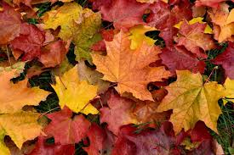  Family Activity: Go on an Autumn Walk in a park or the woods. Take some beautiful autumn photographs. | 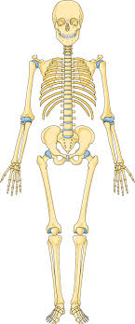  Science: Find out 10 amazing facts about the bones in a Human skeleton. | Play a board game: Make a list of the games that you have at home. Which one would you recommend? Make an advert encouraging others to play the game. Take a photo of yourself playing the game.
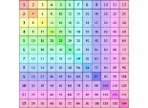  Maths: Make a times tables poster. Choose a times table and make an information poster to support your learning. You could draw pictures, make up a slogan and use bright colours. | French: Create a poster about France. It could include famous landmarks, the flag or famous things related to France. Think back to what we have be learning about in class. | Geography: Explore your street using Google Maps Street View. What year were the photos taken in? Can you notice many changes between then and how your street is now?

Due Date: Monday 20th October 2025

