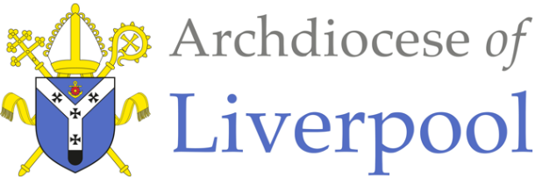

RELIGIOUS EDUCATION : SACRAMENT – EUCHARIST – MEALS – YEAR 1
*Note to teachers/parents and carers.
This work comes from the Come and See Religious Education programme which is taught in all Catholic primary schools in the Archdiocese of Liverpool. We have given a general guide to the learning opportunities that children may have come across under normal timetabling in school. We have suggested and selected a small amount of the programme. The activities aim to keep Religious Education practical and fun. They are in Year groups however, there is no harm in completing other year group work as this will help children to remember and strengthen their learning.
The first part of learning is called – EXPLORE. This shares your child’s everyday experiences and helps them to see how the Catholic faith is lived in their everyday lives. The second part, called – REVEAL shares bible stories and Church tradition that links to their everyday life.

This theme is a SACRAMENTAL theme, and the children will be studying the sacrament of Holy Eucharist – Holy Communion. For Christians, communion has a significant meaning. To receive communion means being in union with Jesus Christ and with one another. It means breaking and sharing the consecrated Bread which Catholics believe is the Body of Christ. To celebrate Eucharist means community. It challenges believers to ask, ‘Can I share this Eucharist if I do nothing to help my brother or sister who is hungry?’ ‘Can I partake of this communion if I refuse to forgive a wrong?’
Different names include:
Eucharist, (Thanksgiving) because it is an action of thanksgiving to God.
The Lord’s Supper, because of its connection with the supper which the Lord took with his disciples on the eve of his Passion.
The Breaking of Bread, because Jesus used this Rite, part of a Jewish meal, when as master of the table he blessed and distributed the bread, above all at the Last Supper. It is by this action that his disciples recognised him after his Resurrection.
The memorial of the Lord’s Passion and Resurrection.
The Holy Sacrifice, because it makes present the one sacrifice of Christ the Saviour and includes the Church’s offering.
Holy Communion, because by this sacrament we unite ourselves to Christ who makes us sharers in his Body and Blood to form a single body.
Holy Mass, (Missa) because the liturgy concludes with the sending forth (missio) of the faithful, so that they may fulfil God’s will in their daily lives. (cf 1328-1332)

In Year 1, the children will be studying the topic of MEALS. In this topic, the children will learn how the parish family gathers for the Eucharist (Mass), Jesus’ special meal. We find strength in gathering for the celebration of the Eucharist and of God’s love in our lives. There are extra notes on the Sacrament of Eucharist for your reference.

RELIGIOUS EDUCATION – YEAR 1 – SACRAMENT – MEALS

EXPLORE – Families and groups share special meals.

At the end of EXPLORE:
Children may be able to talk about which meals are special to them and how they feel about them. They may be able to say what they wonder about why people share special meals and be able to ask and respond to questions about meals which are special to them.

Talk about special meals you have shared together. It might have been a birthday party, Christmas, First Communion or Baptism celebration. Talk about what you did, what you ate where you held it? What made it special?
Some questions to think about and answer…….

SOME KEY QUESTIONS

- When might you have a special meal?
- What makes a meal special?
- Who was at your special meal?
- Who prepared the meal?
- What did you share?
- How did you help?
- What did you like best about it?
- How did it make you feel?

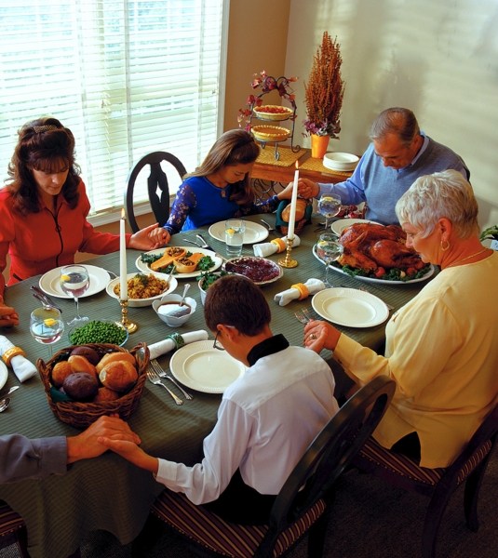
Activities to choose:

- Have you had a birthday during the COVID pandemic? Write a list of the ways it was different from previous birthdays and say how it was special for you.

- Paint a picture of yourself sharing a special meal with your family. Add speech bubbles to say how love and care is being shared.

- Design and make a place mat. Decorate it with appropriate images and words.

- Think about three different special meals you have shared with your family and fill in the grid below.

- Set the table and share a special meal together. Talk about other special meals you’ve shared and how you felt as you shared them.

Special Meals I have eaten with my Family and Friends:
What was the special meal for? | What did you eat? | Who was there? | Why was it special and how did you feel?
REVEAL – Mass as Jesus’ special meal.

At the end of REVEAL:
Children may be able to recognise and perhaps retell the story of the Last Supper.
Children may be able to use religious words to say what happens at Holy Communion during Mass.

The parish family gathers at Mass on Sunday.
When Catholics celebrate Mass, they are celebrating Jesus’ special meal. Jesus feeds us with his Word and himself in Holy Communion.

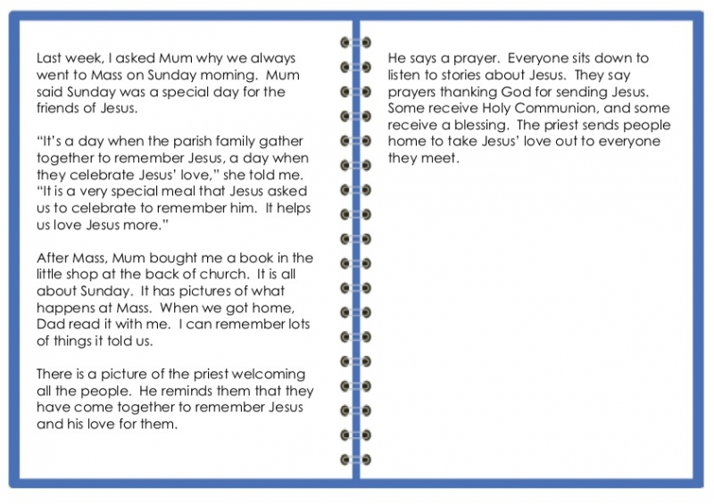
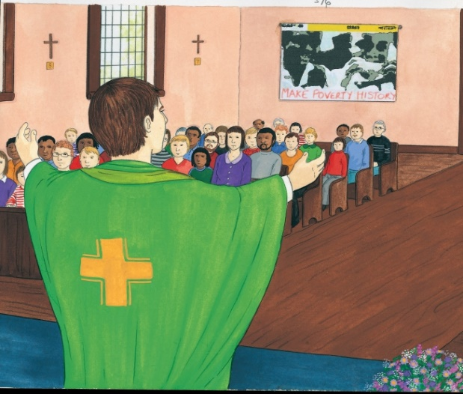
Read Gary’s story together:
Some questions to think about and answer…….

- What do Gary and his family do on Sunday
morning?
- Why do they go to Mass?
- What do they do there?
Activities to choose:

Produce a story board to include some of the things that happen during Mass:- the welcome, listening to stories about Jesus, receiving Holy Communion or a blessing and taking Jesus’ love to everyone.

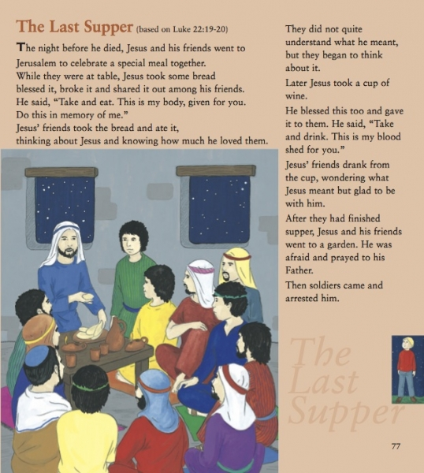
At Mass, Catholics remember the Last Supper Jesus had with his disciples
before he died. After Jesus died, his friends would meet together and
celebrate as he had asked them to. Today, people still celebrate this
special meal when they gather for Mass. The priest repeats the words Jesus said at the Last Supper; “This is my body and this is my blood.” This is Jesus giving himself to us.
Some questions to think about and answer…….
Read the story ‘The Last Supper’ together.

- Why was this called the Last Supper?
- What did Jesus do and say?
- What food and drink did Jesus and his friends share?
- What did Jesus ask people to do?
- During Mass who does what Jesus did at the Last Supper?

Activities to choose:

- Look at the picture of the Last Supper below and write the words Jesus said in speech bubbles.

- Can you see the similarities between the pictures below? Fill in the gaps:

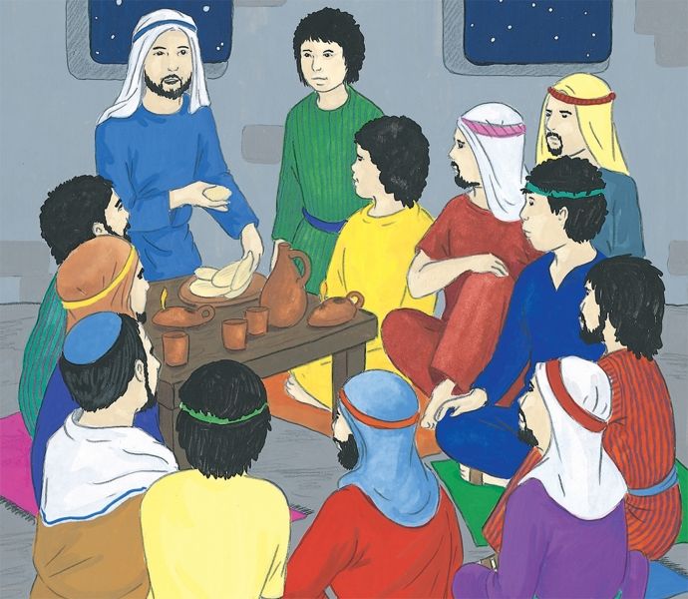

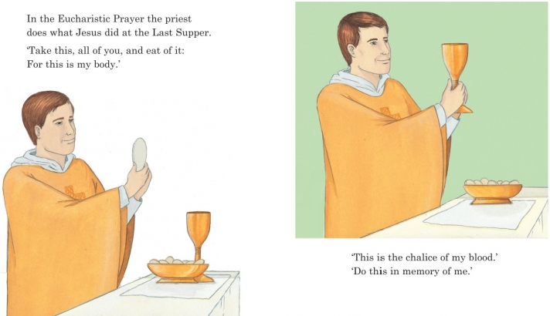

Jesus took bread and said, ‘This is my __________.’ He took the wine and

said, ‘This is my __________.

The priest takes the __________ and says, ‘________________________

___________________________________________________________.’

Then he takes the ____________and says, ‘__________________________________________________________________________________.’

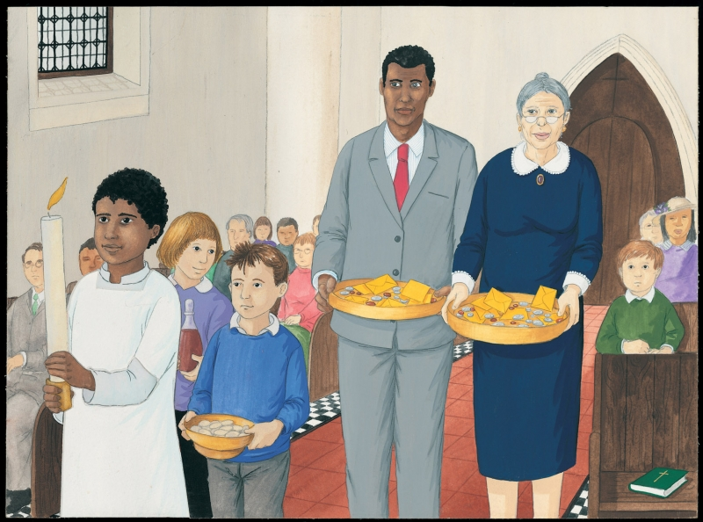
Read the story together:

Last Sunday, when I went to church with Dad and Grandma, Mr Sheridan asked my friend Clare and me if we would take up the gifts of bread and wine to the altar in the procession of gifts. (The gifts we offer represent us giving of ourselves.)
I had never done it before, and I felt quite excited. When the time came, I held the dish with the altar breads, which are called hosts, and carried it very carefully. Clare carried the wine and Mr Sheridan and Grandma took up the collection.

Father James smiled at me. “Thank you, Clare and Tom,” he said. When I returned to my seat, I watched Father James offer the gifts and listened as he asked God our Father to bless the bread and wine that would become Jesus for us. We all replied, “Blessed be God forever.”
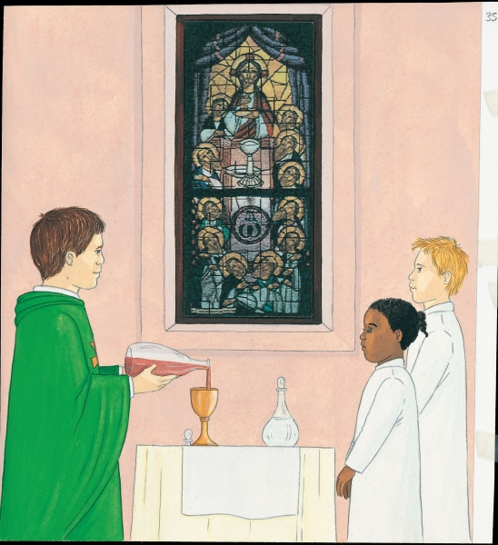
Some questions to think about and answer…….

- What is the food and drink for the special meal?
- What did Father James do with the gifts of bread and wine?
- What did the people reply?

After the priest has said the words that Jesus used at the Last Supper, the parish family prepares to receive Jesus in Holy Communion. As part of preparing to receive Jesus everyone prays the family prayer that Jesus gave us, the Our Father. This is a family prayer because God is a Father to everyone and loves and cares for everyone.
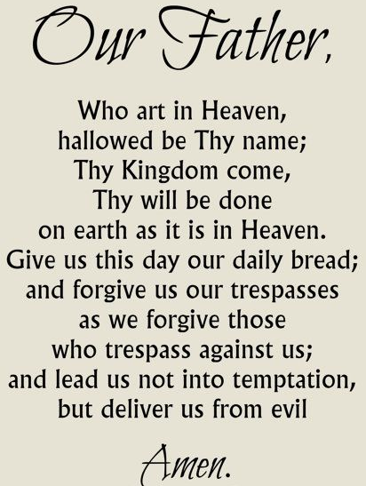

Activities to choose:

- Make up a thank you prayer for God’s gift of food. Try to remember to say it before you eat your meals.

- Make a litany of thanks for all God’s gifts using the response, ‘Blessed be God forever’.

People who have made their First Holy Communion come forward to the Priest and the Extraordinary Minister of Holy Communion to receive Jesus in Holy Communion. They take the host on their hands and take a sip from the chalice. Those who haven’t made their First Holy Communion yet can come forward for a blessing. They cross their arms over their chests and bow their head.
Holy Communion means being close to Jesus and God his Father. It also means being close to each other. We are all God’s children.

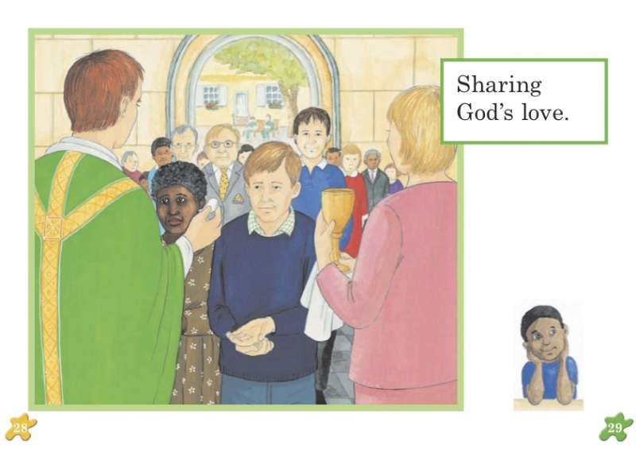
On the host and the chalice, write down the words that Jesus spoke at the Last Supper and the priest says at Mass:

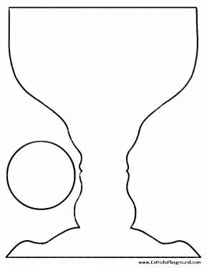

Can you see and label these things in the picture?
Talk about what else you can see.
- The Priest
- The Extraordinary Minister of Holy Communion
- The host
- The chalice

The parish family gathers at Mass to share Jesus’ meal - the celebration of the Last Supper. The parish family also comes together to celebrate at other times. Talk about the occasions when that may occur - Christmas, parish feast day, Pentecost etc.

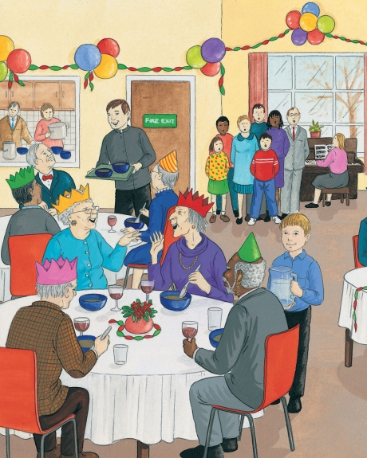
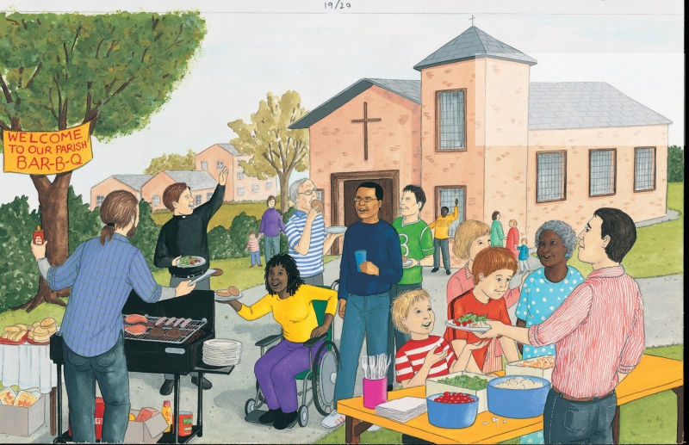
This is a picture of a Parish barbecue. This is a picture of a parish Christmas party for pensioners

Talk about what is happening in the pictures and why you think people are happy.
How are they sharing God’s love?
Menu
1.

2.

3
Activities to choose:

- Retell what is happening at one of the parish celebration meals as if you were one of the children in the picture.

- Cut out one of the pictures and use speech bubbles to show what people could be saying to each other as they celebrate together.



After all the work you have done on MEALS, think what you can do to make family meals happy times, especially during lockdown? Make a big effort to share God’s love during your meals at home. On a menu card, write out 3 things to make shared meals happy times.
Say the Our Father prayer together and remember to thank God for all the food you eat with your family at mealtimes.

