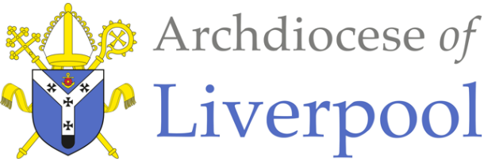
Belonging – A Sacramental Topic
*Note to parents.
This work comes from the Come and See Religious Education programme which is taught in all Catholic schools in the Archdiocese of Liverpool. We have given a general guide to the learning opportunities that your child may have come across in school and have only suggested and selected a small amount of the programme. The activities aim to keep Religious Education practical and fun. They are in Year groups however, there is no harm in completing other lower year group work as well as this will help your child to remember and strengthen their learning.
The first part of learning is called – EXPLORE. This shares your child’s everyday experiences and helps them to see how the Catholic faith is lived in their everyday lives as the theme progresses. The second part, called – REVEAL shares bible stories, religious teachings, lives of saints etc. that can relate to their everyday life. There are suggested activities for each section. Choose those you wish to do and record them as best as you can sending any work undertaken to school.
This theme is a Sacramental theme and focuses on the Sacraments of Baptism (and Confirmation, Marriage and Holy Orders). We understand that not every child or parent will have been baptised, so alongside this document are notes about the Sacrament of Baptism that you may find useful. All the other information you will need is here.

EYFS - WELCOME - EXPLORE
What it is to welcome and be welcomed

- Children may begin to talk about their own experiences and feelings of being welcomed.
- Children may be able to say what they wonder about how they can make others feel welcome.
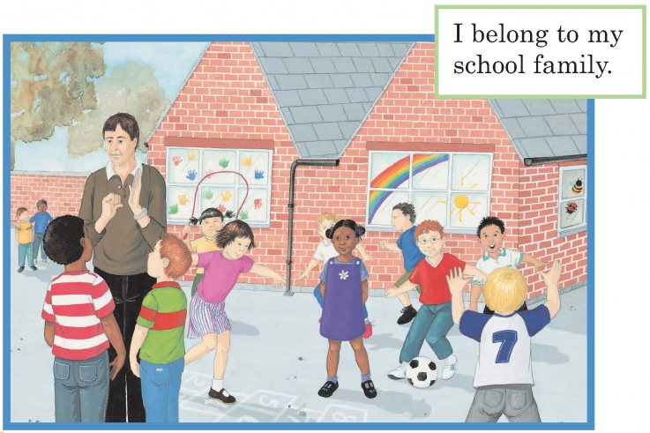

- Ask your child how their school and their teacher made them feel welcome when they started school in their new class. Talk about how they felt at the time.

- Talk about other ways of welcoming people into your house and how we make people feel welcome. How does that make us feel?

Activities:

- Role play inviting a friend to tea and find ways to make them feel welcome.

- Make and decorate a ‘welcome’ sign or mat for your front door using a symbol of welcome that would make someone feel welcome.

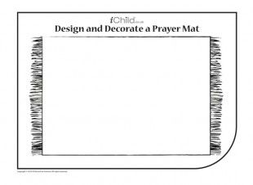
WELCOME

EYFS - WELCOME - REVEAL
Baptism: a welcome to God’s family

- Children may recognise some religious signs and symbols used in baptism.
- Some children may begin to use some religious words and phrases from the Rite of Baptism.

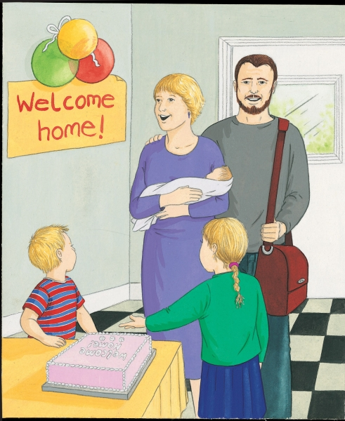
- As a parent, talk about how you welcomed your new baby child into your family at home. How were you and the baby made to feel welcome? Talk about the feelings of everyone in the family.

- Share photographs and any keepsakes you have of this.

- Recall how we show we are special by being given both an individual and family name as a sign of welcome to our family.

- Talk about how important a new baby is in a family and the love and joy they bring.

Activity:

- Draw a picture of your own family and talk about how you feel close to each other.
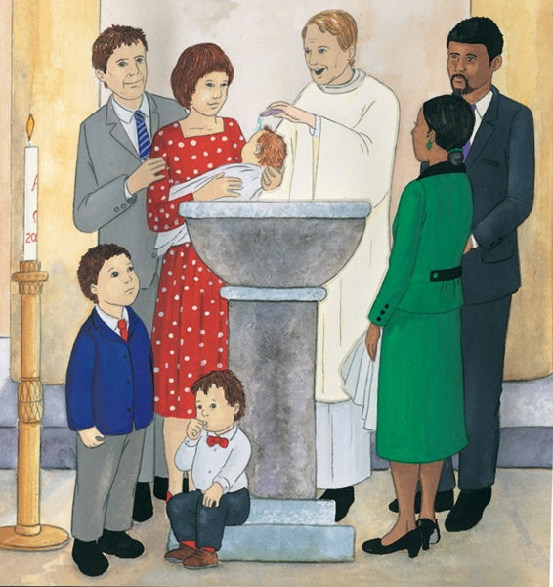
- If your child has been baptised, talk about how they were welcomed into God’s family through Baptism.

- Talk what happened at their Baptism focusing on the water and who was there and what they did. , Use the words the priest said: ‘N, I baptise you in the name of the Father and of the Son and of the Holy Spirit.’ (N- insert child’s name).

- Share photographs of their Baptism if you have any.

- Read this story to your child:

Matthew’s Baptism:

Philip’s mum, dad and little brother, Tom went to church with baby Matthew. It was baby Matthew’s Baptism. Auntie Sarah and Uncle Dave were going to be Matthew’s godparents. Godparents are people who promise to help parents to teach the baby all about Jesus and how to be his friend. Father Devine welcomed them to church and asked them, “What name have you given your child?” Mum and dad answered, “Matthew.”

The family gathered round the baptismal font and watched Father Devine pick up a little shell and dip it into the water. Mum held Matthew over the font and Father Devine poured water over Matthew’s head saying, “Matthew, I baptise you, in the name of the Father and of the Son and of the Holy Spirit.” Auntie Sarah put a white shawl around Matthew and Father Devine said, “Receive this white garment.”


After church all the family gathered together for a party to celebrate Matthew’s baptism – his welcome into God’s family.

Activities: (Choose as many as you would like to do)

- Talk about the following and find them in the picture above:
Godparents, candle, font, water, white garment.

- Make a Baptism candle with a name and symbols of Baptism on it.

- Design a Baptism certificate for Matthew’s Baptism

- Encourage your child to recall what they heard in the story and role play
Matthew’s Baptism. You will need to provide a candle, a white garment, a doll, a bowl and some water.
Ask them to repeat the words of Baptism that the priest used.

- Have a Baptism party to celebrate!

At the end of all the work you have done about WELCOME, say together: Dear God, help us always to show a welcoming smile to others. Thank you for welcoming people into your family in the Sacrament of Baptism. Help them/us to be good members of this family. Amen!
YEAR 1 - BELONGING - EXPLORE
Belonging to different groups

- Children may talk about their experience and feelings about belonging to different groups.
- Children may say what they wonder about belonging and what that means.
- Children may be able to ask and answer questions about their own and others experiences of belonging to different groups.

- Talk about the different groups that your child may belong to e.g. swimming, Rainbows, Beavers, dancing, football, choir etc. and what they do together in these groups. Discuss how they feel in the group and who helps them to feel that they belong. Talk about how someone would know that they belonged to that group – do they wear a uniform, have a badge etc. Ask them how they could make someone new to the group feel that they belong.
- Talk about the different ways of belonging shown in the picture e.g. a team playing together, a pair playing hopscotch together, the teacher signing, two children with their arms around each other, the artwork of handprints on the window.

Activity:
Make a badge to show that you belong to one of the groups or to your own family.

YEAR 1 - BELONGING - REVEAL
Baptism is an invitation to belong to God’s family

- Children may be able to recognise and use some religious words and phrases to begin to describe some actions and symbols used in Baptism e.g. pouring water, lighting the Baptismal candle, anointing with oil etc.
- Children may be able to recognise that Baptism is the beginning of life in the Church community.

- If your child has been baptised, share memories of the day together and look at any photographs or videos you have of the day. Alternatively, read the story about Matthew’s Baptism above. Talk about who was present on the day, who the Godparents were and what the priest said and did.
Explain how the lit candle, stands for the presence of Jesus. Jesus said, “I am the light of the world,” so the candle is a symbol of this. With light we see things more clearly. In Baptism, a lit candle is given to one of the parents as a sign of how they hope the child will always try to live Jesus’ way of love.
At the end of the Baptism everyone says the family prayer of the Church, the ‘Our Father’. This is a sign that the child belongs of the family of the Church. The priest blesses the mother and father and all the people in the church.
Read the extract below:
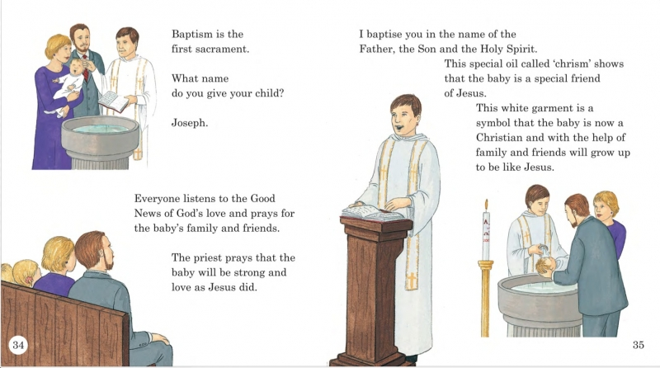

Activities: (choose any you would like to do)
- Make a congratulations card for a newly baptised child. Use suitable symbols that are used at Baptism. Talk about why they have chosen the symbols and what they represent.

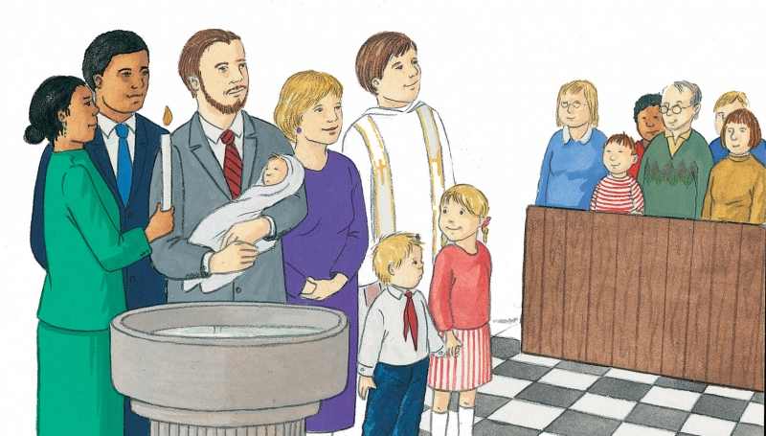
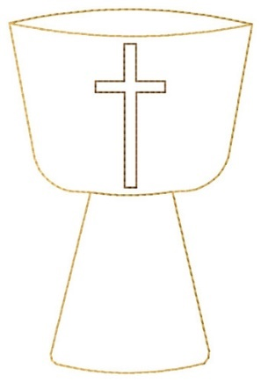
- See if your child can recognise and label all the people and symbols they see in the Baptism picture below:

- On a template of a Baptismal font, write what belonging to the Church family means

At the end of all the work you have done about BELONGING, say together:
For the family I belong to ….. Thank you, Father God
For the groups that I belong to ….. Thank you, Father God
For the Sacrament of Baptism that enables people to belong to God’s family in a special way …..
Thank you, Father God.

YEAR 2 - SIGNS & SYMBOLS - EXPLORE
The love and care shown in the family

- Children may be able to talk about and describe their experiences and feelings about signs which help them and others in daily life and say what symbols are important to them and why.
- Children may be able to say what they wonder about the meaning and importance of some symbols in their life and ask others which ones are important to them.

- Talk about signs and symbols, how a sign tells us something we need to know (for example, McDonald’s, road signs, numbers), and a symbol means something really important (for example, hugs, kisses, tears).


- Read this story together and encourage your child to point out the signs and symbols as you go along.
(Symbols and their meanings used in the story:


welcome: glad to see them hugs and kisses: love, friendship
food: caring and sharing a toast: good wishes, celebration
singing: joy, happiness
engagement ring: love, belonging, commitment, promise
party: celebration
tears: joy, happiness, memories)
This Photo by Unknown Author is licensed under CC BY-NC

Cousin Liz’s engagement party

“Liz told us to look out for McDonald’s along this road,” said Dad.
“Then we’ve got to turn into Princess Road, opposite the park gates,” added Mum who was holding a piece of paper with directions and a map.
“There’s McDonald’s,” shouted Jason. They drove along and there was Princess Road. “Right, Dad!” said Jason.
“Now look out for No. 36,” said Mum. “I bet Liz is feeling like a princess.”
“Will I have to kiss everyone?” asked Jason. “I’ll hate it.”
Dad grinned, and Mum said, “Just remember to behave yourself and don’t get too excited with your cousins, like you did last time.”
“There’s 36,” shouted Jason, glad to change the subject. “There’s the yellow burglar alarm they told us to watch out for.”
Dad tooted the horn and Liz came out to welcome them. Jason was glad to see that David was there as well. “I think that must be Liz’s fiancée, Derek,” said Mum, “Isn’t he tall!”
There were hugs and kisses at the front door. Jason tried to escape before Auntie Terry could kiss him, but he failed! David took Jason into the dining room. “Come and see all this food. I can’t wait to get started,” said David.
“Amazing!” said Jason, at the sight of the sandwiches, salads, trifles and gateaux, crisps, sausages on sticks and pieces of cheese and pineapple. In the middle was a cake with ‘Liz and Derek’ iced on it.

Activities:
- Make a list of all the signs and symbols in the story and what they mean.

- Take the children for a walk in the local area noticing signs and symbols along the way. Discuss why they are used.

- Describe and draw some of the signs and symbols that have been used recently.

YEAR 2 - SIGNS & SYMBOLS - REVEAL
God’s love and care for every family

- Children may be able to recognise the signs and symbols used in Baptism.
- Children may use some religious words and phrases and describe some actions and symbols used in the Sacrament of Baptism.
- Children may be able to recognise that and describe how Christians act in a particular way because they are members of the Church family and followers of Christ.

- (See Baptism Notes for Parents – Signs & Symbols)
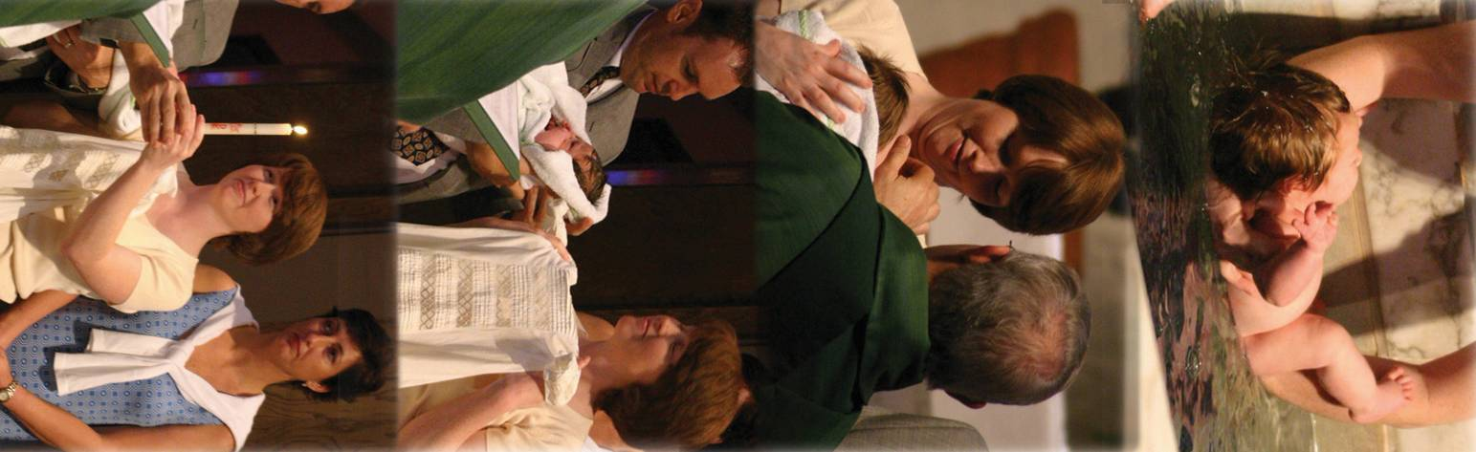
Look at the pictures below. Describe the signs and symbols of Baptism you can see and talk about what they mean.
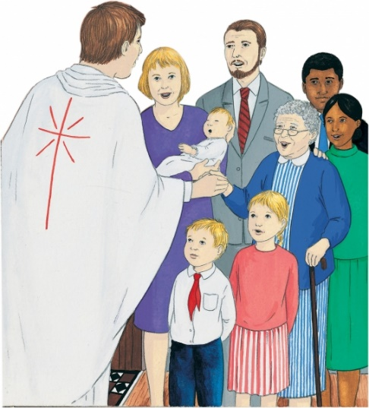
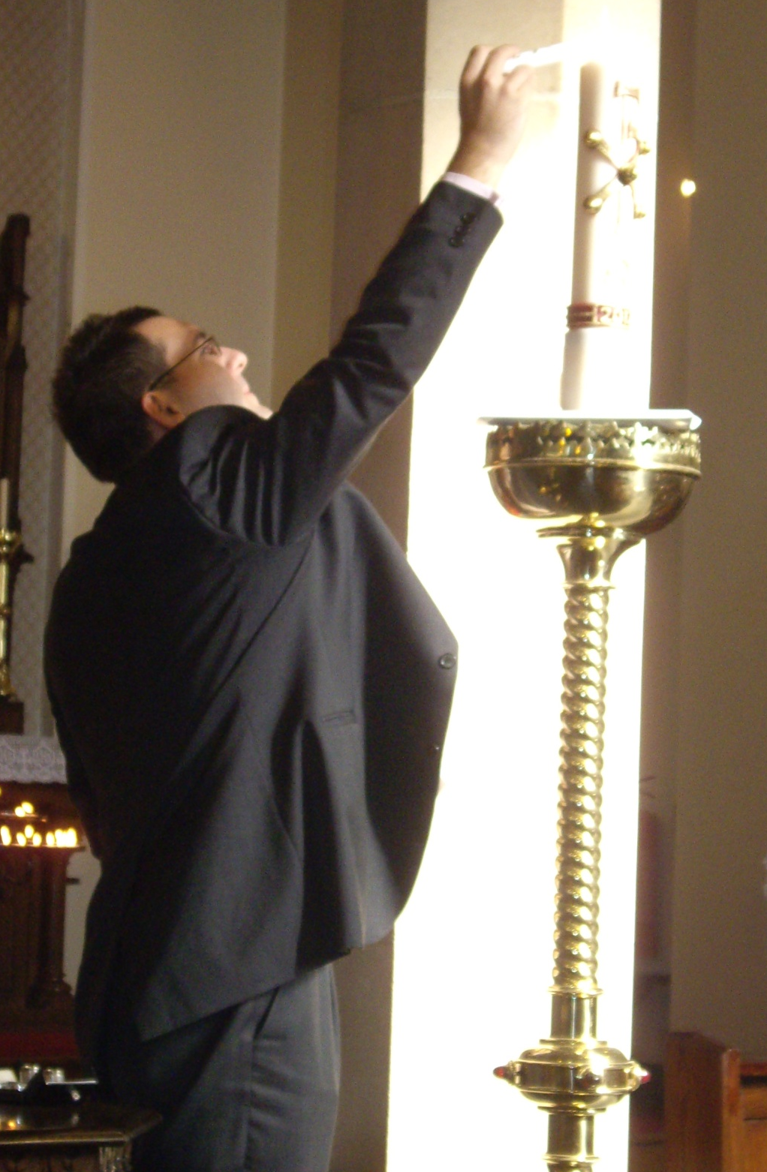
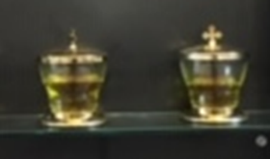

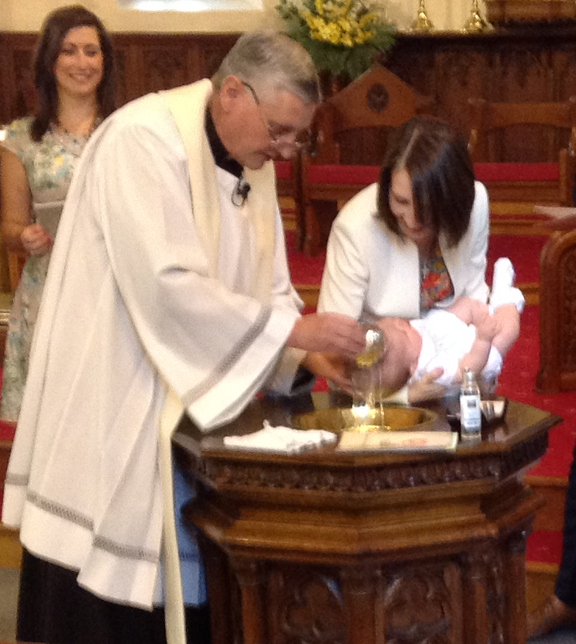

Activities: (choose whichever you would like to do)

- Design an invitation card to a Baptism using some of the symbols you have talked about. Inside the card write down what the symbols mean.

- Make a Baptism candle with a name and symbols of Baptism on it. Write on it the words the priest uses as he pours the water.

- Write a prayer for a newly baptised baby including the characteristics of oil and the Holy Spirit.

At the end of all the work you have done on SIGNS &SYMBOLS, say this prayer or the prayer that you have written:
Thank you, God for the signs and symbols around us that keep us safe and show us that you are always with us. Help all Christians to follow the light of Jesus. Amen!
YEAR 3 - PROMISES - EXPLORE
Belonging to a group involves promises and rules

- Children may be able to ask and answer questions about promises and say about what they wonder about why people make promises.
- Children may be able to make links between their actions and the promises made.

Talk about the groups or clubs they belong to.
- What is good about belonging to a group or club? What do they enjoy?
- What rules do they have to keep and why must they keep them? Are they difficult to keep?
- Was there a ceremony of enrolment or initiation?
- Did they make any promises, and if so, do they have to renew these promises? Why do they have to keep these promises?

Alternatively, you could tell the following story and discuss the above questions:

My name is Paul. When I first joined the karate club, my teacher, who is called Sensei (pronounced ‘Sensay’), told me you should count in Japanese.

One to ten in Japanese sounds like this:

- ichy
- knee
- san
- she
- go
- roku
- sichy
- hatchy
- coo
- joo

He also gives orders in Japanese. Start is ‘ashermay’ and line up is ‘shoyo.’ I had to learn about ‘catters’. There are punches, kicks and blocks. Sensei says, “The most important thing is to promise to do as you are told and never do karate in the playground.”

The belts are white, yellow, orange, red, green, blue, purple, brown, grey and black. You bow when Sensei says “ray.” Kicks are good leg techniques, and they exercise your legs, too. Punches are hand techniques and are very powerful. Blocks are important in karate. I’ve got to decide soon whether I’m going to keep coming. It is very strict here and it is hard work, but I think I’ll carry on. I’m a lot stronger already.

Activities:
- Make an advert for one of your clubs or for Paul’s Karate Club to let others know what it is all about. Make sure you illustrate the promise you or Paul had to make and say why it is important to keep the promises.

- Make a banner for one of the promises that you must keep at one of your clubs or for the scouts / guides (see below) and decorate your banner showing how important it is to live out the promise and keep it.

“On my honour, I promise that I will do my best to do my duty to God and to The Queen, to help other people and to keep the Scout Law.”

"I promise that I will do my best, to be true to myself and develop my beliefs, to serve the Queen and my community, to help other people and to keep the (Brownie) Guide Law."

YEAR 3 - PROMISES - REVEAL
The meaning of the promises made at Baptism

- Children may be able to recognise and give reasons for the promises made in Baptism.

- Talk to your child about the promises made at Baptism:

The parents with the baby and godparents, go to stand around the font. The parents and godparents are asked if they will commit themselves to do all they can to help the child become a good Christian. In order to do this, they make promises to reject evil and all that means and promise to serve God faithfully as they renew their faith in God the Father, Son and Holy Spirit.

The priest/deacon asks the parents and godparents to renew their own faith by responding to three questions with the words I do.

These are the promises that are made:

Priest/deacon: Do you believe in God, the Father, the Almighty, Creator of heaven and earth?

Parents and godparents: I do.

Priest/deacon: Do you believe in Jesus Christ, his only Son, our Lord, who was born of the Virgin Mary, was crucified, died and was buried, rose from the dead, and is now seated at the right hand of the Father?

Parents and godparents: I do.

Priest/deacon: Do you believe in the Holy Spirit, the holy Catholic Church, the Communion of Saints, the forgiveness of sins, the resurrection of the body, and life everlasting?

Parents and godparents: I do.

Look at how each section in turn asks parents and godparents to say they believe God the Father, in Jesus Christ his Son and in the Holy Spirit - the blessed Trinity. (Remind the children that Christians do this every time they make the Sign of the Cross.)
The parents and godparents are making a commitment on behalf of the child that she/he will grow up a member of the Church family and follow the way of Christ and serve God with the help of the Holy Spirit to guide them.

Talk together about:
- what the parents and godparents have to promise and why they do so
- why having a baby baptised is something that needs preparing for
- what it means to make a commitment. (Think back about belonging to a club etc.)

Activity:
- Using the template of a cross, (below) pick out key words and phrases from the promises, write them on the Cross and give reasons for your choices.

At the end of all your work on PROMISES, make a commitment to keep any promises that you make at any clubs that you belong to. You might like to pray for God’s help to do this.


YEAR 4 - CALLED - EXPLORE
The response to being chosen

- Children may be able to ask and respond to questions about what they and others feel about being chosen.
- Children may be able to make links to show how feelings and beliefs can affect the responses they might make to being chosen.

- Talk about with your child about times that they have been specially chosen to do something e.g.:
- been a bridesmaid or a groomsman
- become a member of a football, rounders or netball team, computer club, school choir or orchestra.
- represented their school or club in some way
- read at Mass or school assembly
- done a special job in school e.g. be the register monitor etc.

- Ask them what they were expected to do for the role they were chosen for, why they accepted the invitation to do it and whether it was easy to fulfil this role – did they have to make sacrifices e.g. getting up early, giving time to practise?
- Now talk about a time they were not chosen for a role that they would have liked to have and how they felt at not being chosen.

Activities:
- Write a letter to accept a role as class eco-councillor in your school. Say how you feel in accepting the role and what you understand is required of you as you commit to the role.


- On a sad emoji face, write about how disappointed you are at not being chosen as your class school councillor. Say how you feel and why you should have been chosen.

YEAR 4 - CALLED - REVEAL
Confirmation: A call to witness

- Children will be able to use religious words and phrases to describe what it means to be called and give reasons why and how people are called to live a Christian life in response to God’s call.
- Children may be able to use religious words and phrases vocabulary to give reasons for the actions and symbols used at Confirmation.

- Confirmation is a choice made by people to renew the promises made in Baptism and receive the Gifts of the Holy Spirit, to strengthen their faith. It is a Sacrament of Initiation - of belonging and is usually celebrated by a Bishop.
- At the celebration of Confirmation, each one is called by name and invited to come to the front of the church. The bishop explains the readings to them and helps them to understand what Confirmation means. He says something like this:

‘On the day of Pentecost, the apostles received the Holy Spirit as the Lord had promised. They also received the power of giving the Holy Spirit to others and so completing the work of Baptism.’ The Holy Spirit fills our hearts with the love of God, providing us with the strength to be and act as followers of God.
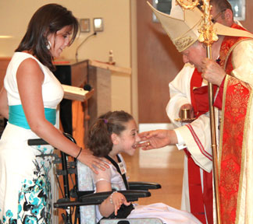
- In Confirmation they choose to become active members of the Church, their lives are given completely to the service of all, as Christ’s was.
- The person who is being confirmed has a sponsor - someone who inspires them in the way they live their faith.
- The gift of the Holy Spirit, signified by the Sign of the Cross made with Chrism, is received as a spiritual sign of becoming more like Christ, so the goodness of Christ should always be seen in the actions and way of life of a confirmed person.
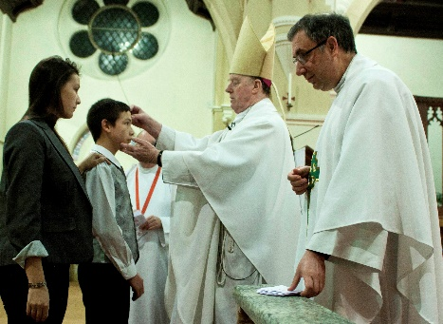
- The person being confirmed is anointed with the Oil of Chrism, a mixture of oil and balsam as a sign of being called and marked out for God’s service.
- The Bishop says, ‘Be sealed with the gift of the Holy Spirit.’ A seal is a sign, a mark or a promise made. The Holy Spirit will always be with the Christian to help and guide him or her.

- Those being Confirmed choose a saint’s name, someone who can be looked up to as an example to follow.

Activities:
- Design a recruitment pamphlet for candidates for Confirmation. Use signs, symbols, and information about Confirmation.

- Write a guide for a candidate for Confirmation to help them know what to expect. Say what symbols, words and actions are used and why.

At the end of all the work you have done on CALLED, say this prayer together:

Holy Spirit fill our hearts with the love of God, provide us with the strength to be and act as followers of God. Come Holy Spirit fill the hearts of the faithful and enkindle in them the fire of thy love.

YEAR 5 - LIFE CHOICES - EXPLORE
Showing care and commitment

- Children may be able to make links to show how their feelings and beliefs affect their own and others’ quality of care and commitment towards each other and the way they behave towards each other.

- Friendships are important in life. When you make friends, you have to think about the other person and show some care and loyalty towards them. Friendship usually means commitment to the other person’s needs as well as your own. This is true in families. In families where there is care, compassion and loyalty to each other everyone will feel better.

- Talk about what it means to be a caring member of your family and what sacrifices you all make to show care and compassion to each other.

- Discuss how you feel when one of the family hurts another or when you fall out with one of your friends. Describe what responsibilities friends and family have towards one another.

- Talk about a time when you celebrated a special time with a) your family b) with your friends.

Activities:

- What ‘ingredients’ do you need to be a loyal friend? Write a recipe for a good and faithful friend.

- Write an article for a magazine giving advice about how to maintain a friendship, include ideas about commitment, responsibility and fidelity.

- Make a paper chain of your friends or family. On it write all the ways you can show fidelity and commitment to each other.



YEAR 5 - LIFE CHOICES - REVEAL
The call to life and love within the community; marriage

- Children may be able to give reasons for the religious actions and symbols used in the Sacrament of Marriage and for the love and service shown by Christians.
- Children may be able to show some understanding of the marriage liturgy, the promises made and of how religious belief shapes the lives of married people.

- Through the Sacrament of Baptism, all Christians are called to share the mission of Jesus and they carry this out in many different ways. God calls each of us to a particular vocation (calling) in life. Everyone has an important, but different role in the mission of the church. Some people’s vocation is to marriage, to the single life or to the religious life. Some people’s vocation is to ordination as a deacon, priest or bishop.

- The Sacrament of Marriage:
For some people the living out of the commitment to love and service will be through marriage.
Marriage is a sacrament of commitment to love and support of each other. It celebrates the gift of love, life and friendship with God and one another. The husband and wife, if blessed with children, will provide a loving family for the children to grow up in.
Before a couple get married, they must take part in a marriage preparation course which usually takes place in the parish or Deanery. The purpose of this is to make sure the couple really understand what they are undertaking as this is a life-long commitment of service.
A man and a woman choose to be married in church because Jesus is important in their lives and they want God’s blessing. This is their response to God’s call to live a life filled with love for one another. The family gather to celebrate the sacrament with them at their wedding. Sometimes the celebration takes place during Mass and other times it is a different liturgy.
The ceremony goes as follows:
- Entrance of the bride – everyone stands to welcome her and joyful music is played
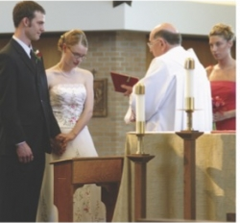
- Prayers of welcome
- Scripture Readings
- Bride and Groom are asked by the priest if they are freely choosing to enter into a marriage with each other.
- After each has said they are, they join hands and make their promises. They each, in turn, say, “I call upon these persons here present to witness that I (name) do take thee (name) to be my lawful wedded wife/husband to have and to hold, from this day forward, for better, for worse, for richer, for poorer, in sickness and in health, to love and to cherish till death do us part.”
- Rings, which are a sign of love and fidelity, are blessed by the priest and exchanged. The bride and groom say to one another, (name), take this ring as a sign of my love and fidelity. In the name of the Father and of the Son and of the Holy Spirit”. (Think about the shape of a ring, that it has no beginning or end and is usually made of gold or a precious metal.)
- The bride and groom and their witnesses sign the register of marriage. This is an official legal document.
- Everyone then joins in with the Our Father, which ends with a blessing in which the priest prays that the couple will be faithful to each other, be an example of Christian life.
- The priest asks that they will be blessed with children and be good parents and, that at the end of their lives they will have everlasting life in Heaven with all the saints.
- The couple leave the church followed by family and friends and celebrations usually follow.

- Talk together about
- how a married couple can show their love, service and fidelity to each other
- why the promises they make are important
- whether the promises are hard to keep and what they commit the bride and groom to
- what the rings symbolise

Activities:
- Design a wedding card using appropriate symbols. Create a prayer for married people, asking God for his strength and guidance to help the couple show their love and service to each other. Incorporate the prayer into the wedding card.

- Make a booklet of the marriage liturgy, explaining what is happening and why, include a choice of appropriate hymns and scripture readings and give reasons for your choices.

- Read the Promises. In your own words say what you think they might mean in terms of thoughts and actions within daily life. Match simplified promises to the actual promises of the sacrament of marriage and give an example of how this might be lived out in married life.
Simplified Promise… | Actual Promise… | How this is might be lived in daily life…
Not to let illness  break us up | In sickness and in health | Looking after one another
To share all I have equally with you
To live with you for ever until one of us dies
Not to let poverty
come between us
To be faithful to
you alone
To love you and look after you tenderly
To begin a new
family with you
To put you first in
my life

At the end of all the work you have done about LIFE CHOICES, say together the prayer you have written. Remember to say thank you to the people who show love and service to you!

YEAR 6 - VOCATION AND COMMITMENT - EXPLORE
Commitment in life

- Children may be able to show they understand what it means to be committed and be able to express why people make commitments.
- Some children will be able to show how their own and others’ commitment to the service and care of others is influenced by beliefs and values.

- Whatever you do in life, you need commitment to do it well. It is not only the high-profile jobs that require it. Whether you are a cleaner or a scientist, you can be committed and do your job really well.
- Think about some of the jobs people do - some paid and some voluntary. Copy this chart, complete it and add more jobs to the list.

Job | What does it involve? | What is the commitment? | What are the personal risks, if any? | How do you measure this commitment?
Parent

Doctor
Firefighter
Lifeboat crew

- Talk about why people choose to do these jobs and what level of commitment is needed for each.
- Discuss what makes a person committed to doing their job and how they show commitment to serve others in the jobs they do.
- Talk about what you and your child are committed to doing and how it feels to be committed and dedicated to something.

Activity:

- Research the training and level of commitment required to be a doctor or a member of a helicopter search and rescue crew or a member of a lifeboat crew.

- Make an advert for one of these jobs and in it, specify what qualities the applicant should have, what values they must adhere to and what they should be prepared to commit to.

YEAR 6 - VOCATION AND COMMITMENT - REVEAL
The vocation to the priesthood and religious life

- Children may be able to give reasons why Christians fulfil their baptismal promises by answering God’s call through their chosen vocation in various ways, including a vocation to the priesthood.
- Children may be able to show they understand how religious belief shapes the lives of Christians, in a variety of ways, through their chosen vocation notably through the priesthood.
- Children may be able to give reasons for the signs and symbols used in the Sacrament of Holy Orders.

- Like people who commit themselves to be friends or to be married, anyone entering religious life makes a commitment. People who get married make vows to each other and commit themselves to family life. A person entering religious life also makes a vowed commitment.

- Some people’s vocation is to marriage or the single life or to the religious life. Some people’s vocation is to become a priest. A priest chooses to follow Jesus in the service of others in the Church. This is his response to God’s call to a life lived with love for God’s people. The apostles were called by Jesus to follow him and, in response, they left everything to be with him. This is also true of every Christian and is especially true of the call to be a priest.

- If the man feels that God is calling him, he will need to apply and to be accepted by the bishop of the diocese. If he is accepted, then he will begin many years of training in a seminary. During this time, he will have the opportunity to pray, learn more about his Faith, how to celebrate the Sacraments, communicate the Good News and have experience of living and serving in the parish community.

- At the end of the training, diocesan priests make promises of celibacy and obedience to their bishop. They do not make a vow of poverty, but they do try to live simply so they can be of service to God’s people.

- At the end of his training, he will be ordained – that is he receives the sacrament of Holy Orders or Ordination. This sacrament is celebrated during Mass and it is the bishop who ordains. The man being ordained is called an ‘ordinand’. The ordinand’s family and friends gather for the celebration.
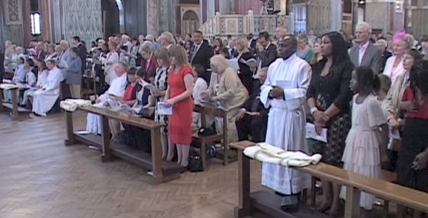
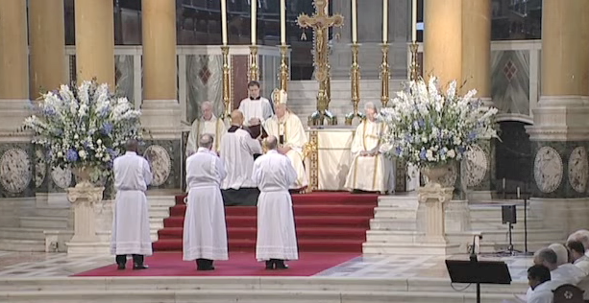

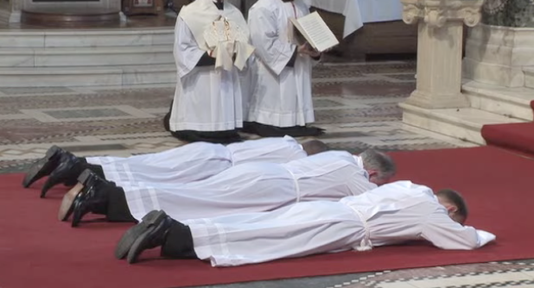
- After the Gospel and homily, the ordinand is called forward from the parish family to stand in front of the bishop who asks him if he has freely chosen to be ordained and will promise to be a good and faithful priest. The ordinand lies flat on the ground in front of the altar while the Litany of the Saints is sung.

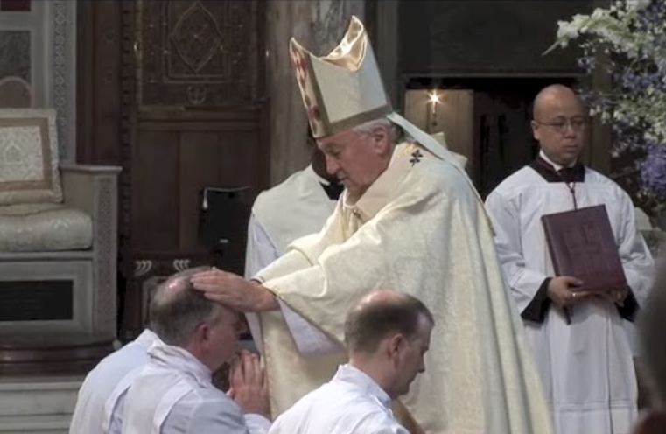
- The bishop lays his hands on the head of the ordinand and prays the prayer of consecration (a prayer asking God to bless and make holy the ordinand, to help him be a faithful witness and co-worker with the bishop.) The man is now ordained as a priest.

- The newly ordained priest receives his stole, (the garment that goes round his neck) and the chasuble, which is the top coloured vestment worn for the celebration of Mass.

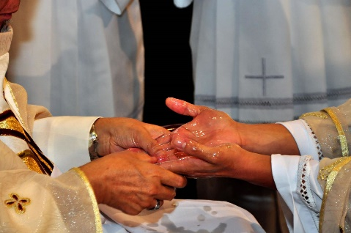
- The bishop anoints the priest’s hands with the Oil of Chrism to make them holy. He is given a paten with a host on it and a chalice with wine in it. The bishop says, ‘Accept from the holy people of God, the gifts to be offered to him’.
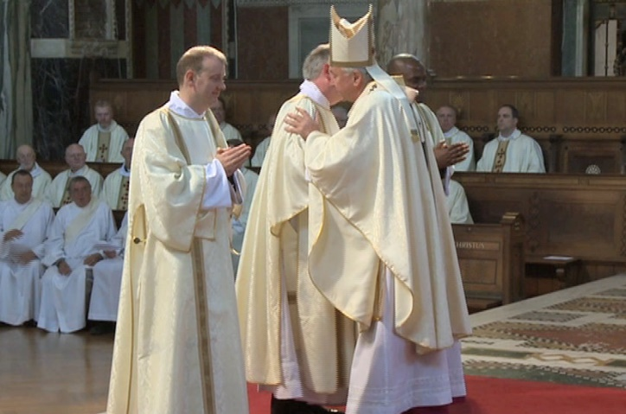

- The bishop and all the other priests present give the new priest a sign of peace to welcome and congratulate him. The newly ordained priest is now prepared to serve the family of God in the parish to which the bishop has appointed him.

Activities:

- Write a reply to a letter in response to a man who is wondering if he has been called to be a priest and wants to understand what is required in becoming a priest and how this would shape his life.

- Give the children a set of pictures (above) of the different stages in the ordination. Ask them to put them in order, saying what is happening in each, why it is happening and its significance.

- Research the life of Saint John Mary Vianney, the patron saint of priests. Write a prayer asking him to guide the life of a priest. Say this prayer at the end of all the work in this topic.

