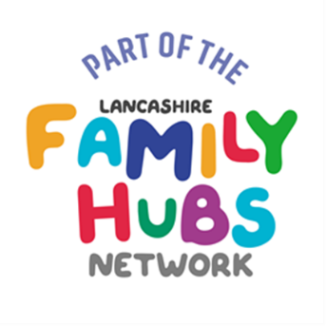
CFWS Parenting offer

Solihull Approach - is theoretical model emerged from practice, therapists and psychologists and facilitates an understanding of emotional health and wellbeing, as well as mental health and child development. The three concepts of containment, reciprocity, and behaviour management facilitate an understanding of the relationship and how to apply this in different contexts. It looks at brain development and how children may behave a certain way. It's for parent who want to understand their children's behaviour.
Nurturing Programme – promoting emotional health and mental wellbeing, relationship skills and positive behaviour management strategies for parents/carers and their children (of any age).
The Nurturing Programme which is evidence-based and universal, puts connecting and building trusting relationships first.
The key elements of The Nurturing Programme are the four constructs, or building blocks, of good emotional health: – self-awareness, appropriate expectations, empathy and positive discipline.
Riding the Rapids – is for Parents of CYP with autism or a specific learning disability NOT parents of CYP with neurodivergence such as a solo diagnosis of dyspraxia, ADHD, ADD. This group is delivered for children of a similar age, so early years, primary and secondary are delivered separately – it can not be mixed groups.
All above programmes run for 10 weeks and are 2 hours per week.
Connective parenting (FIS offer at level 3 on CoN) – Using a trauma informed, Non-Violent Resistance approach to support communication and connection between parent/carer and child.
Positive Relationships: Positive Relationships Stronger Families is a 4 week programme for parents who may be struggling with conflict within their relationships.

Scan to book a group or go to Lancashire County Council Events

