HISTORY
POLICY

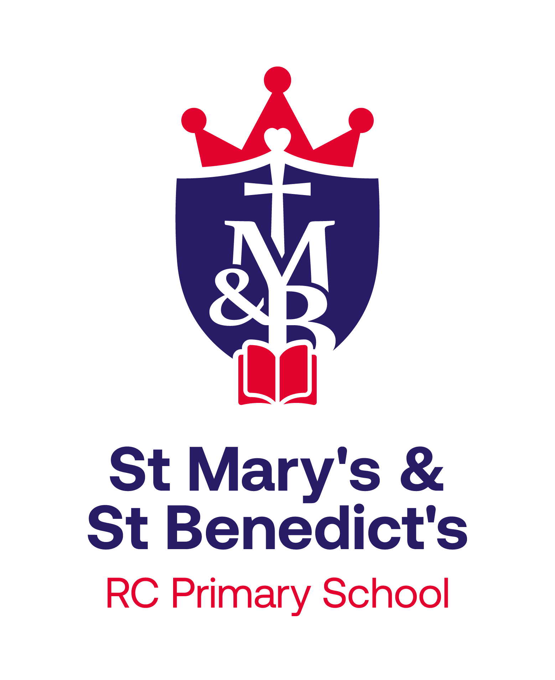

Together in God’s family, we grow in faith, knowledge & love to reach our full potential, and to become the people that we are created to be.

Policy Agreed: February 2023
Review Date: September 2025 (Updated by R Ward.)
Our School Ethos
At St. Mary’s and St. Benedict’s we aim for our curriculum to inspire pupils to be life-long learners with a sense of service to the world that they live in and the people that live in it with them.
We believe our pupils will be life-long learners if they are able to be:
- confident,
- independent,
- curious,
- open-minded,
- enthusiastic,
- observant,
- co-operative and
- resilient individuals.
In order to develop these qualities within our pupils we intend for our curriculum to provide opportunities for children to:
- Be curious and ask questions
- Evaluate and reflect
- Work collaboratively
- Apply their learning
- Solve problems whilst developing resilience
- Communicate their learning
- Challenge ideas
Vision for History
At St. Mary’s and St. Benedict’s, our vision is that each child will receive a high-quality education in History, which fires children’s curiosity about the past in Britain and the wider world. By studying the past, pupils develop a deeper understanding of the present world around them and a greater sense of their own personal identify. In History lessons, pupils are provided with opportunities to discover, explore, investigate, question, analyse and evaluate the world before them, the world as it is now and the world as it will be in generations to come. We aim for children to be equipped with the necessary skills to enable them to be ready for the next step of their learning journey- transitioning into KS3 and flourishing as life-long learners.
History Intent
At St. Mary’s and St. Benedict’s Primary School, our high-quality History curriculum aims to fulfil the requirements of the National Curriculum in an exciting, inclusive and challenging way. We follow the National Curriculum objectives for History and have adapted the curriculum cycle to suit our needs as a school. We have high expectations for our children and we ensure our planning is against Age Related Expectations for each year group. We ensure tasks are appropriately differentiated or adapted to meet the individual needs of our children.
Teachers will inspire the children’s curiosity to know more about the past, encourage them to ask questions and enable them to have a better understanding of the society in which they live and that of the wider world. The children will gain knowledge and a coherent understanding of people, events and periods in history whilst being provided with opportunities to interpret information from different sources, evaluate historical information and use methods of historical enquiry. Each year children have the opportunity to partake in Historical workshops to create awe and wonder around a particular topic. We welcome visitors in to school to share their experiences from the past and bring History to life.
History Implementation
We plan History using the Lancashire County Council scheme of work, which we have adapted to suit our needs. As our school has mixed aged classes, we plan History on a 2 year cycle to ensure all children have complete coverage of the National Curriculum and have access to the same experiences. We ensure that there are opportunities for children of all abilities to develop their skills and knowledge in each topic and we build planned progression into the scheme of work so that the children are increasingly challenged as they move up through the school. We focus on ‘sticky knowledge’ as children progress through school as we encourage children to recall their prior learning when beginning a new topic. Children record their History work in their Topic books. Teachers annotate their plans and use Assessment for Learning methods to ensure all children can access the History curriculum at their own level. We are beginning to use ‘retention grids’ to recap prior learning and aid retention of key knowledge. Children and families have access to Knowledge Organisers throughout the topic with key vocabulary, useful websites and links to prior and future knowledge. These are available on our School website so families can explore the topic at home.
In Key Stage 1 children develop an awareness of the past, using common words and phrases relating to the passing of time. They should know where the people and events they study fit within a chronological framework and identify similarities and differences between ways of life in different periods. Children should use a wide vocabulary of everyday historical terms. In Key Stage 2 children continue to develop a chronologically and understanding of British, local and world history, establishing clear narratives within and across the periods they study. They should identify connections, contrasts and trends over time and develop the appropriate use of historical vocabulary. They should regularly ask and answer questions about change, cause, similarity and difference, and significance.
History Impact
We know that children have achieved in History through the use of Assessment for Learning which is used by all teachers and is set out in our Feedback Policy. We use Assessment for Learning to formatively assess children through their progress in books. We moderate our children’s attainment through conducting ‘Book Looks’ at regular points throughout the academic year. We measure progress through the use of continuous monitoring which includes the use of pupil voice, book looks, learning walks and the monitoring of planning. The end of unit assessments allow teachers to review our children’s progress, identify strengths and recognise areas for development. This allows us to make changes accordingly and raise attainment.
Specific Nature of History
The National Curriculum in England and History Programmes of Study, identify that History should inspire a pupil’s curiosity to know more about the past. Teaching at our school should quip pupils to ask perceptive questions, think critically, weigh evidence, sift arguments and develop perspective and judgement. The curriculum is structured in a way that equips pupils with knowledge about diverse societies, relationships between different groups and an understanding of the process of change.
The National Curriculum for History aims to ensure that all pupils:
- know and understand the history of these islands as a coherent, chronological narrative, from the earliest times to the present day: how people’s lives have shaped this nation and how Britain has influenced and been influenced by the wider world.
- know and understand significant aspects of the history of the wider world: the nature of ancient civilisations; the expansion and dissolution of empires; characteristic features of past non-European societies; achievements and follies of mankind.
- gain and deploy a historically grounded understanding of abstract terms such as ‘empire’, ‘civilisation’, ‘parliament’ and ‘peasantry’.
- understand historical concepts such as continuity and change, cause and consequence, similarity, difference and significance, and use them to make connections, draw contrasts, analyse trends, frame historically-valid questions and create their own structured accounts, including written narratives and analyses.
- understand the methods of historical enquiry, including how evidence is used rigorously to make historical claims, and discern how and why contrasting arguments and interpretations of the past have been constructed History – key stages 1 and 2.
- gain historical perspective by placing their growing knowledge into different contexts, understanding the connections between local, regional, national and international history; between cultural, economic, military, political, religious and social history; and between short- and long-term timescales.
Our school uses a variety of teaching and learning styles in history lessons. Our primary aim is to develop the children’s knowledge, skills and understanding in history and we use a variety of teaching and learning styles in our history lessons. We believe in whole-class teaching methods and combine these with enquiry-based research activities. We believe children learn best when:
- They have access to, and are able to handle history facts;
- They go on visits to museums and places of interest;
- They have access to secondary sources such as books and photographs;
- Visitors talk about personal experiences of the past;
- They listen to and interact with stories from the past;
- They undertake fieldwork by interviewing family and older friends about changes in their own and other people’s lives;
- They use role play, drama and dance to act out historical events;
- They are shown, or use independently, resources from the internet and videos;
- They are able to use non-fiction books for research;
- They are provided with opportunities to work independently or collaboratively, to ask as well as answer historical questions.
We have four Substantive concepts that run throughout our History Curriculum; Civilisation, Justice/ Equality, Childhood and Migration. These concepts act as threads that children experience at different points in their primary school career, allowing them to make links with prior learning and look ahead at their future learning. This ensures our History curriculum is progressive and children’s knowledge is built upon. As the children revisit each Historical concept, they build on previously taught learning, making connections and developing their understanding and knowledge of each concept.
When planning each topic, ‘disciplinary concepts’ are planned for, focusing on the specific knowledge and Historical skills relevant to the topic. The disciplinary progression throughout KS1 and KS2 covers change and continuity, causes, sources and evidence, similarities and differences, significance, chronology, consequences, and historical interpretations.
Each unit of work is structured around an overarching enquiry question. Each enquiry question is broken down into specific, key questions, which create clear, progressive steps throughout the geographical unit. This carefully sequenced learning allows the children to delve into the topic and confidently answer the overarching question by the end of the topic.
Sequencing within History

The History curriculum at St. Mary’s and St. Benedict’s allows for the progression of units and coverage of Key Learning. The Key Learning is identified for each unit for the Year Group. Within each topic, key skills and knowledge are outlined, along with prior knowledge and future knowledge. Planning allows for each component to be practiced sufficiently for it to be secure.

We plan History using the Lancashire County Council scheme of work, which we have adapted to suit the needs of our school. As our school has mixed aged classes, we plan History on a 2 year cycle, Cycle A and Cycle B, to ensure all children have complete coverage of the National Curriculum and have access to the same topics. We ensure that there are opportunities for children of all abilities to develop their skills and knowledge in each topic and we build planned progression into the scheme of work so that the children are increasingly challenged as they move up through the school.
Our History curriculum focuses on ‘Sticky Knowledge’ as we plan opportunities for children to recall their prior learning, whilst also looking forwards at what they are going to learn next. We see these as essential building blocks needed to be successful in our current and future learning.
Our History units are outlined in our ‘Yearly Topic Overview’ which shows each unit covered from Early Years to Year 6. Within this document, it also outlines the Substantive concept which are revisited throughout children’s school career.

Assessment within History

Assessment for Learning is embedded in History lessons and children are active in reviewing the successes in their work and identifying, with support from their teacher, target areas for development.

Work is assessed in line with the Assessment Policies. Key learning is checked at 3 points in the year to ensure children are secure in their History knowledge before moving on. Teacher’s formatively assess children’s learning and use Assessment for Learning to move children’s learning forward or redirect learning. We use Assessment for Learning to formatively assess children through their progress in books. We moderate our children’s attainment through conducting ‘Book Looks’ at regular points throughout the academic year. We measure progress through the use of end of topic Teacher assessments. We have recently introduced assessment sheets, which have a series of objectives relating to each unit throughout the year. Teachers use this as a working document and tick off whether a child has met that objective, or partially met it, as the topic is taught. These assessment sheets then inform assessment judgements, as the teachers can objectively look at how many targets have been achieved. History is monitored continually from Early Years through to Year 6. We monitor the teaching of History through the use of pupil voice, learning walks, book looks and planning checks. Teachers annotate their plans and use Assessment for Learning methods to ensure all children can access the Geography curriculum at their own level.
Marking is in line with the school’s Feedback and Marking Policy.
Inclusion within History
Provision is made for children with a range of SEND that can be grouped into four broad categories of need, as detailed below:

1. Communication and Interaction

Children and young people in this category have speech, language and communication needs (SLCN) which make it difficult to communicate with others. This may be because they have difficulty saying what they want to, understanding what is being said to them or they do not understand or use social rules of communication.

Children and young people with ASD, including Asperger’s Syndrome and Autism, who are likely to have particular difficulties with social interaction may belong to this category.

2. Cognition and learning
Support for learning difficulties may be required when children and young people learn at a slower pace than their peers, even with appropriate differentiation.
Specific learning difficulties (SpLD), affect one or more specific aspects of learning. This encompasses a range of conditions such as dyslexia, dyscalculia and dyspraxia.
3. Social, emotional and mental health difficulties
Children and young people may experience a wide range of social and emotional difficulties which manifest themselves in many ways. These may include becoming withdrawn or isolated, as well as displaying challenging, disruptive or disturbing behaviour.
Other children and young people may have disorders such as attention deficit disorder, attention deficit hyperactive disorder or attachment disorder.
4. Sensory and/or physical needs
Some children and young people require special educational provision because they have a disability which prevents or hinders them from making use of the educational facilities generally provided. These difficulties can be age related and may fluctuate over time.
Within History, like any other subject, we make adaptations to our curriculum to ensure all children can access the curriculum at their level. For example, children can access Dragon Dictation if they are struggling to make their work legible. Children have amendments to their seating arrangement if, for example, they wear a hearing aid. We implement strategies in line with recommendations from external agencies to ensure children approach their work with confidence, for example, using a ‘Must do’, ‘Could do’, ‘Should do’ chart for children who need their work breaking down into manageable chunks.
As a school, St Mary’s & St Benedict’s RC Primary School is committed to ensuring that all children get access to the full curriculum and we will provide suitable amendments to provision to allow this to happen.
At the bottom of this webpage: https://www.smsb.lancs.sch.uk/send/ there is a comprehensive list of subjects and the SEND adaptations that are suggested for each area. Class staff are required to consider these documents to best meet the needs of pupils with identified needs.
English as an Additional Language (EAL)
At St Mary’s & St Benedict’s, we believe that:
• EAL children learn to speak, read and write in English through immersion in a broad, rich curriculum
• EAL learners make the best progress within a whole school context, where children are educated with their peers.
• Bilingualism is viewed as a positive and life-enriching asset.
We work with the EAL team at Lancashire County Council, when deemed appropriate, to access specialist teacher support for pupils. This additional input is co-ordinated between pupil’s class teacher and the SLT lead for EAL provision.
Able, Gifted and Talented (AGT) pupils

At St Mary’s & St Benedict’s, we understand that all children require support and challenge in their learning in order to make progress and reach their potential. Subject leaders work with teachers to identify and support these children through our teaching and learning activities, our more able (MA) pupils are given a wide variety of challenges and experiences which develops their resilience, inspires them and deepens their understanding of the tasks.

They are encouraged to develop their abilities to ask questions, explain and reason, persevere, communicate their thoughts and take risks in their learning. We strive to provide creative means to increase their independence and curiosity, leading to an ever-increasing love of learning.

