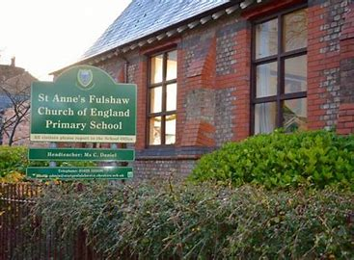

St. Anne’s Fulshaw Primary School Eco Garden Project
St. Anne’s Fulshaw is the oldest existing school in Wilmslow, situated in the heart of the Chapel Lane community. Our school is on Nursery Lane, directly opposite St Anne’s Fulshaw Church, which houses our local preschool, and is close to the local shops.
Our front garden is a small patch of land, bordering directly onto the pavement of Nursery Lane and is clearly visible to all passers-by and neighbours. Currently, the garden contains old, overgrown shrubs and self-seeded trees.
It obscures the front of our building, (including an original plaque with the school motto) and is a wasteland.
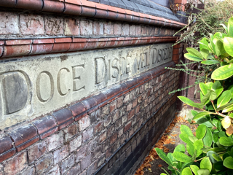
By improving this garden, we would be enhancing the local environment for everyone in our neighbourhood, as well as encouraging biodiversity and creating wildlife habitats.
Our entire school has been involved in creating ideas for our garden and the children are very excited at the prospect of creating a wildlife habitat. Attached are some of the most interesting submissions* from our children, aged 5-11.
The Eco Committee, (Molly, Evelyn, Elina, Muhammad, Zara, Althea and Emily), which consists of Year 5/6 students, have created our plan and provided more detailed drawings of each part of the design,* also attached.
Traditionally, our Eco Committee organise recycling, and run competitions to engage our pupils in learning about green issues, and it will be their responsibility to help maintain our garden once constructed. They will be supported by Mrs. Freeman, our ‘gardening TA’, and her gardening club, which contains children of all ages in school.
We need funds to buy trees and specimen plants for our garden; a list of plants we intend to use follows. Some of these suggestions have been taken from “RHS - Gardening in a Changing Climate”, others are plants we have had previous success growing in our gardens behind school. Where possible, we will use the expertise, and buy plants from, our very local plant supplier, “Blackbrook Herbs”, which is actually situated on Nursery Lane.

Selected Trees:
Crab apple- for blossom and fruit
Amelanchier
Holly- existing and evergreen
Shrubs:
Buddleia- existing
Berberis- berries for birds
Forsythia
Shrub roses- for the flowers and hips
Pollinator-friendly plants - a diverse variety of native and non-native plants
Clematis montana- growing through railings
Honeysuckle- growing through railings
Borage- for bees
Michaelmas daisies- late flowering
Tickseed
Yarrow
Foxglove- no hazard to children as access is supervised
Marigold
Nettles- for butterflies
Ajuga- for bees
Lavender and verbena

For sustainability, we will be placing water butts in the garden where they can catch the rain from the school guttering. Gardening in our school has always been organic and we will only use peat free products.
Animal Habitats
Very importantly, our garden will have a wildlife pond. We intend to reuse a preformed pond which has been donated. This will provide a small shape with shelves, on which we can plant different types of marginal plants, and will allow access to visiting animals such as frogs, toads and other wildlife like foxes and hedgehogs. These animals can access the garden freely as two sides are surrounded by railings. Please see attached images of our plan for the pond *and an image of our ideal wildlife pond, which is surrounded by pebbles and shade giving plants.
We will be repurposing an old bookcase to create a bug hotel, using canes, pine cones and other suitable garden materials and will create log piles for minibeasts, which will also allow animals to shelter or hibernate.
We intend to build a hedgehog house from wood and other recycled materials. We have already had success with one of these on our school field. The pupils have been “Hedgehog Heroes” for several years, supporting the work of the Hedgehog Conservation Trust and encouraging our neighbours to extend the Hedgehog Highway into their gardens. Improving our front garden would help further extend our Hedgehog Highway.
We already feed the birds and have bird boxes made by pupils in our grounds at the rear of school. We will be delighted to provide birds with food and water at the front of the school as well, for neighbours to enjoy. This will be a regular extra task for the children.
We need materials to construct a gravel path through the garden to allow us to visit without damaging the habitats and plants. Our intention is for the entire school to use this area in wildlife studies. We will use yellow rattle to suppress the growth of grass in this area as this would hinder growth of the other plant species.
We already teach the children about sustainability, recycling and climate change, but this garden will enhance the opportunity to show what this means, to share this learning with the local community, and for the children to teach and learn from example.
The Eco Committee have suggested designing and making a flag to fly from the existing flag pole, to advertise our garden, and to encourage others to change their green spaces to encourage biodiversity. We intend to ask the local WI to help with the making of our flag; their sewing group helped us to create a beautiful tapestry to celebrate the school’s 140th anniversary in 2016. The children would also like to create a noticeboard to pass on information about our projects to passing pedestrians.
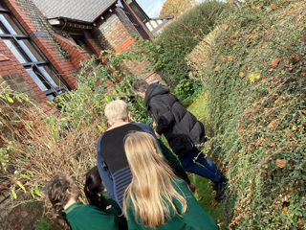
We have asked for advice from “Transition Wilmslow” and Mel Harris visited school to meet the children, inspect our plans and offered her ongoing support.

The school also has an excellent relationship with “Love the Lane”, a community group which has revamped Chapel Lane and the surrounding area.
Creating an Eco garden would give pupils and parents the chance to increase the biodiversity of our school environment, learn how to create these environments elsewhere, and enjoy watching the garden grow and mature.
By improving this urban space, we would be creating an enduring legacy for the entire Fulshaw community and enhancing the wellbeing of all involved.

