CHESTNUT CLASS 2026-2027
AUTUMN TERM
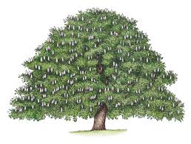
Dear Parents and children in Chestnut Class,
Welcome back to school after the summer. Here are some bits of information about what we will be doing this term.

Activities and Class Topics

Literacy
Our first unit of work will be based on “Ocean Meets Sky” by the Fan Brothers. This is a beautifully illustrated book about a dream and we will use it to create our own dream narratives. Our second text will be “The Search for the Giant Arctic Jellyfish” by Chloe Savage. Using this book, the children will create their own captain’s log.
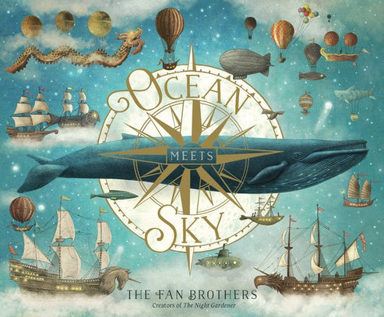

Mathematics
For maths we will be teaching from the White Rose scheme and through this scheme the children will develop understanding and skills in place value; mental calculation and paper and pencil procedures for addition, subtraction, multiplication and division; recognising and calculating fractions and decimals, data handling and reasoning about shapes and measures, position and direction. We will work on learning times tables throughout the year and use TTRockstars to help us.

History and Geography
Our first topic will be all about Antarctica. We will be finding out about latitude and longitude and how these relate to climate around the world. Considering living in Antarctica, learning about Shackleton’s expedition and using grid references .
In history we will explore how children’s lives have changed over time. We will look at the work children did in Tudor and Victorian times and find out about the changes Lord Shaftesbury made. We are planning a day at Quarry Bank Mill on Friday 20th November where the children can experience children’s living and working conditions for themselves.

DT and Art
In art sessions we will be looking at the drawings of Alex Sheffler . We will be learning about line, pattern, texture, form, tone and shading as well as learning to question, observe and refine our own work.


Science
Our first theme in science will be forces and magnetism. Learning about contact and non-contact forces, including friction and magnetism. Our second theme will be

PE
Our class will have PE on Thursdays and Fridays this term, so all children need to have their kit in school on these days; however, it would be useful for your child to have a PE kit on their peg all week. As the weather grows colder, I would also recommend a sweatshirt and joggers or track suit to be available in their PE bag. Our lessons this term will be problem solving and cricket on Thursdays with Mrs. Campey and Football with Stockport FC on Fridays.

Reading
Reading is a very important part of everything we do in Chestnut Class. Sometimes we will share a book as a whole class, other times we will read individually. Children who still need support will be worked with each day but every day we have a quiet reading time and once a week each child will take part in a group reading or writing session to develop their reading and writing skills and discuss texts. Children are encouraged to read regularly, preferably every day, at home and will bring home their new reading records in the first few days.

Mrs Campey will teach Chestnut Class every Thursday

Computing
We will be learning about networks and the internet and after half term we will move on to computer systems and networks.
RE:
In our first half term we will be learning about creation from the views of many religions. Our second theme will be

Homework
Once we have settled into school, your child should receive 2 or 3 pieces of homework each week, as follows: Maths workbooks, a literacy or topic based piece and a spelling pattern to learn. Spellings will be tested on Fridays. Maths and Literacy homework will be given on Tuesdays and due back in school the following Monday. Each child will be given a homework diary this year and we ask you to check and sign it each week to let us know that the homework has been done.

Extra Information
Bags We ask the children to bring in a pump bag each week, as mentioned, and it is crucial that this bag is a drawstring bag as we will be keeping these bags in our small cloakroom. We do not have the room for every child to bring in a backpack each day, our cloakroom is small, back packs drop to the floor and cause a significant trip hazard. If you feel your child needs to use a backpack please let me know, but otherwise please only use a backpack on days where your child is going to an after school club such as WFA, and needs extra kit in school.

Water: We encourage the children to drink water during the day and therefore encourage them to bring in a water bottle. Please ensure your child’s bottle is labelled and we will remind them to bring the bottle home daily for washing!

Pencil cases Children are allowed to bring a pencil case from home, though this is not a necessity, please limit the size of the case as large cases take up valuable room on the desks.

This year we will have Mrs. Sizemore in class to support our children. We hope this information is helpful but do feel free to share any concerns or worries you may have regarding your child.

Kind regards
Jacky Chapman and Charlotte Campey (teachers)
jchapman@stannesfulshaw.net
ccampey@stannesfulshaw.net
Sam Sizemore (TA) ssizemore@stannesfulshaw.net

