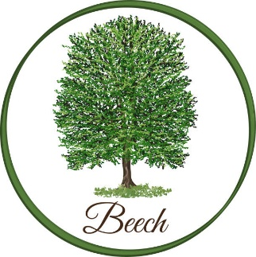
Summer Term

Dear Parents,
We had a wonderful time on our residential trip to Ghyll Head just before the Easter holiday. The children were fantastic throughout—they showed great enthusiasm, resilience, and teamwork, and were an absolute joy to take.
This term in English, we will be reading A Story Like the Wind by Gill Lewis. The children will explore themes, characters, and setting in depth, building up to writing their own engaging flashback narrative, focusing on descriptive language and structure.
In Maths, we are continuing to follow the White Rose scheme, which the children are already familiar with. We will begin the term with statistics, learning how to interpret and present data using a range of graphs and charts. Please continue to encourage your child to practise their times tables regularly, as this supports their confidence and progress across all areas of maths.
In Science, we will be exploring Light and Reflection. The children will investigate how light travels, how we see objects, and how reflections are formed. They will carry out practical experiments using mirrors and different light sources, and learn about shadows, including how they change in size and direction.
In History, we will be studying the impact of World War 2, looking at how it affected people’s daily lives, including evacuation, rationing, and the role of key events and figures.
In Art, we will be exploring the work of the artist Njideka Akunyili Crosby. The children will study her unique style, which combines painting, collage, and photography, and they will experiment with mixed media techniques to create layered, personal pieces inspired by her work. They will also develop their skills in composition, texture, and storytelling through art.
In PE, we will be developing our netball skills, focusing on passing, movement, and teamwork, as well as improving our understanding of the rules of the game. In athletics, we will work on running, jumping, and throwing techniques, building both skill and stamina. On Fridays, we will continue with football, where the children will develop their control, coordination, and game awareness. PE bags should be brought into school on Mondays and taken home on Fridays.
Homework will be given out on Wednesdays and is due in on Mondays. I will also be running a homework club on Wednesdays straight after school until 4pm. This is a great opportunity for children to complete their homework in a supportive environment, with help available if needed.
Kind regards,
Mrs H Watts and Mr M Lewis
hwatts@stannesfulshaw.net

