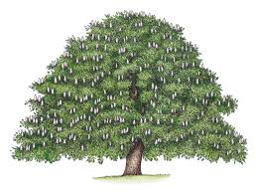

Dear Parents and children in Chestnut Class

Welcome back to school after our Christmas holiday and thanks to everyone for their generous Christmas gifts.
Here are some bits of information about what we will be doing this term.

Activities and Class Topics

Literacy
Our first unit of work will be based on “Dear Earth” by Isabel Otter. We will be working up to writing our own letters to the environment. Our second text will be “Arthur and the Golden Rope” by Joe Todd- Stanton. Inspired by this book we will write our own mythical narratives and information guides.
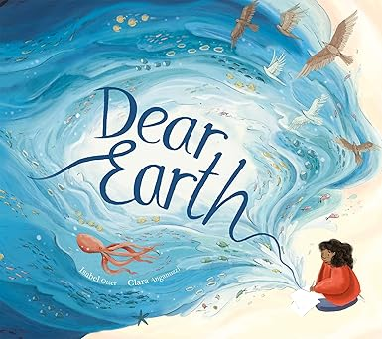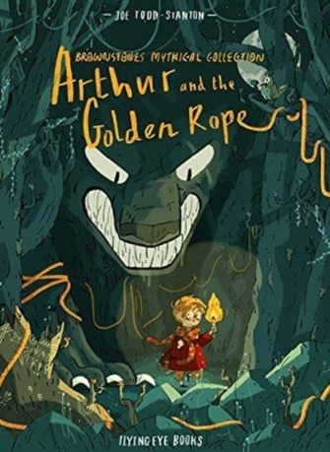

Mathematics
For maths we will be teaching from the White Rose scheme and through this scheme the children will develop understanding and skills in place value; mental calculation and paper and pencil procedures for addition, subtraction, multiplication and division; recognising and calculating fractions and decimals, data handling and reasoning about shapes and measures, position and direction. We will work on learning times tables throughout the year and use TTRockstars to help us. More emphasis will be put on TTRockstars homework, as this practise is so essential to all of our Maths development in KS2.

History and Geography
In our first topic will be asking “Why do we need Rainforests?” This topic ties in beautifully with our literacy topic and will teach us about the structure and environmental importance of rainforests
In history we will be asking “why did the Romans settle in Britain?”

DT and Art
In Art sessions we will be learning about Georgia O’Keefe and looking closely at her beautiful enlarged flower paintings and working towards creating our own.
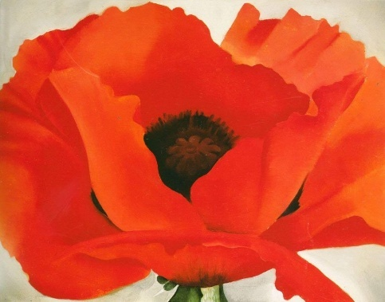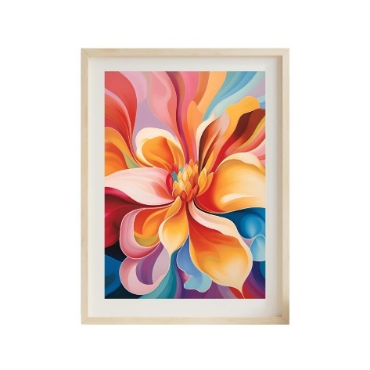
In DT we will be building our own castle inspired structures.

Science
Our first theme in science will be Rocks, Soils and Fossils. This builds on work touched on in our Volcano topic last term. Our second theme will be “living things and their Habitats”, a perfect topic for Spring.

PE
As before, our class will have PE on Thursdays and Fridays, so all children need to have their kit in school on these days; however, it would be useful for your child to have a PE kit on their peg all week. With the weather growing colder, I would also recommend a sweatshirt and joggers or track suit to be available in their PE bag and for girls who wear tights in school, to be sure they have socks in their kit. If your child has long hair, please make sure they have it tied up for lessons. Our lessons this term will be dance and then hockey on Thursdays with Mrs. Campey and Football with Stockport FC on Fridays.

Reading
Reading is a very important part of everything we do in Chestnut Class. Sometimes we will share a book as a whole class, other times we will read individually. Children who still need support will be worked with each day but every day we have a quiet reading time and once a week each child will take part in a group reading or writing session to develop their reading and writing skills and discuss texts. Children are encouraged to read regularly, preferably every day, at home and will bring home their new reading records in the first few days.

Mrs Campey will teach Chestnut Class every Thursday

RE
We will start by learning about Islam and researching some key questions: Is Muhammad important to all Muslims? How have religious people contributed to local and world history?
We will then move to Judaism and revisit the life of Abraham and Moses.

Computing
This term we will be creating video trailers by taking photographs and recording videos to tell a story then using software to edit and enhance their media by adding music, sounds and text with transitions.
Later in the term the children will experience creating their own websites and create content for it.

Homework
Once we have settled into school, your child should receive 2 or 3 pieces of homework each week, as follows: Maths workbooks, a literacy or topic based piece and a spelling pattern to learn. Spellings will be tested on Fridays. Maths and Literacy homework will be given on Wednesdays and due back in school the following Tuesday. Each child will be given a homework diary this year and we ask you to check and sign it each week to let us know that the homework has been done.

In the weekend of 23rd and 24th January, I will be asking the class to take part in the Big Garden Birdwatch for the RSPB. For more info please go to Big Garden Birdwatch. Please encourage your child to start feeding the birds now, this should ensure some feathered visitors when we need to count them.

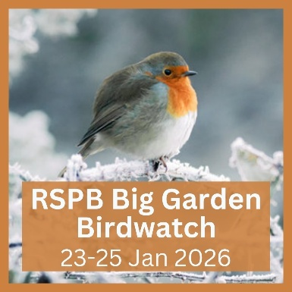

Extra Information
Bags : We ask the children to bring in a pump bag each week, as mentioned, and it is crucial that this bag is a drawstring bag as we will be keeping these bags in our small cloakroom. We do not have the room for every child to bring in a backpack each day, our cloakroom is small, back packs drop to the floor and cause a significant trip hazard. If you feel your child needs to use a backpack please let me know, but otherwise please only use a backpack on days where your child is going to an after school club such as WFA, and needs extra kit in school.
Last term many children missed PE sessions because they had no kit. It is really important that all children receive 2 PE sessions each week so please ensure their kit is in school.
Water We encourage the children to drink water during the day and therefore encourage them to bring in a water bottle. Please ensure your child’s bottle is labelled and we will remind them to bring the bottle home daily for washing!

Pencil cases Children are allowed to bring a pencil case from home, though this is not a necessity, please limit the size of the case as large cases take up valuable room on the desks. Pencil cases must fit in your child’s drawer. Please ensure you child does not bring in toys to play with in class.

Kind regards,

Jacky Chapman and Charlotte Campey (teachers)
jchapman@stannesfulshaw.net
ccampey@stannesfulshaw.net

Dawn Freeman and Sam Sizemore (TAs)

