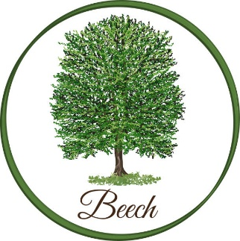
Spring Term

Dear Parents,
Welcome back after the Christmas holiday and thank you so much for all your generous gifts.
This term in English, we will be reading the graphic novel The Hound of the Baskervilles to inspire our writing. We will explore character, atmosphere, and suspense to develop engaging narrative writing skills.
In Maths, we are continuing to use White Rose, which the children are familiar with. We are starting the term with fractions and decimals. Please encourage your child to continue learning their times tables, as this helps them in all areas of maths.
In Science, we will explore Earth and space, learning about day and night and the movement of the Earth, planets, and the Moon.
In History, we will learn about what life was like during Tudor times, exploring daily life, homes, and important events.
In Art, we will explore the work of the artist Hundertwasser, using his style to inspire our own creative designs.
In PE, we will be developing our hockey skills on Wednesdays, focusing on teamwork, coordination, and gameplay. On Fridays, we will continue with football.
PE bags need to be brought into school on Mondays and taken home on Fridays. On Wednesdays, we will be developing our hockey skills, focusing on teamwork, coordination, and gameplay, and Fridays will continue to be football with Brendan from SCFC.
Mrs Young will teach Music on Tuesdays. This term, we will explore Indian music using GarageBand, with a focus on creating and performing our own pieces.
Homework will be given out on Wednesdays and is due in on Mondays. I will be running a homework club on Wednesdays straight after school until 4pm. This is the perfect opportunity for the children to complete their homework with support, if needed.
Key Dates
- Tuesday 10th February – Beech Class Winter Warmer (Grandparents’ Lunch)
- Wednesday 25th February – Beech Class Assembly, 2.30pm
- Monday 2nd March and Tuesday 3rd March – Parents’ Evening
- Monday 23rd March – Wednesday 25th March – Ghyll Head Residential
- Ghyll Head Residential information evening – TBC
Kind regards,
Mrs H Watts and Mr M Lewis
hwatts@stannesfulshaw.net

