WEEK ONE | FAVOURITES MONDAY | WORLD TUESDAY | ROAST WEDNESDAY | PIZZA PARTY THURSDAY | FISH FRIDAY
Main Meal | Red Tractor Pork Sausage Roll/ Halal Chicken sausage Roll & Home-baked Potato Wedges | Beef /Halal Beef Taco with Corn Tortilla, Tomato Sauce & Sunny Rice | Roast Chicken/ Halal Roast Chicken, Gravy, Yorkshire Pudding & Roast Potatoes | Margherita Pizza & Home-baked Potato Wedges | MSC Fish Fingers & Chips
Vegetarian Main Meal | Macaroni Cheese | Italian Quorn Meatballs served with Pasta VG   | Quorn Grill, Gravy, Yorkshire Pudding & Roast Potatoes | Vegetable Sausage in a Bun with Home-baked Potato Wedges VG | Vegetable Fingers & Chips
Baked Jacket Potatoes/ Sandwiches/ Pasta | Jacket Potato with Cheesy Beans, Tuna Mayo or Cheese or Beans   | Pasta with Tomato & Basil Sauce | Jacket Potato with Cheesy Beans, Tuna Mayo or Cheese or Beans | Freshly Made Sandwich with Cheddar, Tuna Mayonnaise or Ham | Jacket Potato with Cheesy Beans, Tuna Mayo or Cheese or Beans
Dessert | Vanilla Shortbread ^{VG}  & Chocolate Sauce | Chocolate & Pear Crumble ^{VG}  & Custard   | Strawberry Jelly ^{VG} | Oaty Date Cookie | Vanilla Ice Cream
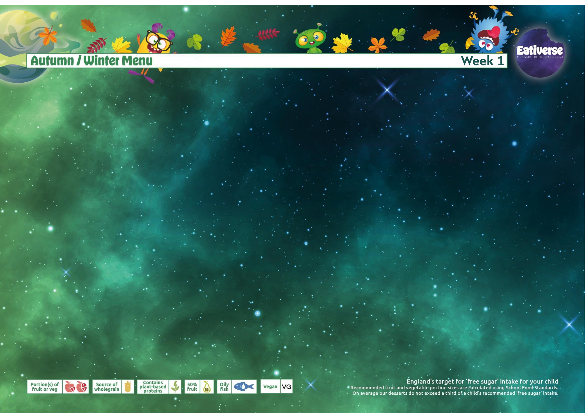

Available Daily: Fresh Bread, Selection of Vegetable and Fresh Salad, Fresh Fruit & Yoghurt

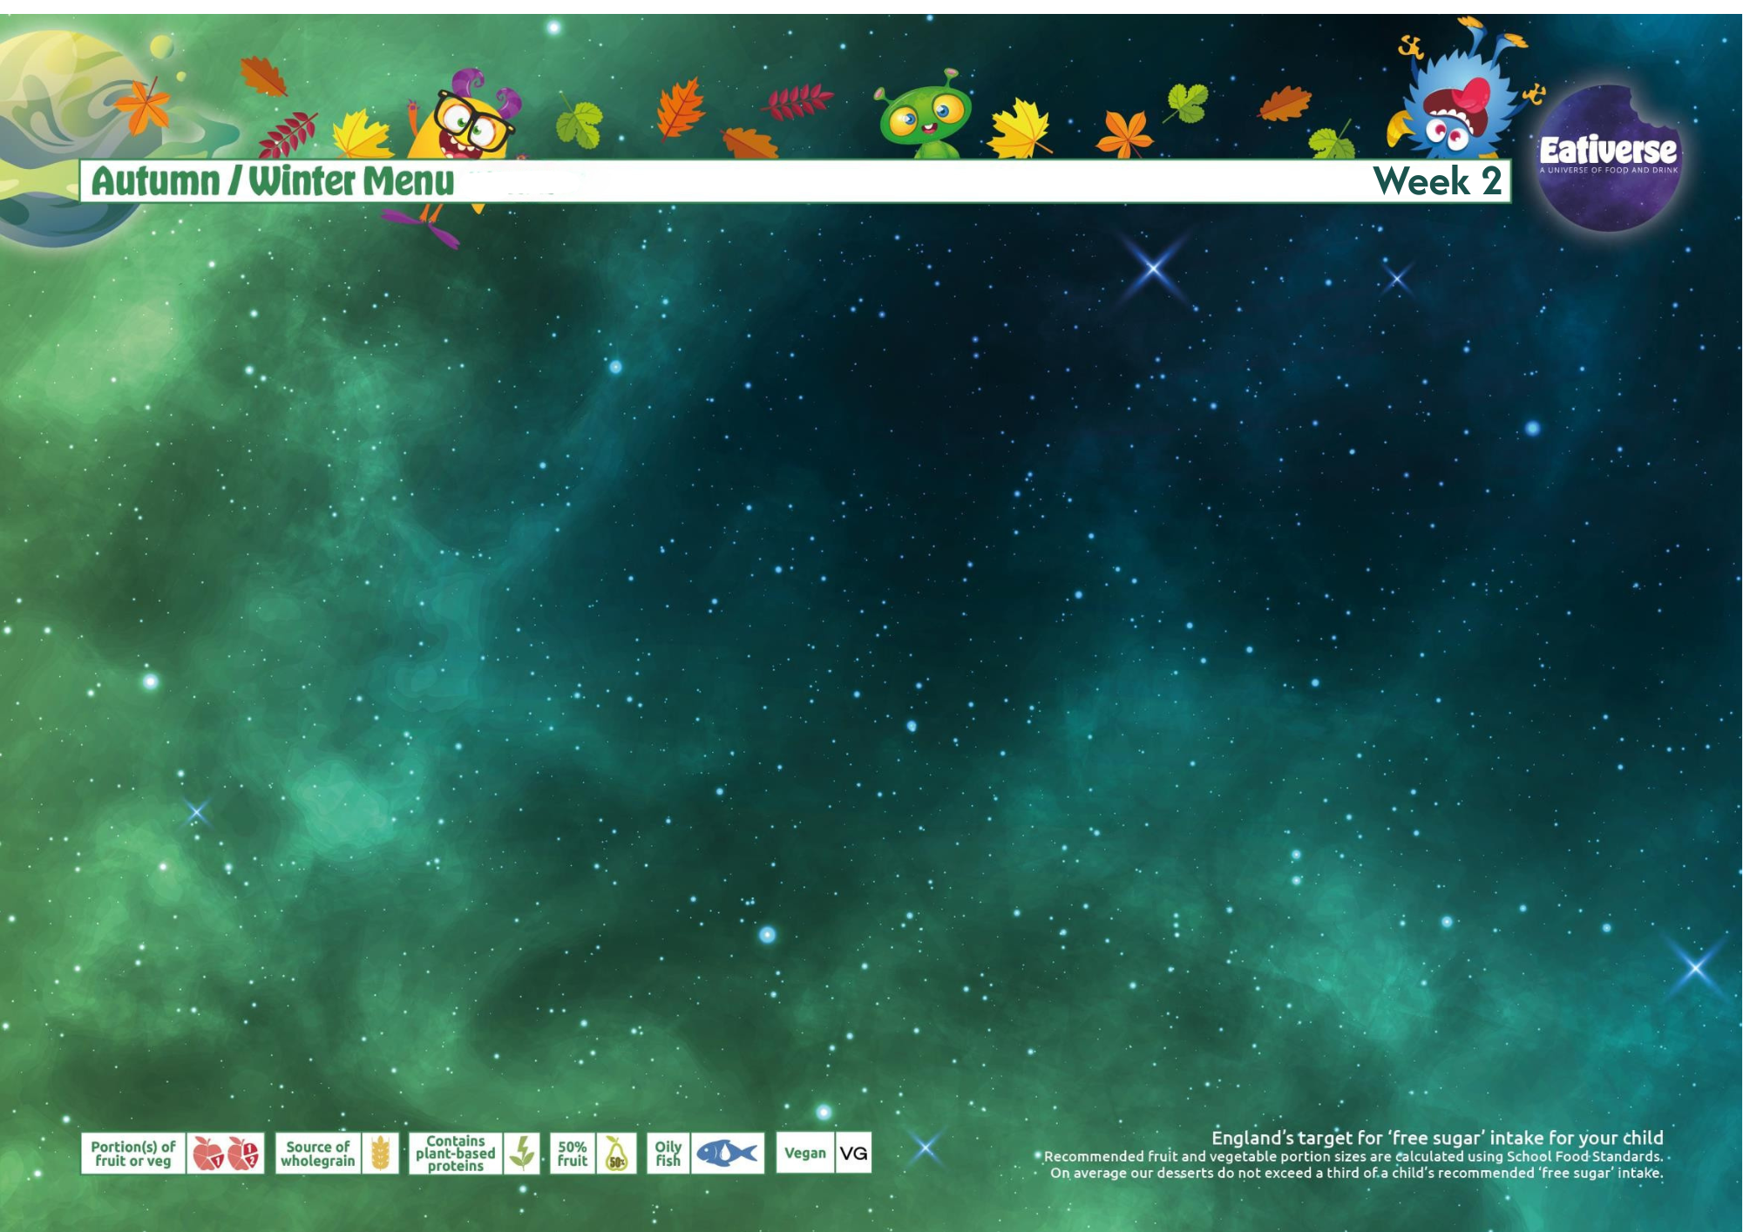

WEEK TWO | FAVOURITES MONDAY | WORLD TUESDAY | ROAST WEDNESDAY | PIZZA PARTY THURSDAY | FISH FRIDAY
Main Meal | Pork Sausage/ Halal Chicken Sausage with Mash & Gravy | Red Tractor Beef Pasta/ Halal Beef Pasta Bolognese & Garlic Bread   | Roast Chicken/ Halal Roast Chicken, Gravy, Yorkshire Pudding & Roast Potatoes | Margherita Pizza & Home-baked Potato Wedges | MSC Battered Pollock & Chips
Vegetarian Main Meal | Veggie Sausage & Mash with Gravy ^{VG} | Plant-based Pasta Bolognese & Garlic Bread | Quorn Grill, Gravy, Yorkshire Pudding & Roast Potatoes | Vegetable Chili & Sunny Vegetable Rice VG | Roast Mediterranean Vegetable, Tomato and Mozzarella Tart
Baked Jacket Potatoes/ Pasta | Jacket Potato with Cheesy Beans, Tuna Mayo or Cheese or Beans | Jacket Potato with Cheesy Beans, Tuna Mayo or Cheese or Beans | Pasta with Tomato & Basil Sauce | Jacket Potato with Cheesy Beans, Tuna Mayo or Cheese or Beans | Pasta with Tomato & Basil Sauce
Dessert | Shortbread Pin Wheels & Fruit Slices ^{VG} | Chocolate Fudge Cake | Apple Crumble VG & Custard | Flapjack ^{VG} | Chocolate Mousse

Available Daily: Fresh Bread, Selection of Vegetable and Fresh Salad, Fresh Fruit & Yoghurt

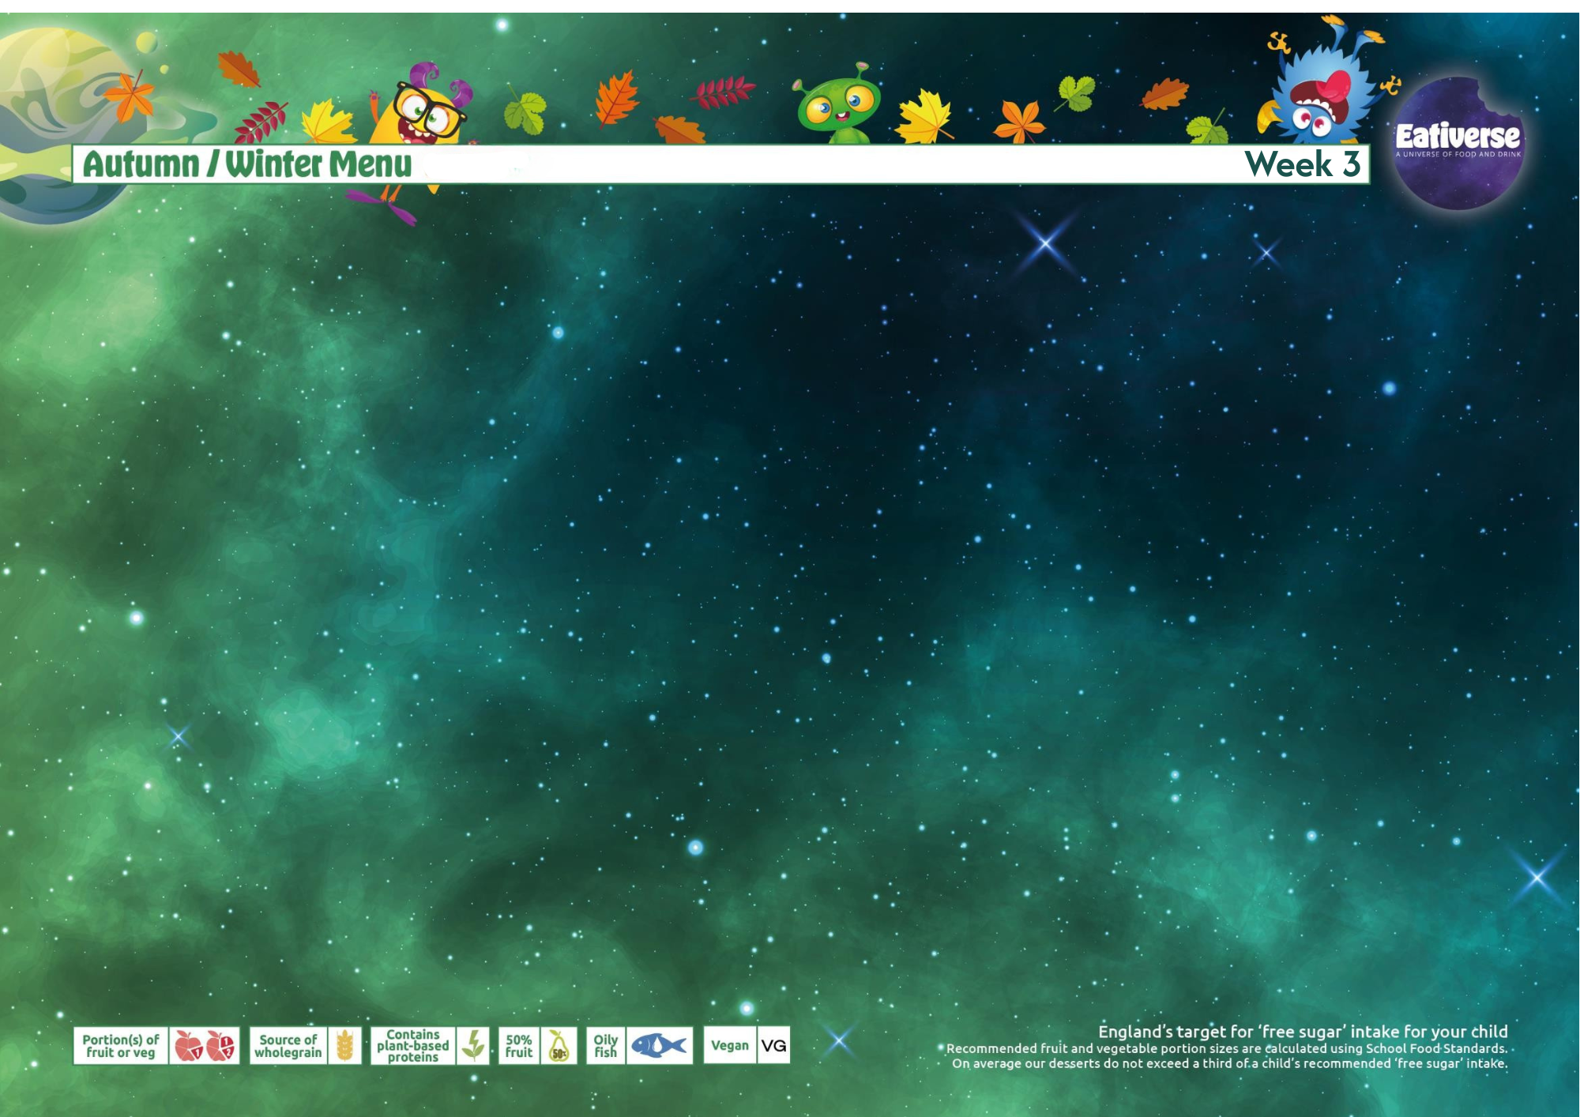

WEEK THREE | FAVOURITES MONDAY | WORLD TUESDAY | ROAST WEDNESDAY | PIZZA PARTY THURSDAY | FISH FRIDAY
Main Meal | Beef Burger/ Halal Lamb Burger with Home-baked Potato Wedges | Mild Chicken /Halal Chicken Curry served with Mixed Rice | Roast Gammon/ Halal Chicken, Gravy, Stuffing & Roast Potatoes | Margherita Pizza & Home-baked Potato Wedges | MSC Fish Fingers & Chips
Vegetarian Main Meal | Vegetable Burger with Home-baked Potato Wedges | Vegetable Sausage Hotdog served with Home-baked Wedges | Quorn Grill, Gravy, Stuffing & Roast Potatoes | Sweet & Sour Vegetables & Sunny Rice VG | Cheese & Onion Roll with Chips & Ketchup
Baked Jacket Potatoes/ Pasta | Jacket Potato with Cheesy Beans, Tuna Mayo or Cheese or Beans | Pasta with Cheese or Tomato & Basil Sauce | Jacket Potato with Cheesy Beans, Tuna Mayo or Cheese or Beans | Pasta with Tomato & Basil Sauce | Jacket Potato with Cheesy Beans, Tuna Mayo or Cheese or Beans
Dessert | Chocolate Oaty Slice VG | Syrup Sponge Pudding & Custard | Apple & Cinnamon Rolls | Vanilla Cookie & Fruit Slice VG | Iced Sponge Cake with Sprinkles
Available Daily: Fresh Bread, Selection of Vegetable and Fresh Salad, Fresh Fruit & Yoghurt

