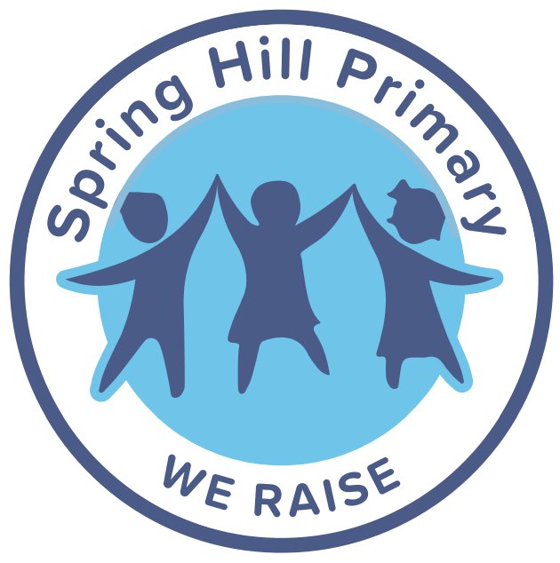
Anti Bullying Policy

September 2026

At Spring Hill Community Primary School, we are committed to creating an inclusive and equitable environment where all children, regardless of their background or protected characteristics, are treated with respect and dignity. We have taken several measures to eliminate discrimination and other prohibited conduct in accordance with the Equality Act 2010. At Spring Hill Primary School, we see the need for a positive and effective equality. More information on this is available in our Equality policy.

Philosophy & Purpose

Spring Hill Community Primary School believes everyone is equal and deserves to be treated with dignity and respect. Bullying in any form is unacceptable and can have serious, long-lasting effects on children’s wellbeing, learning and happiness. This policy aims to ensure a safe and nurturing environment, where bullying is prevented, challenged, and addressed consistently.
Our key aims are:

- To ensure a secure and happy environment free from threat, harassment, discrimination, or any form of bullying behaviour.
- To create a culture where all members of the community are treated with dignity and respect and understand that bullying is never acceptable.
- To ensure a consistent and thorough approach to preventing, challenging, and responding to bullying incidents.
- To inform pupils, parents and staff of the school’s expectations and foster partnership to maintain a bullying free environment.
- To outline the school’s commitment to continuously improving the approach to tackling bullying through monitoring and review.

Legal & Regulatory Framework

This policy is informed by and operates in accordance with:
- The Education and Inspections Act 2006
- The Equality Act 2010
- The Children Act 1989 and 2004 (safeguarding duties)
- Statutory guidance: Keeping Children Safe in Education
- DfE guidance: Preventing and Tackling Bullying and Behaviour in Schools.
- Data protection legislation (GDPR) and the school’s own Data Protection Policy
- The school’s own Behaviour Policy, Safeguarding Policy and SEND/Inclusion Policy.

The Governing Body will review this policy annually. The policy will be published on the school website and shared with staff, pupils and parents via newsletters or induction.

Definition of Bullying

Bullying is defined as deliberately hurtful, unkind, or threatening behaviour which is intentional, repeated, and involves a real or perceived imbalance of power between the perpetrator and the target. It may be carried out by an individual or a group, towards an individual or a group.
Forms of bullying include, but are not limited to:

- Physical (e.g., hitting, kicking, pushing, inappropriate or unwanted physical contact)
- Verbal (e.g., name calling, ridicule, comments)
- Relational / social (e.g., excluding someone, spreading rumours, ostracising)
- Cyber / online (e.g., messaging, social media, email aimed at upsetting someone)
- Child on Child abuse (including sexual harassment, discriminatory or prejudice-based bullying)
- Visual or written (e.g., graffiti, gestures, wearing offensive insignia)
- Damage to individual property, theft, or extortion

At Spring Hill, we do not consider bullying to be:
- Isolated incidents (physical or verbal)
- A ‘falling out’
- A ‘one off’ disagreement

Bullying may be motivated by prejudice or negative attitudes toward someone’s:
- Race or ethnicity
- Religion or belief
- Sex or gender
- Sexual orientation
- Disability or special educational needs
- Appearance or health condition
- Family or caring responsibilities
- Any vulnerable characteristic

Roles and Responsibilities

All members of the Spring Hill Community Primary School have a shared responsibility to prevent and respond to bullying. The Governing Body is responsible for ensuring the policy is up to date, implemented effectively, and monitored for impact. The Headteacher and Senior Leadership Team (SLT) oversee the day-to-day management of bullying concerns, ensuring appropriate investigation, intervention, and reporting, and maintaining a positive school climate. The Pastoral Team provides targeted support for pupils affected by bullying, delivers preventative programs, and works closely with staff, pupils, and families to promote emotional wellbeing. Class teachers and support staff are responsible for supervising pupils, modelling positive behaviour, challenging bullying, and recording any incidents in CPOMS promptly. Pupils are encouraged to act as active bystanders, report incidents, and support peers in line with the school’s RAISE values. Parents and carers are expected to support the school’s approach by reinforcing positive behaviours at home, communicating concerns, and working collaboratively with staff to resolve issues. Together, this collaborative approach ensures a safe, inclusive, and respectful environment for all.

School Ethos and Culture – RAISE Values & Behaviour Curriculum

Our RAISE Values (Responsibility, Aspirational, Inclusivity, Service, Empowerment) permeate every aspect of school life. Through the Behaviour Curriculum and our broader curriculum, we teach pupils:
- What positive behaviour looks like and sounds like
- How to reflect on their actions and their impact on others
- To be inclusive, supportive and respect differences
- To speak up, seek help, and support others

Assemblies, PSHRE, computing, and cross curricular themes reinforce these values. Pupils are encouraged to develop resilience, empathy, and responsible behaviour. The school recognises that behaviour is a form of learning—hence our structured Behaviour Curriculum supports pupils in developing social and emotional skills, interpreting behaviour expectations, and understanding consequences.

Protected Characteristics

- We explicitly address bullying based on protected characteristics, in line with the Equality Act 2010. Pupils learn about and are supported to respect:
- Race
- Disability
- Religion or belief
- Sex (boys/girls)
- Sexual orientation (age-appropriate language)
- Family structure
- We will not tolerate derogatory, discriminatory, or harassing behaviour or language targeting any of these characteristics. Staff will challenge and record such language and behaviour as a priority.

Prevention & Early Intervention

Whole school culture
- Senior Leadership Team, all staff, governors, pupils, and parents work collaboratively to create a climate of mutual respect.
- Staff model respectful, inclusive behaviour and intervene when they observe unkind or exclusionary behaviour.
- We ensure safe spaces and trusted adults, so pupils feel comfortable reporting incidents.

Curriculum & education
- Our PSHRE, computing (and other subjects) includes lessons on relationships, difference, anti-bullying and online behaviour.
- Assemblies and workshops address topics such as “What is bullying,” “How to intervene as a bystander,” “Online safety” and “Respecting difference.”
- Pupils are involved in developing anti-bullying work through weekly behaviour lessons.

Specific initiatives
- We run Anti-bullying Week (including Odd Socks Day) annually to highlight bullying issues and celebrate difference.
- Pupils are provided with tools to report privately (e.g., “What I Want My Teacher to Know” notes).
- Staff supervision is particularly vigilant at vulnerable times and places (arrival/departure, break/lunch times, cloakrooms, toilets, corridors).
- We use mentoring, social skills groups, and pastoral check-ins for children identified as vulnerable or at risk.

Reporting & Recording Procedure

Reporting
- Pupils, parents, or staff can report bullying.
- Pupils can use a “What I Want My Teacher to Know” note, speak to any trust adult in school, or speak to the Pastoral Team / SLT.
- Parents can contact the class teacher, Pastoral Team, or Headteacher via the school office or email.
Recording
- All bullying concerns (including allegations of bullying) are logged on CPOMS, under the appropriate category.
- Records will include date/time, persons involved, type of bullying, description, action taken, outcome, follow up.
- The designated behaviour lead/SLT monitors the data, analyses for patterns, reports termly to governors.

Investigation
We use the guidance and recommendations from the Anti-Bullying Alliance when addressing all allegations of bullying.
- A member of SLT or Pastoral Team leads each investigation.
- Steps:
- Ensure the safety and support of the pupil(s) affected.
- Conduct interviews with all parties (victim, alleged perpetrator, and any witnesses).
- Determine whether the incident meets the bullying definition.
- Consider any safeguarding issues: if there is reasonable cause to suspect significant harm, refer to children’s social care (Children Act 1989).
- Meet with parents/carers of both target and perpetrator (as appropriate) to explain findings and agreed actions.
- Document outcome and next steps, including monitoring arrangements.

Responding to Bullying – Intervention & Consequences

Support for the child who experienced bullying
- Pastoral support plan agreed with the pupil, class teacher, and pastoral staff.
- Check-ins with a trusted adult.
- Peer support or mentoring as appropriate.
- Adjustments (e.g., seating plans, supervision) to ensure safety.

Supporting the child displaying bullying behaviour
- Behaviour support plan including targeted intervention (social skills group, mentoring).
- Restorative justice approach: conversation between parties (if safe), reflection on impact, repair work.
- Sanctions appropriate to the nature of the behaviour (loss of privileges, internal exclusion, fixed term exclusion only in extreme circumstances) aligned to the Behaviour Policy.
- Monitoring of behaviour plan and review of progress.

Whole class or community responses

- Assemblies or class sessions may address themes if incidents affect multiple pupils.
- Review supervision/lunchtime/recess arrangements if patterns appear.
- Work with parents to reinforce home-school partnership.

Cyberbullying
- Online bullying is treated as seriously as face-to-face bullying if it affects pupils’ school life or wellbeing.
- Pupils are taught digital safety via our computing and PSHRE curricula (e.g., safe use of social media, what to do if they receive upsetting messages).
- Staff will record online or digital incidents on CPOMS, investigate and may involve external agencies (CEOP, police) when necessary.
- The school may confiscate devices or restrict access when online behaviour breaches school rules.
- Parents are provided with guidance and encouraged to monitor children’s online activity.

Bullying Outside School

- The Headteacher or SLT may act when bullying occurs off school premises (e.g., on the way to or from school, on social media, during school organised trips) if it impacts the individual’s safety, learning or school community.
- Where appropriate, the school will liaise with external agencies (police, local authority, transport providers) to manage off‐site issues.

Derogatory or Prejudice Based Incidents

- Derogatory or offensive language (including homophobic slurs, racist remarks, ableist comments) is unacceptable and will be challenged, recorded, and monitored.
- A prejudice-based incident is defined as one-off unkind behaviour motivated by prejudice. Even if it does not meet bullying criteria, it will be recorded and addressed.
- The school uses these records to target interventions, monitor trends and review its approach.

Training, Monitoring & Review
- The Headteacher ensures all staff (teaching assistants, welfare staff) receive training on the anti-bullying policy and interventions.
- DSL and SLT are responsible for day-to-day monitoring analysing CPOMS data, identifying trends, producing termly reports to governors and staff.
- Governors review policy impact through data, pupil voice, staff feedback, learning walks and focus groups.
- The policy is formally reviewed every 12 months (or sooner if needed), with consultation of staff, pupils, parents, and governors.

Support for Vulnerable Pupils

- Pupils with SEND, those with social, emotional, or mental health needs, or from vulnerable backgrounds may be at increased risk of bullying.
- The school will proactively identify such pupils and provide:
- Additional adult check ins
- Small group intervention (friendship groups, social skills)
- Liaison with external agencies (CAMHS, family support, behaviour specialists)
- Reasonable adjustments to address needs (e.g., visual supports, alternative play spaces)

Working with Parents & Carers

- The school values effective partnership with families.
- On receipt of a report, parents will be informed of the incident, offered meetings, and included in next step planning.
- Parents are encouraged to contact the school with concerns and to support their child in reporting bullying, modelling positive digital behaviour, and promoting the RAISE values at home.

Data Protection & Confidentiality

- All CPOMS records are stored securely, access restricted to relevant staff (DSL, SLT).
- Records are retained following the school’s Data Protection and retention policy.
- Confidentiality is maintained: pupils involved will be made aware of how the school is responding, but identity of others may only be disclosed where strictly necessary and in line with safeguarding obligations.

Links with Other Policies
This anti-bullying policy should be read in conjunction with the following school policies:
- Safeguarding & Child Protection Policy
- Behaviour Policy
- Online Safety / Safety Policy
- SEND / Inclusion Policy
- Complaints Policy

Date of Last Review: September 2026
Date of Next Review: September 2027

