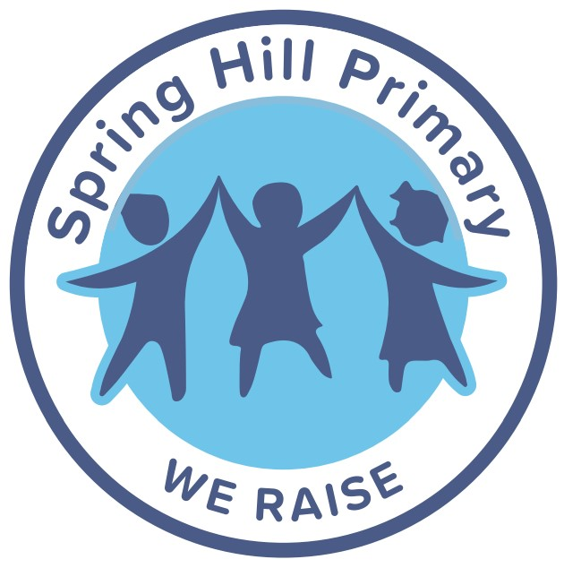

PSHRE

(including Relationships and Sex Education (RSE))

Policy 2026

Awaiting Ratification from governors.

Table of Contents
Intent 3
Implementation 3
Impact 3
Teaching and Learning of DT in the Early Years 4
Key Stage One and Two Curriculum 4
Resources 6
Assessment 7
Equal opportunities 7
Inclusion 7
Equalities 7
Role of the Subject Leader 8

Spring Hill School is at the heart of our community and everything we do is based around the needs of our children and their families. We provide children with the best possible education through an irresistible, ambitious curriculum, high quality teaching including opportunities and experiences which together promote excellence in both behaviour and learning.
The school environment is one where children thrive and it effectively equips them with the necessary life skills, attributes, knowledge and understanding they need for an ever-changing world in which they contribute successfully to society.

Spring Hill instils a passion for learning for the whole school family through enquiring minds and caring hearts to achieve personal excellence. We find opportunities to continually improve for the future in a caring and inclusive environment which promotes co-operative, respectful and nurturing relationships, where all school life is safe and fun.

Our Aims
To foster mutually beneficial relationships with parents, the wider community and professionals with a focus on continuous improvement.
To promote and develop life-long habits for a healthy body and healthy mind.
To provide a curriculum that is relevant to the context of the school and its community
To raise aspirations through high expectations and fostering self-belief so that children flourish and lead successful and happy lives.
To create an environment which recognises and nurtures unique gifts, curious minds, develops talents and personalities.
To provide learning experiences and opportunities which create awe and wonder and develop a love of learning – leading to lifelong learners

Our Values

Responsibility Aspirational Inclusivity Service Empowerment
We RAISE!

Overview:
The following policy outlines how, at Spring Hill, we endeavour to prepare our children for their lives beyond the classroom and in the wider world through the teaching of the statutory RSHE objectives through our teaching in PSHRE (personal, social, health, relationships and economic education).
We believe that PSHRE is an important and necessary part of all pupil's education and it is a key element of school life taught throughout all areas of the curriculum. Our school believes that PSHRE education should be taught in regularly timetabled lessons in a progressive way to ensure that children have the best opportunities to learn about the world around them.
This policy explains how we embody our school values and along with lessons, assemblies and other special days that we celebrate, we teach children the knowledge and skills to ensure our children are safe, happy and healthy. We teach children the skills they need to live as successful citizens within their communities and enable them to celebrate their uniqueness and treat others with respect.
We want to ensure that we educate the whole child through the PSHRE curriculum as we believe that this positively impacts the individual, the school community and the wider community- both present and future.

Subject Content
R(S)HE is taught within the subject of PSHRE within the school and that this is taught in-line with the statutory guidance.
'PSHE education is the school subject through which children and young people acquire the knowledge, understanding and skills they need to manage their lives, now and in the future.
PSHE education develops the qualities and attributes pupils need to thrive as individuals, family members and members of society'
(PSHE Association, 2024)
Within the RSHE curriculum, the statutory elements of relationships and health education are included within the curriculum content. To deliver this content, Spring Hill use the PSHE Association materials during lessons and this is enhanced with the Pol-Ed resources across the curriculum.
The PSHRE and Citizenship education scheme of work runs throughout school years R to 6. This scheme of work and all of its resources have been produced to be fully in line with the Learning Outcomes and Core Themes outlined in the PSHE Association Programme of Study which is our nationally approved body for PSHE education, The EYFS work to the standards in the PSED area of their curriculum.
All aims are taught through the three core areas of PSHRE and Citizenship education, which are: Health and Wellbeing, Relationships and Living in the Wider World.
All lessons will cover content in an age-appropriate manner.
Health and Wellbeing lessons will explore physical wellbeing, healthy lifestyles, mental health, growing and changing, keeping safe and drugs, alcohol and tobacco.
Relationships lessons will explore families and close positive relationships, friendships, managing hurtful behaviour and bullying, safe relationships and respecting self and others.
Living in the Wider World lessons will explore our shared responsibilities, communities, media literacy and digital resilience and economic wellbeing (money and aspirations, work and career) and British Values
At Spring Hill, we have taken the decision to not teach any of the sex education content which goes beyond what is taught in the Science curriculum. We teach only the statutory health and relationships content. This means that there is none of the statutory content that can be withdrawn from.
At Spring Hill there is transparency in what is taught and that parents are able to view any materials that are being used to teach the children. This can be done with prior arrangement through the office to visit school and book a meeting with the PSHRE leader.

How the subject is taught
Teaching at Spring Hill is progressive and builds on prior knowledge so that the content is age and stage appropriate.
The lessons are taught weekly by the class teacher or a trained person familiar to the children. this ensures that the person delivering the content knows the children well.
There are times when the curriculum is enhanced by external providers who are checked by school and have had the relevant safeguarding procedures shared with them. When these take place, there will be a member of school staff present at these deliveries. These visitors have been chosen to benefit the learning of the children and that they suit the needs of the children within school.
Visitors that are used regularly to support the enhanced delivery of the PSHRE curriculum include:
- Fire brigade
- Rock Kidz
- Police
- Road Safety Team
At times there may be occasions when themed weeks or specific events means that a visitor not listed here would further complement the curriculum and therefore this is not an exhaustive list. At times when a visitor is invited in addition to the list above for PSHE, parents will be made aware and the content of the session will be checked ahead of the delivery just as it has been for the visitors listed above.

Responsibilities
Our governing body will work closely with school staff to monitor the teaching and learning of PSHRE education.
Our headteacher and senior leaders will support all staff in school in the preparation and delivery of PSHRE education and work to create a school ethos which supports and upholds content in the curriculum.
Our PSHRE education subject leader will create and implement a whole school scheme of work appropriate to our school setting. They will also support and monitor teaching and learning in this area. The subject leader will also have oversight of any PSHRE visitors that attend school to enhance the curriculum and ensure that they have been shared the policy ahead of the visit. They will also ensure that they have checked any materials that are to be delivered by an external visitor ahead of their delivery to children.
Our class teachers will deliver high quality weekly PSHRE education lessons which follow the school’s scheme of work and current best practice. They will use the approved resources to ensure that the delivery of PSHRE is in line with the agreed content. Our class teachers will also consider any vulnerabilities or barriers to learning that the children may have and plan lessons to ensure that provide inclusive learning opportunities for all pupils. Class teachers will ensure that any external visitors delivering to the class will be done so in their presence and the teacher will support the delivery of this as needed.
Our support staff will enhance the delivery of PSHRE by providing targeted intervention wherever needed. They will also support (where possible) the lessons in classrooms and support wider inclusion of children who may have a barrier to their engagement.
Our pupils will engage respectfully and responsibly with all taught content.
Our parents and carers will be fully informed about what their children will be learning and will be actively encouraged to participate in the curriculum where appropriate.
External Visitors will be responsible for reading the policy and being aware of the relevant safeguarding procedures ahead of a delivery to children .

Right to Withdraw
Parents have a legal right to withdraw their children from the non-statutory element of sex education however, at Spring Hill, we have chosen not to deliver this content. Due to this, there is no content that parents can withdraw their children from that fits into the statutory health and relationships content.

Accessibility for All Pupils
Inclusive approaches are taken to all subjects at Spring Hill and PSHRE is no different. All children who may be identified as having a barrier to their learning or who may need further emotional support are known to staff and are supported accordingly to ensure they can access the learning.
Children who may have identified SEND needs have access to widget vocabulary to support their understanding of new language. There are also additional scaffolds in place to support new learning and there is targeted support in flashback time which allows children to access more challenging key concepts through further intervention.

Monitoring and Evaluation
At Spring Hill, we ensure that the monitoring of the subject is regular to ensure that the curriculum is correct and bespoke for the children in the classes.
Using half termly monitoring by the senior leadership team and the PSHRE lead, we are able to ensure that the curriculum meets the needs of the children.
Monitoring and evaluation can take the form of book looks, learning walks or lesson visits and are used to inform future planning of the curriculum.

Parental Access to Curriculum Materials
Parents and carers are able to access (with full transparency) the materials that will be used to teach the content within the PSHRE curriculum. As there is a lot of online delivery from a platform for the Pol-Ed resources, we encourage parents to make an appointment through the office to come into school to view materials with the PSHRE lead at a mutually convenient time.
We greatly value our parents and carers; we believe that their understanding of PSHRE and what their children will be learning is vital in gaining optimum outcomes.
We will send out guidance about the unit and what it entails. Parent and carers information sessions will be held to discuss the teaching of more sensitive content. Parents and carers are invited to view this policy and our curriculum at any point.
We are committed to following government guidance on the rights and responsibilities of parents and carers concerning PSHRE.

Answering Questions
At Spring Hill, we encourage children to be inquisitive learners which means we encourage them to ask questions about things they want to learn more about.
In PSHRE we are committed to ensuring that questions are responded to in-line with the agreed curriculum content and in a factual and age-appropriate way.
Should there be a question asked by a child that falls outside of this agreed remit, the children will be thanked for their question and it will be explained that this isn't currently the content that is being delivered. An adult will then make a note of the question and report this to the PSHRE lead through the usual reporting channels.
The senior team and the PSHRE lead will then decide on a course of action which may include reaching out to an adult at home to explain the nature of the question. School will offer to support any answers or conversations with the child or leave it with the adults at home to address as they wish.
There may be times when it is necessary to use the medical and antinomically correct names for the body parts to ensure that children have the correct vocabulary to report any concerns which may be linked to safeguarding. If this is the case, staff will repeat back the correct vocabulary using the 'doctors words' should this be necessary.
Should a child disclose something or ask a question which they ask to remain confidential, the usually safeguarding procedures and protocols will be followed. These are outlined in the safeguarding policy.

Policy Development and Review
This policy was written in line with the guidance in preparation for implementation in September 2026 and was shared with stakeholders for approval.
This policy will be reviewed on a bi-annual basis unless there are any significant changes to the curriculum and/or the delivery of it. In this case, it will be reviewed sooner.

Appendices
- Statutory guidance references: Relationships Education, Relationships and Sex Education and Health Education guidance
- curriculum overview
Possible:
- Links to resources

