Woodland Community School Pupil Premium Strategy 2024-27

This document details our school’s use of Pupil Premium (for the 2024 to 2025 academic year) funding to help improve the attainment of our eligible pupils and, where appropriate, their ineligible peers.

It outlines our Pupil Premium strategy, how we intend to spend the funding in this academic year and the effects that this spending is having as the year progresses. It also shows how we may spend the next two years’ Pupil Premium Grant if the funding continues, based on the effects measured and the lessons learned.

School overview
Detail | Data
School name | Woodland Primary School
Number of pupils in school | 309
Proportion (%) of pupil premium eligible pupils | 176 (53%)
Academic years that our current pupil premium strategy covers | 2024-27
Date this strategy was published | September 2026
Date on which it will be reviewed | Jan 27
Statement authorised by | K. Taberner
Pupil premium lead | D Chadwick
Governor / Trustee lead | C. Cooper

At Woodland Primary School we recognise that Ofsted uses the term ‘Disadvantaged Pupils’ for what we will refer to in our strategy as Pupil Premium (PP) pupils, because we recognise that not all pupils in receipt of the funding are disadvantaged, and we understand the stigma that might be attached to the phrase by parents.
Snapshot of current Disadvantaged statistics (Date: 21st Sept 2026)
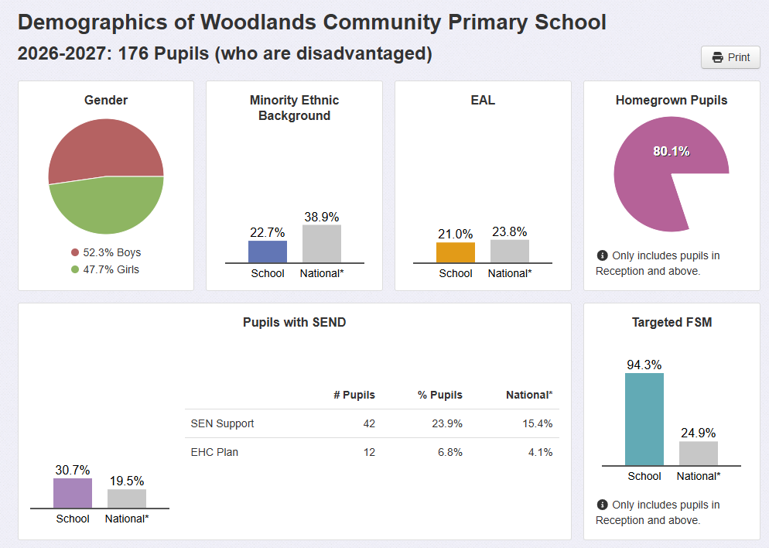
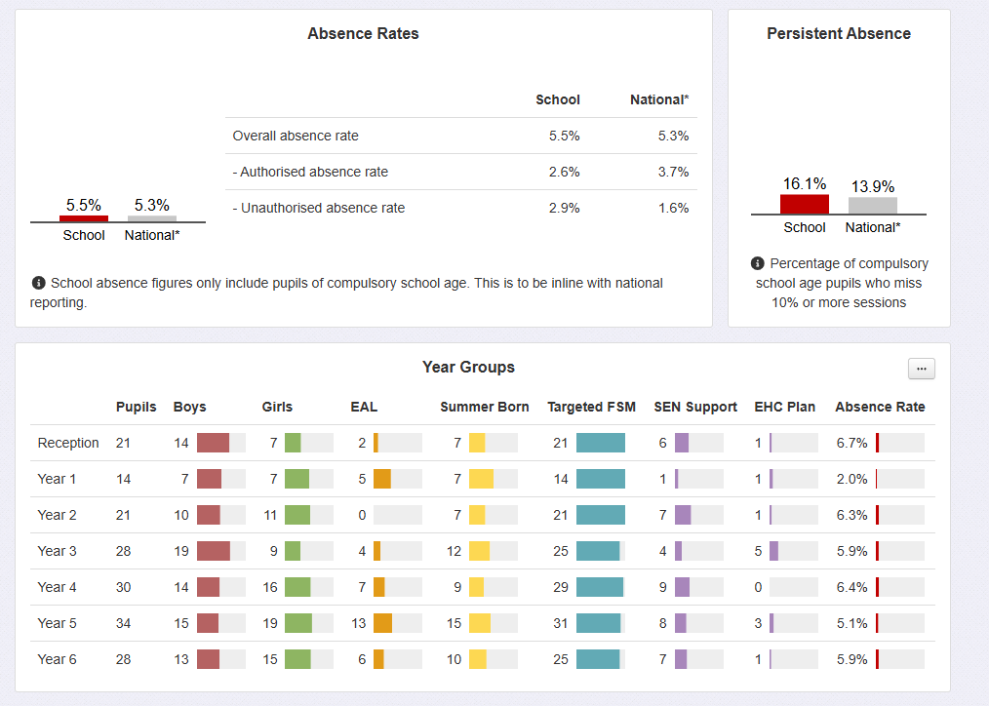

Funding overview
Detail | Amount
Pupil premium funding allocation this academic year | £ 238,700 (154 x £1550)
Pupil premium funding carried forward from previous years (enter £0 if not applicable) | £0
Total budget for this academic year | £238,700
Headlines
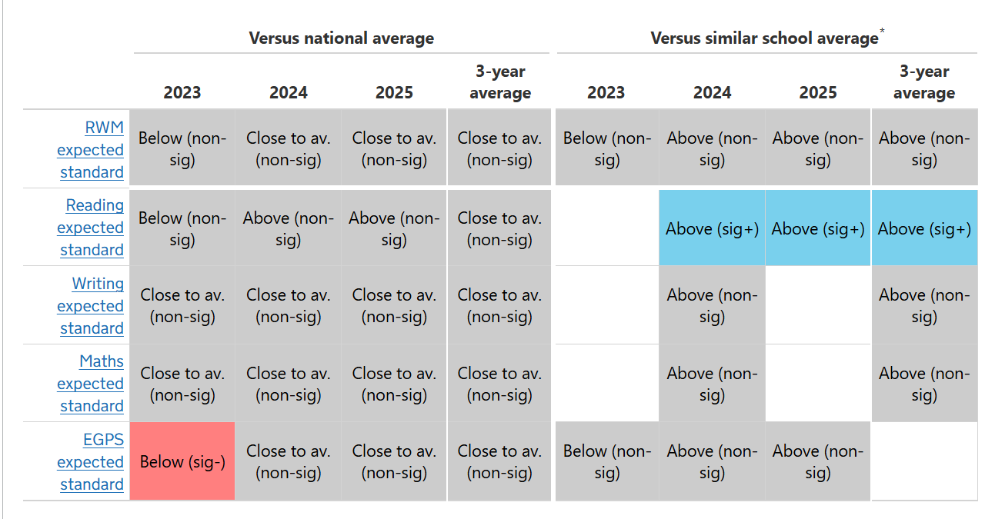
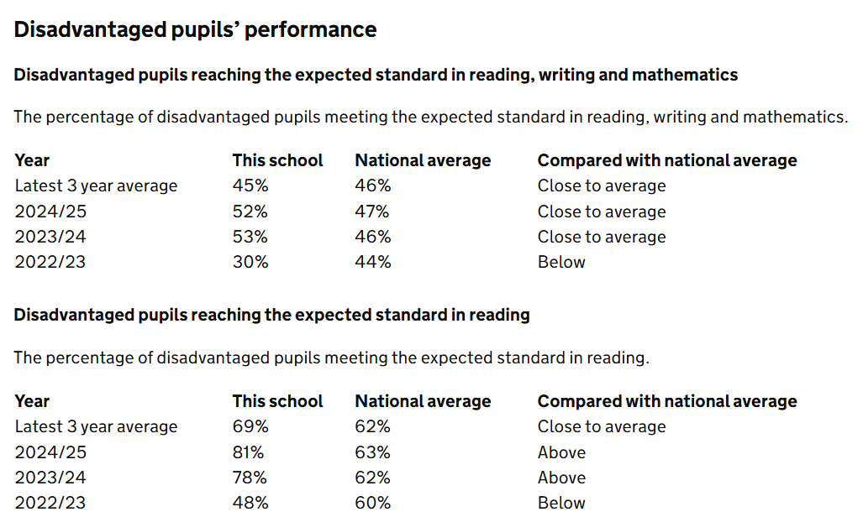
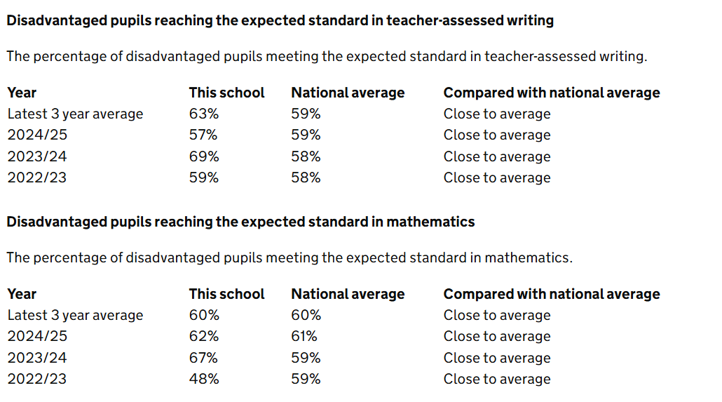

25.26 Attendance
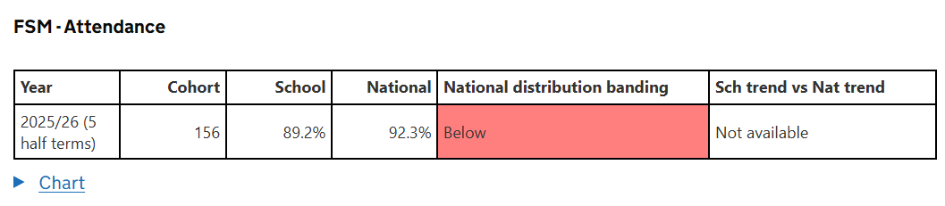
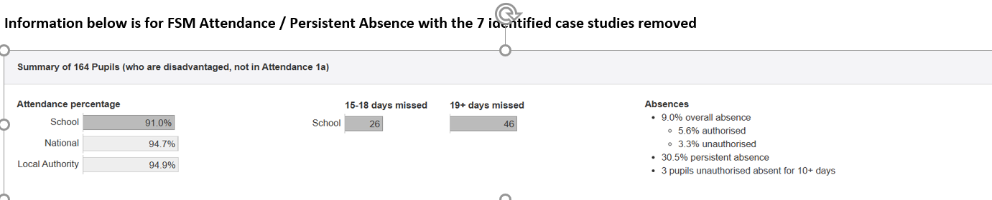

ASSESSMENT HEADLINES
W0oodland Community School 2025.26 Published data:
End of KS2 Attainment | Woodland School |  |  | Averages (National / LA Non dis - disadvantaged)
End of KS2 Attainment | PP | NPP | Combined PP and Non | National | Lancs
Reaching expected standard in Reading | 78% | 91% | 85% | 63%
Reaching expected standard in Writing | 57% | 84% | 72% | 60%
Reaching expected standard in Mathematics | 61% | 82% | 70% | 62%
Reaching expected standard in R, W & M | 44% | 73% | 55% | 49%

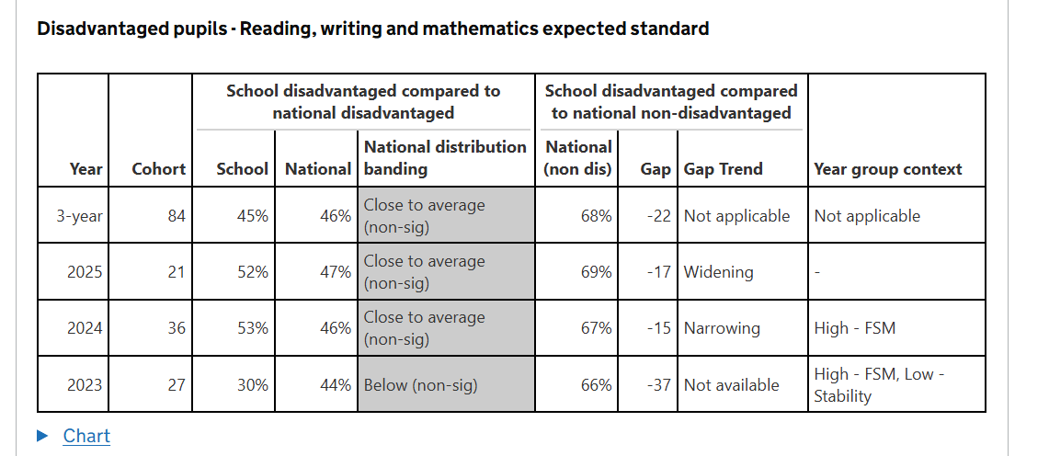
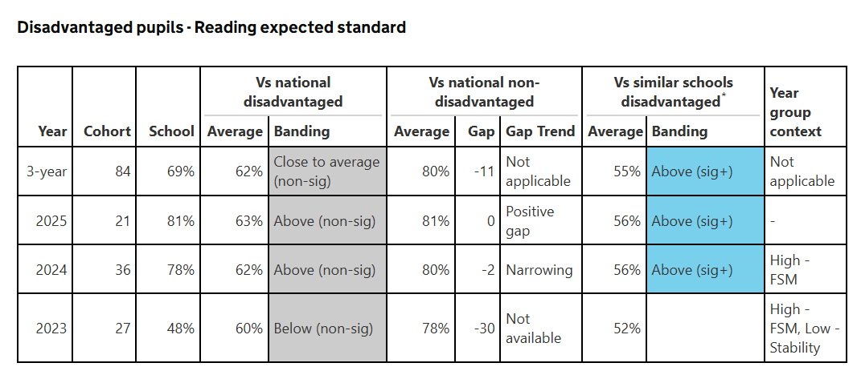
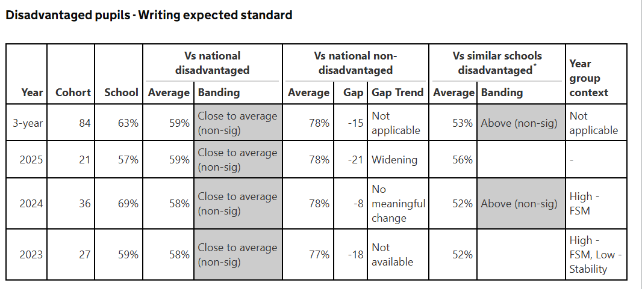
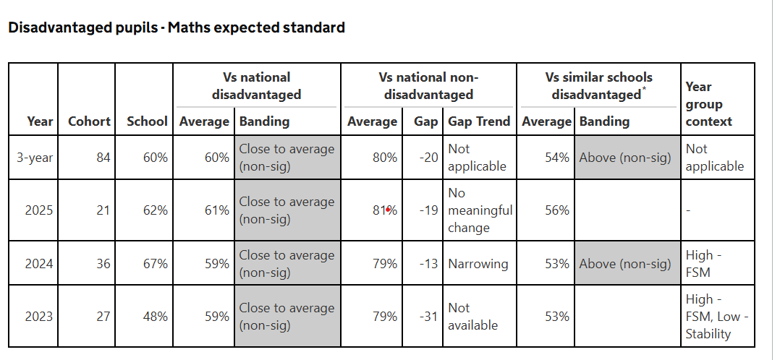

Progress
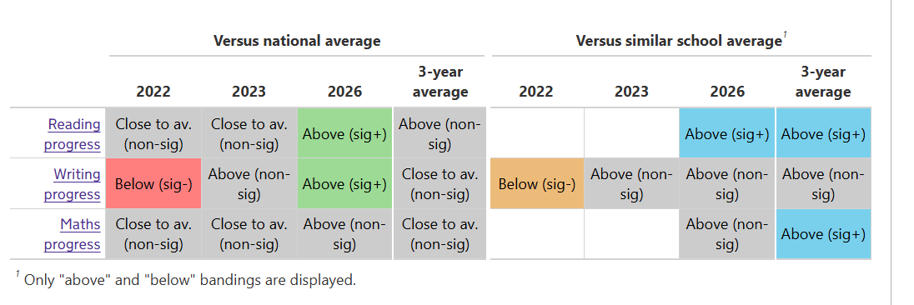

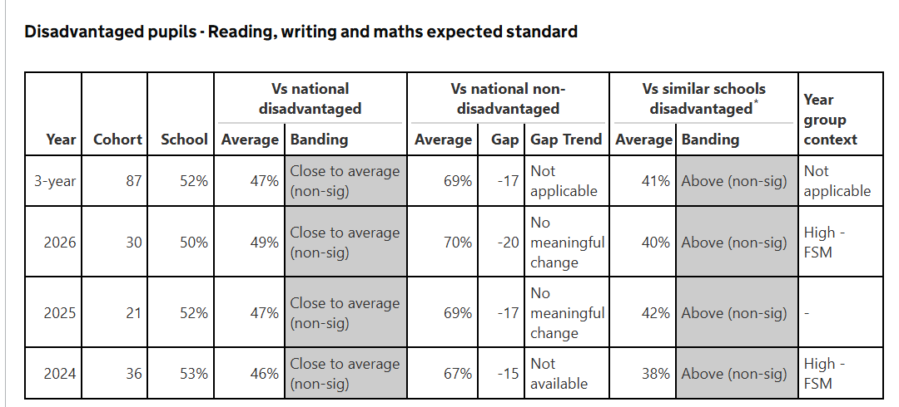
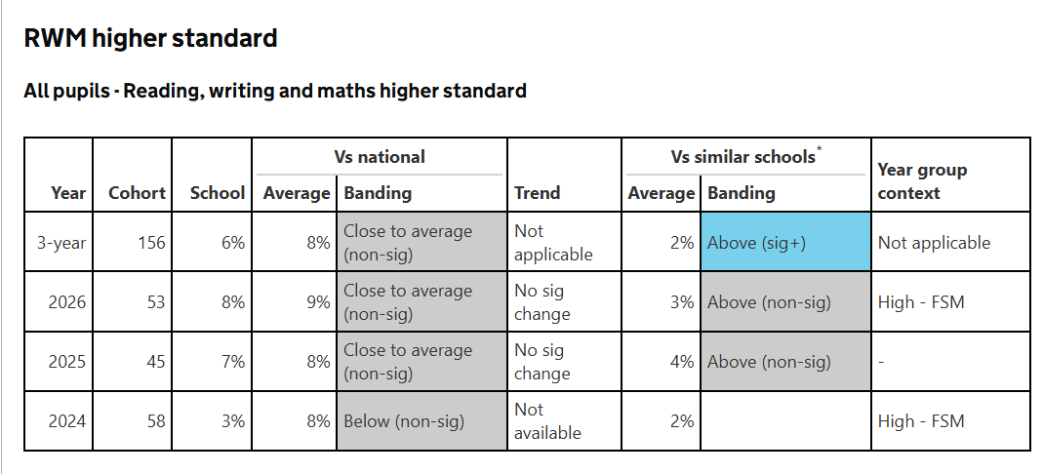
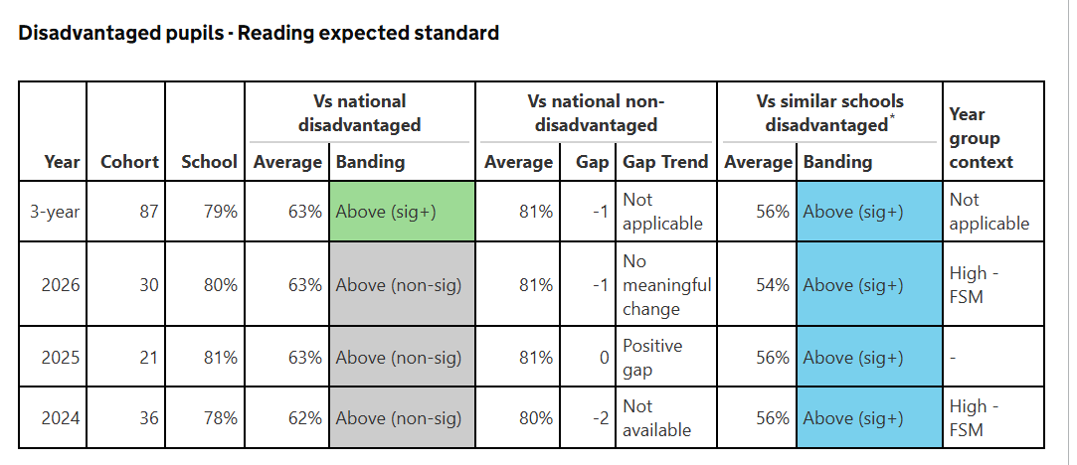
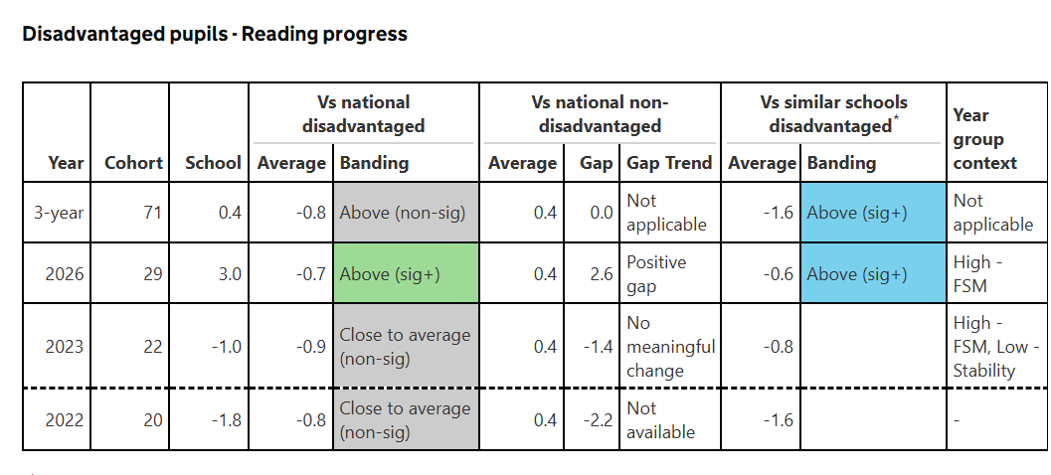

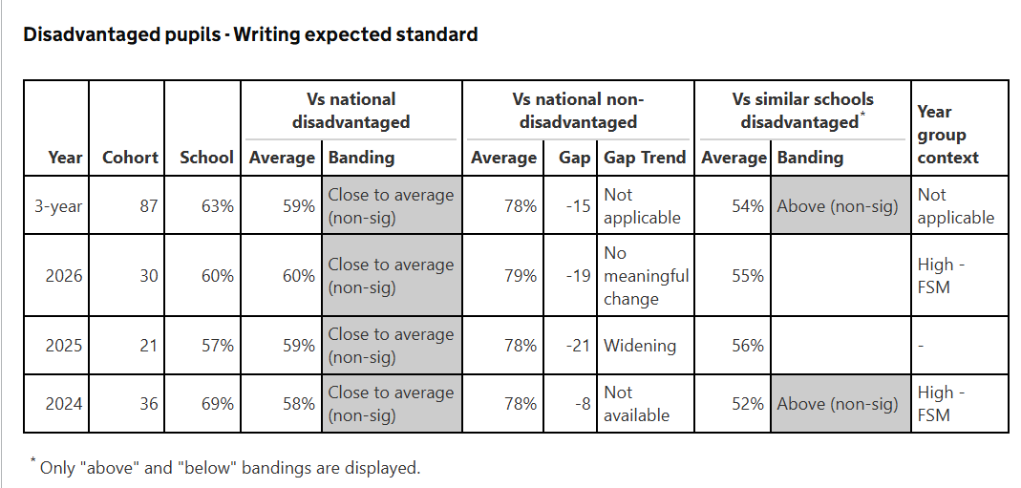
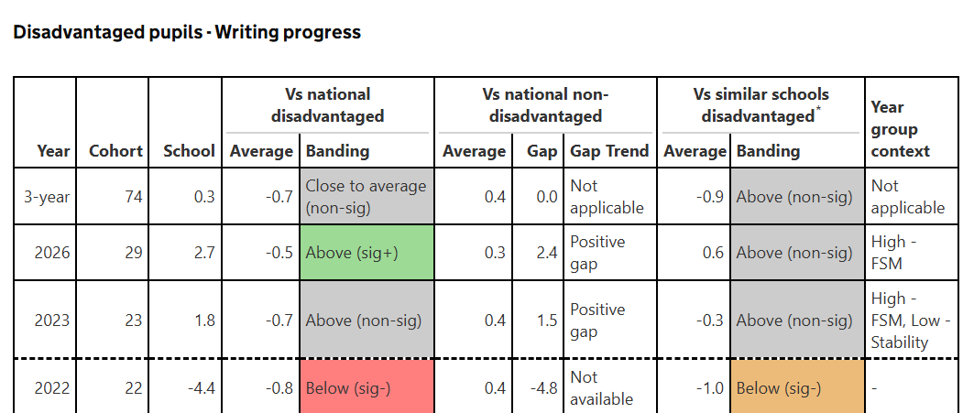

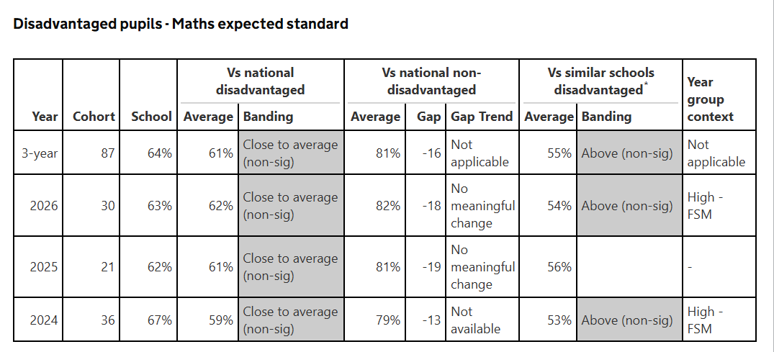
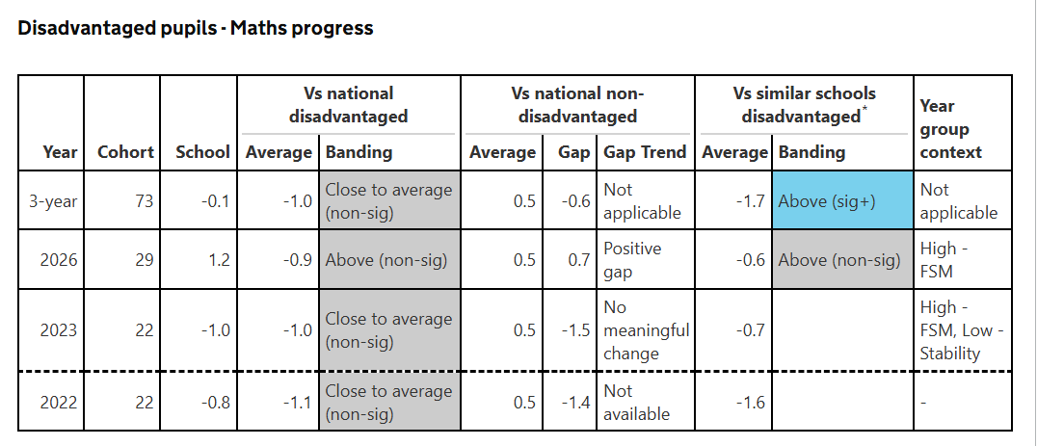

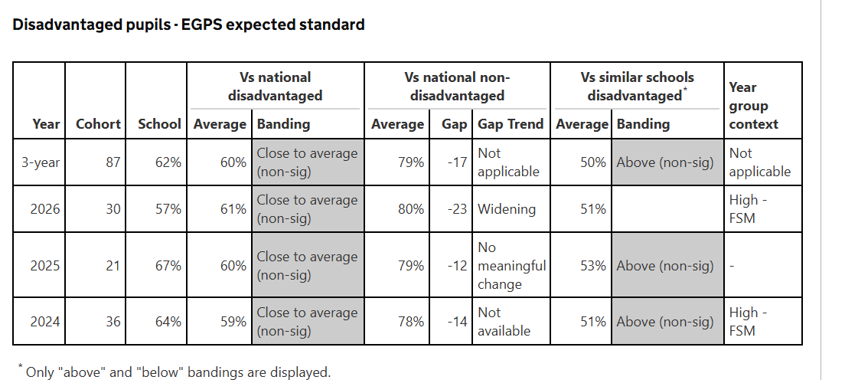

Impact Statement (2025/26) – Rationale for 26/27
Our IDSR provides evidence of sustained positive educational outcomes for our disadvantaged pupils, particularly when our results are compared with schools serving similar pupil populations.
Our three-year disadvantaged attainment averages are:
Subject Woodland National disadvantaged Similar schools
Reading 79% 63% 56%
Writing 63% 59% 54%
Mathematics 64% 61% 55%
Combined RWM 52% 47% 41%

Our three-year progress measures provide further evidence of the positive outcomes achieved by our disadvantaged pupils.
Subject Woodland National disadvantaged Similar schools
Reading +0.4 -0.8 -1.6
Writing +0.3 -0.7 -0.9
Mathematics -0.1 -1.0 -1.7

Our three-year reading and mathematics progress outcomes were statistically significantly above the averages for disadvantaged pupils in similar schools.
Our 2026 progress results provide particularly encouraging evidence. Disadvantaged pupils achieved progress scores of +3.0 in reading, +2.7 in writing and +1.2 in mathematics.
Reading and writing progress were statistically significantly above national disadvantaged averages, while reading progress was also statistically significantly above the similar-schools disadvantaged average.
These outcomes are important when considering the high proportion of disadvantaged pupils attending our school and the barriers to learning identified within our strategy.
We believe these sustained outcomes support the continuation of our existing teaching and intervention model.
However, we recognise that positive school-level outcomes do not independently establish the effectiveness of individual spending decisions. We will therefore continue evaluating our provision and adapting it in response to pupils' needs.
Pupil Premium Strategy 2026–2027
Analysis of our school context, evidence of impact and future priorities
Our contextual report, combined with our latest IDSR, provides a rationale for continuing our existing pupil premium strategy while strengthening how we evaluate its impact.
In particular, our three-year academic outcomes and 2026 progress results support the continuation of our teaching and intervention model. Our contextual information also strengthens the justification for our investment in pastoral care, attendance and support for families.

Pupil Premium Strategy

Statement of intent
Before reading our statement of intent, it is important to recognise the issues and potential barriers Our contextual report identifies several important characteristics of the community we serve.
Contextual indicator | Our school or local area
Pupil premium eligibility | 53.2%
Overall deprivation | Within the most deprived 20% nationally
Education and skills deprivation | Within the most deprived 10% nationally
Income deprivation | Decile 2
Employment deprivation | Decile 2
Health and disability deprivation | Decile 2
Households without access to a car | Approximately 29%
Adults without qualifications | Approximately 28%
Our local community experiences significant socioeconomic challenges. These findings reinforce the importance of providing consistently high-quality teaching, targeted academic support and appropriate wider provision.
We recognise that neighbourhood characteristics do not describe the circumstances of every pupil. We therefore use our knowledge of individual children, internal assessments and attendance information to identify specific barriers and determine appropriate support
OUR STATEMENT OF INTENT
At Woodland Primary School we aim to effectively and efficiently use resources to have the maximum impact on the outcomes of Pupil Premium (PP) pupils. Our ultimate aim is to implement a sustained response for all children, but particularly for those from socio-economically ‘disadvantaged’ backgrounds. Within the PP Strategy, we will also consider how to align chosen approaches with PP spending and broader school improvement priorities.
The PP Strategy is cyclical and embedded within a broader strategic implementation cycle. The strategy will be sustained over a three-year period, including ongoing monitoring and evaluation in an annual cycle. In order to develop an effective pupil premium strategy we have developed an in-depth understanding of the challenges that our disadvantaged pupils are facing. This involved diagnostic assessments of academic challenges and the assessment of wider barriers to learning. This strategy has been developed to address these key challenges.
Woodland has adopted the 3-tiered approach recommended by the Education Endowment Fund (EEF), the DfE and Ofsted, to supporting Pupil Premium pupils in order to balance approaches to improving teaching, targeted academic support and wider strategies. The 3-tiered approach will ensure the school focuses on a number of strategies that are likely to make the biggest difference. Within this tiered model an evidence-based approach has been adopted. Quality first teaching is one of the biggest drivers of pupil attainment, particularly for those from ‘disadvantaged’ backgrounds. Consequently, improving quality first teaching is a top priority for PP spending. Evidence consistently shows the positive impact that targeted academic support can have, including children who are not making good progress across the spectrum of achievement. Therefore, the strategy considers how classroom teachers and teaching assistants can provide targeted academic support, including how to link structured one-to-one support or small group intervention to classroom teaching. Wider strategies which relate to what are likely to be the most significant non-academic challenges (or barriers to achievement) in our school have also been identified and planned for.
Effective implementation is fundamental to the impact of the strategy. The school is committed to two key factors crucial to good implementation: (a) Implementation will be treated as a process, not an event; planned and executed in stages, and (b) We will create a leadership environment and school climate that is conducive to good implementation.
School leaders will continually monitor the progress of the PP Strategy, adapting approaches when and where appropriate as the year proceeds. As actions and approaches are implemented support will be provided for staff so that they can take ownership of them and deliver them successfully. As challenges (barriers to achievement) emerge these will be addressed through flexible and motivating leadership. We aim to respond to implementation data to tailor and improve approaches.

Challenges (Barriers to achievement)

This details the likely key challenges or barriers to achievement that we have identified among our Pupil Premium pupils.
Challenge number | Detail of challenge
1 | Delayed communication and language skills (Very low on-entry attainment requiring high levels of consistent additional progress to ‘close the gaps’)
2 | Social, emotional and behavioural needs
3 | Lack of parental engagement and family support
4 | Poor attendance

Intended outcomes
This explains the outcomes we are aiming for by the end of our current strategy, and how we will measure whether or not they have been achieved.

Intended outcome (with challenge number) | Success criteria
Improved level of communication and language skills by the end of the Early Years Foundation Stage. (1) | All PP pupils will have made good progress from their on entry assessments in Nursery / reception, unless their SEN inhibits this.
Apart from those with SEND and an EHCP, all PP Pupils will pass the phonics screening by the end of Year 2. (2) | All PP pupils will follow a structured phonics programme throughout Reception and Year 1. Gaps in learning will be identified on a regular basis and focused interventions planned to close these gaps during Year 2.
Improving parental engagement. (3) | All PP parents will report on children’s reading through their reading diaries. PP pupils who are not engaging with reading at home will, in agreement with parents, complete reading in school and at after school clubs.
Improving behaviour for learning (4) | More than 85% of PP pupils will make the expected level of progress in all curriculum areas (unless their SEN inhibits this.) The frequency of class teachers reporting behaviour as a barrier to learning will decrease.
Reduced proportion of persistent absentees. (5) | PP pupils’ average attendance will be raised to 92% (26/27). If attendance for an individual PP pupil does fall below 9% within a half term, planned interventions will ensure this improves for all pupils the following half term.
Raise attainment in writing and maths across the school (6) | Aim for 90% of pp pupils for each cohort making expected progress over the course of the academic year.

Part A: Activity in this academic year (2026/27)
This details how we intend to spend our Pupil Premium (and Recovery Premium funding) this academic year to overcome the challenges listed above.

Activity (with challenge number addressed) | Evidence that supports this approach (rationale) | Intended and actual impact with lessons learned
Maintain high staff to pupil ratio to allow for smaller class sizes / continued focused high quality first point teaching (1, 3, 6)  Estimated cost: £80,000 | We will continue investing in additional teaching staff to maintain smaller teaching groups and ensure that our pupils benefit from high-quality classroom teaching.  Our school contextual report identifies education and skills as a particularly significant area of deprivation within our community. This reinforces the importance of providing a strong educational foundation and ensuring that pupils receive the teaching and support necessary to overcome identified barriers.  Our IDSR provides encouraging evidence supporting the continuation of our existing teaching model.  Our three-year disadvantaged progress outcomes exceed the corresponding national disadvantaged and similar-school averages across reading, writing and mathematics.  Our three-year reading and mathematics progress outcomes were statistically significantly above the similar-school disadvantaged averages.  Our 2026 progress results provide further supporting evidence:  Subject Our disadvantaged progress  Reading +3.0  Writing +2.7  Mathematics +1.2  Our reading and writing progress outcomes were statistically significantly above national disadvantaged averages.  These results demonstrate the positive progress pupils are making within our existing teaching and intervention model.  We believe they provide a rationale for continuing our investment in additional teaching staff, particularly when considered alongside the socioeconomic challenges identified in our contextual report.  Supporting EEF evidence  The EEF Teaching and Learning Toolkit: Reducing Class Size identifies an average impact of approximately one additional month of progress.  We recognise that simply reducing class sizes does not guarantee improved outcomes. Our investment is therefore intended to enable teachers to make more effective use of additional teaching capacity, including increased opportunities for individual feedback, responsive teaching and addressing identified misconceptions. We also draw on the EEF evidence concerning feedback, which identifies the importance of providing pupils with information that helps them improve their learning.  Evaluating impact in 2026/27  We will evaluate how our additional teaching capacity contributes to pupils' educational outcomes.  We will continue monitoring disadvantaged attainment and progress, with particular attention to writing and mathematics.  Our objective is to sustain the positive progress demonstrated in our three-year averages and 2026 results while increasing the proportion of disadvantaged pupils achieving the expected standard.  We will also evaluate how effectively teachers use smaller teaching groups to identify and address learning gaps | Performances of disadvantaged and non- disadvantaged termly during pupil progress meetings will be reviewed
Aim to raise attainment in writing.  Estimated Cost: £ 4000 | We will introduce our Woodland Writing Structure, developed and adapted from Joanne Taylor's Architecture for Writing programme, to establish a consistent, progressive and evidence-informed approach to teaching writing across the school.  Our decision is informed by our IDSR, which demonstrates encouraging progress among disadvantaged pupils while identifying writing attainment as an area requiring further improvement.  Our three-year disadvantaged writing attainment average is 63%, compared with 59% nationally and 54% in similar schools. Our 2026 disadvantaged writing progress score of +2.7 was statistically significantly above the national disadvantaged average. However, our disadvantaged writing attainment remains below that of national non-disadvantaged pupils, with grammar, punctuation and spelling identified as particular areas for development.  Our Woodland Writing Structure will provide a systematic approach to developing vocabulary, oracy, sentence construction, grammar and independent writing. It is designed to strengthen consistency in teaching and address the specific barriers identified through our assessments.  The approach draws on teaching practices supported by the EEF's guidance on improving literacy in Key Stage 2, particularly the importance of explicitly teaching writing strategies, developing spoken language and providing structured support.  Our investment will cover CPD for staff to observe Architecture for writing, training for staff, support staff professional development, consistent implementation and the delivery of daily, targeted writing interventions by our highly skilled teaching assistants. These interventions will be closely linked to classroom teaching and informed by diagnostic assessment, reflecting the EEF's evidence on teaching assistant interventions.  Our focus for 2026/27 is to embed the Woodland Writing Structure consistently across the school, sustain our positive writing progress and increase the proportion of disadvantaged pupils achieving the expected standard. We will evaluate its impact through moderated writing assessments, analysis of independent writing and regular monitoring of pupils receiving targeted support. | Gap between non pp and pp pupils to close across cohorts  Progress of disadvantaged pupils to in line or exceed national non disadvantaged.
Aim to raise attainment in maths by increasing attainment measures. (6)  Estimated cost: £6000 | We will continue to strengthen our established approach to mathematics through Red Rose Maths, investment in high-quality mathematical resources and structured professional development. Our aim is to improve teaching consistency, deepen mathematical understanding and increase disadvantaged pupils' attainment.  Our decision is informed by our IDSR, which demonstrates encouraging outcomes for disadvantaged pupils. Our three-year disadvantaged mathematics attainment average is 64%, compared with 61% nationally and 55% in similar schools. Our three-year mathematics progress was statistically significantly above the similar-school disadvantaged average, while our 2026 disadvantaged mathematics progress score of +1.2 provides further evidence of positive outcomes.  We recognise the importance of building on these achievements while continuing to address gaps in mathematical knowledge and understanding.  We will invest in additional mathematics resources, including practical equipment and the Red Rose Maths teaching materials, to support the consistent use of mathematical representations, develop conceptual understanding and strengthen pupils' mathematical fluency and reasoning.  Alongside this investment, we will introduce mathematics teaching triads as a structured programme of continuing professional development. Teachers will work collaboratively in groups of three, rotating between one another's classrooms to observe teaching, identify and share effective practice, and provide constructive professional feedback. This approach will enable us to develop teaching expertise, strengthen consistency and embed effective mathematics teaching across the school. Funding will be used to cover staff so they can be released to observe and demonstrate good practice.  Our approach is informed by the EEF's guidance on improving mathematics in Key Stages 2 and 3, particularly its recommendations concerning mathematical representations, assessment and targeted intervention.  Our mathematics triads will reflect the principles outlined in the EEF's Effective Professional Development guidance. Through focused observation, professional discussion, feedback and agreed actions, we will provide opportunities for teachers to develop and refine their classroom practice.  Our additional teaching staff will continue to support responsive teaching, while our highly skilled teaching assistants will deliver daily, targeted mathematics interventions. These interventions will address identified misconceptions, consolidate essential mathematical knowledge and provide additional opportunities for pupils to develop fluency. This approach is supported by the EEF's evidence on teaching assistant interventions.  Our focus for 2026/27 is to sustain the positive progress demonstrated in our IDSR while increasing disadvantaged pupils' mathematical attainment. We will evaluate the impact of our investment through termly assessments, monitoring the effective use of mathematical resources, reviewing improvements in teaching practice arising from our mathematics triads and assessing the progress of pupils receiving targeted interventions. | Attainment of PP pupils to narrow in line with national averages.  Attainment of pp pupils to narrow to non pp averages.
Intentions for 2026/27– Teaching

During this period we will:
- Further develop all pupils’ understanding their own learning, and their ability to self-regulate effectively
- Sustainably continue providing structured interventions to PP pupils where necessary

These intentions will only be taken forward if data supports the actions and approaches chosen. Otherwise, revisions will be made to this section by July 2027

Targeted academic support (for example, tutoring, one-to-one support structured interventions)

Activity (with challenge number addressed) | Evidence that supports this approach (rationale) | Intended and actual impact with lessons learned
Maintain a consistently effective support staff ratio in each cohort to support teaching and intervention  Estimated cost: £70,000 | We will continue investing in highly skilled teaching assistants who deliver daily, targeted academic interventions within our classrooms. Our approach ensures that additional support is an integral part of everyday teaching rather than an occasional intervention delivered separately from the curriculum.  Our teaching assistants work alongside class teachers to identify pupils requiring additional support and deliver carefully planned interventions that address specific learning needs. They are also directed by our SENco and SEN dept to support pupils with their SSP (School Support Plan)  These interventions provide regular opportunities to revisit learning, address misconceptions, reinforce essential knowledge and develop pupils' confidence.  We prioritise daily provision because it enables us to respond promptly when assessment identifies gaps in understanding and provide consistent opportunities for pupils to consolidate their learning. Our contextual report identifies substantial socioeconomic disadvantage within our community, including particularly high levels of education and skills deprivation.  This reinforces the importance of ensuring that pupils receive additional academic support where necessary, without relying on families to provide supplementary learning opportunities outside school.  Evidence from our IDSR  Our three-year disadvantaged progress outcomes provide encouraging evidence supporting our existing teaching and intervention model.  Our three-year reading and mathematics progress outcomes were statistically significantly above the corresponding similar-school disadvantaged averages.  Our 2026 disadvantaged progress results were particularly encouraging:  - Reading: +3.0  - Writing: +2.7  - Mathematics: +1.2  Reading and writing progress were statistically significantly above national disadvantaged averages.  These outcomes are consistent with our overall approach to high-quality teaching and additional academic support.  Although we cannot attribute these results exclusively to our teaching assistants, they provide a rationale for continuing our established model while strengthening the evaluation of individual interventions.  Supporting EEF evidence  Our approach is closely aligned with the EEF Teaching and Learning Toolkit: Teaching Assistant Interventions.  The EEF identifies an average impact equivalent to approximately four additional months of progress for teaching assistant interventions.  Importantly, the research distinguishes between general classroom support and teaching assistants delivering structured, targeted interventions.  We recognise that the effectiveness of additional teaching assistants depends on how they are trained, deployed and supported.  Our teaching assistants therefore deliver interventions that are planned in partnership with class teachers and closely connected to current classroom learning.  We also draw on the EEF Teaching and Learning Toolkit: Small Group Tuition, which identifies an average impact equivalent to four additional months of progress.  Our daily interventions provide opportunities for pupils to receive additional explanation, practise essential skills and address specific gaps identified through assessment.  We recognise that frequency alone does not guarantee effectiveness. The quality of teaching, appropriate targeting and regular assessment are central to our approach.  Evaluating impact in 2026/27  We will strengthen our evaluation of daily interventions by establishing clear learning objectives and identifying pupils' starting points. Class teachers and teaching assistants will work together to review progress and adapt interventions.  We will evaluate the impact of our additional support through improvements in identified learning objectives, classroom performance and wider assessment outcomes.  Particular attention will be given to writing, mathematics and early literacy, ensuring that our daily interventions respond directly to the priorities identified within our IDSR. | Identified pupils to make accelerated targets.  Interventions agreed at pupil progress meetings.
Intentions for 26.27– Targeted academic support

During this period we will:
- Continue to provide focused support to small groups by support staff (incorporating a strong level of CPD where appropriate)
- Continue to make similar attainment / progress levels as those seen in 25.26 and 26.27 KS2 results in reading by maintaining high standard of phonics teaching through Read, Write inc (with relevant high quality CPD for all staff who give this provision). Develop fluency and competency in reading in KS2 through the implementation of the ‘Destination Reader’ programme. Increase Writing proficiency through ‘Architecture for Writing’. Develop maths Mastery through Red Rose Maths

These intentions will only be taken forward if data supports the actions and approaches chosen. Otherwise, revisions will be made to this section by Jan 2027 / Mar 2027

Wider strategies (for example, related to attendance, behaviour, wellbeing)

Activity | Evidence that supports this approach (rationale) | Intended and actual impact with lessons learned
Subsidise a team of pastoral support staff.  Estimated cost: £60,000 | Children at Woodland who experience emotional or behavioural barriers to learning, will be supported by a designated team of staff. Their aim is to support a continuing ‘smooth running’ of the school and work with individuals /groups who are experiencing specific difficulties which may prove to be a barrier to learning. This system of support is not only essential for helping the identified children but ensuring other learners are not disrupted. OFSTED’s report on pupil premium supports this and recommends this as a good use of funding. Last year, 52 disadvantaged pupils received regular support from the pastoral team to remove barriers to being in class. This included support entering school, on the playground, 1 to 1 support to access learning. | Reduced number of incidents being recorded on CPOMS  Trends for targeted disadvantaged children’s attendance and persistant absenteeism to regularly exceed 92%
Provide staff training on behaviour for learning (4)  Estimated cost - £1000 | Use Lancashire consultants to critique current practices and provide training to staff on implementing and embedding learning behaviour strategies. EEF - +5 | Observations will show increased level of engagement from children across cohorts.
Run a walking bus service. (5)  Estimated cost: £3,500 | To support our commitment to raising levels of punctuality, attendance and maintain effective safeguarding procedures, PP funding is used to employ staff who pick up and escort children safely to school from our local area. | Attendance and punctuality of the targeted PP and non PP children will continue to be above 95%
Breakfast club (5)  Estimated cost: £3000 | Providing a breakfast club offers many benefits to children and their families - improves learning, attendance and behaviour at school, punctuality, healthy eating, social development, and fun through play. A previous EEF report supports this approach.
Maintain a minibus for school purposes. (5)  Estimated cost: £8000 | A minibus has been purchased by school to provide free transport to and from school for those pupils (PP and otherwise) to support attendance and punctuality, The minibus will only be used in certain circumstances and staff will follow current policies when transporting children. | Attendance and punctuality of the targeted PP and non PP children will continue be in line with school expectation of 95%
Intentions for 2026.27– Wider strategies

During this period we will:
- Aim to move PP attendance to 93% by extending and improving attendance programmes

These intentions will only be taken forward if data supports the actions and approaches chosen. Otherwise, revisions will be made to this section by July 2025

Total budgeted cost: £ 236,000. Any additional funding required will be sourced from school’s main budget.

Externally provided programmes
Please include the names of any non-DfE programmes that you purchased in the previous academic year. This will help the Department for Education identify which ones are popular in England
Programme | Provider
Lancashire Support Advisors | LCC
Red Rose Maths | LCC

Part B: Review of outcomes in the previous academic year

How we spent / impact
This details the impact that our pupil premium activity had on pupils in the 24.25 academic year.

Further information

