Woodland Community School Pupil Premium Strategy 2024-27

This document details our school’s use of Pupil Premium (for the 2024 to 2025 academic year) funding to help improve the attainment of our eligible pupils and, where appropriate, their ineligible peers.

It outlines our Pupil Premium strategy, how we intend to spend the funding in this academic year and the effects that this spending is having as the year progresses. It also shows how we may spend the next two years’ Pupil Premium Grant if the funding continues, based on the effects measured and the lessons learned.

School overview
Detail | Data
School name | Woodland Primary School
Number of pupils in school | 331 inc Nursery
Proportion (%) of pupil premium eligible pupils | 164 (49.5%)
Academic years that our current pupil premium strategy covers | 2024-27
Date this strategy was published | September 2025
Date on which it will be reviewed | Mar 26
Statement authorised by | K. Taberner
Pupil premium lead | D Chadwick
Governor / Trustee lead | C. Cooper

At Woodland Primary School we recognise that Ofsted uses the term ‘Disadvantaged Pupils’ for what we will refer to in our strategy as Pupil Premium (PP) pupils, because we recognise that not all pupils in receipt of the funding are disadvantaged, and we understand the stigma that might be attached to the phrase by parents.
Jan 2026 Data
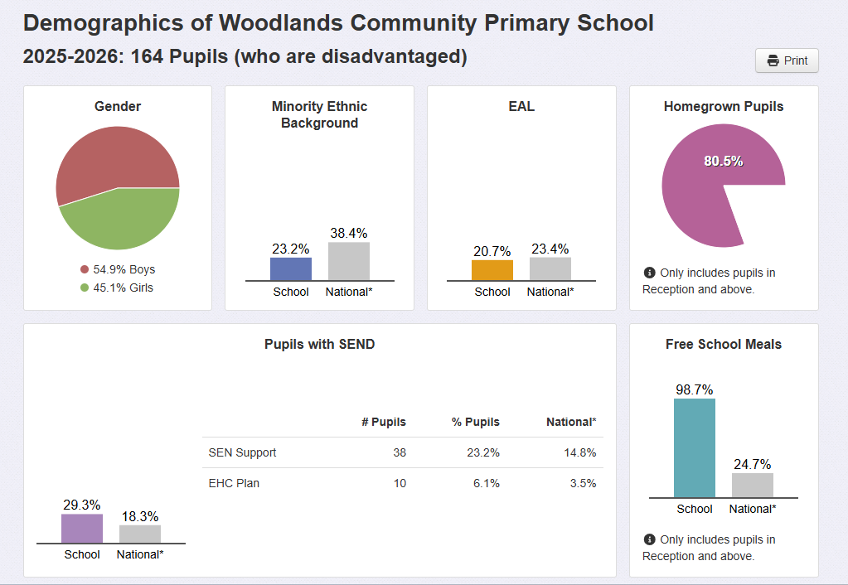

Funding overview
Detail | Amount
Pupil premium funding allocation this academic year | £ 234,825 (155 x £1515)
Pupil premium funding carried forward from previous years (enter £0 if not applicable) | £0
Total budget for this academic year | £234,825
Headlines

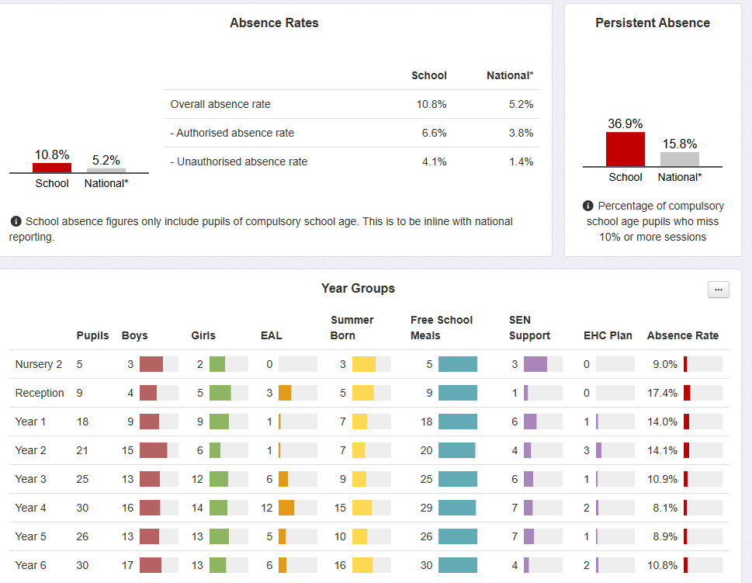

ASSESSMENT HEADLINES
W0oodland Community School 2024/25 Published data:
End of KS2 Attainment | Woodland School |  |  | Averages (National / LA Non dis - disadvantaged)
End of KS2 Attainment | PP | NPP | Combined PP and Non | National | Lancs
Reaching expected standard in Reading | 76% | 96% | 87% | 75 % - (58% est)
Reaching expected standard in Writing | 57% | 84% | 72% | 72% – (53% est.)
Reaching expected standard in Mathematics | 62% | 92% | 76% | 74% – (54% est)
Reaching expected standard in R, W & M | 52% | 80% | 67% | 62% - (46%(est)

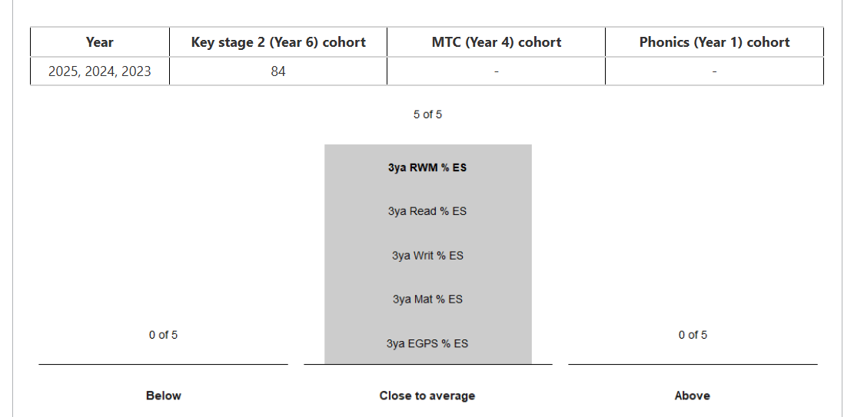
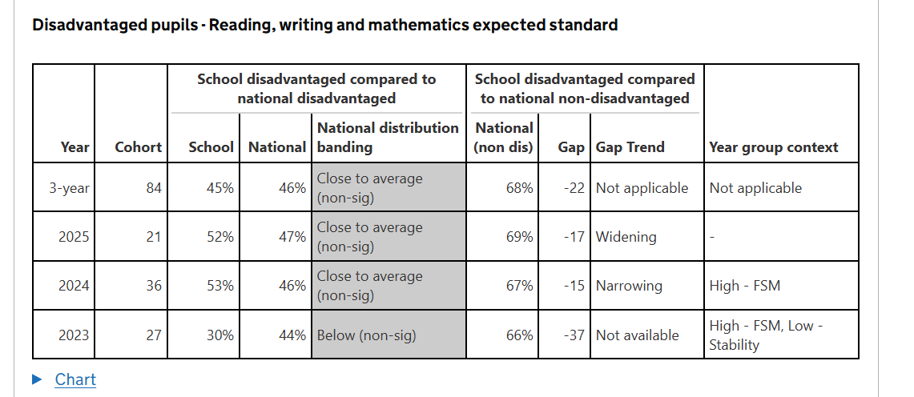
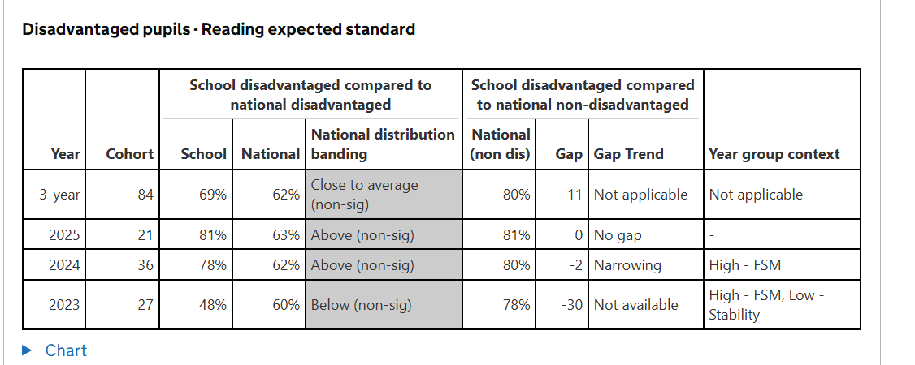
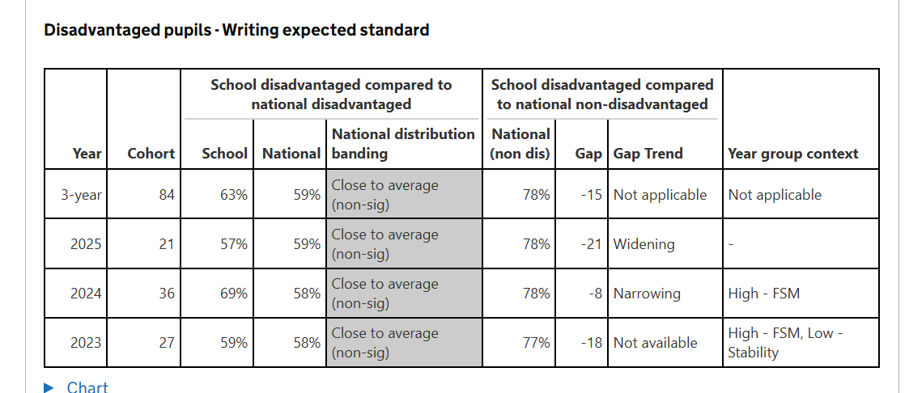

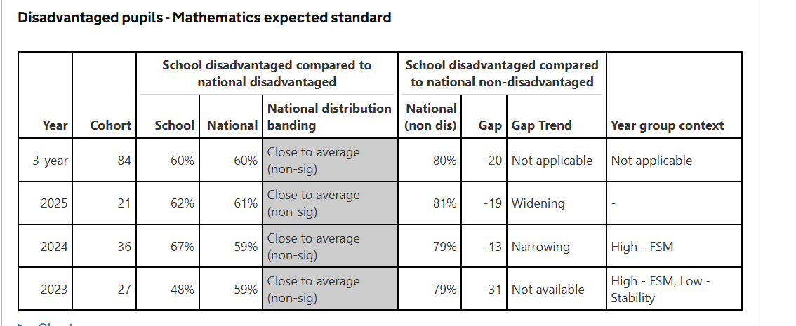

Pupil Premium Strategy

Statement of intent
At Woodland Primary School we aim to effectively and efficiently use resources to have the maximum impact on the outcomes of Pupil Premium (PP) pupils. Our ultimate aim is to implement a sustained response for all children, but particularly for those from socio-economically ‘disadvantaged’ backgrounds. Within the PP Strategy, we will also consider how to align chosen approaches with PP spending and broader school improvement priorities.
The PP Strategy is cyclical and embedded within a broader strategic implementation cycle. The strategy will be sustained over a three-year period, including ongoing monitoring and evaluation in an annual cycle. In order to develop an effective pupil premium strategy we have developed an in-depth understanding of the challenges that our disadvantaged pupils are facing. This involved diagnostic assessments of academic challenges and the assessment of wider barriers to learning. This strategy has been developed to address these key challenges.
Woodland has adopted the 3-tiered approach recommended by the Education Endowment Fund (EEF), the DfE and Ofsted, to supporting Pupil Premium pupils in order to balance approaches to improving teaching, targeted academic support and wider strategies. The 3-tiered approach will ensure the school focuses on a number of strategies that are likely to make the biggest difference. Within this tiered model an evidence-based approach has been adopted. Quality first teaching is one of the biggest drivers of pupil attainment, particularly for those from ‘disadvantaged’ backgrounds. Consequently, improving quality first teaching is a top priority for PP spending. Evidence consistently shows the positive impact that targeted academic support can have, including children who are not making good progress across the spectrum of achievement. Therefore, the strategy considers how classroom teachers and teaching assistants can provide targeted academic support, including how to link structured one-to-one support or small group intervention to classroom teaching. Wider strategies which relate to what are likely to be the most significant non-academic challenges (or barriers to achievement) in our school have also been identified and planned for.
Effective implementation is fundamental to the impact of the strategy. The school is committed to two key factors crucial to good implementation: (a) Implementation will be treated as a process, not an event; planned and executed in stages, and (b) We will create a leadership environment and school climate that is conducive to good implementation.
School leaders will continually monitor the progress of the PP Strategy, adapting approaches when and where appropriate as the year proceeds. As actions and approaches are implemented support will be provided for staff so that they can take ownership of them and deliver them successfully. As challenges (barriers to achievement) emerge these will be addressed through flexible and motivating leadership. We aim to respond to implementation data to tailor and improve approaches.

Challenges (Barriers to achievement)

This details the likely key challenges or barriers to achievement that we have identified among our Pupil Premium pupils.
Challenge number | Detail of challenge
1 | Delayed communication and language skills (Very low on-entry attainment requiring high levels of consistent additional progress to ‘close the gaps’)
2 | Social, emotional and behavioural needs
3 | Lack of parental engagement and family support
4 | Poor attendance

Intended outcomes
This explains the outcomes we are aiming for by the end of our current strategy, and how we will measure whether or not they have been achieved.

Intended outcome (with challenge number) | Success criteria
Improved level of communication and language skills by the end of the Early Years Foundation Stage. (1) | All PP pupils will have made good progress from their on entry assessments in Nursery / reception, unless their SEN inhibits this.
Apart from those with SEND and an EHCP, all PP Pupils will pass the phonics screening by the end of Year 2. (2) | All PP pupils will follow a structured phonics programme throughout Reception and Year 1. Gaps in learning will be identified on a regular basis and focused interventions planned to close these gaps during Year 2.
Improved parental engagement. (3) | All PP parents will report on children’s reading through their reading diaries. PP pupils who are not engaging with reading at home will, in agreement with parents, complete reading in school and at after school clubs.
Improved behaviour for learning (4) | More than 85% of PP pupils will make the expected level of progress in all curriculum areas (unless their SEN inhibits this.) The frequency of class teachers reporting behaviour as a barrier to learning will decrease.
Reduced proportion of persistent absentees. (5) | PP pupils’ average attendance will be raised to 91.5% (24/25) to 93% (25/26). If attendance for an individual PP pupil does fall below 93% within a half term, planned interventions will ensure this improves for all pupils the following half term.
Raise attainment in Writing across the school (6) | Aim for 90% of pp pupils for each cohort making expected progress over the course of the academic year.

Part A: Activity in this academic year (2025/26)
This details how we intend to spend our Pupil Premium (and Recovery Premium funding) this academic year to overcome the challenges listed above.

Activity (with challenge number addressed) | Evidence that supports this approach (rationale) | Intended and actual impact with lessons learned
Maintain high staff to pupil ratio to allow for continued focused high quality first point teaching (1, 3, 6)  Estimated cost: £100,000 | Despite the EEF toolkit only identifying a +2 month additional progress score, attainment at KS2 standardised tests for 24/25 was above national averages (for disadvantaged pupils) for reading, writing and maths. Therefore we continue to support the Governors commitment to reducing class sizes. This allows staff at Woodland to adapt teaching to a stronger degree. It also allows for CPD opportunities - staff can be released from class to observe best practice in house. | Performances of disadvantaged and non- disadvantaged termly during pupil progress meetings will be reviewed
Aim to raise attainment in writing.  Estimated Cost: £ 2000 | The EEF (Education Endowment Foundation) report (July 2021) based on the assessments made of disadvantaged children compared with those taken in 2019 ie pre-pandemic has provided guidance we have observed for the previous 3 years.  Taking into account findings from the recent EEF report – we continue to build up on the successes of the ‘Talk for writing programme’ in a bid to raise attainment and develop engagement of writing with particular groups including PP. Working in conjunction with the Lancashire advisor for English – we will purchase their training and recommended resources (where possible) to continue to raise the attainment of pupils which is currently in line with national averages. 24 / 25 KS 2 results show that Woodland has matched national levels for all pupil (72% - EXS 2025) but the focus is to narrow the gap between PP and non PP. Estimated national values for disadvantaged pupils are at 53% for EXS 2025. Woodland achieved 58% in 2025 | Gap between non pp and pp pupils to close across cohorts  KS2 predicted / actual results to maintain level with national averages.
Aim to raise attainment in maths by increasing attainment measures. (6)  Estimated cost: £3000 | 24/25 analysis shows attainment in maths is increasing over the 3 yr trend with school exceeding national averages for all pupils and narrowing the gap between pp and non-pp. We recognise there were no progress measures this year which Woodland uses as a strong indicator of performance for pp pupils given low starting points. We will continue to embed the Red Rose Mastery Scheme created by Lancs County Council. This approach focuses on uses of mathematical discussion, models and images through a contextual approach. School successfully participated in the pilot project for reception last year and will build on this. This will involve purchasing resources in the EYFS including the ‘numberland’ resources and provide a consistent approach to teaching maths across the key stages.  School will also purchase the RRM books (6 per child) to raise the status and standard of presentation | Attainment of PP pupils to narrow in line with national averages.  Attainment of pp pupils to narrow to non pp averages.
Intentions for 2025/26 – Teaching

During this period we will:
- Further develop all pupils’ understanding their own learning, and their ability to self-regulate effectively
- Sustainably continue providing structured interventions to PP pupils where necessary

These intentions will only be taken forward if data supports the actions and approaches chosen. Otherwise, revisions will be made to this section by July 2025

Targeted academic support (for example, tutoring, one-to-one support structured interventions)

Activity (with challenge number addressed) | Evidence that supports this approach (rationale) | Intended and actual impact with lessons learned
Maintain a high support staff ratio in each cohort to support teaching and intervention  Estimated cost: £90,000 | Following on from intervention from teachers, Woodland School aims to use additional support staff, linked to specific cohorts to support the teachers in delivering adapted teaching during the Maths and English hours.  As always our support staff will continue to help address progress of PP children through additional targeted intervention directed by the class teacher – building on the +4 months additional progress identified by the EEF.. | July 2025 update
Intentions for 24.25 – Targeted academic support

During this period we will:
- Continue to provide focused support to small groups by support staff (incorporating a strong level of CPD where appropriate)
- Continue to make similar asttainment levels as those seen in 23.24 and 24 / 25 KS2 results in reading by maintaining high standard of phonics teaching through Read, Write inc (with relevant high quality CPD for all staff who give this provision). Develop fluency and competency in reading in KS2 through the implementation of the ‘Destination Reader’ programme.

These intentions will only be taken forward if data supports the actions and approaches chosen. Otherwise, revisions will be made to this section by July 2026.

Wider strategies (for example, related to attendance, behaviour, wellbeing)

Activity | Evidence that supports this approach (rationale) | Intended and actual impact with lessons learned
Employ a team of pastoral support staff.  Estimated cost: £25,000 | Children at Woodland who experience emotional or behavioural barriers to learning, will be supported by a designated team of staff. Their aim is to support a continuing ‘smooth running’ of the school andd work with individuals /groups who are experiencing specific difficulties which may prove to be a barrier to learning. This system of support is not only essential for helping the identified children but ensuring other learners are not disrupted. OFSTED’s 2018 report on pupil premium supports this and recommends this as a good use of funding. | Reduced number of incidents being recorded on CPOMS  Trends for targeted disadvantaged children’s attendance and persistant absenteeism to regularly exceed 90%
Provide staff training on behaviour for learning (4)  Estimated cost - £1000 | Use Lancashire consultants to critique current practices and provide training to staff on implementing and embedding learning behaviour strategies. EEF - +5 | Observations will show increased level of engagement from children across cohorts.
Run a walking bus service. (5)  Estimated cost: £3,500 | To support our commitment to raising levels of punctuality, attendance and maintain effective safeguarding procedures, PP funding is used to employ staff who pick up and escort children safely to school from our local area. | Attendance and punctuality of the targeted PP and non PP children will continue to be above 95%
Breakfast club (5)  Estimated cost: £3000 | Providing a breakfast club offers many benefits to children and their families - improves learning, attendance and behaviour at school, punctuality, healthy eating, social development, and fun through play. A previous EEF report supports this approach.
Maintain a minibus for school purposes. (5)  Estimated cost: £8000 | A minibus has been purchased by school to provide free transport to and from school for those pupils (PP and otherwise) to support attendance and punctuality, The minibus will only be used in certain circumstances and staff will follow current policies when transporting children. | Attendance and punctuality of the targeted PP and non PP children will continue be in line with school expectation of 95%
Intentions for 2024.25 – Wider strategies

During this period we will:
- Aim to move PP attendance to 95% by extending and improving attendance programmes

These intentions will only be taken forward if data supports the actions and approaches chosen. Otherwise, revisions will be made to this section by July 2025

Total budgeted cost: £ 235,500 (The remaining difference (between funding of 234,825) of £675 will be met from main budget)

Externally provided programmes
Please include the names of any non-DfE programmes that you purchased in the previous academic year. This will help the Department for Education identify which ones are popular in England
Programme | Provider
Lancashire Support Advisors | LCC
Red Rose Maths | LCC

Part B: Review of outcomes in the previous academic year

How we spent / impact
This details the impact that our pupil premium activity had on pupils in the 24.25 academic year.
W0oodland Community School 2024 / 25 Published data:
End of KS2 Attainment | Woodland School |  | Averages (National / LA)
 | PP | NPP | National | Lancs
Reaching expected standard in Reading | 76% | 96% | 58%
Reaching expected standard in Writing | 57% | 84% | 53%
Reaching expected standard in Mathematics | 62% | 92% | 54%
Reaching expected standard in R, W & M | 52% | 80% | 46% | 59%

ATTENDANCE
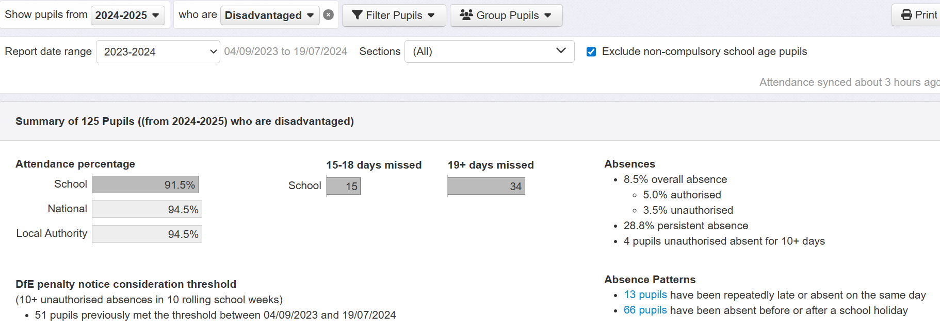

Further information

